

**SpiraTest®, SpiraTeam®, SpiraPlan®**

**User Manual**

Version 6.0

Inflectra Corporation

Contents

1. Introduction 3

1.1. Quality Assurance 3

1.2. Product Management 3

2. Functionality Overview 5

2.1. Requirements Management 5

2.2. Test Case Management 5

2.3. Release Planning 6

2.4. Sprint Planning 7

2.5 Incident Tracking 7

2.6 Task Management 7

2.7. Products and Users 8

2.8. Document Management 8

2.9. Risk Management 8

2.10. Source Code Tracking 8

2.11. Build Management 9

2.12. Instant Messenger 9

2.13 Miscellaneous 9

3. User/Product Management 14

3.1. Login Screen 14

3.2. My Page 17

3.3. Global Navigation 23

3.4. Product Home 31

3.5. Program Home 48

3.6. My Profile 52

3.7. My Timecard 55

4. Requirements Management 57

4.1. Requirements List 57

4.2. Requirement Details 65

5. Test Case Management 81

5.1. Test Case List 81

5.2. Test Case Details 90

5.3. Test Step Details 110

5.4. Execute Test Case(s) 115

5.5. Test Run List 133

5.6. Test Run Details 135

5.7. Test Set List 140

5.8. Test Set Details 145

5.9. Automation Host List 158

5.10. Automation Host Details 160

5.11. Test Configurations List 164

5.12. Test Configuration Details 166

6. Incident Tracking 169

6.1. Incident List 169

6.2. Incident Details 173

6.3. Incident Board 184

7. Release Management 190

7.1. Release List 190

7.2. Release Details 196

7.3. Build Details 209

8. Task Tracking 212

8.1. Task List 212

8.2. Task Details 218

8.3. Task Board 227

9. Resource Tracking 234

9.1 Resource Details 235

10. Document Management 238

10.1. Document List 238

10.2. Document Details 242

11. Reports Center 250

11.1. Reports Configuration 251

11.2. Requirement Reports 254

11.3. Test Case Reports 256

11.4. Incident Reports 260

11.5. Task Reports 261

11.6. Release Reports 262

11.7. Summary Graphs 264

11.8. Snapshot Graphs 270

11.9. Date-Range Graphs 280

11.10 Custom Graphs 284

11.11. Risk Reports 286

12. Source Code 288

12.1. Source Code File List 288

12.2. Source Code File Details 289

12.3. Source Code Revision List 292

12.4. Source Code Revision Details 293

13. Planning Board 296

13.1. Product Backlog Planning 300

13.2. Release Planning 303

13.3. Release Backlog Planning 306

13.4. Sprint Backlog Planning 310

14. Mobile Access 314

14.1. My Page 314

14.2. My Profile 316

14.3. Example List Page 317

14.4. Example Details Page 319

14.5. Test Execution 322

15. Program Management 324

15.1. Program Planning Board 324

15.2. Program Release Plan 330

15.3. Program Incident List 331

16. Risks Management 332

16.1. Risks List 332

16.2. Risk Details 336

Appendix 1: Keyboard Shortcuts 347

Legal Notices 349

# 1. Introduction

The Spira™ family of applications from Inflectra® are a powerful set of tools that help you manage your software lifecycle.

SpiraTest® is our powerful and easy to use requirements, test and defect management system, ideal for quality assurance teams.

SpiraTeam® is our integrated Application Lifecycle Management (ALM) system that manages your product's requirements, releases, test cases, issues and tasks in one unified environment.

SpiraPlan® expands on the features in SpiraTeam® to provide a complete Enterprise Agile Planning® solution that lets you manage risks, products, programs and the entire organization with ease.

This user manual outlines the features and functionality available in all three Spira™ products, and demonstrates how to use the system on a typical product.

## 1.1. Quality Assurance

Quality Assurance is a key component of the Software Development Life-Cycle (SDLC), which needs to be integrated into the planning and management of a program or product from its inception. Too often though, QA is implemented as *Quality Control* - whereby testing that the required functionality works as expected, is performed at the end, when it is most costly to make corrections and changes.

To manage QA across a product from day one, it is imperative that the original requirements are documented together with the use-cases that validate the desired functionality. These use-cases then form the basis of the test scripts that can be executed to validate that the functionality has been correctly built, and that the requirements have been satisfied. During the execution of these test scripts, failures may occur, which are recorded as *incidents* - either to be fixed or documented depending on the severity.

Typically, these activities require people to use at least three different types of software:

* Requirements Management
* Test Script Management
* Defect / Issue / Bug Tracking

However, this stove-piped approach has many limitations and drawbacks, most importantly the fact that there is no *traceability* between the different artifacts. How can the product manager know that all the requirements have been tested? Conversely, how can the developer know which test script was responsible for a recorded bug – needed to accurately reproduce the issue?

## 1.2. Product Management

As described in the Agile Manifesto, traditional waterfall software methodologies and lifecycles have failed to delivery products on-time and on-budget. In addition, many systems built this way will fail to provide the expected business value as there is no ability to quickly refine the requirements as the product progresses.

Consequently, software development has been transformed with these new ideas and concepts, with new agile methodologies such as Scrum, and Kanban becoming common. However, the traditional tools of product management - requirements specifications, high level product plans, GANTT charts, white-board schedules and top-down task management - are too cumbersome and not well suited.

# 2. Functionality Overview

This section outlines the functionality provided by SpiraPlan® in the areas of requirements management, test case management, release planning, sprint planning, incident tracking, task management and product / user management.

Please note, that SpiraPlan® is designed for use on a very wide range of devices from desktops, to tablets, to smartphones. This guide is written using desktop conventions (e.g. using ‘click’ throughout where ‘tap’ would apply on mobile devices) but the functionality remains very similar throughout the application across all devices and platforms. See section 14 for more information.

## 2.1. Requirements Management

SpiraPlan® provides the ability to create, edit and delete product scope / requirements in a hierarchical organization that resembles a typical scope matrix. Each requirement is associated with a particular importance level and a status identifier that designates where the requirement is in the development lifecycle (requested, planned, in-progress and completed). The requirements can be organized according to which part of the system they relate to (called the Component) as well as being organized into different types (features, qualities, use cases, etc.). Certain types (such as use cases) allow you to define the scenario steps that help describe that requirement.

In addition, each requirement can be mapped to one or more test cases that can be used to validate that the functionality works as expected. This mapping is called the “Requirement Test Coverage”, since the test cases “cover” the requirement so that if all the tests can be executed successfully, then the requirement is validated.

At the same time, from a development perspective, the team begins initial estimation of the lowest-level requirements in the requirements matrix to determine the complexity and associated resourcing. Once the high-level release schedule has been determined, the requirements can then be prioritized and scheduled against the appropriate release according to their business priority.

Once the release is underway, the requirements are further decomposed into their constituent low-level product tasks that can be assigned to the product team. The system will track the progress and revised estimates for the tasks and display them against the requirements so that risks to the schedule can be quickly determined.

## 2.2. Test Case Management

SpiraPlan® provides the ability to create, edit and delete product test cases that are stored in a hierarchical folder structure that resembles Windows Explorer ®. Each test case consists of a set of test steps that represent the individual actions a user must take to complete the test. These test steps also contain a description of the expected result and any sample data elements that the tester should use when performing the action. When a user executes a test case, the results are stored in a test run that contains the success/failure status of each test step as well as the actual observed result that the tester experienced.

In addition each test case is mapped to one or more requirements that the test is effectively validating, providing the test coverage for the requirement. During the execution of the test case, each failure can be optionally used to record a new incident, which can then be managed in the incident tracking module (see below). This provides complete traceability from a recorded incident to the underlying requirement that was not satisfied.

To streamline the assignment and tracking of multiple test cases, SpiraPlan® allows users to select groups of test cases and arrange them into *test sets*. Each test set can contain test cases from a variety of different folders and can be associated with a specific release of the system being tested.

### 2.2.1. Test Automation

As well as being able to store and manage manual test cases, SpiraPlan® can be used to manage the scheduling and execution of automated test scripts for a variety of third-party test automation engines. This allows you to centrally plan your automated testing and monitor the results of automated unit, functional and load testing remotely. For example, you could schedule a set of automated functional tests to run on five different machines (each with a different browser/OS combination) at 2:00 AM and have the results be ready for the next morning.

## 2.3. Release Planning

SpiraPlan® provides the ability to track different versions / releases of the application being tested. Each product in the system can be decomposed into an unlimited number of specific product releases, denoted by name and version number. Requirements and Test Cases developed during the design phase can then be assigned to these different releases. When a tester executes a series of test cases, they are able to choose the version of the product being tested and the resulting test run information is then associated with that release.

From a product planning perspective, the releases are the major milestones in the product, which are further sub-divided into sprints which are separate mini-products with associated product scope and tasks. The product’s requirements are scheduled at a high-level against the releases and the detailed tasks are scheduled against specific sprint within the release.

In addition, all incidents raised during the testing process are associated with this release, allowing the development team to easily determine which version of the product is affected. Finally as the incidents are resolved and verified during the testing phase, the appropriate release can be selected to indicate which release the incident was resolved and/or verified in.

## 2.4. Sprint Planning

As described in section 2.3, in addition to high-level product releases, SpiraPlan® can also track the individual sprints that comprise a release, giving the product manager the option to manage agile methodology products within the SpiraPlan® environment. Unlike the release planning stage, where high-level requirements are estimated and scheduled, the sprint planning phase involves assigning each of the requirements, incidents and tasks in the product backlog against a specific sprint until the available effort in the sprint has been completely allocated.

When you first create sprints, you specify the start and end-dates together with the notional number of product resources assigned to the sprint and any non-working days. SpiraPlan® uses this information to calculate the planned effort available to the sprint, from which it will subtract the estimated task and incident effort values to determine how much effort is available to schedule.

## 2.5 Incident Tracking

SpiraPlan® provides the ability to create, edit, assign, track, manage and close incidents that are raised during the testing of the software system under development. These incidents can be categorized into bugs, enhancements, issues, training items, limitations, change requests, and risks, and each type has its own specific workflow and business rules. Typically each incident is raised initially as a ‘New’ item of type ‘Incident’. Following the review by the product manager and customer, they are changed to one of the other specific types, given a priority (critical, high, medium or low), and status changed to ‘Open’. Once it is assigned to a developer for fixing, it is changed to status ‘Assigned’.

The developer now works to correct the incident, after which time its status changes to ‘Fixed’ or ‘Not Reproducible’ depending on the actions taken (or not taken). Finally the product manager and customer verify that it has indeed been fixed, and the status is changed to ‘Closed’. SpiraPlan® provides robust sorting and filtering of all the incidents in the system, as well as the ability to view the incidents associated with particular test cases and test runs, enabling drill-down from the requirements coverage display, right through to the open incidents that are affecting the requirement in question.

## 2.6 Task Management

As described above, in addition to storing the requirements for a product, SpiraPlan® includes the capability of drilling each lowest-level requirement down further into a series of work items called ‘Tasks’. These tasks are the discrete activities that each member of the development team would need to carry out for the requirement to be fulfilled. Each task can be assigned to an individual user as well as associated with a particular release or sprint. The system can then be used by the product manager to track the completion of the different tasks to determine if the product is on schedule.

The tasks can be organized into different folders as well as categorized by different types (development, testing, infrastructure, etc.), each of which can have its own *workflow* which defines the process by which the task changes status during the product lifecycle.

## 2.7. Products and Users

SpiraPlan®supports the management of an unlimited number of users and products, which can be administered through the same web interface as the rest of the application. All artifacts (requirements, tests and incidents) are associated with a particular product, and each user of the system can be given a specific role for the particular product. So, a power user of one software product may be merely an observer of another. That way, a central set of users can be managed across the enterprise, whilst devolving product-level administration to the manager of the product. In addition to these administration functions, each user profile and product has its own personalized dashboard view of all the pertinent and relevant information. This feature reduces the information overload associated with managing such a rich source of product information, and allows a single user or product snapshot to be viewable at all times for rapid decision-making.

## 2.8. Document Management

SpiraPlan® includes an integrated document management collaboration system that can be used to upload, manage and share documents between the different members of the product. This module includes support for uploading files and URLs, versioning of documents, the ability to organize into folders and categorize and search using meta-tags.

## 2.9. Risk Management

SpiraPlan® (not available in SpiraTest or SpiraTeam) enables a complete risk management workflow. This module aids in the analyzing and categorizing of risks based on their Probability and their impact, which produces a calculated risk exposure. The tool tracks both risks and their mitigations, and provides dynamic risk reporting tools.

## 2.10. Source Code Tracking

SpiraPlan® and SpiraPlan® provide the ability to browse your source code repository from within the main web application. This is an excellent way for managers and casual users of the product to browse the files and revisions of the software code without needing to install the version control software on their own workstations. In addition all users have the ability to link source code revisions with SpiraPlan® artifacts–providing traceability from requirements, incidents, and tasks to the code changes that were made to implement the required feature, or fix the identified defect. Should a defect resurface later, you can view the associated source code revisions to determine which changes were made and did they truly correct the defect.

## 2.11. Build Management

SpiraPlan® includes the ability to integrate with a variety of continuous integration / automated build servers so that the results of automated builds can be displayed in SpiraPlan linked to the associated release or sprint. In addition, the results of automated tests and source code operations can be linked to the build events, providing traceability from a specific build to the bugs that were fixed, tests that were run and source code files that were modified.

## 2.12. Instant Messenger

SpiraPlan® comes with a build-in integrated instant messaging capability. This lets users see which users are currently logged-into the system, maintain a list of contacts and where available, send short instant messages to other users. Any messages exchanged can then be posted to relevant artifacts in the system as permanent comments.

## 2.13 Miscellaneous

### 2.13.1. Artifact Relationships

The sections above have outlined the different features and functions available in the system, and have described the various artifacts managed in the system (e.g. products, users, requirements, tests, etc.). To aid in understanding how the information is related, the following diagrams illustrates the relationships between the different artifacts and entities:

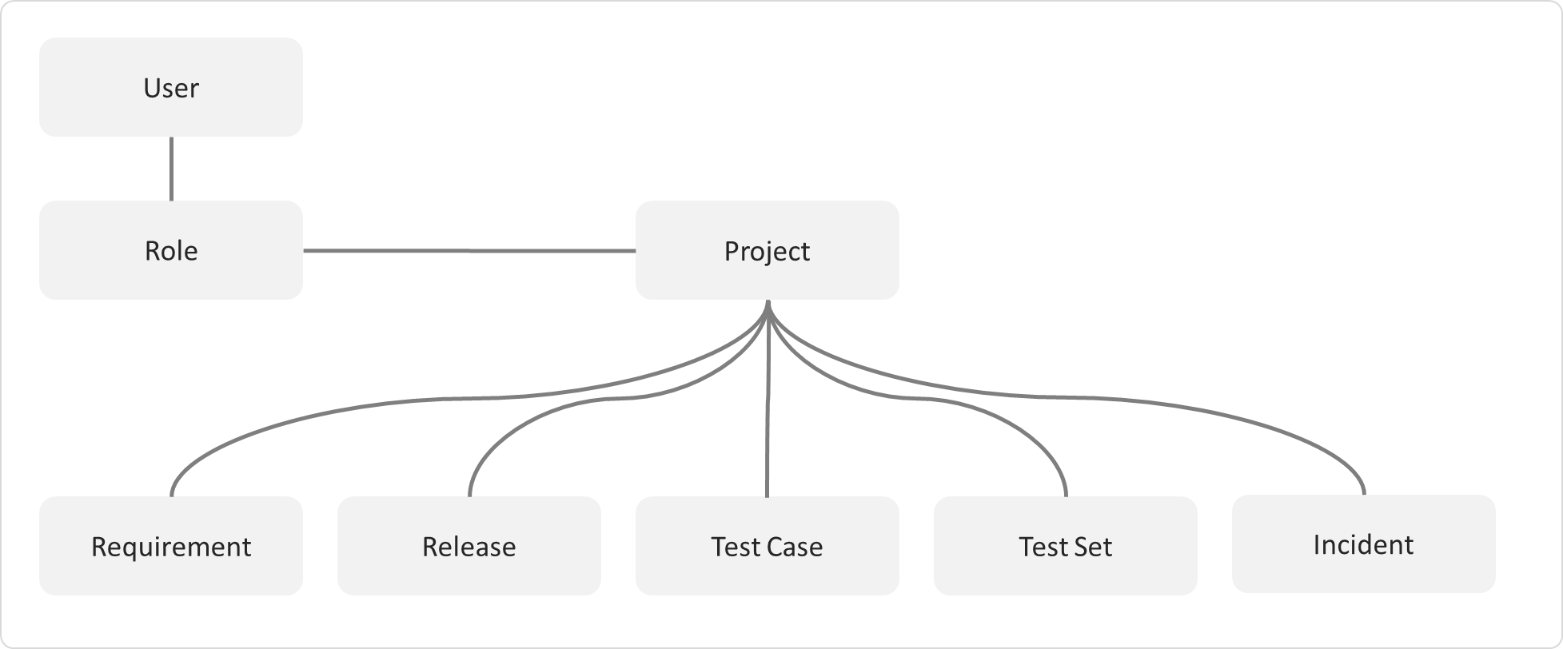

Figure 1: The main entities that comprise a SpiraTest product.

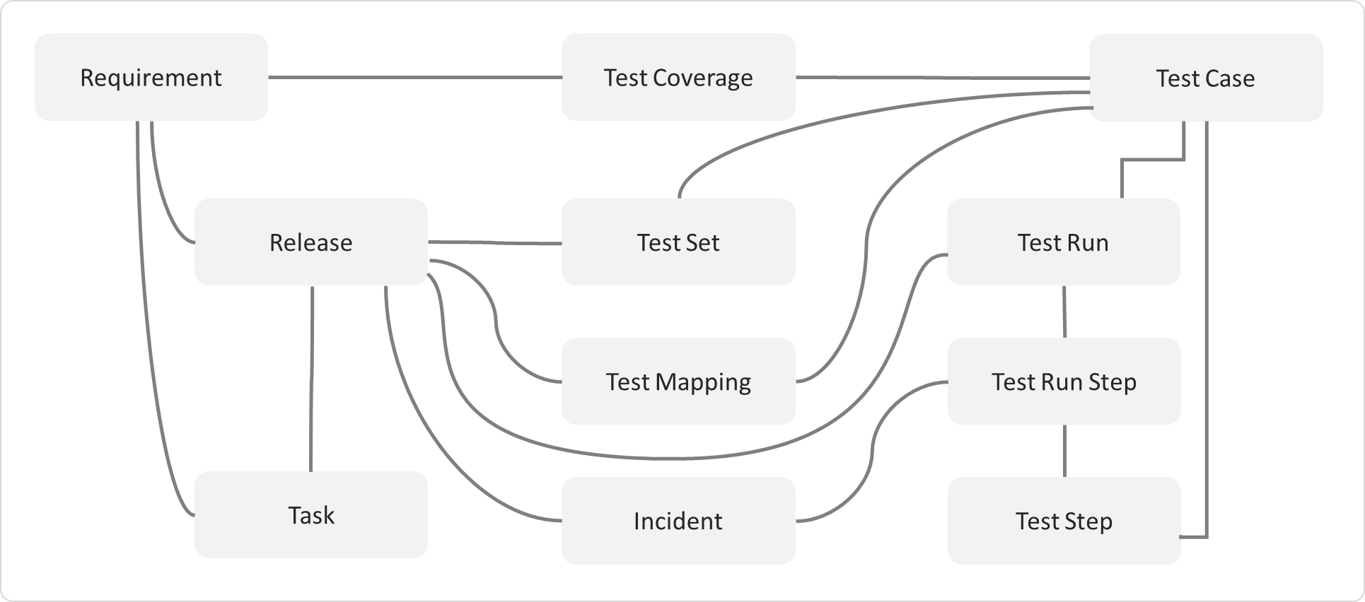

Figure 2: The relationships between the various SpiraTest entities

With these overall concepts in mind, the rest of this help manual will outline the functionality in each of the SpiraPlan® screens, and provide specific information on how to manage each of the artifacts illustrated above. Note that this manual does not explain the Administration-level functionality of the system; for that, please refer to the *SpiraPlan® Administration Guide*.

### 2.13.2. Artifact Naming Conventions

On various screens in the system, you will see lists of artifacts (requirements, test cases, etc.) together with a unique identification number. In order to make it easier to recognize at a glance which type of artifact the identification number refers to, SpiraPlan® uses a system of two-letter prefixes which help identify the type of artifact being displayed. The current prefixes used by the system are:

|  |  |  |  |
| --- | --- | --- | --- |
| Artifact | Prefix | Artifact | Prefix |
| Product | PR | Program | PG |
| User | US | Incident Type | IT |
| Requirement | RQ | Incident Priority | IP |
| Requirement Step | RS | Incident Severity | IV |
| Test Case | TC | Workflow | WK |
| Test Step | TS | Workflow Transition | WT |
| Test Run | TR | Custom Property Values | PV |
| Test Run Step | RS | Product Role | RX |
| Incident | IN | Task | TK |
| Incident Status | IS | Test Set | TX |
| Custom List | CL | Document | DC |
| Document Type | DT | Document Folder | DF |
| Automation Host | AH | Build | BL |
| Release/Sprint | RL | Component | CP |
| Risk | RK | Risk Mitigation | RM |

In addition, certain artifacts in the system are displayed with an icon that helps distinguish them from each other, and provides additional context on the state of the artifact:

| Icon | Artifact Description |
| --- | --- |
|  | Program |
|  | Product |
|  | Summary Requirement |
|  | Detailed Requirement |
|  | Use Case Requirement |
|  | Use Case Scenario Step |
|  | Folder |
|  | Test Case with Test Steps |
|  | Test Case without Test Steps |
|  | Test Set |
|  | Test Run |
|  | Test Step |
|  | Linked Test Case |
|  | Test Automation Host |
|  | Test Configuration |
|  | Release |
|  | Iteration / Sprint |
|  | Component |
|  | Task |
|  | Incident |
|  | Risk |
|  | Risk Mitigation |
|  | Source Code Revision |
|  | Product User |
|  | Build |
|  | Artifact has an Attachment |

# 3. User/Product Management

This section outlines how you can log into SpiraPlan®, view your personalized home-page that lists the key tasks that you need to focus on, and drill-down into each of your assigned products in a single dashboard view. In addition to your personal homepage, each of your products has its own dashboard that depicts the overall product health and status in a single comprehensive view.

## 3.1. Login Screen

Upon entering the SpiraPlan® URL provided by your system administrator into your browser, you will see the following login screen:

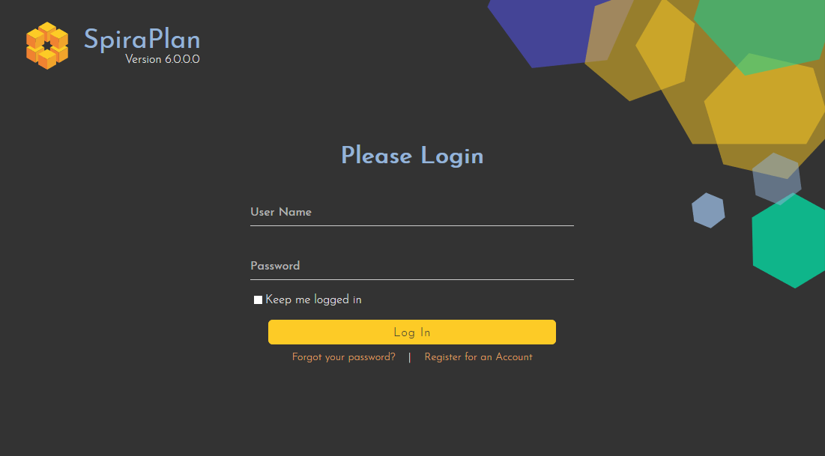

You need to enter your given user-name and password into the system in the appropriate boxes then click the Log In button to gain access to the application. Normally you only remain logged in to the application whilst in active use, and you will be asked to log-in again after either closing the browser or 20 minutes of inactivity. To prevent this, and to stay logged-in to SpiraPlan® regardless of browser window closing or inactivity, select the “Keep me logged in” check-box before clicking the Log In button. Note that this setting is specific to each individual computer you are logging-in from, and that it will be reset when you explicitly log-out with the log-out link (described in more detail in section 3.3).

If for any reason you are unable to login with the provided username/password combination, and error message will be displayed. If you cannot remember the correct log-in information, click on the “Forgot your password” link and your password will be emailed to the email address currently on file. The reset password screen is illustrated below:

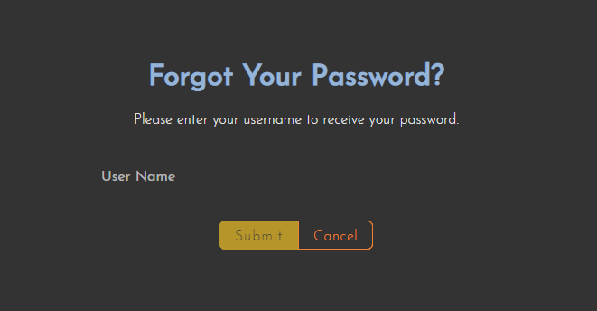

If you don’t have a SpiraPlan®account setup, clicking on the “Register for an account?” link will take you to a form that you need to fill-in, which will be forwarded to the system administrator, who will need to approve your account before it is active in the system. This screen is illustrated below:

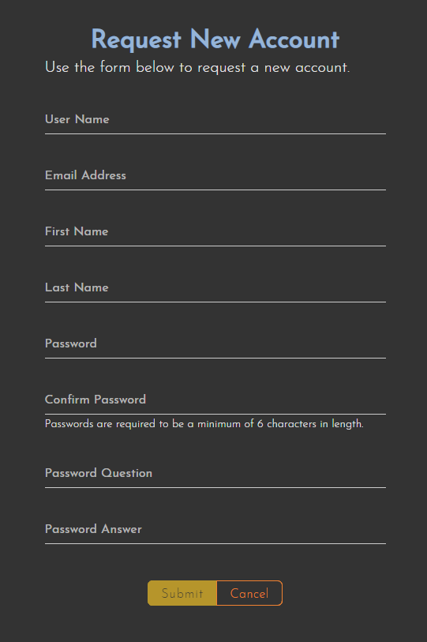

In addition, the system will prevent you logging on to the system with the same username *at the same time* on multiple computers. This is to avoid the system getting confused by a user trying to make contradictory actions at the same time. If for any reason you do try and log in to the system when you already have an active session in progress, you will see the following screen:

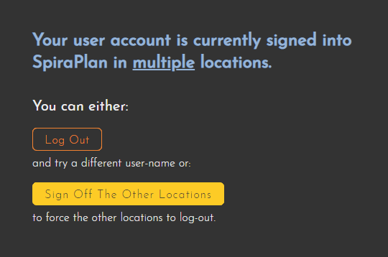

You have two choices: you can either click the “Log Out” link and try logging in as a different user, or if you want to log-off any other active sessions (e.g. you closed the browser and the session is still listed as active), simply click the “Sign Off The Other Locations” link, and you will be logged in to the application.

Since SpiraPlan®is licensed to organizations for a specific number of concurrent users – unless they have purchased an unlimited Enterprise license – only a fixed number of users may be active at the same time. So, for example if an organization has a five (5) concurrent user license and a sixth user tries to log-in, they will be presented with the following screen:

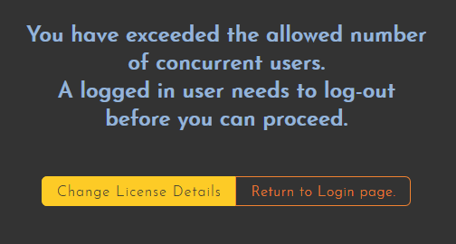

This means that one of the other users who is already logged-in, needs to click the “Log Out” button so that one of the concurrent licenses is freed for your use. If the user has logged out by closing the browser, the system may not have detected the logout. In this case, the other user needs to log back in, and then click the “Log Out” link.

## 3.2. My Page

Once you have successfully logged in, you will initially be taken to your personalized home page called “My Page”. Please note, that the very first time you log in you will be asked if you want to take a quick orientation tour of the application (which will look similar to the screenshot below).

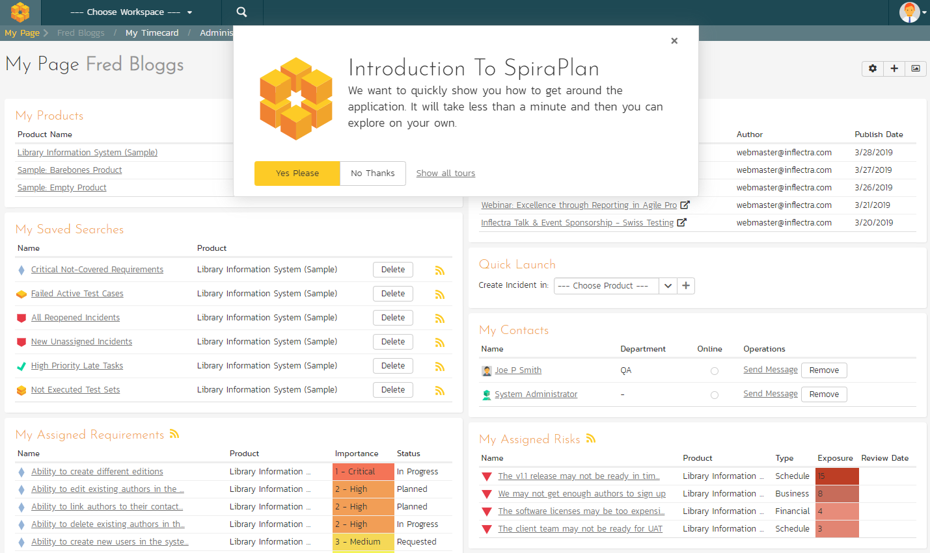

Note that once you have successfully logged-in and chosen a product, SpiraPlan®remembers this selection, and on subsequent log-ins will automatically select that product, and highlight it for you in the “My Products” list (see 3.2.1 below).

Your homepage contains all the information relevant to you—consolidated onto a single page for you to take immediate action. By default the page lists the information for all products that you are a member of. However, you can choose to filter by the current product, to get a more focused list.

Next to some of the widgets is an RSS icon (), this allows you to subscribe to the information as a Really Simple Syndication (RSS) newsfeed. This can be useful if you want to be notified about recently assigned items without having to setup email notifications or being logged into SpiraPlan continuously. If you don’t see an RSS icon next to the widgets on your My Page it means that you have not enabled RSS newsfeeds in your profile. For more details on configuring your RSS preferences, please refer to section 3.6 (My Profile).

Initially the page is loaded in ‘view mode’ which means that the various ‘widgets’ on the page are displayed with minimum visual clutter (no toolbars or control icons) that makes it easy to scan the items on the page and see what work has been assigned. To switch the page to ‘edit mode’, click on the button with the cog icon () on the right:

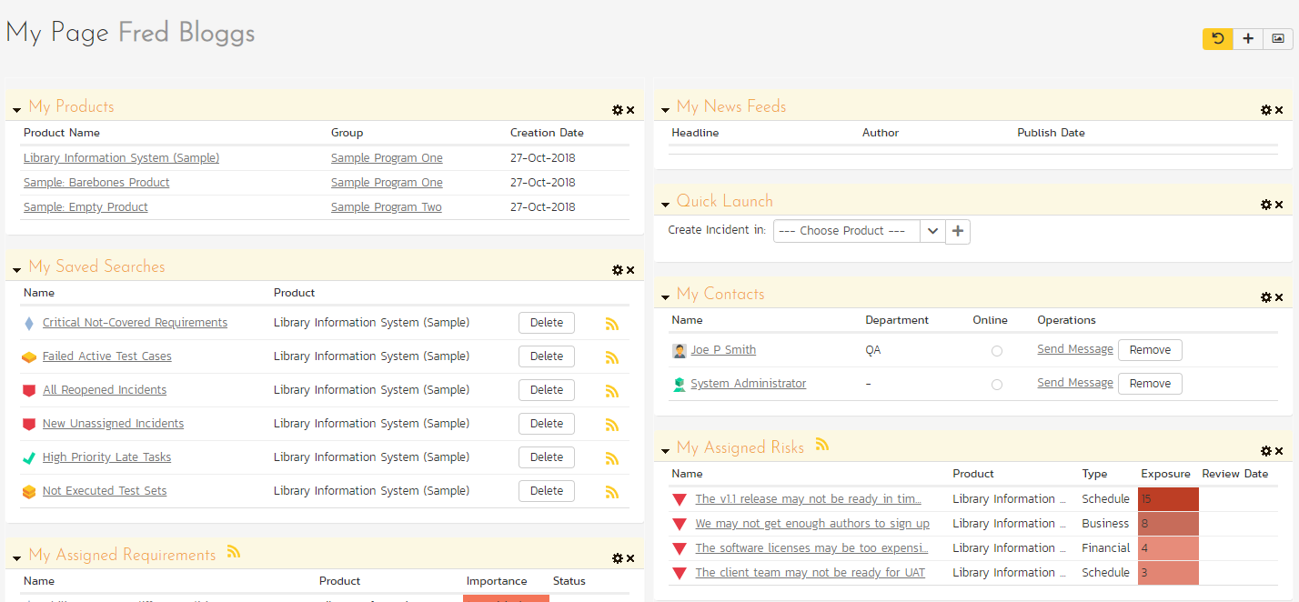

In this mode, each of the ‘widgets’ displayed on the page can be minimized by clicking on the arrow icon () in the top-left of the window, or closed by clicking-on the cross icon () in the top-right of the window. This allows you to customize your page to reflect the types of information that are relevant. If you have closed a widget that you subsequently decide you want to reopen, you can add them back to the page display by clicking the “Add Items” button at the top of the page. In addition, the various widgets have a “settings” icon () that allows you to customize how that widget appears. The settings are specific to each widget and in general allow you to specify how many rows of data are displayed and what columns are displayed.

You can move and reposition the various widgets on the dashboard by clicking the mouse on the title bar of the widget you want to move and dragging it to the desired location. This change will be remembered when you next login to the system. Once you have the dashboard configured the way you like it, you can click “Return to Normal View” to switch back to ‘view mode’.

When you load your ‘My Page’ for the first time it will consists of the following main elements:

* My Products
* My Saved Searches
* My Assigned Requirements
* My Assigned Test Cases
* My Assigned Test Sets
* My Pending Test Runs
* My Assigned Incidents
* My Detected Incidents
* My Assigned Tasks
* Quick Launch
* My Contacts

However these are not the only widgets available. If you click on the “Add/Remove” items hyperlink it will display the list of any additional widgets that are available:

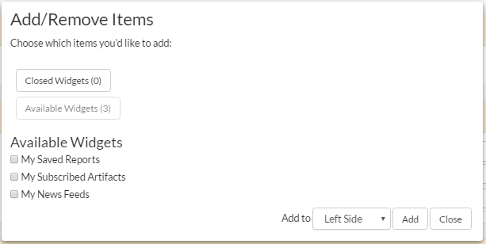

You can add the additional widgets by selecting the appropriate checkbox, choosing the destination location (left side vs. right side) and then click the [Add] button. The additional widgets available in the My Page are:

* My Saved Reports
* My Subscribed Artifacts
* My News Feeds

### 3.2.1. My Products

This section lists all the products you have been given access to, together with the name, description, program and date of creation. To view the description of the product, simply position the mouse pointer over the link, and a tooltip window will popup containing the description.

When you initially view the page, all of the products will be shown as links. When you click on a product to view, you will be taken to that product’s home-page, and that product will be set as the current product. That product will now appear highlighted in your home-page (see above screen-shot). To change the currently selected product, simply click on the link of another product name. You can always change your current product by clicking on the drop-down-list of products displayed on the global navigation bar to the right of the “Search” box.

If you are a program member, the name of the program will also be displayed as a hyperlink. In which case, clicking on the program hyperlink will take you to the Program dashboard (see section 3.5).

### 3.2.2. My Saved Searches

This section lists any filters/searches you have saved from the various artifact list screens throughout the application. This allows you to store specific combinations of searches that you need to perform on a regular basis (e.g. display all newly logged incidents, display all requirements that are completed but have no test coverage).

The name of the saved search is displayed along with an icon that depicts which artifact it’s for and the product it refers to. Clicking on the name of the saved search will take you to the appropriate screen in the product and set the search parameters accordingly. Clicking the “Delete” button next to the saved search will delete it. Clicking on the RSS icon will allow you to subscribe to the specific search so that it will be displayed in your RSS newsreader. This allows you to setup customized lists of information that can be displayed outside of SpiraPlan.

### 3.2.3. My Assigned Requirements

This section lists all the requirements you have been made owner of, across *all the different products* you are a member of. This typically means that the product manager has assigned you to be responsible for either developing the supporting test cases or decomposing the requirement into its detailed work breakdown structure of product tasks. The requirement name is displayed, along with its status (requested, accepted, in-progress, etc.) and its importance.

### 3.2.4 My Assigned Test Cases

This section lists all the test cases you have been made owner of, across *all the different products* you are a member of. This typically means that the product manager has assigned you to be responsible for executing the assigned test scripts. To aid in this process, the script name is displayed, along with its last execution status (failed, passed or not-run) and date of last execution. This enables you to see how recently the tests have been run, and whether they need to be re-run.

If you click on the test-name hyperlink, you will be taken to the details page for this test-case (see section 5.2) and the product that the test-case belongs to will be made your current product. If you click on the play button to its right you will launch the test-case in the test-case execution module (see section 5.4) so that you can easily retest failed cases.

### 3.2.5. My Assigned Test Sets

This section lists all the test sets (groups of test cases) you have been made owner of, across *all the different products* you are a member of. This typically means that the product manager has assigned you to be responsible for executing the test cases contained within the test set against a specified release of the system under test. To aid in this process, the test set name is displayed, along with its status, the product it belongs to, the number of remaining test cases to be executed, and the date by which all the tests need to have been run.

If you click on the test-set name hyperlink, you will be taken to the details page for this test-set (see section 5.6) and the product that the test-set belongs to will be made your current product. If you click on the play button to its right you will launch the test-cases contained within the test-set in the test-case execution module (see section 5.4) so that you can easily carry out your assigned testing task.

### 3.2.6 My Pending Test Runs

This section lists any test runs that you started executing in the test case module but haven’t yet completed. Until a test case or test set is fully executed, a pending test run entry is stored in the system so that you can continue execution at a later date.

Any pending test run can be either deleted or resumed by clicking on the appropriate button. In addition, there is the option to reassign the test run to another user that is a member of the product.

### 3.2.7 My Assigned Tasks

This section lists all the product tasks that you have been made the owner of across *all the different products* you are a member of. This typically means that the manager of the product in question has assigned development tasks to you that need to be completed so that a release can be completed and/or a requirement can be fulfilled. The tasks are listed in ascending date order so that the items with the oldest due-dates are displayed first. In addition, each task is displayed with a progress indicator that graphically illustrates its completion against schedule. See section 8 – task management for details of the different progress indicators.

Clicking on the task name hyperlink will take you to the task details page. This page will describe the task in more detail, illustrate which requirement and release it is associated with, and also allow you to view the change log of actions that have been performed on it.

### 3.2.8 My Assigned Incidents

This section lists all the open incidents you are the owner of, across *all the different products* you are a member of. This typically means that the product manager has assigned you to be responsible for resolving the incident. In the case of a bug, this can mean actually fixing the problem, whereas for other incident types (e.g. training item) it may mean simply documenting a workaround. In either event, this section highlights the open incidents you need to manage, ranked by importance/priority and categorized by type, with the open date displayed to give you a sense of the age of the incident.

Clicking on the incident name hyperlink takes you to the incident details page (see section 6.2) that describes the incident in more detail, and allows you to add new information or change its status to indicate actions taken. In addition, if you position the mouse pointer over the name of the incident, a more detailed description is displayed as a “tooltip”.

### 3.2.9 My Detected Incidents

This section lists all the open incidents that you have detected, across *all the different products* you are a member of. These incidents are not necessarily ones that you need to take an active role in resolving, but since you were the originator – either by executing a test case or just logging a standalone incident – you can watch them to make sure that they are resolved in a timely manner.

Clicking on the incident name hyperlink takes you to the incident details page (see section 6.2) that describes the incident in more detail, and allows you to add new information or change its status to indicate actions taken. In addition, if you position the mouse pointer over the name of the incident, a more detailed description is displayed as a “tooltip”.

### 3.2.10. Quick Launch

This widget allows users to quickly record a new incident in any of the products that they belong to. It’s a shortcut that avoids having to first select a product, go to Tracking > Incidents and then click “New Incident”. Instead you simply choose the product from the dropdown list and click the arrow icon to bring up the new incident creation screen.

### 3.2.11. My Contacts

This widget displays a list of any other users in the system that you have listed as a personal contact:

Each user is displayed along with their graphical avatar, department and a colored indicator that lets you know if they are online or not. If they are online you can then send them an instant message (which will be described later in section 3.3. To remove an existing contact, just click on the ‘Remove’ button. To add a new user, simply locate them in the Tracking > Resources page and then use the <Add As Contact> button.

### 3.2.12. My Saved Reports

This section lists any reports you have saved from the reports center. This allows you to store specific combinations of report elements, format, filters and sorts (see the section on Reporting for more details on how to configure a report) for reports that you need to run on a regular basis:

### 3.2.13. My Subscribed Artifacts

This widget displays a list of all the artifacts in the system that you have subscribed to (by clicking on the Subscribe icon on the item). You can display the item by simply clicking on the hyperlink. In addition, if changes are made to any of the artifacts an email notification will be sent to you. You can click on the “Unsubscribe” button to remove the item from this list.

### 3.2.14. My News Feeds

This widget allows you to subscribe to an external newsfeed and have the results be displayed inside SpiraPlan. By default it will be set to the newsfeed from the Inflectra website that displays a list of recent company and product announcements. You can add multiple instances of the widget to the dashboard, allowing you to read multiple news sources at once. Typical uses for this widget are to add news from product management and testing news sites/blogs or to add information from other tools in your organization that can display their data in RSS format.

### 3.2.15. My Assigned Risks (SpiraPlan only)

This section lists all the risks you are the owner of across *all the different products* you are a member of. Clicking on the risk name hyperlink will take you to the risk details page. This page will describe the risk in more detail.

### 3.2.16. My Assigned Documents

This section lists all the documents you are the owner of across *all the different products* you are a member of. Clicking on the risk name hyperlink will take you to the documents details page. This page will describe the documents in more detail.

## 3.3. Global Navigation

Regardless of the page you are on, SpiraPlan®will always display the global navigation bar, consisting of a number of different sections, depending on the user and where they are in the system.



Under some of the icons and headings are secondary menu options that display when you click on the section in question. The sections and menus available in the global navigation are show below:

* **Product Icon** (shown as SpiraPlan above): this will always take you to “My Page” as discussed above
* **Workspace Icon**: this shows you the type of workspace you are on, for example a program or a product. Clicking it will take you to that workspace’s homepage (described in section 3.4, and 3.5)
* **Workspace Selector**: this shows the name of the current workspace. Clicking it will show all your available workspaces and clicking any of these will change you to that workspace
* **Artifacts Selector**: when visible, this shows the name of the current artifact for the current workspace. Clicking it will show all your available artifacts and clicking any of these will change you to that artifacts main page. For product workspaces these artifacts are grouped as follows:
  + Planning
    - Requirements (described in Section 4)
    - Planning Board (described in Section 13)
    - Releases (described in Section 7)
    - Documents (described in Section 10)
  + Testing
    - Test Cases (described in Section 5)
    - Test Sets (described in Section 5.7)
    - Test Runs (described in Section 5.5)
    - Automation Hosts (described in Section 5.9)
  + Tracking
    - Incidents (described in Section 6)
    - Tasks (described in Section 8)
    - Risks (described in Section 14)
    - Resources (described in Section 9)
    - Source Code (described in Section 12)
* **Reporting** (described in section 11)
* **User Profile Icon**
  + My Profile (described in Section 3.6)
  + My Timecard (described in Section 3.7)
  + Documentation (described in Section 3.3.3)
  + Show on boarding tours (described in Section 3.3.5)
  + Keyboard shortcuts
  + Log Out (described in Section 3.3.2)
* **Administration Icon**: This is visible if you are a system administrator, or if you are an owner/administrator of the current workspace or its template. Clicking the icon will display the relevant administration menu. This is described in the separate *SpiraPlan Administration Guide*.

### 3.3.1. Global Search

SpiraPlan includes a global search that can be used to search across product and artifact type for items that include the entered keywords in either the name or description field:

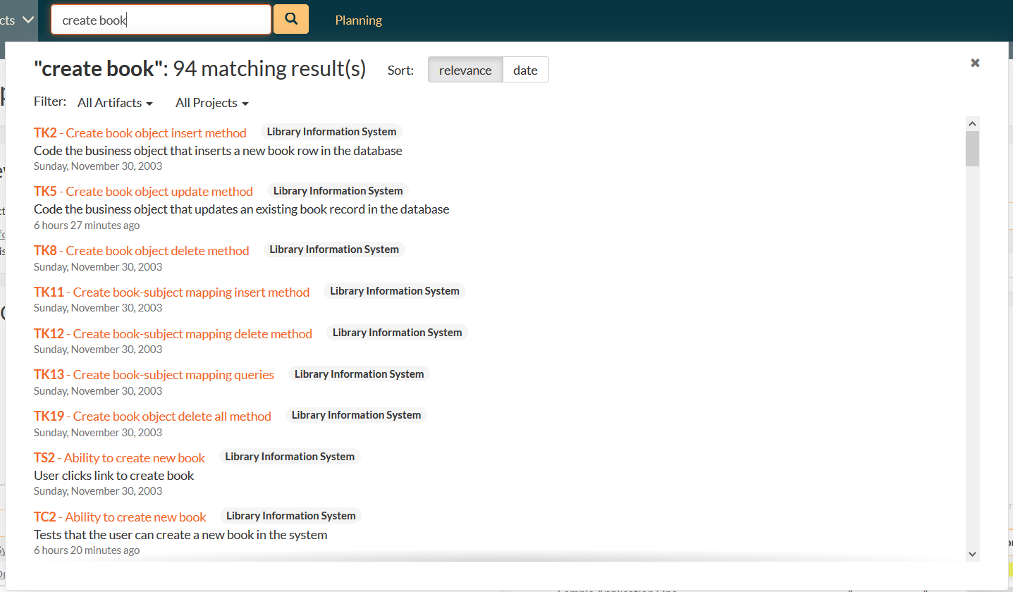

You can search for individual keywords by simply entering them in the search box and clicking the arrow button on the right. You can search for phrases by enclosing the words in double quotes. You can also **search for a specific artifact** by its unique **two-letter prefix and ID number**.

For example, searching on **book name** will find any artifacts that include either of the two words book and name in the name or description. Searching on **“book name”** will only return items that have that exact phrase in either the name or description. Searching on **TC2** will display just the Test Case with ID=2:

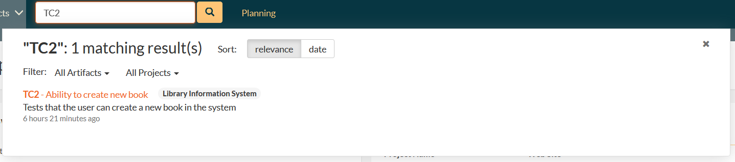

When you get a list of search results, you can choose to order by relevance (the default) or by most recent. Searching by relevance finds the artifacts that have the greatest match with the keywords:

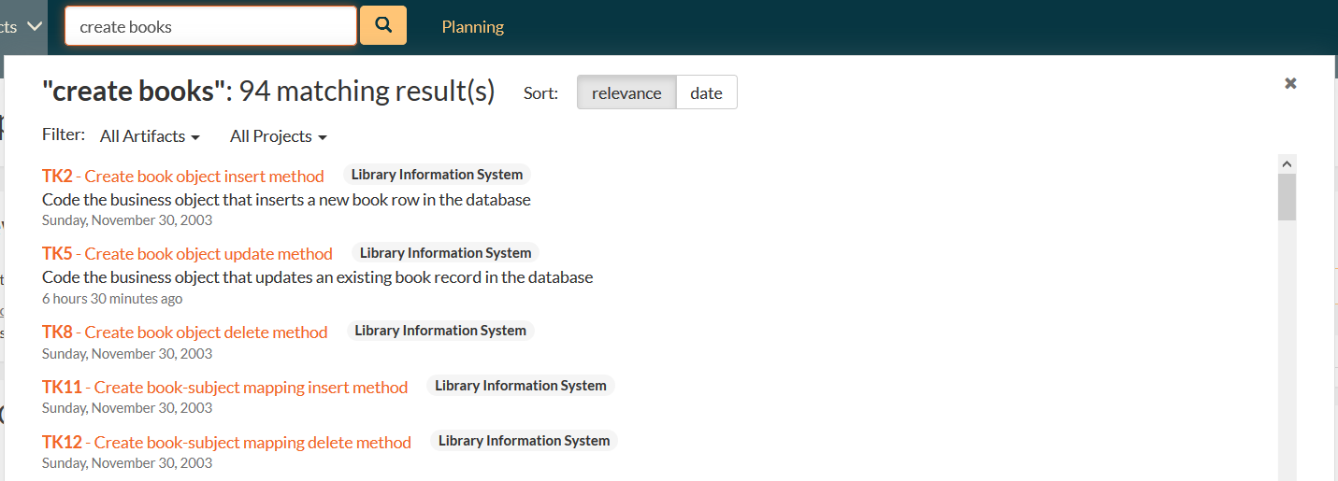

The search by date is useful when you want to find recent items that match the search keywords:

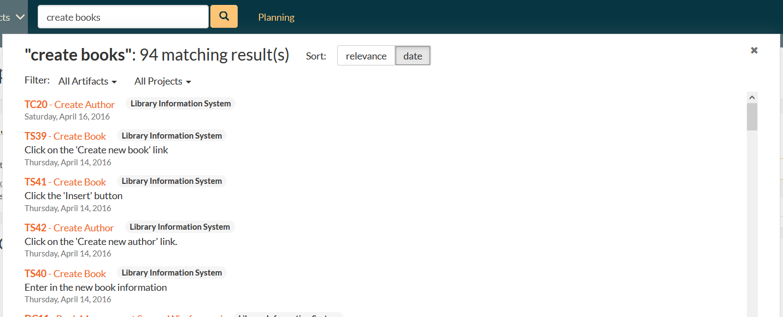

In addition, you can filter the results by artifact type and/or product to narrow down the search:

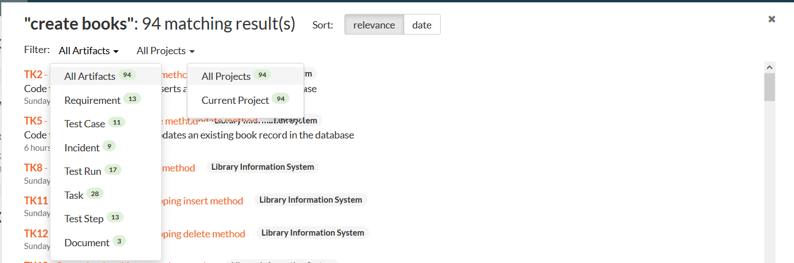

For example, if you filter by requirement, the list of results will be narrowed accordingy:

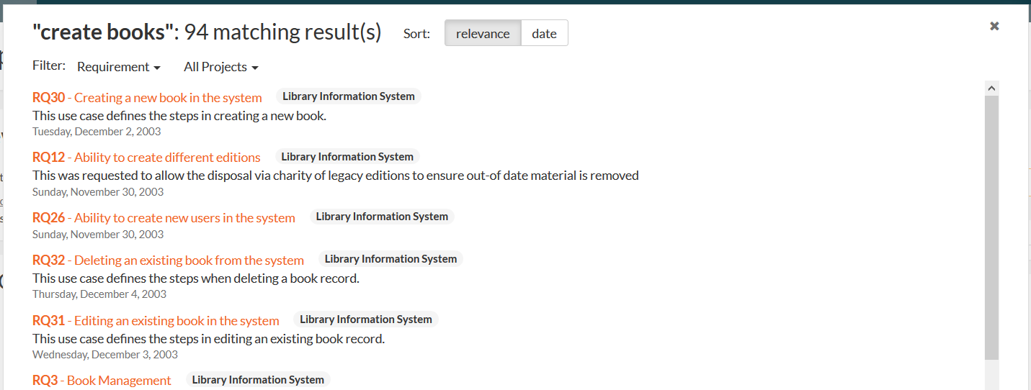

### 3.3.2. Log Out

Clicking on the “Log Out” link will immediately log you out of your current session and return you to the login page illustrated in section 3.1. If you had set the “Keep Me Logged In” option during your previous login, that setting will be reset; so if you want to avoid having to keep logging-in, you’ll need to re-check that box during your next log-in.

### 3.3.3. Documentation

Clicking on this link on any page will bring up the online version of this manual shown below:

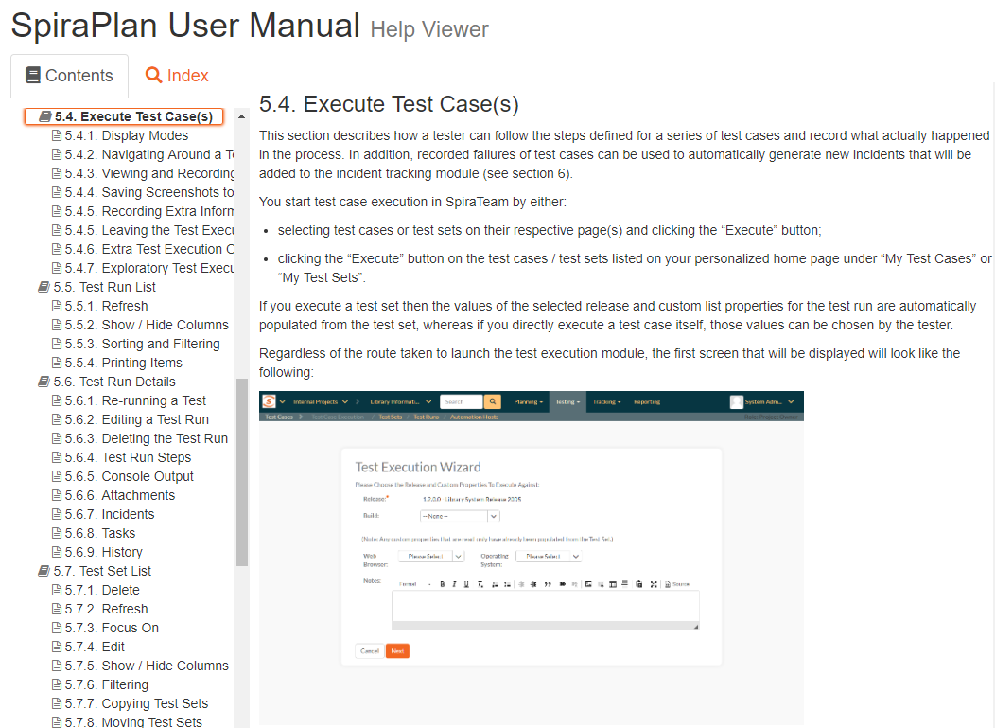

Clicking on any of the triangles expand links in the left hand table of contents will open up the detailed list of topics for each of the main areas of the system. In each area, clicking on one of the individual links will open the appropriate section in the help manual. By default, the reading-pane will open to the help item that is most closely related to the screen you happened to be on when you clicked the “Help” link.

You can search the index by using the “Index” tab.

If you want to share a specific help page with a colleague in your organization, send them the url from the address bar.

### 3.3.4. Choosing a Workspace

Workspaces in SpiraPlan set out the scope for the data you want to view and interact with. The most common workspace type is a product:

* A product contains all the requirements, sprints, defects, and tests associated to it.
* Programs are groups of products, where you can look across all the products in that program at once

Choosing, for example, a Product or Program from the list of your assigned workspaces in the drop-down-menu allows you to quickly and easily jump between workspace regardless of the page you happen to be on. When you choose a new workspace, you will be taken to the same page in the selected workspace (assuming that you have permissions to view that page). Any workspace with a little cog at the end is a workspace that you are an owner/admin of.

You can use CTRL+click to open the new product in a separate browser tab:

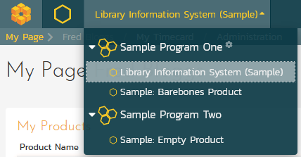

### 3.3.5. Show Onboarding Tours

When you first login to SpiraTeam, the system will show you a welcome page, together with a tour that walks you through the key features of the application. If you would like to see that again, you need to click on the “Show Onboarding Tours” option, under the user profile menu. SpiraPlan will then display the **onboarding tour** main dialog again:

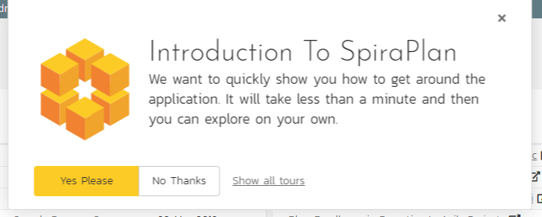

You can click ‘No Thanks to dismiss it, or ‘Yes Please’ to start the tour.

### 3.3.6. Instant Messenger

The Spira instant messenger is available in both SpiraPlan® and SpiraPlan® and allows you to send short messages instantaneously to other users in the system. You can see the status of other users by looking for the small green circle next to the list of users in the ‘My Contacts’ widget as well as the various user fields in the system:

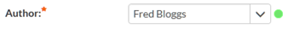

When a user is online and available to communicate with, the small circle will be filled-in green. If you click on the green circle, it will open up the instant messenger window for that user:

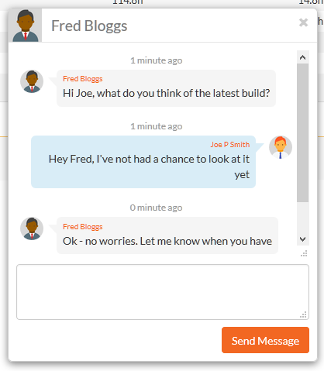

You can then enter in a message to the other user, which will then cause a conversation window to open inside their web browser with your message displayed. The other user can then enter in their responses, allowing the two users to have a real-time conversation:

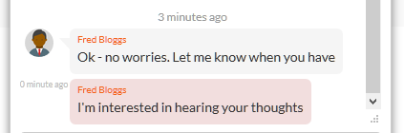

To make it easier to see what’s new, all unread messages are displayed in a message box with a darker shade. In addition, the user’s avatar image is displayed at the start of each message group.

If the message window appears on a SpiraPlan® window that contains a specific artifact (e.g. a requirement, test case, task, etc.) there will be the option to ‘Post as Comments’. If you click this option, any messages selected with a checkbox will be automatically posted to the current artifact as comments. This is useful if you have a conversation related to a specific item and you want to have the outcome permanently recorded as part of the audit trail. Otherwise, instant messages will be automatically purged from the system after 90 days.

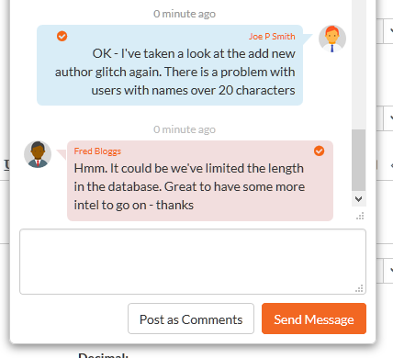

## 3.4. Product Home

When you click on either the “Product Home” tab or the name of the product in the “My Page” product list, you will be taken to the homepage of the specific product in question:

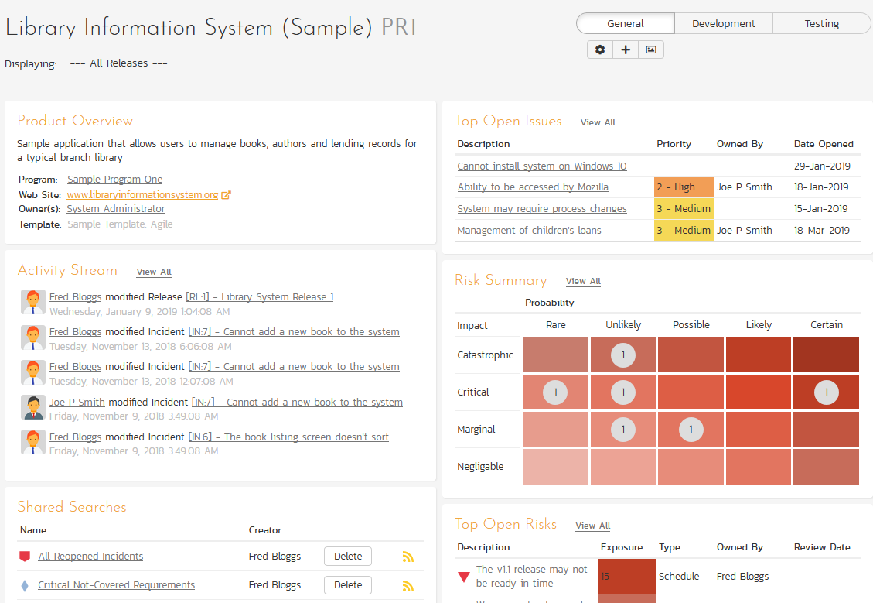

This page summarizes all of the information regarding the product into a comprehensive, easily digestible form that provides a “one-stop-shop” for people interested in understanding the overall status of the product at a glance. It contains summary-level information for all types of artifact (requirements, test cases, incidents, etc.) that you can use to drill-down into the appropriate section of the application.

You will see a small “i" in a circle at the top right of every chart. Hovering or clicking on this will show you information about that chart.

In addition to viewing the product home page, you can choose to filter by a specific release, to get the homepage for just that release (and any child sprints).

Just like the ‘My Page’, the Product Home dashboard is initially loaded in ‘view mode’ with pre-configured set of widgets. The Product Home also offers 3 versions you can quickly switch between. While each of these can be customized as you want, by default they are designed to help different types of product member – be they managers, testers, or developers.

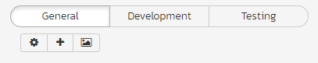

To download an image of the entire dashboard click the ‘picture’ button beneath the currently selected view.

To switch the page to ‘edit mode’, you should click on the button with the cog icon () below the currently selected Product Home view.

Once in ‘edit mode’, each of the ‘widgets’ displayed on the product homepage can be minimized by clicking on the arrow icon () in the top-left of the window, or closed by clicking-on the cross icon () in the top-right of the window. In addition, the widgets allow you change their settings by clicking on the settings icon ().This allows you to customize your view of the product to reflect the types of information that are relevant to you. If you have closed a widget that you subsequently decide you want to reopen, you can rectify by clicking the “Add Items” button at the top of the page, and locating the closed item from the list of ‘Closed Widgets’.

When you load your ‘Product Home’ for the first time it will default to the “General” view. The following table shows which widgets are displayed on the different views of the ‘Product Home’:

|  |  |  |  |  |
| --- | --- | --- | --- | --- |
| Widget Name | General | Development | | Testing |
| Product Overview | Y | Y | Y | |
| Activity Stream | Y | Y | Y | |
| Shared Searches | Y |  |  | |
| Requirements Summary | Y | Y | Y | |
| Requirements Coverage | Y |  | Y | |
| Release Task Progress | Y | Y |  | |
| Requirements Graphs | Y | Y |  | |
| Late Finishing Tasks | Y | Y |  | |
| Task Graphs | Y | Y |  | |
| Top Open Issues | Y | Y |  | |
| Risk Summary | Y |  |  | |
| Top Open Risks | Y |  |  | |
| Test Execution Status | Y |  | Y | |
| Release Test Summary | Y |  | Y | |
| Incident Summary | Y | Y | Y | |
| Incident Open Count | Y | Y | Y | |
| Requirement Incident Count | Y | Y | Y | |
| Requirements Regression Coverage |  |  | Y | |
| Test Set Status |  |  | Y | |
| Incident Aging |  | Y |  | |
| Incident Test Coverage |  |  |  | |
| Tag Cloud |  |  |  | |
| Recent Builds |  | Y |  | |
| Late Starting Tasks |  | Y |  | |
| All Pending Test Runs |  |  | Y | |
| Source Code Commits |  | Y |  | |
| Test Run Progress |  |  | Y | |
| Test Case Progress By Day |  |  | Y | |

Please note that different widgets are shown by default for the “Developer” and for the “Tester” views.

If you click on the “+ Add” items button it will display the list of any additional widgets that are available for that view. Below is what this looks like for the ‘General’ view:

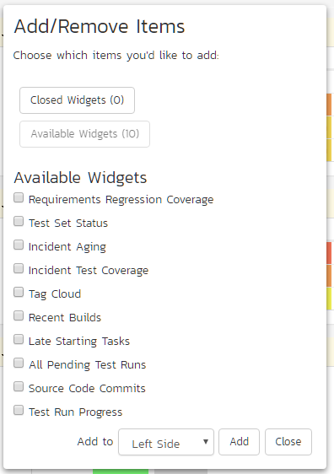

You can add the additional widgets by selecting the appropriate checkbox, choosing the destination location (left side vs. right side) and then click the “Add” button.

Each of the different widgets listed is described in more detail below:

### 3.4.1. Product Overview

This section displays the name of the product, together with a brief description, the web-site that points to any additional information about the product, and the names of the owners of the product.

### 3.4.2. Shared Searches

This section lists any filters/searches have been saved from the various artifact list screens throughout the application and marked as **shared filters**. This allows users to store specific combinations of searches that the product team needs to perform on a regular basis (e.g. display all newly logged incidents, display all requirements that are completed but have no test coverage).

The name of the saved search is displayed along with an icon that depicts which artifact it’s for and the person who created it. Clicking on the name of the saved search will take you to the appropriate screen in the product and set the search parameters accordingly. If you are the creator of the saved search, clicking the “Delete” button next to the saved search will delete it. Clicking on the RSS icon will allow you to subscribe to the specific search so that it will be displayed in your RSS newsreader. This allows you to setup customized lists of information that can be displayed outside of SpiraPlan.

### 3.4.3. Requirements Summary

This section consists of a summary table that displays the aggregate count of requirements in the system broken-down by importance (on the x-axis) and status (on the y-axis). This allows the product manager to determine how many critical vs. low priority enhancements are waiting to be implemented, vs. actually being implemented. In addition, it makes a distinction between those requirements simply requested and those actually planned for implementation, so the product manager can see what the backlog is between the customer’s demands, and the plan in place. Clicking on the “View Details” button at the top of the table simply brings up a detail graph that you can customize by selecting the axes. Clicking on the individual values in the cells will display the requirements list with the filter set to match the importance and status of the value.

### 3.4.4. Requirements Coverage

This section consists of a bar graph that displays the aggregated count of requirements test coverage for the product. The Passed, Failed, Blocked, Caution and Not-Run bars indicate the total count of requirements that have tests covering them, allocated across the execution status of the covering tests. For example, if a requirement is covered by *four tests*, two that have passed, one that has failed and one that has not yet been run, the counts would be passed = 0.5, failed = 0.25 and not-run 0.25. These fractional quantities are then summed across all the requirements to give the execution status breakdown of the covered requirements.

In addition to the five statuses for the covered requirements, the sixth (“Not Covered”) bar depicts the total number of requirements that have no tests covering them, putting the five other bars into perspective. Typically a product is in good health if the “Not Covered” bar is zero, and the count of “Passed” requirements is greater than “Failed”, “Caution” or “Not Run”. The greatest risk lies with the “Blocked”, “Not Covered” and “Not Run” status codes, since the severity/quantity of any bugs lurking within is not yet fully known.

If you position the mouse pointer over any of the four bars, the color of the bar changes slightly and the underlying raw data is displayed as a tooltip, together with the percentage equivalent. Clicking on the any of the bars in the chart will take you to the requirements list page (see section 4.1) with the corresponding filters set.

When you filter the product home by release/sprint, this widget will filter the requirements coverage graph to only include ***requirements that are specifically mapped to the selected release/sprint***. This is useful when you want to determine the test coverage of new requirements that are being added to the specific release/sprint. If instead you want to determine the regression test coverage for a release, you should add the separate “Requirements Regression Coverage” widget to the page instead.

### 3.4.5. Requirement Incident Count

This section displays a count of the total number of incidents, and the number of open incidents mapped against requirements in the system, sorted by the requirements that have the most open incidents first. This section is useful for determining the parts of the application that have the most instability, as you can look at the requirements that have yielded the greatest number of incidents. Clicking on any of the requirements hyperlinks will take you to the detail page for the requirement in question (see section 4.2). *You can configure in the settings whether to include requirements with no open incidents, and also how many rows of data to display.*

### 3.4.6. Top Open Issues

This section displays a breakdown of the top issues logged against the product, in order of decreasing priority. Note that items not given a priority are listed at the top, since critical issues could be lurking in that list, and the product manager will want to immediately review these to assign priorities. Clicking on the issue item hyperlink will take you to the incident details page for the issue in question (see section 6.2). *You can configure in the settings whether to use Priority or Severity for the display, and also how many rows of data to display.*

### 3.4.7. Risk Summary

This section displays a two dimensional matrix of the open risks logged against the product of impact against probability. Combined these two dimensions are reflected in the risks exposure and each differently colored rectangle in the matrix represents one possible exposure. The number of risks that have a particular exposure are shown inside each rectangle as appropriate. Clicking on that number will take you to the risk list page filtered by the relevant exposure*.*

### 3.4.8. Top Open Risks

This section displays a breakdown of the top risks logged against the product, in order of decreasing priority. Note that items not given a priority are listed at the top, since critical risks could be lurking in that list, and the product manager will want to immediately review these to assign priorities. Clicking on the risk item hyperlink will take you to the incident details page for the risk in question (see section 6.2). *You can configure in the settings whether to use Priority or Severity for the display, and also how many rows of data to display.*

### 3.4.9. Release Test Summary

This widget allows you to quickly ascertain the test execution status of each of the active releases that make up the current product in one snapshot. Each release is displayed together with a graphical display that illustrates the execution status with different colored bars. In addition, if you hover the mouse over the graphical display it will display a tooltip that provides a more detailed description of the number of tests in each status.

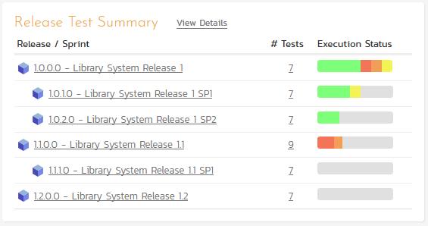

Each release will display the aggregate status of any test cases directly assigned to itself, together with the test status of any child sprints that are contained within the Release. Clicking on one of the releases will drill you down one level further and display the test execution status for the parent release as well as each of the child sprints separately:

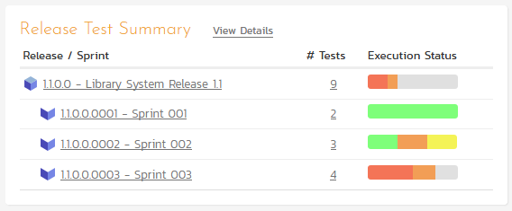

### 3.4.10. Incident Summary

This section consists of a summary table that displays the aggregate count of incidents in the system broken-down by priority (on the x-axis) and status (on the y-axis). This allow the product manager to determine how many critical vs. low priority incidents are waiting to be addressed, and how many new items need to be categorized and assigned. Clicking on the “View Details” link at the top of the table simply brings up a detail graph that you can customize by selecting the axes. Clicking on the individual values in the cells will display the incident list with the filter set to match the priority and status of the value.

By default this summary table displays the total count of all incidents – regardless of type, however my changing the drop-down list to a specific incident type (e.g. bug, enhancement, issue, etc.), the product manager can filter the summary table to just items of that type. *You can also configure in the settings whether to use Priority or Severity for the x-axis*

### 3.4.11. Test Execution Status

This section consists of a bar graph that displays the aggregated count of test cases in each execution status for the product. Note that this graph does not consider past test-runs when calculating the totals in each status (Passed, Failed, Not Run, etc.), it simply looks at each test-case and uses the last-run status as the best health indicator. Thus if a test case that previously passed, has subsequently failed upon re-execution, it will be considered a failure only.

If you position the mouse pointer over any of the five bars, the color of the bar changes slightly and the underlying raw data is displayed as a tooltip, together with the percentage equivalent. Clicking on any of the bars will bring up the product test case list (see section 5.1) with the appropriate filter applied.

In addition to the bar-chart, there is also a display of the total number of test runs recorded for the product, and a list of the *five most recent* days of recorded test-runs, together with the daily count.

### 3.4.12. Release Task Progress

This widget allows you to quickly ascertain the task progress of each of the active releases that make up the current product in one snapshot. Each release is displayed together with a graphical display that illustrates the completion percentage and status with different colored bars. In addition, if you hover the mouse over the graphical display it will display a tooltip that provides a more detailed description of the number of tasks in each status.

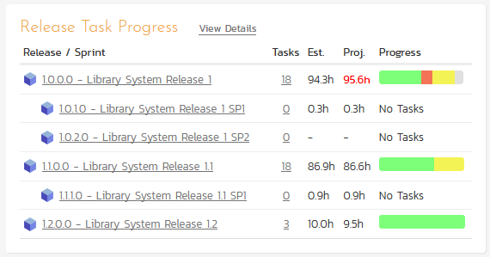

Each release will display the aggregate progress of any tasks directly assigned to itself, together with the task progress of any child sprints that are contained within the Release. Clicking on one of the releases will drill you down one level further and display the task progress for the parent release as well as each of the child sprints separately:

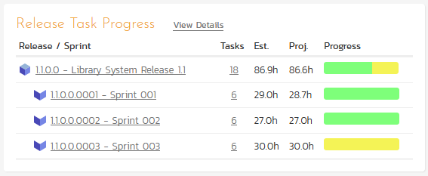

### 3.4.13. Late Finishing Tasks

This section displays the list of any product tasks that have not yet been completed, but whose scheduled end date has already elapsed. A graphical progress bar is included with each task in the grid, so that you can easily see which tasks are nearest completion.

### 3.4.14. Late Starting Tasks

This section displays the list of any product tasks that have not yet started, but whose scheduled start date has already elapsed:

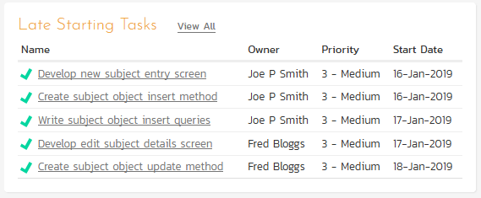

Each task is listed along with its owner, priority and due-date so that you quickly ascertain how many days late it will be starting, how important it is to the product, and who needs to be contacted to get more information.

### 3.4.15. Requirements Regression Coverage

This section consists of a bar graph that displays the aggregated count of requirements test coverage for the product in a similar fashion to the ‘Requirements Coverage’ widget:

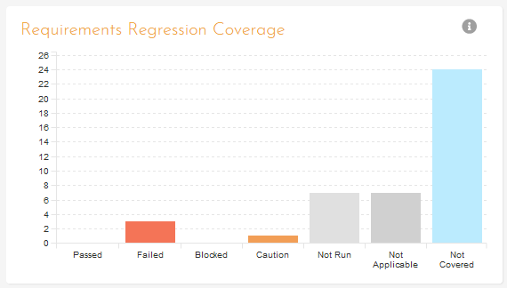

However, unlike the ‘Requirements Coverage’ widget, when you filter the product home by release/sprint, this widget will filter the requirements coverage graph to include all requirements (regardless of release/sprint), but only considering covering test cases that are associated with the selected release/sprint. This is useful when you want to determine the regression requirements test coverage of a specific release (i.e. does running all the tests relevant to this release cover all the necessary requirements, not just new requirements).

### 3.4.16. Test Set Status

This section consists of a bar graph that displays the aggregated count of test cases in each execution status for each test set in the product:

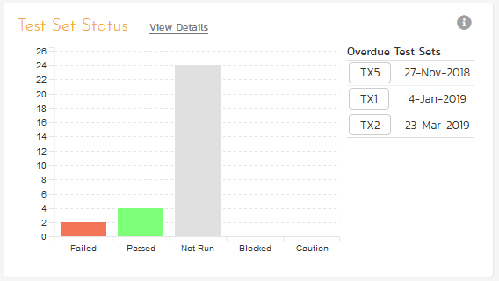

Therefore if you have the same test cases stored in multiple test sets, then this widget will display the total test case count for all combinations of test set. This is useful if you have the same test cases being executed in different environments – represented by different test sets – and you need to make sure that the tests passed successfully in all environments.

If you position the mouse pointer over any of the five bars, the color of the bar changes slightly and the underlying raw data is displayed as a tooltip, together with the percentage equivalent. Clicking on any of the bars brings up the product test set list (see section 5.6) page with the appropriate filter applied. In addition to the bar-chart, there is also a display of (up to) the *five most overdue test sets in the product*.

### 3.4.17. Incident Aging

This section displays the number of days incidents have been left open in the system. The chart is organized as a histogram, with the count of incidents on the y-axis and different age intervals on the x-axis.

### 3.4.18. Incident Test Coverage

This section displays a bar-graph that illustrates the execution status of any test cases that previously failed and resulted in the generation of an incident that has subsequently been resolved. This is very useful when a test case was executed in Release 1.0 and an incident was logged. That incident has now been resolved in Release 1.1 (and is in a closed status) but we need to know that the test case that caused the failure has been successfully re-run. Any test cases listed as Blocked, Caution, Not-Run, Not Applicable, or Failed in this graph need to be executed to verify that all resolved bugs in the release have truly been fixed.

### 3.4.19. Task Graphs

This widget lets you quickly view the three main graphs used when measuring the progress of tasks in an agile methodology:

1. **Task Velocity** – this graph shows the total estimated and actual effort delivered in each product release and/or sprint
2. **Task Burnup** – this graph shows the cumulative amount of work outstanding for each release/sprint in the product with separate lines for the estimated, remaining and completed effort.
3. **Task Burndown** – this graph shows the remaining work that needs to be done for each release/sprint in the product with separate lines for the estimated, remaining and completed effort.

For each of the three graphs you can click on the “Display Data Grid” link to display a grid of the underlying data that is represented in the graph and also there are options to save the graph in a variety of different image formats.

### 3.4.20. Tag Cloud

This widget lets you see the list of document tags being used in the product:

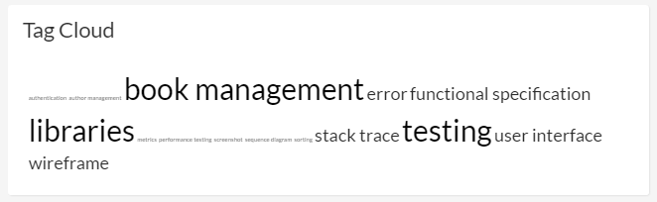

The size of the tag name indicates the relative frequency of its usage in the product. Clicking on a document tag will open up the Document List page (see section 10.1) with the filter set to the tag you clicked on. This will display a list of related documents that have been tagged with the same tag name.

### 3.4.21. Recent Builds

This widget displays a list of the most recent builds that have been performed as part of the current release or sprint:

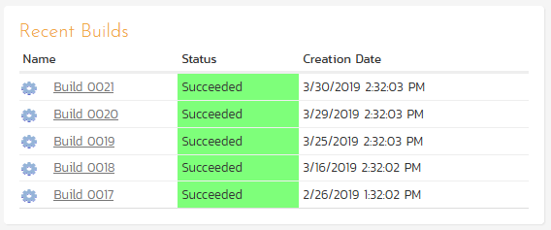

For each build it will display whether the build succeeded or failed, the date the build occurred and the name of the build together with a hyperlink to the build details (see section 7.2.7). Note: If no release or sprint is selected then the widget will not display any data.

### 3.4.22. Requirements Graphs

This widget lets you quickly view four different graphs used when measuring the progress of requirements in an agile methodology. They are described in more detail in Reports section (11.8) of this manual.

1. **Requirement Velocity** – this graph shows the actual velocity delivered in each product release and/or sprint compared to the product average and the rolling average.
2. **Requirement Burnup** – this graph shows the cumulative number of story points outstanding for each release/sprint in the product with separate lines for the actual and ideal burnup overlaid on top of a bar-graph that shows the completed story points per release/sprint.
3. **Requirement Burndown** – this graph shows the remaining number of story points that needs to be done for each release/sprint in the product with separate lines for the actual and ideal burndown overlaid on top of a bar-graph that shows the completed story points per release/sprint.
4. **Requirements Coverage** – this graph shows the number of requirements that have test cases that are passed, failed, blocked, cautioned, not run as well those requirements that do not have any test cases (not covered). Unlike the main Requirements Coverage graph on the home page, this one is segmented by requirement importance.

For each of the three graphs you can click on the “Display Data Grid” link to display a grid of the underlying data that is represented in the graph and also there are options to save the graph in a variety of different image formats.

### 3.4.23. Test Run Progress

This section consists of a chart that displays the last 30 days of test run activity, broken down, for each day, by the test run status. This is a useful chart to quickly track the testing activity of the product – this is not the same as overall product status.

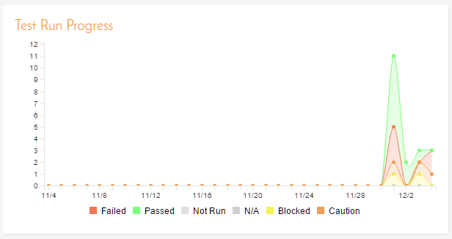

### 3.4.24. Test Case Cumulative Progress

This section consists of a chart that displays the last 30 days of test case executions cumulatively. That means it will display for each day, the total number of test cases executed plus the status from any previous days that have not been changed. Any test cases not executed up to that point will be considered “not run” and will appear in the “not run” category. For example, if you have 10 test cases created on day 1 you will see 10 test cases “not run” on day 1. On day 2, you execute 5 test cases and fail them all, you will now see 5 test cases failed and 5 not run. On day 3, you execute 3 of the previous 5 test cases and pass them. You will now see 3 test cases passed, 2 failed and 5 not run.

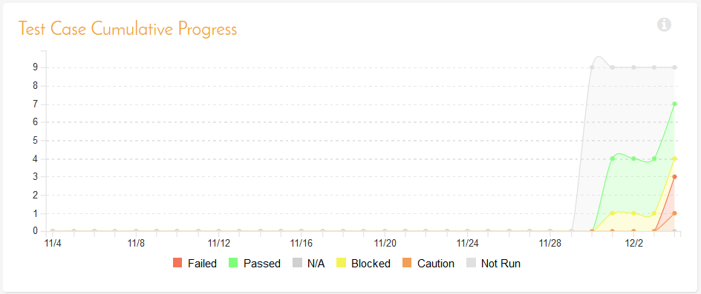

### 3.4.25. Source Code Commits

This section consists of a chart that displays the last 3 months of code commits to the product (if you are using the source code functionality of the application). Commits are aggregated by week. The chart is color coded by bottom quartile, the middle 50%, and the top quartile of activity.

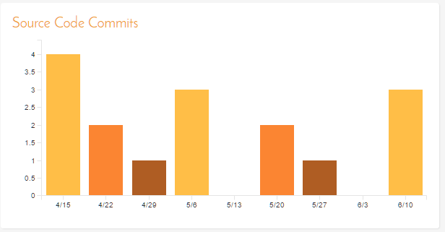

### 3.4.26. Incident Open Count

This section show a bar chart to visualize the breakdown of all open incidents in the product by priority. The chart’s bar match the color assigned to that priority. Clicking on the “View Details” link at the top of the widget loads a chart builder where you can further refine and filter the chart to meet your needs.

### 3.4.27. All Pending Test Runs

This section lists all the test runs that are currently being executed by testers in the product. Until a test case or test set is fully executed, a pending test run entry is stored in the system so that you can continue execution at a later date.

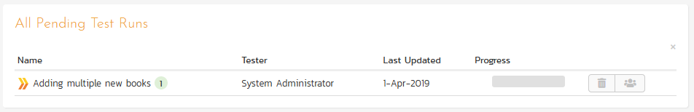

Any pending test run can be either deleted or reassigned to another user that is a member of the product by the product manager or test manager.

## 3.5. Program Home

When you click on either the Program name in the global navigation or the name of the program in the “My Page” product list, you will be taken to the homepage of the specific program in question:

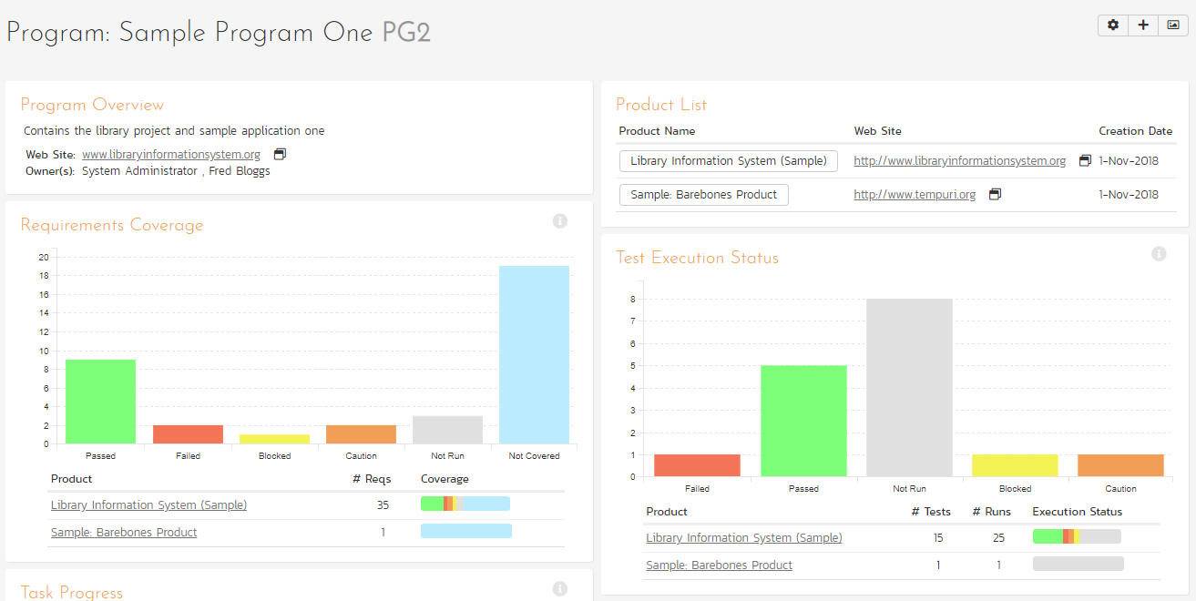

This page summarizes all of the information regarding the program into a comprehensive, easily digestible form that provides a “one-stop-shop” for people interested in understanding the overall status of the group as a whole as well as the relative performance of the different products that make up the group. It contains summary-level metrics for all types of artifact (requirements, test cases, tasks, incidents, etc.) that you can use to drill-down into the appropriate product for more details.

You will see a small “i" in a circle at the top right of every chart. Hovering or clicking on this will show you information about that chart.

In a similar manner to the ‘My Page’, the Program Home dashboard is initially loaded in ‘view mode’ which means that the various ‘widgets’ on the page are displayed with minimum visual clutter (no toolbars or control icons) that makes it easy to scan the items on the page and see the health of the status of the product at a glance. To switch the page to ‘edit mode’, you should click the button with the cog icon () on the right.

Once in ‘edit mode’, each of the ‘widgets’ displayed on the program homepage can be minimized by clicking on the arrow icon () in the top-left of the window, or closed by clicking-on the cross icon () in the top-right of the window. In addition, the widgets allow you change their settings by clicking on the settings icon ().This allows you to customize your view of the program to reflect the types of information that are relevant to you. If you have closed a widget that you subsequently decide you want to reopen, you can rectify by clicking the “+ Add” button at the top of the page, and locating the closed item from the list of ‘Closed Widgets’.

When you load the ‘Program Home’ for the first time it will consists of the following main elements:

* Group Overview
* Requirements Coverage
* Task Progress
* Product List
* Test Execution Status
* Incident Aging
* Recent Builds

However these are not the only widgets available. If you click on the “Add/Remove” items hyperlink it will display the list of any additional widgets that are available:

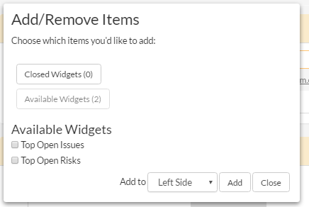

You can add the additional widgets by selecting the appropriate checkbox, choosing the destination location (left side vs. right side) and then click the “Add” button. The additional widgets available in the Program Home dashboard are:

* Top Open Issues
* Top Open Risks

Each of the different widgets listed is described in more detail below:

### 3.5.1. Program Overview

This section displays the name of the program, together with a brief description, the web-site that points to any additional information about the program, and the names of the owners of the program.

### 3.5.2. Product List

This section lists all the active products that make up the group, together with the name, description, program and date of creation. To view the description of the product, simply position the mouse pointer over the link, and a tooltip window will popup containing the description.

### 3.5.3. Requirements Coverage

This section consists of a bar graph that displays the aggregated count of requirements test coverage for the entire program. The Passed, Failed, Blocked, Caution and Not-Run bars indicate the total count of requirements that have tests covering them, allocated across the execution status of the covering tests

Under the main bar graph is displayed a table containing each product in the group and a colored bar illustrating the specific requirements coverage distribution for that product. That way you can see both the aggregate coverage and also the relative coverage for the products. *You can configure in the widget settings whether you want to see the aggregate bar graph, and/or the product-specific requirements coverage.*

### 3.5.4. Task Progress

This section consists of a bar graph that displays the aggregated count of tasks by progress category for the entire program. The ‘On Schedule’, ‘Late Finish’, ‘Late Start’ and ‘Not Started’ bars indicate the total count of tasks that are in that category for all the products in the group.

Under the main bar graph is displayed a table containing each product in the group and a colored bar illustrating the specific task progress for that product (using the same coloring convention as the main graph). That way you can see both the aggregate task progress and also the relative progress for each product. *You can configure in the widget settings whether you want to see the aggregate bar graph, and/or the product-specific task progress.*

### 3.5.5. Test Execution Status

This section consists of a bar graph that displays the aggregated count of test cases by execution status for the entire program. The Passed, Failed, Blocked, Caution and Not-Run bars indicate the total count of test cases that are in that category for all the products in the group.

Under the main bar graph is displayed a table containing each product in the group and a colored bar illustrating the specific test case execution status for that product (using the same coloring convention as the main graph). That way you can see both the aggregate test status and also the relative status for each product. *You can configure in the widget settings whether you want to see the aggregate bar graph, and/or the product-specific test status.*

### 3.5.6. Incident Aging

This section displays the number of days incidents have been left open in the system. The chart is organized as a histogram, with the count of incidents on the y-axis (for all products in the group) and different age intervals on the x-axis.

Under the main bar graph is displayed a table containing each product in the group and a colored bar illustrating the distribution of open incidents by priority for that product. That way you can see both the aggregate aging for the group and also the relative priority of open incidents for each product. *You can configure in the widget settings whether you want to see the aggregate aging histogram, and/or the product-specific incident count by priority.*

### 3.5.7. Top Open Issues

This section displays a breakdown of the top issues logged against any of the products in the group, in order of decreasing priority. Note that items not given a priority are listed at the top, since critical issues could be lurking in that list, and the product manager will want to immediately review these to assign priorities. Clicking on the issue item hyperlink will take you to the incident details page for the issue in question (see section 6.2). *You can configure in the settings whether to use Priority or Severity for the display, and also how many rows of data to display.*

### 3.5.8. Top Open Risks

This section displays a breakdown of the top risks logged against any of the products in the group, in order of decreasing priority. Note that items not given a priority are listed at the top, since critical risks could be lurking in that list, and the product manager will want to immediately review these to assign priorities. Clicking on the risk item hyperlink will take you to the incident details page for the risk in question (see section 6.2). *You can configure in the settings whether to use Priority or Severity for the display, and also how many rows of data to display.*

### 3.5.9. Recent Builds

This widget displays a list of the most recent build and its status for each product in the program/program. For each product it will display whether the build succeeded or failed, the date the build occurred and the name of the build together with a hyperlink to the build details (see section 7.2.7).

## 3.6. My Profile

When you click on the “My Profile” button (the top item in the user dropdown) in the global navigation, you will be taken to the page in the system that allows you to view and edit your personal profile:

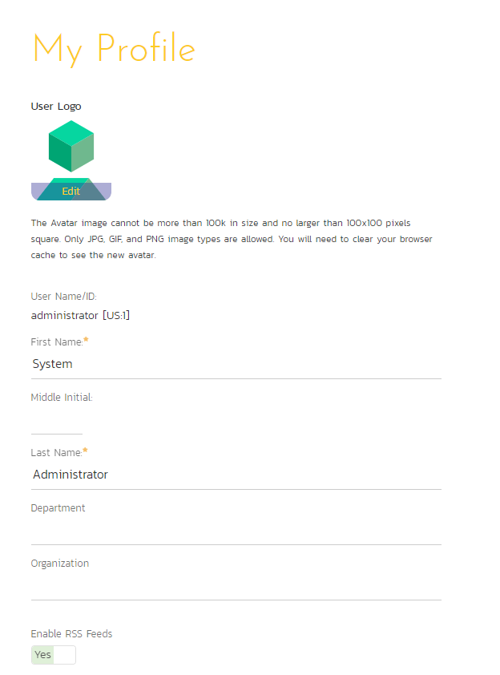

You can change your user information including your first-name, last-name, middle-initial, avatar icon, department and your choice of start-page. Clicking the “Save” button will commit the changes, whereas clicking <Cancel> returns you back to either “Product Home” or “My Page” depending on whether you have a product currently selected or not.

If you want to be able to subscribe to RSS feeds of the information assigned to you in the “My Page”, make sure that the “Enable RSS Feeds” switch is set to “Yes” and an RSS token has been generated underneath.

You can change your start page to be any of the following:

* **My Page** – When you first log-in, you will be taken to your “My Page” dashboard
* **Last Opened Product** – When you first login-in, you will be taken to the home page for the product you last had open
* **Last Opened Program** - When you first login-in, you will be taken to the home page for the program you last had open

### 3.6.1. Change Password

In addition to being able to update your user information, you can optionally change your password at the same time. To change your password, on the Change Password tab fill in the three boxes with your current password, and your new password repeated for verification. Then when the “Save” button is clicked, the system will update your password, otherwise you will simply get a warning message indicating what needs to be corrected.

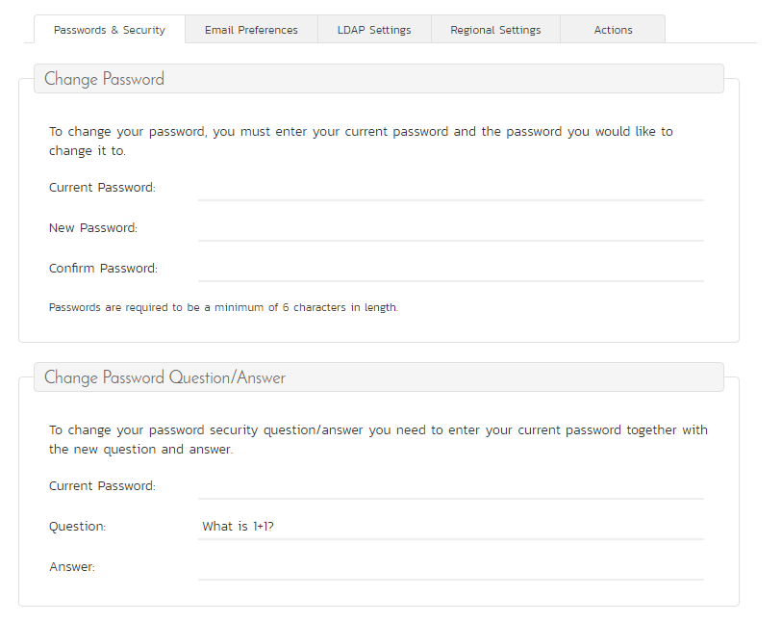

You can also change the current password retrieval question and answer by entering in your current password (for security reasons) as well as the new password question and answer.

Note: If your SpiraTest user profile is linked to an account stored in an external LDAP server, you may find the change password option is disabled. This is because the system uses the password held in the external server. To change the password in this case, please contact your system administrator who will be able to help you change the password in your LDAP environment.

### 3.6.2. Email Preferences

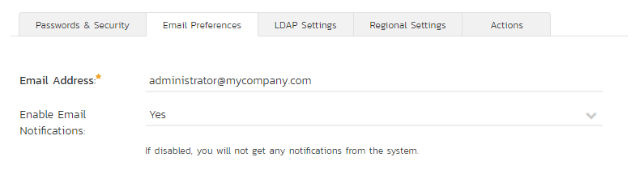

Here you can configure the email address that the application will send notifications to, and whether or not you want to receive email notifications.

If the Enable Notifications cannot be changed, it means that the system is either not configured to send out notifications, or the administrator has disabled user’s ability to opt out of notifications being sent.

### 3.6.3. LDAP Settings

This tab will show configured LDAP options for your account. At this time, no configurable options are on this tab, it is for reference only.

### 3.6.4. Regional Settings

This tab will display the current culture and timezone associated with your profile:

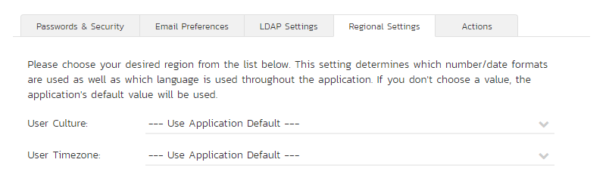

By default all profiles will be set to use the application’s default culture and timezone. This means that the language, number formats and timezone used in the application will be the ones decided by the person who installed the system. However there are cases where you want to use a different language, timezone or number format (for example, a German employee working in the German office of a French company might want to use the German culture instead of French). You can change the culture and/or timezone to any of the options listed in the dropdown list.

Note: The system will only be installed with a certain number of language packs, so in some cases a selected culture will only change the number formats and not the languages displayed.

### 3.6.5. Actions

This tab displays the list of recent actions that you have performed in the system (across all products):

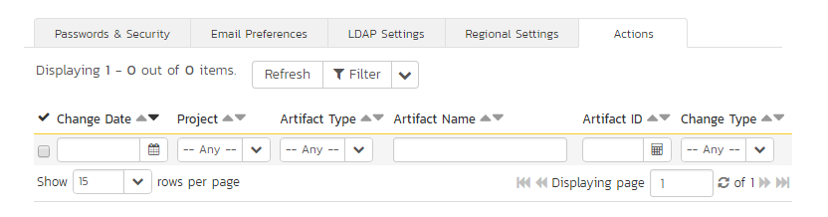

You can search and filter the grid to find changes by product, change date range, artifact type and type of change (added, deleted, or modified).

## 3.7. My Timecard

When you click on My Page > My Timecard the system will display a timecard that allows you to enter the effort worked on incidents and tasks currently assigned to you (across all your products):

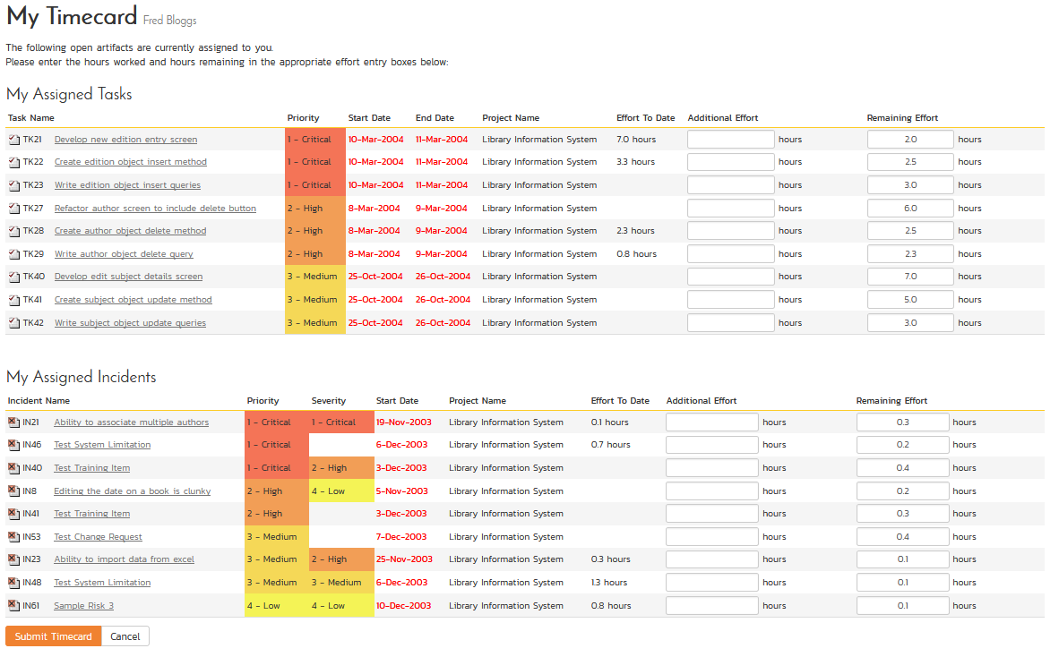

The system will only include products that have time-tracking enabled for incidents and tasks, so if some of your assigned incidents or tasks are missing, please check with the product owner of the products affected to have them enable time-tracking.

Each task or incident will be displayed along with its priority, severity, start-date, end-date, product name effort remaining and effort expended to date. For each item you can then indicate the additional actual effort performed (which will be added to the “actual effort”) and modify the amount of hours remaining. Once you are satisfied, click [Submit Timecard] to commit the changes.

# 4. Requirements Management

This section outlines how the requirements management features of SpiraPlan® can be used to develop a requirements / scope matrix for a product, and how you can map any existing test-cases to the requirements. Typically when starting a product, developing the requirements list is the first activity after the Administrator has set up the product in the system.

## 4.1. Requirements List

When you click on the Planning > Requirements link on the global navigation bar, you will initially be taken to the requirements list screen illustrated below:

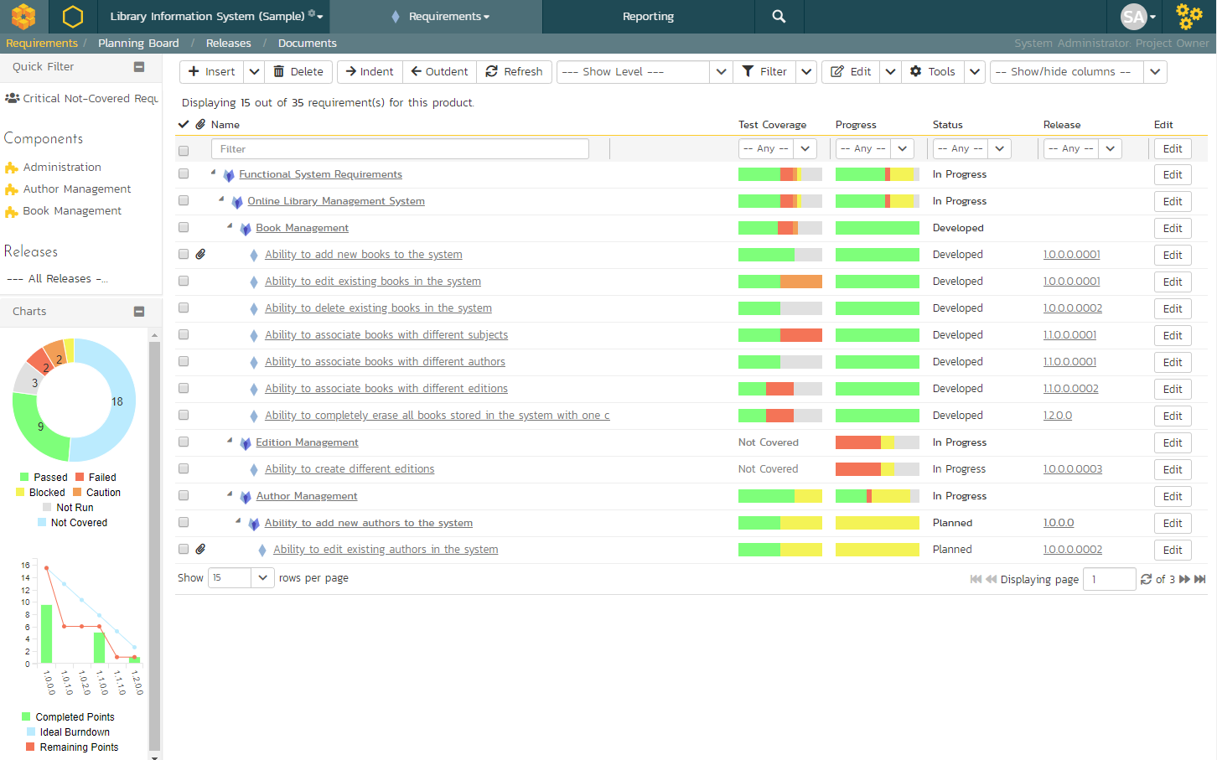

The requirements list consists of a hierarchical arrangement of the various requirements and functionalities that need to be provided by the system in question. The structure is very similar to the Work Breakdown Structure (WBS) developed in Microsoft Product®, and users of that software package will find this very familiar to use. When you create a new product, this list will initially be empty, and you will have to start using the “Insert” button to start adding requirements.

Requirements come in two main flavors: summary items shown in **bold-type**, and detail items shown in normal-type with a hyperlink. When you indent a requirement under an existing requirement, the parent is changed from a detail-item to a summary-item, and when you outdent a child item, its parent will return to a detail-item (assuming it has no other children). This behavior is important to understand, as only detail items are assigned a status themselves; the summary items simply display an aggregate of the worst-case assessment of their children’s status. Both summary and detail items can be mapped against test-cases for test-coverage, in addition the summary items display an aggregate coverage status.

Each requirement is displayed along with its importance/priority (ranked from “Critical” to “Low”), its completion status (from “Requested” to “Completed”), the version of the software that the requirement is planned for, and graphical indicators that represents its test coverage status and its task progress.

For those requirements that have no test-cases covering them (i.e. validating that the requirement works as expected) the indicator consists of a white solid bar, bearing the legend “Not Covered”. For those requirements that have *at least one* test-case mapped against them, they will display a block graph that illustrates the last execution status of each of the mapped test-cases. Thus if the requirement is covered by two test cases, one of which passed, and one of which wasn’t run, the graph will display a green bar (50% passed) and an equal length gray bar (50% not run). To determine the exact requirements coverage information, position the mouse pointer over the bar-chart, and the number of covering tests, along with the pass / fail / blocked / caution / not-run breakdown will be displayed as a “tooltip”.

For those requirements that have at least one task associated with them, they will display a block graph that illustrates the relative numbers of task that are on-schedule (green), late-starting (yellow), late-finishing (red) or just not-started (grey). These values are weighted by the effort of the task, so that larger, more complex tasks will be change the graph more than the smaller tasks. To determine the exact task progress information, position the mouse pointer over the bar-chart and the number of associated tasks, along with the details of how many are in each status will be displayed as a “tooltip”.

### 4.1.1. Insert

Clicking on the <Insert> icon inserts a requirement *above* the currently selected requirement – i.e. the one whose check-box has been selected, at the same level in the hierarchy. If you want to insert a requirement below an existing item, you can use the Insert > Child Requirement option instead. If you insert a requirement without first selecting an existing requirement from the list, the new requirement will simply be added at the end of the list. Note that if the full list of requirements are paginated, the new requirement will be at the bottom of the last page.

Once the new requirement has been inserted, the item is switched to “Edit” mode so that you can rename the default name and choose a priority, status and/or author.

### 4.1.2. Delete

Clicking on the “Delete” button deletes all the requirements whose check-boxes have been selected. If any of the items are summary items, the child requirements are also deleted. If all the children are deleted from a summary item, it changes back into a non-summary item.

### 4.1.3. Indent

Clicking on the “Indent” button indents all the requirements whose check-boxes have been selected. If any of the items are made children of a requirement that had no previous children, it will be changed from a detail item into a summary item.

### 4.1.4. Outdent

Clicking on the “Outdent” button de-indents all the requirements whose check-boxes have been selected. If any of the items were the only children of a summary requirement item, then that item will be changed back from a summary item to a detail item.

### 4.1.5. Refresh

Clicking on the “Refresh” button simply reloads the requirements list (not the entire page). This is useful as other people may be modifying the list of requirements at the same time as you, and after stepping away from the computer for a short-time, you should click this button to make sure you are viewing the most current requirements list for the product.

### 4.1.6. Edit

Each requirement in the list has an “**Edit**” button display in its right-most column. When you click this button or just *double-click* on any of the cells in the row, you change the item from “View” mode to “Edit” mode. The various columns are made editable, and “Update” “Cancel” buttons are displayed in the last column:

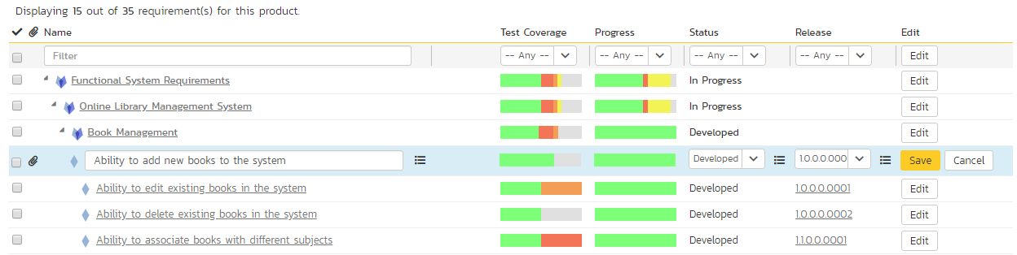

If you click “Edit” on more than one row, the “Update” and “Cancel” buttons are only displayed on the first row selected. You can make changes to all the editable rows and then update the changes by clicking the one “Update” button. Also, if you want to make the same change to multiple rows (e.g. to change five requirements from “In Progress” status to “Completed”), you can click on the “fill” icon to the right of the editable item, which will propagate the new value to all editable items in the same column.

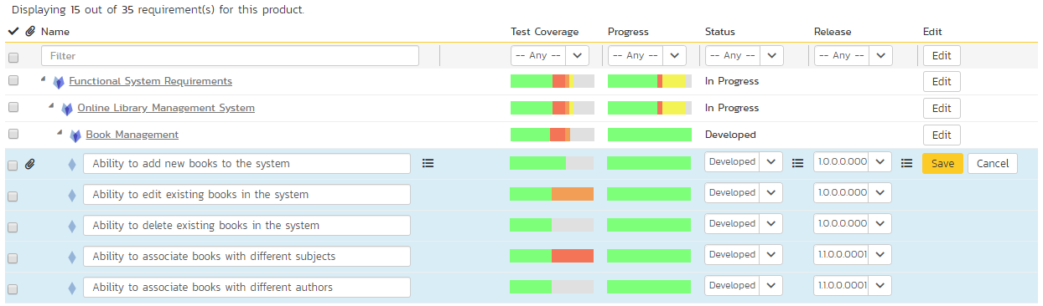

If you want to edit lots of items, first select their checkboxes and then click the [Edit] button on the same row as the Filters and it will switch all the selected items into edit mode.

When you have made your updates, you can either click “Save” to commit the changes, or “Cancel” to revert back to the original information. Alternatively, pressing the <ENTER> key will commit the changes and pressing the <ESCAPE> key will cancel the changes.

### 4.1.7. Show Level

Choosing an indent level from the ‘Show Level’ drop down box allows you to quickly and easily view the entire requirements list at a specific indent level. For example you may want to see all requirements drilled-down to the *third* level of detail. To do this you would simply choose ‘Level 3’ from the list, and the requirements will be expanded / collapsed accordingly.

### 4.1.8. Filtering

You can easily filter the list of requirements as illustrated in the screen-shot below:

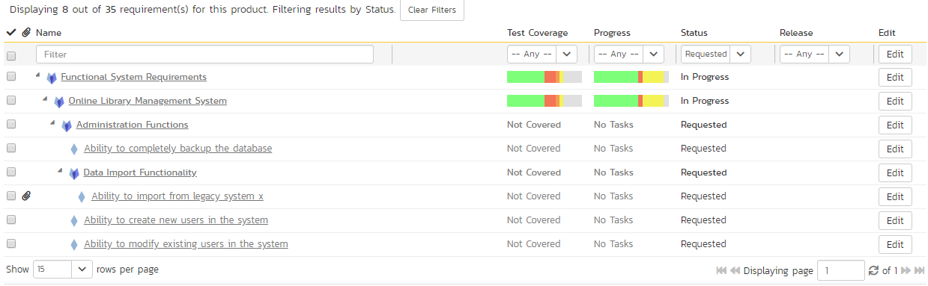

To filter the list by any of the displayed columns, you either choose an item from the appropriate drop-down list or enter a free-text phrase (depending on the type of field) then click the <Filter> icon or press the <ENTER> key to apply the different filters. Note that the name field is searched using a “LIKE” comparison, so that searching for “database” would include any item with the word database in the name. The other freetext fields need to be exact matches (e.g. dates, requirement numbers). In the screen-shot above, we are filtering on Status = Requested.

In addition, if you have a set of filters that you plan on using on a regular basis, you can choose the option Filter > Save Filter to add the current filter to the list of saved filters that appear on your ‘My Page’. If you would like to share the filter with other members of the product, choose the “Share with other members of the product” option. The list of saved filters can also be retrieved by clicking Filter > Retrieve Filter:

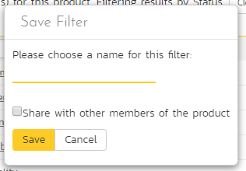

As a shortcut, the left hand panel includes a set of **Quick Filters** that can be applied in a single-click:

* **The topmost section** – This displays any saved requirement filters created by the current user alongside any ‘shared’ filters. The latter are marked with an icon showing a group of people.
* **Components** – This section lists the components defined for the current product. Clicking on any of the components in the list will filter the requirements to only show those that belong to the selected component.
* **Releases** – This section lists the releases and sprints defined for the current product. Clicking on any of the releases or sprints in the list will filter the requirements by that release/sprint.

### 4.1.9. Show / Hide Columns

This drop-down list allows you to change the fields that are displayed in the requirement list as columns for the current product. To show a column that is not already displayed, simply select that column from the list of “Show…” column names and to hide an existing column, simply select that column from the list of “Hide…” column names. This is stored on a per-product basis, so you can have different display settings for each product that you are a member of. The fields can be any of the built-in fields or any of the custom properties set up by the product owner.

### 4.1.10. Copying Requirements

To copy a requirement or set of requirements, simply select the check-boxes of the requirements you want to copy and then select the Edit > Copy Items menu option. This will copy the current requirements selection to the clipboard. Then you should select the place where you want the requirements to be inserted and choose the Edit > Paste Items option.

The requirements will now be copied into the destination location you specified. The name of the copied requirements will be prefixed with “Copy of…” to distinguish them from the originals. Note that copied requirements will also include the test coverage information from the originals.

### 4.1.11. Moving Requirements

To move a requirement in the requirements hierarchy, there are two options:

1. Click on the requirement you want to move and then drag it to the location you want it moved. An empty space will appear to show you where it will be inserted:

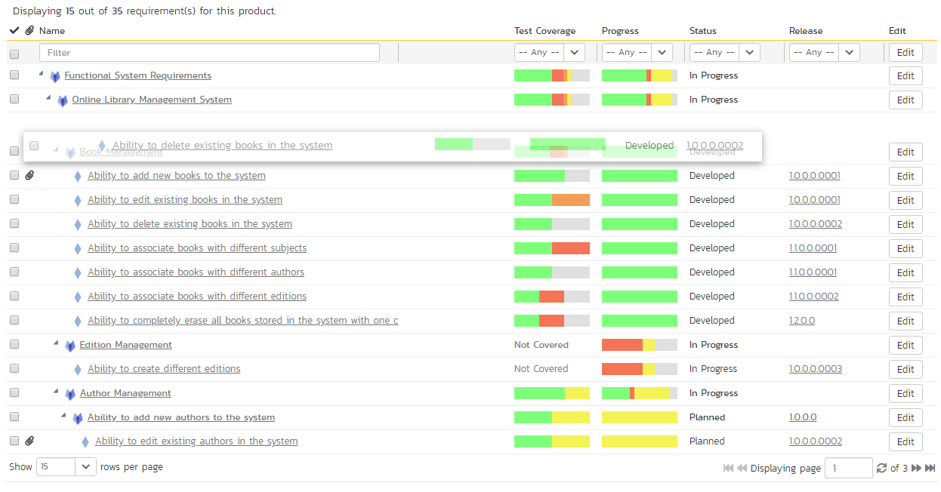

Once you have the requirement positioned at the correct place that you want it inserted, just release the mouse button. To move multiple items simply select their checkboxes and then drag-and-drop one of the selected items.

1. Alternatively, you can select the check-boxes of the requirements you want to move and then select the Edit > Cut menu option. This will cut the current requirements selection to the clipboard. Then you should select the place where you want the requirements to be inserted and choose the Edit > Paste option. The requirements will now be moved into the destination location you specified.

### 4.1.12. Exporting Requirements

To export a requirement or set of requirements from the current product to another product in the system, all you need to do is select the check-boxes of the requirement(s) you want to export and then click the Tools > Export To Product button. This will then bring up a list of possible destination products:

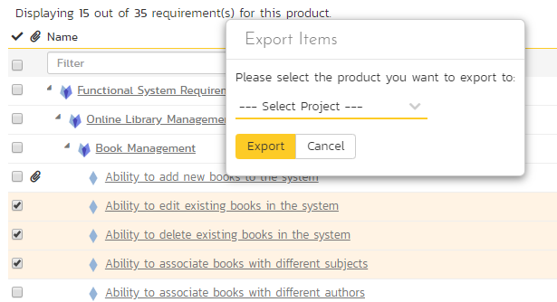

Once you have chosen the destination product and clicked the “Export” button, the requirements will be exported from the current product to the destination product. Any file attachments will also be copied to the destination product along with the requirements.

### 4.1.13. Creating Test Cases from Requirements

To quickly create test cases from a group of requirements, all you need to do is select the check-boxes of the appropriate requirements and then click Tools > Create Test Cases. This will then create new test cases based on the selected requirements.

### 4.1.14. Creating a Test Set from Requirements

To quickly create a new test set from a group of requirements, all you need to do is select the check-boxes of the appropriate requirements and then click Tools > Create Test Set. This will then create new test set containing the test cases that are already mapped to the selected requirement(s).

### 4.1.15. Printing Items

To quickly print a single requirement or list of requirements you can select the items’ checkboxes and then click Tools > Print Items. This will open a new window containing a printable version of the selected items.

### 4.1.16 Focus-On Branch

Sometimes you will a list of filtered requirements displayed and you would like to view all of the items that in the same branch of the requirements tree, even those that don’t match the current filter. To view the branch, select the checkbox of the branch and then click Tools > Focus on, and the system will clear the current filters and then expand just the selected branch.

### 4.1.17. Right-Click Context Menu

SpiraPlan® provides a shortcut – called the *context menu* - for accessing some of the most commonly used functions, so that you don’t need to move your mouse up to the toolbar each time. To access the context menu, right-click on any of the rows in the requirements list and the following menu will be displayed:

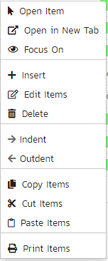

You can now choose any of these options as an alternative to using the icons in the toolbar.

### 4.1.18. Viewing Requirements from Shared Products

If you are displaying the requirements list for a product has required shared from other products, you will see the option on the top-right to view the requirements from the shared product(s):

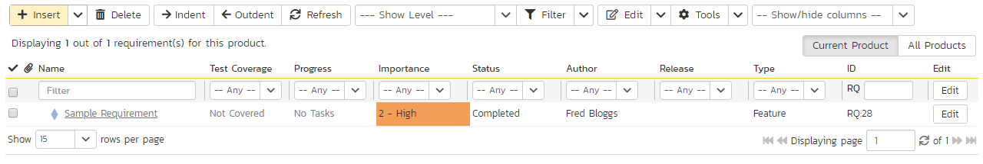

If you choose the option to show the requirement from ‘All Products’ and not just the current product, the shared products are displayed, grouped under the name of the product they are being shared from:

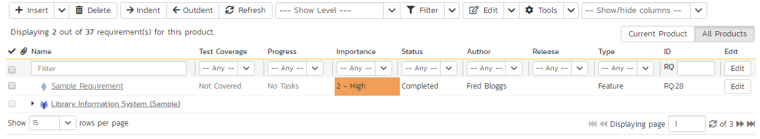

Note: Any requirements shared from other products will be read-only and won’t display any of their custom properties. However you can expand/collapse these shared requirements and filter using the standard fields.

## 4.2. Requirement Details

When you click on a requirement item in the requirements list described in section 4.1, you are taken to the requirement details page illustrated below:

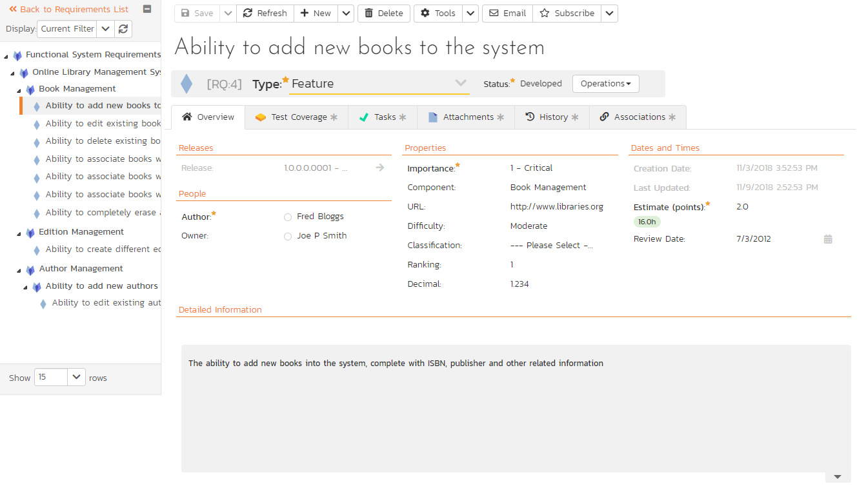

This page is made up of *three* areas;

1. the left pane displays the requirements list navigation;
2. the right pane’s header, which displays: the operations toolbar; the editable name of the selected requirement; and the info bar (with a shaded background), which also contains the workflow status transitions (see below); and
3. the right pane’s tabbed interface with rich information related to the requirement.

Please note that on smaller screen sizes the navigation pane is not displayed. While the navigation pane has a link to take you back to the requirements list, on mobile devices a ‘back’ button is shown on the left of the operations toolbar.

The navigation pane can be collapsed by clicking on the “-“ button, or expanded by clicking anywhere on the gray title area. On desktops the user can also control the exact width of the navigation pane by dragging and dropping a red handle that appears on hovering at the rightmost edge of the navigation pane.

The navigation pane shows a list of the peer requirements to the one selected. This list is useful as a navigation shortcut; you can quickly view the coverage information of all the peer requirements by clicking on the navigation links without having to first return to the requirements list page. The navigation list can be switched between three different modes:

* The list of requirements matching the current filter
* The list of all requirements, irrespective of the current filter
* The list of requirements assigned to the current user

On the main right hand side of the page, which of the fields for the currently selected requirement are available and which are required will depend on your stage in the requirement workflow. For example, a requested requirement might not require a “Release” whereas a planned requirement could well do. The types of change allowed and the fields that are enabled/visible/required will depend on how your product administrator has set up the system for you. Administrators should refer to the *SpiraPlan Administration Guide* for details on configuring the requirement workflows to better meet their needs.

Depending on the user’s role and whether they are listed as the owner or author of the requirement, displayed in the info bar beneath the requirement name is the current workflow status and an “operations” button which, when clicked, will show a set of allowed workflow operations:

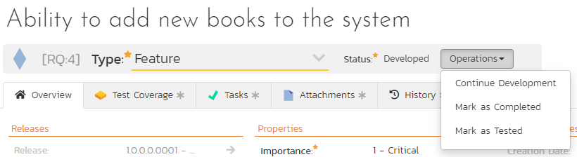

These workflow transitions allow the user to move the requirement from one status to another. For example when the requirement is in the Developed status, you will be given the options to:

* **Continue Development** – changes status to “In-Progress”
* **Mark as Completed** – changes the status to “Completed”
* **Mark as Tested**- changes the status to “Tested”

After changing the status of the requirement by clicking on the workflow link, you can then fill in the additional fields that are now enabled and/or required. Once you’ve made the changes to the appropriate requirement fields, you can either click “Save”, “Save and Close”, or “Save and New” to commit the changes or “Refresh” to discard the changes and reload the requirement from the database. In addition you can print the current requirement by clicking “Print”, which will display a printable version of the page in a separate window.

Please note that if digital signatures have been enabled for a particular workflow operation (and therefore a digital signature is required to confirm the status change. Workflow operations requiring a digital signature are marked with a padlock icon:

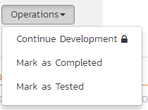

On attempting to save changes made after clicking a workflow operation that requires a digital signature you will be presented with the following popup:

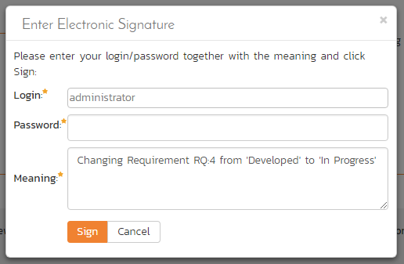

Using the “Email” button on the toolbar, you can send an email containing details of the requirement to an email address or another user on the system:

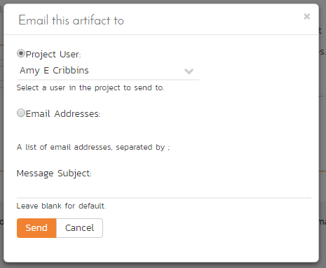

You can specify the subject line for the email, and either a list of email addresses, separated by semicolons, or an existing product user .The content of the email is specified in the System Administration – Notification Templates.

To be notified of any changes made to the current artifact via email, click the “Subscribe” button. If you already subscribed, the button will instead let you “Unsubscribe” to stop receiving emails about that particular artifact. Depending on your role, you may also see a dropdown arrow to the right of this button. This will let you subscribe others in the product to this artifact.

The bottom part of the right pane can be switched between six views: “Overview”, “Test Coverage”, “Tasks”, “Attachments”, “History” and “Associations”, each of which will be described in more detail below.

### 4.2.1. Overview - Details

The Overview tab is divided into a number of different sections. Each of these can be collapsed or expanded by clicking on the title of that section. It displays the description, fields and comments associated with the requirement.

The top part of this tab displays the various standard fields and custom properties associated with the requirement. Fields (both standard and custom) are grouped under the collapsible headings (marked by orange text and underline) in the screenshot below. For instance, all fields regarding dates are grouped together in the “Dates and Times” area.

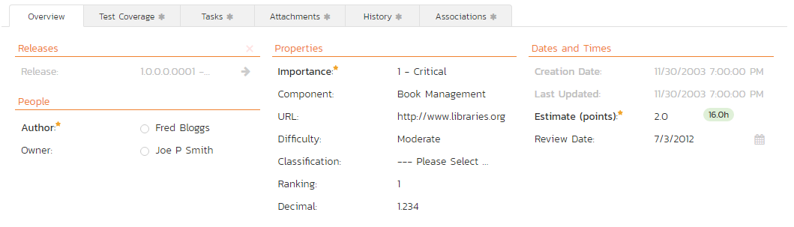

### 4.2.1.1. Followers

Using the “Subscribe” button on the toolbar, you can quickly follow the item, and receive updates on certain changes to it. Depending on your role, you may also see a dropdown to this button, which let’s you add another product member as a follower to this item.

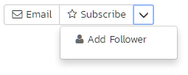

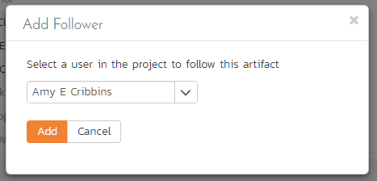

You can also quickly see who is following an incident under the “People” section in the Overview tab.

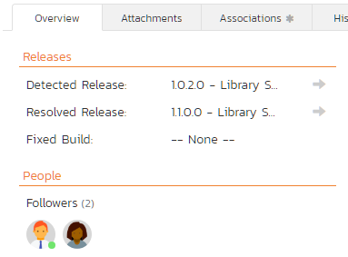

To view information about the follower, or to unfollow them from the item, hover over their avatar to display a user profile card.

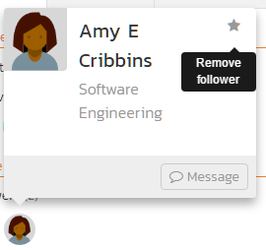

### 4.2.2. Overview – Detailed Information

The Detailed Information section contains the long, formatted description of the requirement, as well as any rich text custom fields. You can enter rich text or paste in from a word processing program or web page into these fields. Clicking on the shaded areas of one of these detailed fields will display the rich text toolbar.

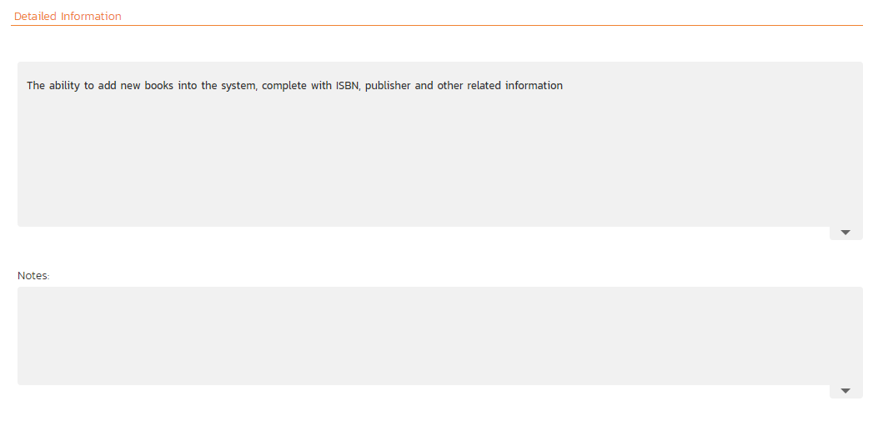

### 4.2.3. Overview - Comments

The Comments section allows you to add and view discussions relating to the requirement:

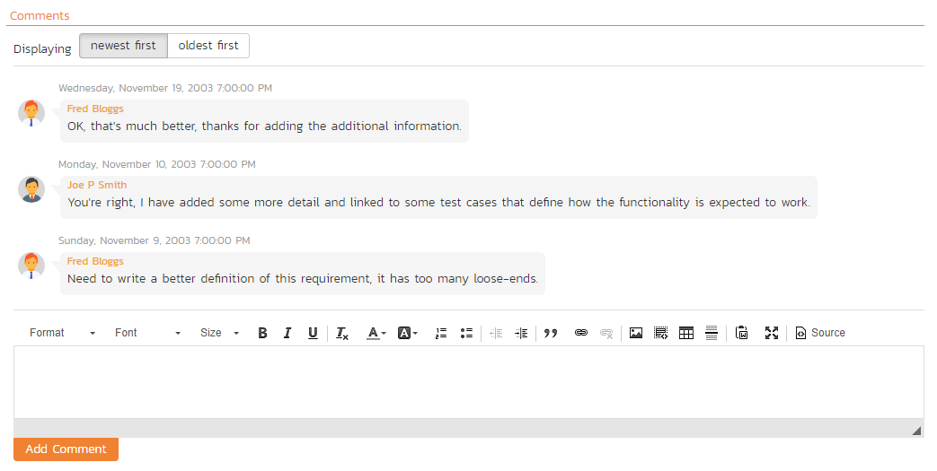

Existing comments are displayed in order underneath the textbox in date order (either newest first or oldest first). To add a new comment, enter it into the textbox, and click the “Add Comment” button.

### 4.2.4. Overview – Scenario

If you are editing a ‘Use Case’ type of requirement, there will be a special ‘Scenario’ section where you can enter in the scenario steps that define the use case:

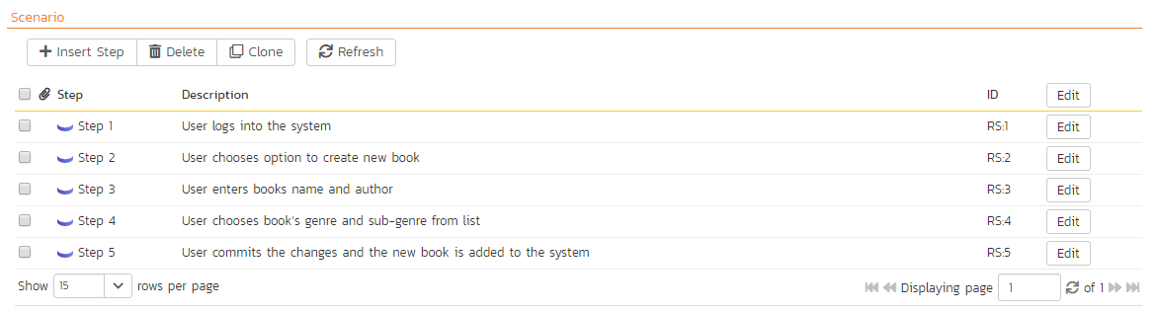

This section displays the various steps that a user would perform when carrying out the defined use case. The list of use case steps displays the position number, and the description. If a test case is created from this use-case, the steps will be used to create the test steps.

Clicking on the “Insert Step” button inserts a new step *before* the currently selected (by means of the check-box) step. Clicking the “Insert Step” button without selecting an existing step will insert a new step at the end of the list. When a new step is inserted, the fields are displayed in “Edit” mode, so the description, field is editable, allowing you to enter the data:

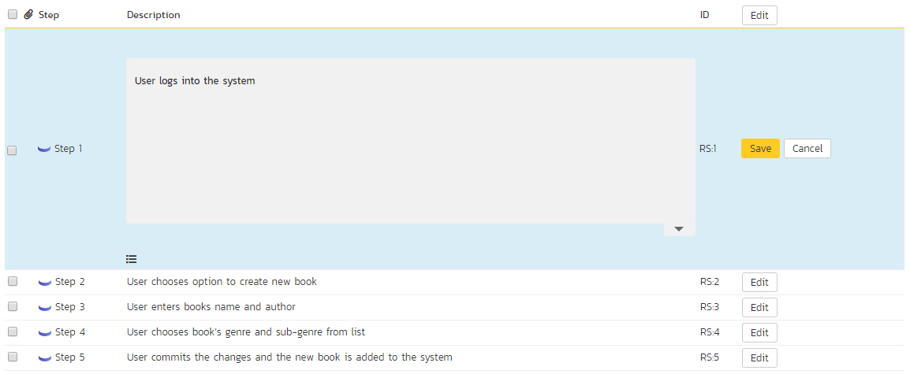

To move the steps in the list, click on the step you want to move and drag it to the location you want it moved.

### 4.2.5. Test Coverage

This tab shows the test coverage information for the requirement in question:

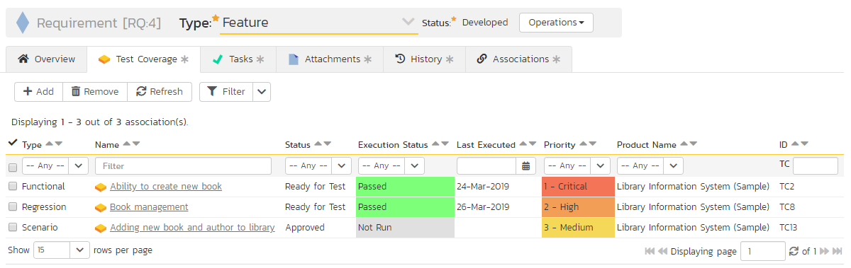

The tab displays a grid containing the test cases already mapped to this requirement. You can filter that list by the test case type, name, status, execution status, execution date, priority, product name and ID. You can remove an existing test case by selecting its check box and clicking the ‘Delete’ button. This doesn’t delete the test case, just removes it from the requirement.

Hovering the mouse over the names of the test cases will display a “tooltip” consisting of the test case name, place in the folder structure and a detailed description.

To add a new test case to the requirement, simply click on the ‘Add’ button:

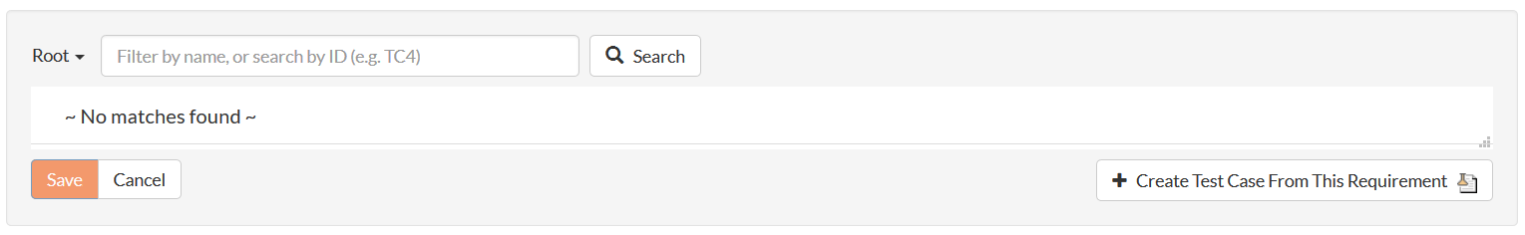

You can search for a test case by its ID if you know it (make sure to include the “TC” prefix):

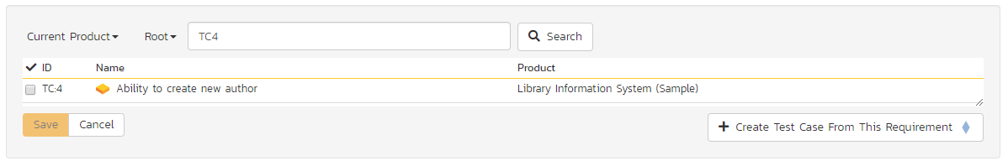

Otherwise, you can search for the test cases by choosing a folder from the dropdown and/or entering a partial name match:

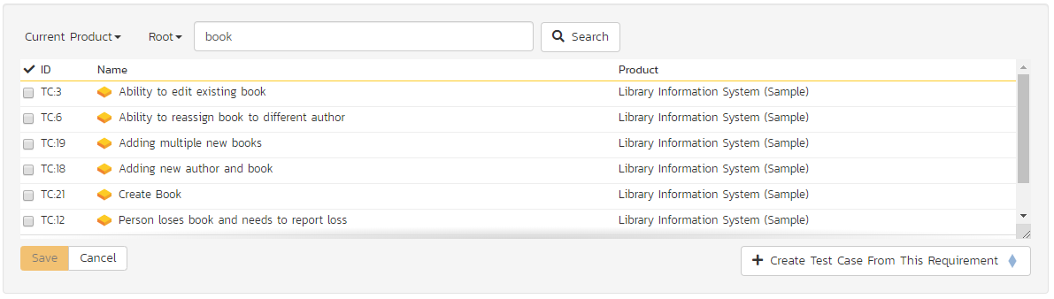

One you have found the desired test case(s), simply select their check boxes and click the ‘Save’ button to add them to the current requirement:

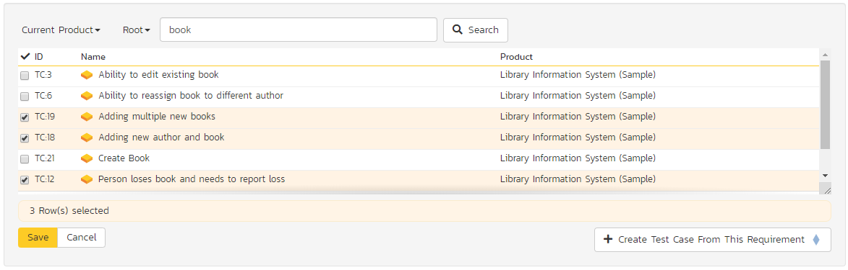

Finally, as a shortcut you can click the “Create Test Case from This Requirement” button to create a new test case in the list of covered test cases that will be automatically linked to this requirement. This is useful when you have created a new requirement and want to generate an initial covering test to be fleshed-out later.

### 4.2.6. Tasks

This tab shows the list of product tasks that need to be completed for the requirement to be satisfied:

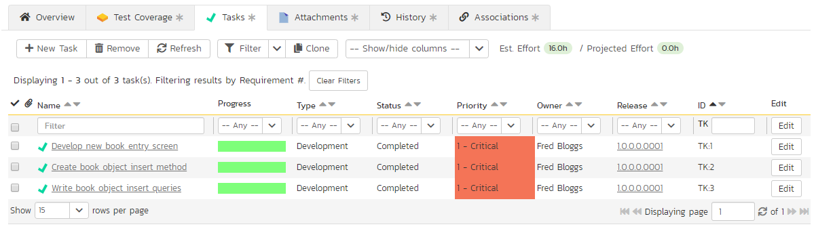

Each of the tasks is displayed together with, by default, its name, description (by hovering the mouse over the name), progress, priority, start-date, current owner, estimated effort, producted effort and numeric task identifier. Clicking on the task name will bring up the Task Details page which is described in more detail in section 8.2. This allows you to edit the details of an existing task.

You can perform the following actions on a task from this screen:

* **New Task** – inserts a new task in the task list with a default set of values. The task will be associated with the current requirement.
* **Remove** – removes the task from this requirement without actually deleting the task
* **Refresh** – updates the list of tasks from the server, useful if other people are adding tasks to this requirement at the same time.
* **Filter / Apply Filter** – Applies the entries in the filter boxes to the list of tasks
* **Clear Filters** – Clears the current filter, so that all tasks associated with the current requirement are shown.
* **Edit** – Clicking the “Edit” button to the right of the task allows you to edit the task inline directly on this screen. Only columns visible will be editable.
* **Show/Hide Columns** – Allows you to choose which Task columns are visible

The system has a series of shortcuts that simplify the editing of requirements and tasks:

* If you create a new task on the requirements page, the priority, release/sprint and owner are automatically copied from the parent requirement. You can change these suggested values before clicking “Save”
* When you assign a release/sprint to a requirement, its status automatically changes to “Planned”
* When at least one task assigned to the requirement changes from “Not Started” to “In Progress”, the parent requirement automatically switches from “Planned” to “In Progress”
* When all the tasks under the requirement are completed, the parent requirement will switch to the “Completed” status.
* If you manually move a requirement that has *no associated tasks* from “Planned” to “In Progress”, the system will automatically generate one task under the requirement and use the requirement’s planned effort field to generate the task’s estimated effort.

### 4.2.7. Attachments

The attachment tab displays the list of documents, screenshots or web-links (URLs) that have been “attached” to the requirement. The documents can be in any format, though SpiraPlan® will only display icons for certain known types.

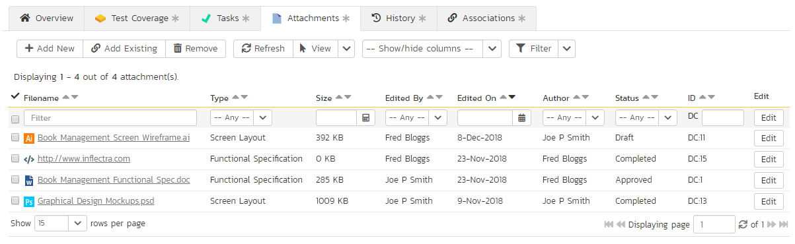

The attachment list includes the filename/URL that was originally uploaded together with the file-size (in KB), name of the person who attached it and the date uploaded. In addition, if you position the pointer over the filename and hold it there for a few seconds, a detailed description is displayed as a tooltip.

To actually view the document, click on the filename hyperlink and a new web browser window will open. Depending on the type of file, this window will either display the document / web-page or prompt you for a place to save it on your local computer. To remove an existing attachment from a requirement, simply click the “Remove” button and the attachment will be removed from the list. Using the standard filter/sort options you can also sort and filter the list of attachments to make it more manageable.

If you are using SpiraPlan or SpiraTeam (but not SpiraTest) you can also choose to include file attachments stored in a linked version control system (e.g. Subversion, CVS, Perforce, etc.) by selecting the “Include Source Code Documents” option.

To attach a new document to the requirement, you need to first click the “Add New” button to display the new attachment dialog box:

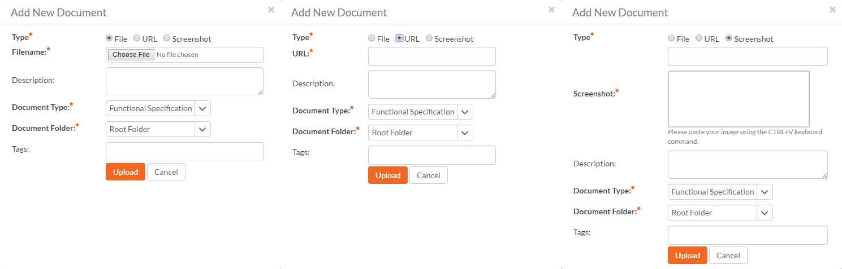

There are three different types of item that can be attached to a requirement:

* To upload a file, choose “File” as the type and then click the Browse button and select the file from your local computer, optionally enter a detailed description then click the “Upload” button. The document will be copied from your computer and attached to the artifact.
* To attach a web-link (URL) to the artifact, you need to choose “URL” as the type and then enter the fully qualified URL (e.g. [http://mywebsite.com?Document=1](http://mywebsite.com/?Document=1)), an optional description and then click the “Upload” button to attach the web-link.
* To attach a screenshot to the artifact, you need to choose “Screenshot” as the type and then copy the image to your computer’s clipboard (e.g. on Windows computers, the PRINT SCREEN button captures the current page and adds to the clipboard). Once the image is in the clipboard, paste it into the editor using CTRL+V (or the equivalent keystroke for your operating system) and the item will appear in the preview window. You can then fill in the other fields and click “Upload” to attach the image.

Note: If you are using a non-Windows® computer (e.g. Macintosh®) that doesn’t put file extensions on filenames (e.g. .xls for an Excel sheet) automatically, then you will need to manually add the file extension to the filename before uploading if you want it to be displayed with the correct icon in the attachment list.

You can also associate an existing document (that’s already stored in SpiraTeam) with the requirement. To do that, click on the “Add Existing” button to bring up the add file association dialog box:

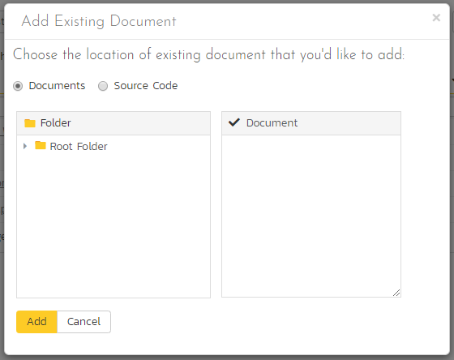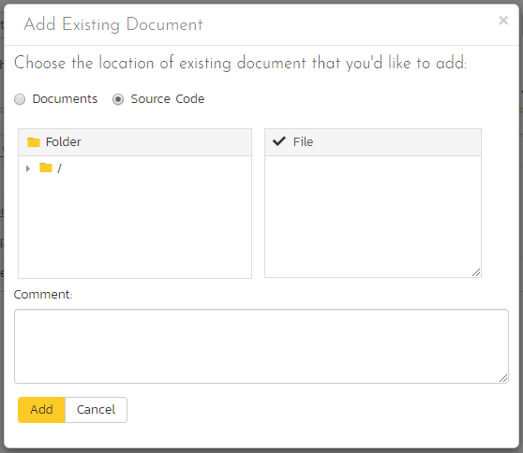

You can then choose to either associate a document stored in the SpiraPlan Documents repository or (in the case of SpiraPlan/SpiraTeam but not SpiraTest) from the linked source code repository. In either case you first select the appropriate folder, and then pick the document(s) from the file list on the right. In the case of a source code file association you can also add a comment.

### 4.2.8. History

This tab displays the list of changes that have been performed on the requirement artifact since its creation. An example requirement change history is depicted below:

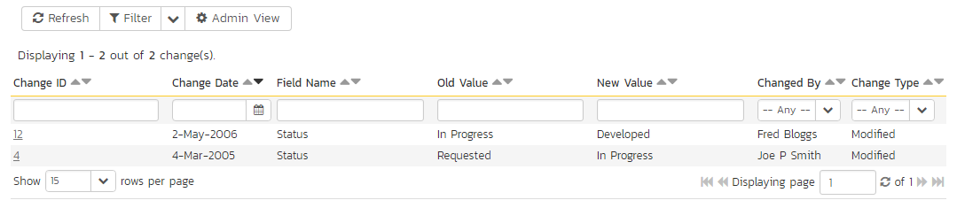

The change history displays the date that each change was made, together with the fields that were changed, the old and new values and the person who made the change. This allows a complete audit trail to be maintained of all changes in the system. In addition, if you are logged in as a product administrator you can also click on the “Admin View” hyperlink to revert any unwanted changes.

### 4.2.9. Associations

This displays a list of any incidents, source code revisions or other requirements that are associated with this requirement:

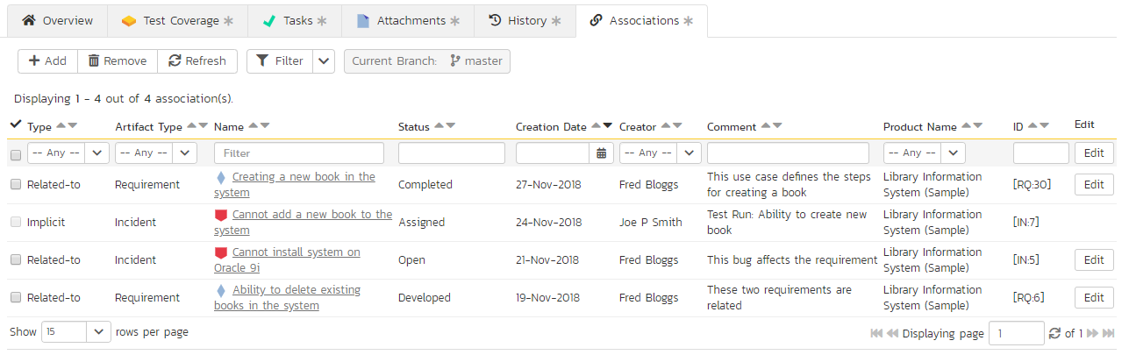

The requirements in this list are those a user has decided are relevant to the current one and has created a direct link between them. In the case of incidents, the association can be either due to the creator of an incident directly linking the incident to the requirement, or it can be the result of a tester executing a test-run and creating an incident during the test run. In this latter case, the check-box to the left of the association will be unavailable as the link is not editable.

Each association is displayed with the type of association (related-to, vs. a dependency), name of the artifact being linked-to, type of artifact (requirement, incident, etc.), the name of the person who created the association, and a comment that describes why the association was made. In the case of an indirect association due to a test run, the comment will contain the name of the test run.

In addition, when using SpiraPlan or SpiraTeam, the system automatically scans the source code repository for any revisions that are linked to this artifact.

You can perform the following actions on an association from this screen:

* **Delete** – removes the selected association to the other artifact. This will only delete the association, not the linked artifact itself.
* **Refresh** – updates the list of associations from the server, useful if other people are adding associations to this requirement at the same time.
* **Filter / Apply Filter** – Applies the entries in the filter boxes to the list of associations
* **Clear Filters** – Clears the current filter, so that all associations for the current requirement are shown.
* **Edit** – Clicking the “Edit” button to the right of the associations allows you to edit the association type and comment fields inline directly on this screen.

To create a new association, click the “Add” button to display the add association panel:

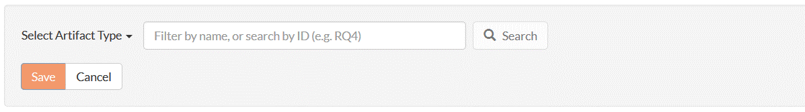

If you know the ID of the requirement or incident you want to associate, you can enter its ID prefixed by the appropriate token (“RQ” for requirement or “IN” for incident):

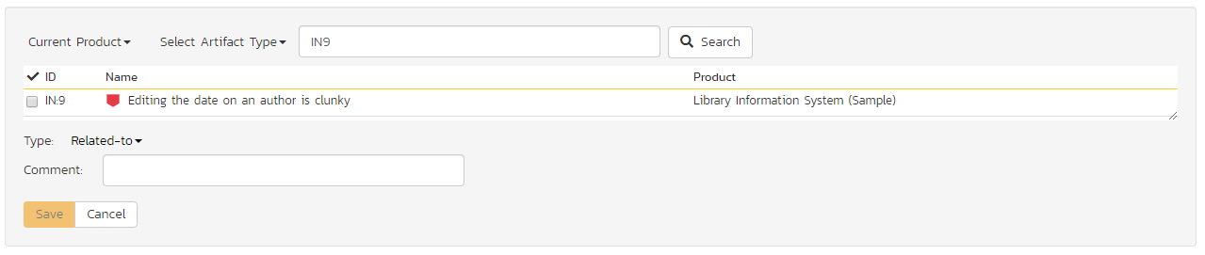

Otherwise you should choose the Artifact Type (and Product if making a cross-product association):

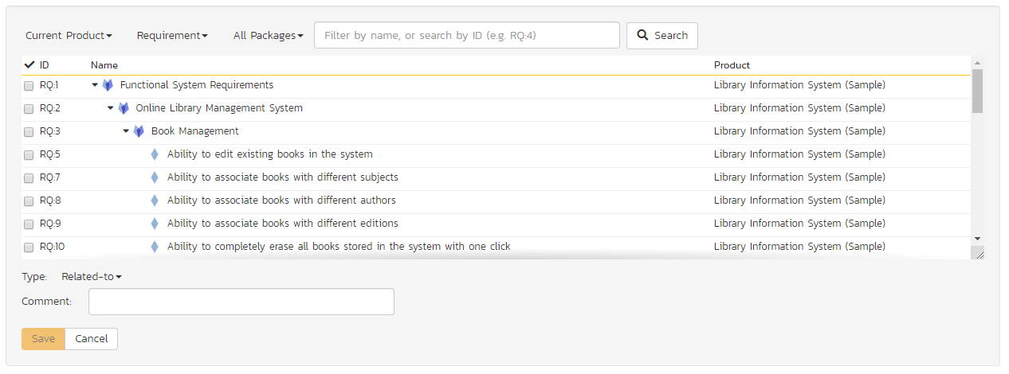

You can narrow down your search by entering a keyword:

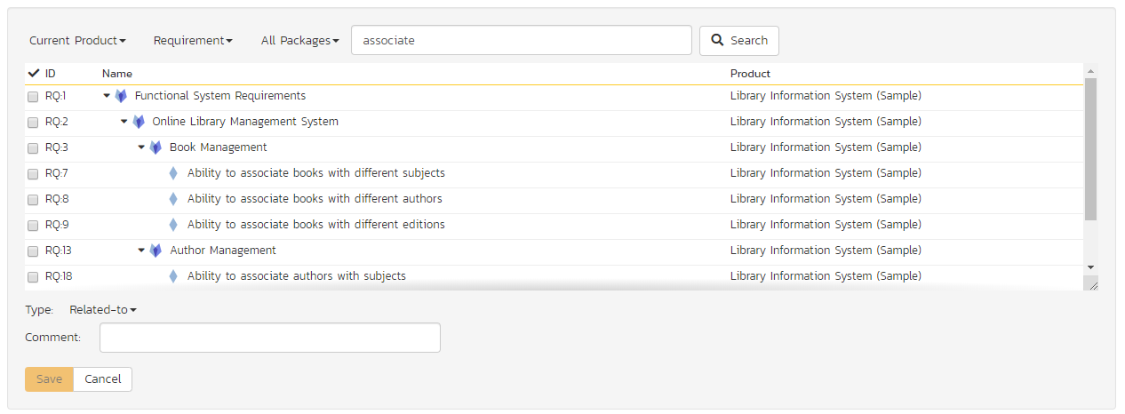

For requirements, you can also choose a package from the list to narrow down the results:

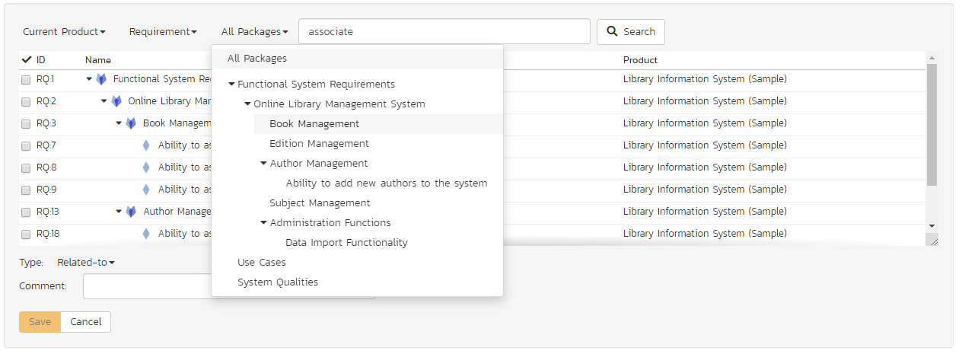

Once you have a list of artifacts, you should select the checkboxes of the items you want to associate with the current requirement and click the ‘Save’ button.

You can add a comment that explains the rationale for the association and choose the type of association being created:

* **Related-to:** this is used to specify that the two artifacts are simply related
* **Depends-on:** this is used to specify that the current artifact has a dependency on the one being linked to.

# 5. Test Case Management

This section outlines how the use-case / test-case management features of SpiraPlan® can be used to develop the business use-cases for the system, which specify how the different pieces of functionality are expected to work in practice. In addition, these use/test-cases form the basis of the business specification of the system when associated with the underlying requirements matrix. Typically when starting a new product:

* The requirements matrix is entered first
* Then the list of use-cases is developed to outline the key scenarios that need to supported to implement the requirement
* Then the use-cases are fleshed out into full test-cases by adding the detailed test-steps with the expected result and suggested sample-data
* Finally the tests are grouped into test-sets so that they can be assigned to users in batches for execution and tracking.

However when migrating existing products into SpiraPlan®, you may need to migrate the test-case list first, and then add the supporting requirements matrix afterwards.

## 5.1. Test Case List

When you click on the Testing > Test Cases link on the global navigation bar, you will initially be taken to the test case list screen illustrated below:

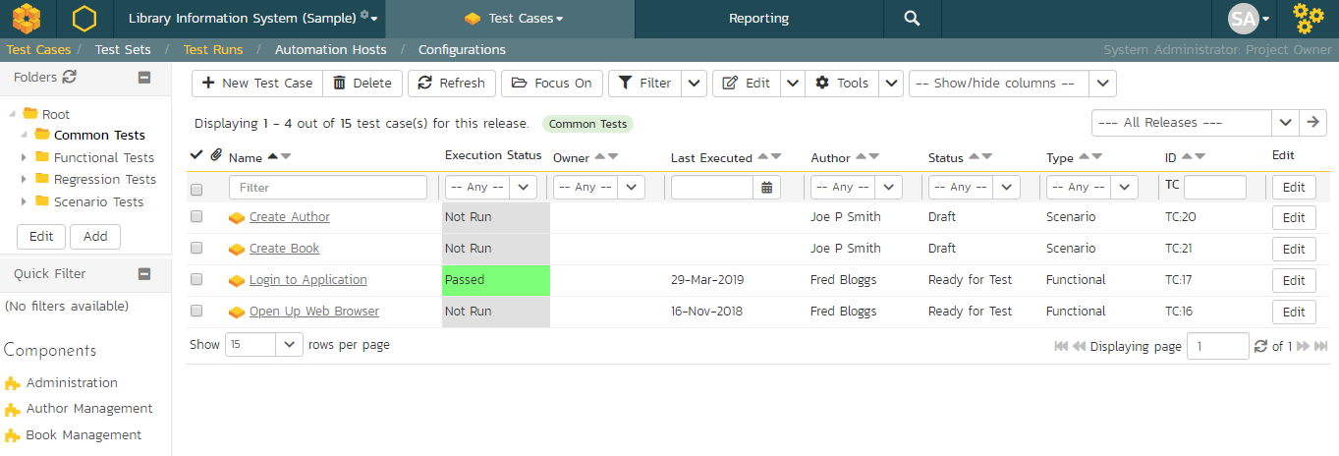

The test case list consists of a hierarchical arrangement of the various test folders and test cases. The structure is very similar to the folder structure in Microsoft Windows® Explorer, and users will find this very familiar and intuitive to use. A folder tree is on the left hand side—with triangle icons to expand / collapse each folder. Contents of the selected folder (the one marked in bold on the folder tree) are shown on the right hand side.

When you create a new product, this list will initially be empty, and you will have to use the “New Test Case” button to start adding test cases to the system. A new product will also not have any test folders—only the base “Root” folder will be visible. To add a test folder, you click the “Add’ button at the bottom of the folder tree on the left.

The list shows all test folders (shown with a folder icon), and test cases (shown with a document icon) inside the currently selected folder. You can place test folders and test cases into test folders. All of the items in the list have a name, together with the most recent execution status (passed, failed or not-run), and owner, author, execution date, active flag and test case number. Clicking on a test case’s hyperlink will take you to the test case details page for the item in question (see section 5.2).

It is important to understand that only test cases are assigned a status themselves; the test folders instead display a test execution bar graph that illustrates the aggregate execution status of its child test-cases. Thus, if the test folder contains two test cases, one of which passed, and one of which wasn’t run, the graph will display 50% green and 50% gray.

To determine the exact aggregate test folder execution status information, position the mouse pointer over the bar-chart, and the number of tests in each of the execution statuses (passed, failed, not-run, blocked, caution) will be displayed as a “tooltip”. Note that if you change the owner of a test folder, then all the child test cases will be assigned the same owner. This allows you to more easily associate entire folders to test cases to be executed by a specific user.

### 5.1.1. Add a Test Case

Click the “New Test Case” button will add a test case in the currently displayed folder (ie the one marked in bolder on the folder tree and also shown in the yellow information box). The new test case will be added at the bottom of the list.

Once the new test case has been inserted, the item is switched to “Edit” mode so that you can rename the default name and choose an owner and/or author. Note that all new test cases are initially set with an execution status of “Not Run”.

### 5.1.2. Delete

Clicking on the “Delete” button deletes all the test cases and/or test folders whose check-boxes have been selected. If any of the items are test folders, then the entire contents of that folder will also be deleted (as you would expect in Microsoft Windows® Explorer or OS X Finder).

### 5.1.3. Execute

Clicking on the “Execute Tests” button (accessed from the “Tools” menu or context menu) executes all the test cases selected, together with all the test cases contained with any selected test folders. The test execution functionality of SpiraPlan® is explained in more detail in section 5.3.

### 5.1.4. Refresh

Clicking on the “Refresh” button simply reloads the test case list. This is useful as other people may be modifying the list of test cases at the same time as you, or executing specific test cases, and after stepping away from the computer for a short-time, you can click this button to make sure you are viewing the most current test case list for the product.

### 5.1.5. Editing a Test Case

Each test case in the list has an “Edit” button in its right-most column. When you click this button (or *double-click* on any of the cells in the row), you change the item from “View” mode to “Edit” mode. The various columns are made editable, and “Update” and “Cancel” buttons are displayed in the last column:

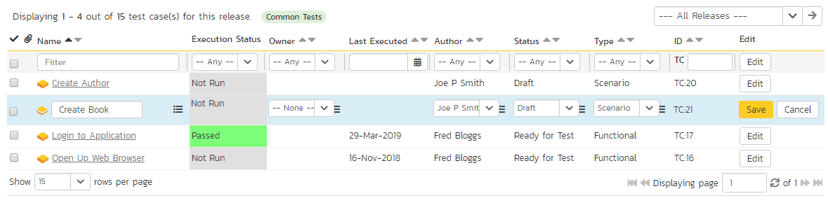

If you click “Edit” on more than one row, the “Update” and “Cancel” buttons are only displayed on the first row, and you can make changes to all the editable rows and then update the changes by clicking the one “Update” button. Also, if you want to make the same change to multiple rows (e.g. to change the owner of five test cases from “Fred Bloggs” to “Joe Smith”), you can click on the “fill” icon to the right of the editable item, which will propagate the new value to all editable items in the same column.

If you want to edit lots of items, first select their checkboxes and then click the “Edit” button on the same row as the Filters (ie the topmost edit button) and it will switch all the selected items into edit mode.

When you have made your updates, you can either click “Update” to commit the changes, or “Cancel” to revert back to the original information. Alternatively, pressing the <ENTER> key will commit the changes and pressing the <ESCAPE> key will cancel the changes.

### 5.1.6. Editing a Test Folder

Test folders shown on the right hand list pane do not have an “Edit” button. To edit a test folder, first click the “Edit” button at the bottom of the left hand folder tree. This will place the whole folder tree into edit mode—each folder will get a small “Edit” button of its own.

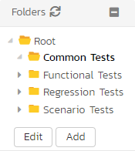

Clicking on the “Edit” button of the folder you want to edit will display a pop up dialog. This allows you to: move the folder into a new or different parent folder; edit the name of the folder; or add a more detailed description. Click “Update” to commit the changes, “Cancel” to revert back to the original information, or “Delete” to delete the folder (and all of its contents). Note that on clicking “Delete” a warning box will appear to make sure you don’t accidentally delete something.

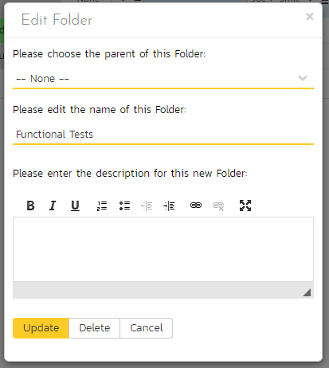

### 5.1.7. Show / Hide Columns

This drop-down list allows you to change the fields that are displayed in the test case list as columns for the current product. To show a column that is not already displayed, simply select that column from the list of “Show…” column names and to hide an existing column, simply select that column from the list of “Hide…” column names. This is stored on a per-product basis, so you can have different display settings for each product that you are a member of. The fields can be any of the built-in fields or any of the custom properties set up by the product owner.

Note: If you hide the ‘execution status’ column, the test case folders will no longer show the count of test cases contained within the folder.

### 5.1.8. Filtering

You can easily filter the list of test cases as illustrated in the screen-shot below:

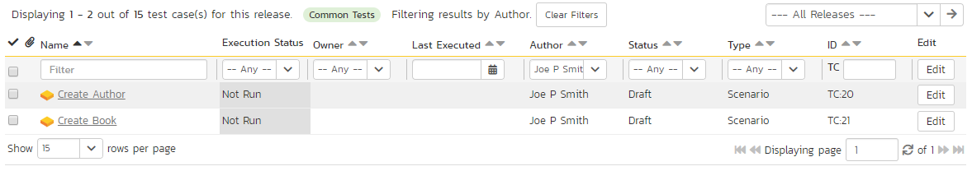

To filter the list by any of the displayed columns, you either choose an item from the appropriate drop-down list or enter a free-text phrase (depending on the type of field) then click “Filter” or press the <ENTER> key to apply the different filters. Note that the name field is searched using a “LIKE” comparison, so that searching for “database” would include any item with the word database in the name. The other freetext fields need to be exact matches (e.g. dates, test case numbers). In the screen-shot above, we are filtering on Owner = (None).

In addition, if you have a set of filters that you plan on using on a regular basis, you can choose the option Filter > Save Filter to add the current filter to the list of saved filters that appear on your ‘My Page’. The list of saved filters can also be retrieved by clicking Filter > Retrieve Filter:

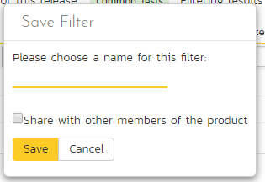

Because the same test case can be run against more than one release, sometimes you want to see the execution information for the displayed test cases for different releases. If you select a release or sprint from the dropdown marked “All Releases” on the right above the table, then the execution information for that specific release will be displayed. If the dropdown is set to "all releases", then it shows only the most recent execution information. In both cases, all test cases (as per any filter) are listed.

### 5.1.9. Copying Test Cases

To copy one or more test cases, simply select the check-boxes of the test cases you want to copy and then select the Edit > Copy Items menu option. This will copy the current test case selection to the clipboard. Then select the place where you want the test cases to be inserted and choose the Edit > Paste Items option.

The test cases will now be copied to the destination you specified. The name of the copied test cases will be prefixed with “Copy of…” to distinguish them from the originals.

### 5.1.10. Moving Test Cases or Folders

There are two options for moving test cases or folders:

1. Click on the test case/folder you want to move in the right hand list and drag it to the folder in the left hand folder tree you want it moved to. The background of the new folder will change to show where it will be inserted:

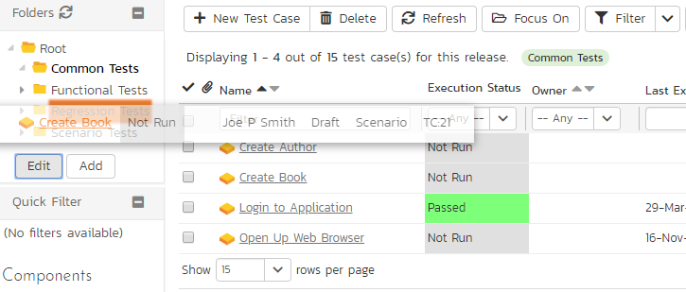

Once you have the test case/folder positioned at the correct place that you want it inserted, just release the mouse button. To move multiple items simply select their checkboxes and then drag-and-drop one of the selected items.

1. Alternatively you can simply select the check-boxes of the test cases you want to move and then select the Edit > Cut Items menu option. This will cut the current test selection to the clipboard. Then select the place where you want the test cases to be inserted and choose the Edit > Paste Items option. The test cases will now be moved into the destination specified.

### 5.1.11. Exporting Test Cases

To export a test case or set of test cases from the current product to another product in the system, select the check-boxes of the test case(s) you want to export and then click Tools > “Export to Product”. This will bring up a list of possible destination products:

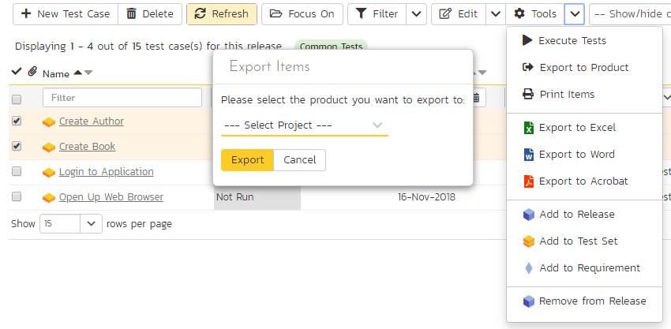

Once you have chosen the destination product and clicked the “Export” button, the test cases will be exported from the current product to the destination product. Any file attachments will also be copied to the destination product along with the test cases.

### 5.1.12. Adding Test Cases to a Release, Test Set or Requirement

To quickly add a series of test cases to a Release, Test Set or Requirement, select the check-boxes of the appropriate test cases and then click Tools > Add to Release / Test Set / Requirement. This will bring up a dialog box displaying either a list of available releases, test sets or requirements (depending on which option was chosen):

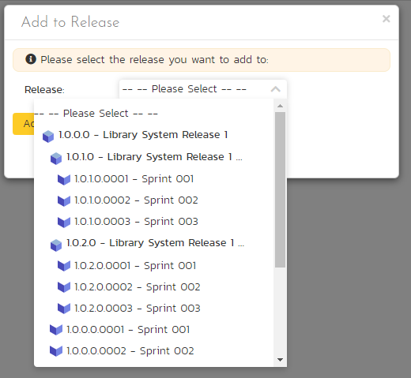

Once you have chosen the destination release / test set / requirement, clicking “Add” will add the selected test cases to the destination release / test set / requirement.

### 5.1.13. Viewing the Test Status for a Release

By default, when you view the list of test case cases, it will display an aggregate status for all releases of the product. I.e. the test list will include all the test cases in the system (regardless of which release they apply to) and the execution status will reflect the most recent test run – regardless of which release it was for.

To change the test case list to just display test cases and execution status for a particular release, change the release selected in the drop-down list located in the yellow information panel (on the right-hand side) from “All Releases” to a specific release:

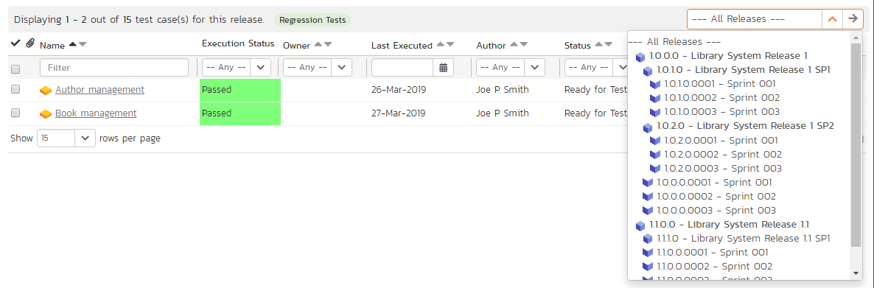

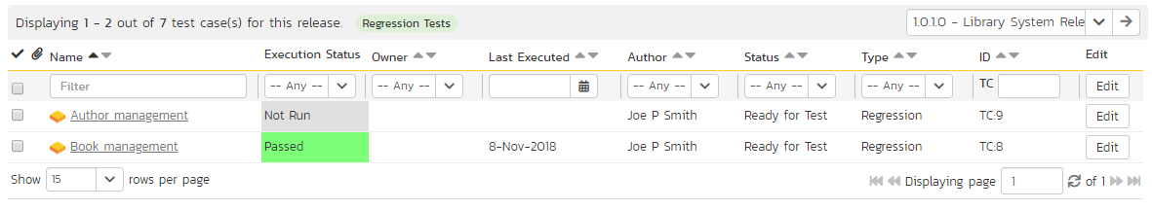

As illustrated in the example above, when the drop-down list is changed to select a specific release, the list of test cases is filtered to just those mapped to the release in question. In addition, the execution status for the test releases will only reflect test runs for that specific release (and any child sprints if applicable). As can be seen in our example, many test cases that have been run for other releases now show the “Not Run” status since they’ve not been run for this specific release.

As a shortcut, when you select a specific release for viewing, subsequent execution of any of the test cases via the Tools > Execute Tests menu option will default the test run to the selected release.

### 5.1.14. Printing Items

To quickly print a single test case, test folder or list of test cases you can select the items’ checkboxes and then click Tools > Print Items. This will create a printable report of the selected items in a new window.

### 5.1.15. Right-Click Context Menu

SpiraPlan® provides a shortcut – called the *context menu* - for accessing some of the most commonly used functions, so that you don’t need to move your mouse up to the toolbar each time. To access the context menu, right-click on any of the rows in the test case list and the following menu will be displayed:

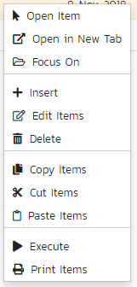

You can now choose any of these options as an alternative to using the icons in the toolbar.

## 5.2. Test Case Details

When you click on a test case item in the test case list described in section 5.1, you are taken to the test case details page illustrated below:

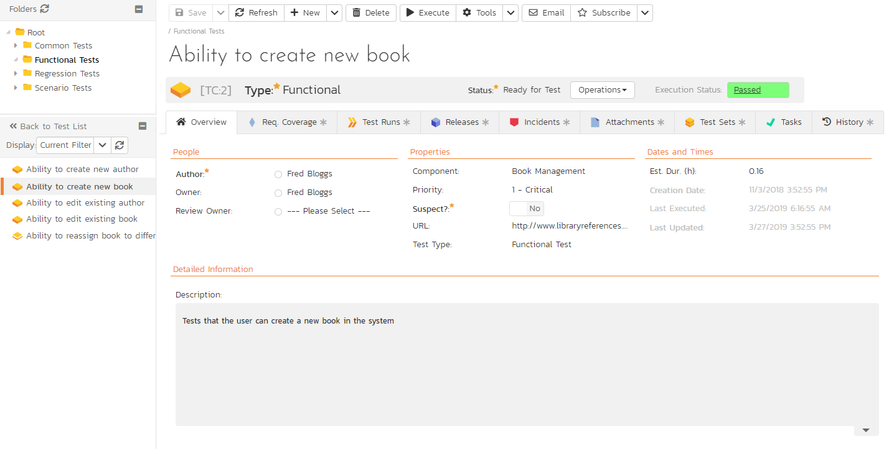

This page is made up of *three* areas;

1. the left pane displays the test case folders and list navigation;
2. the right pane’s header, which displays: the operations toolbar; the editable name of the selected test case; and the info bar (with a shaded background), which also contains the workflow status transitions (see below); and
3. the right pane’s tabbed interface with rich information related to the test case.

The navigation pane consists of a link that will take you back to the test case list, as well as a list of the peer test cases to the one selected. This latter list is useful as a navigation shortcut: you can quickly view the detailed information of all the peer test cases by clicking on the navigation links without having to first return to the test cases list page. The navigation list can be switched between three different modes:

* The list of test cases matching the current filter
* The list of all test cases, irrespective of the current filter
* The list of test cases assigned to the current user

If you are editing an existing item, the fields that are available and the fields that are required will depend on your stage in its workflow. The types of change allowed and the email notifications that are sent will depend on how your product administrator has setup the system for you. Administrators should refer to the *SpiraPlan Administration Guide* for details on configuring workflows to meet their needs.

Depending on the user’s role and whether they are listed as the owner or author of the test case, displayed in the info bar beneath the test case name is the current workflow status and an “operations” button which, when clicked, will show a set of allowed workflow operations.

These workflow transitions allow the user to move the item from one status to another. For example when the test case is in the Ready for Review status, you will be given the options to:

* **Approve Test Case** – changes status to “Approved”
* **Reject Test Case** – changes the status to “Rejected”
* **Return to Draft** - changes the status to “Draft”

Please note that if digital signatures have been enabled for a particular workflow operation (and therefore a digital signature is required to confirm the status change. Workflow operations requiring a digital signature are marked with a padlock icon as in the example below:

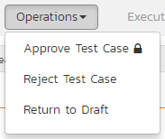

On attempting to save changes made after clicking a workflow operation that requires a digital signature you will be presented with a popup similar to the one below (which is for a requirement):

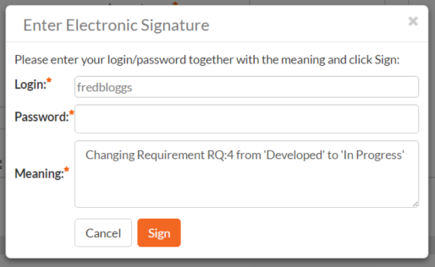

The top part of the right pane allows you to view and/or edit the name of the particular test case. Once you are satisfied with any changes made here or to the information below, click “Save”. Alternatively, if you click the dropdown you can either click “Save and Close” (which will take you back to the list page after saving); or “Save and New” to commit the changes and immediately create another test case. In addition you can: create a replica of the current test case by clicking “Clone”; delete the current artifact by choosing “Delete”; discard any changes made by clicking “Refresh”; or print or export it using from the “Tools” dropdown.

Clicking the “Execute” button will immediately prepare the current test case for execution and then take you to the test execution screen (see section 5.4 below)

Using the “Email” button on the toolbar, you can send an email containing details of the test case by either specifying an email address or another user on the system:

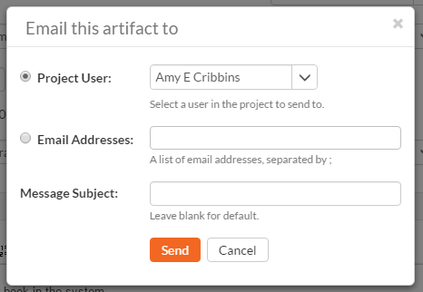

You can specify the subject line for the email, and either a list of email addresses, separated by semicolons, or an existing product user. The content of the email is specified in the System Administration – Notification Templates.

To be notified of any changes made to the current artifact via email, click the “Subscribe” button. If you already subscribed, the button will instead let you “Unsubscribe” to stop receiving emails about that particular artifact. Depending on your role, you may also see a dropdown arrow to the right of this button. This will let you subscribe others in the product to this artifact

The lower part of the right pane can be switched between *eight* different views by clicking the appropriate tab. Initially the pane will be in “Overview” mode, but it can be switched to “Requirements Coverage”, “Test Runs”, “Releases”, “Incidents”, “Attachments”, “History”, and “Test Sets” modes if so desired. Each of these views is described below.

### 5.2.1. Overview - Details

The Overview tab is divided into a number of different sections. Each of these can be collapsed or expanded by clicking on the title of that section. This tab displays the fields, detailed information, and comments associated with the test case.

The top part of this tab displays the various standard fields and custom properties associated with the test case. Fields (both standard and custom) are grouped under the collapsible headings (marked by orange text and underline) in the screenshot below. For instance, all fields regarding dates are grouped together in the “Dates and Times” area.

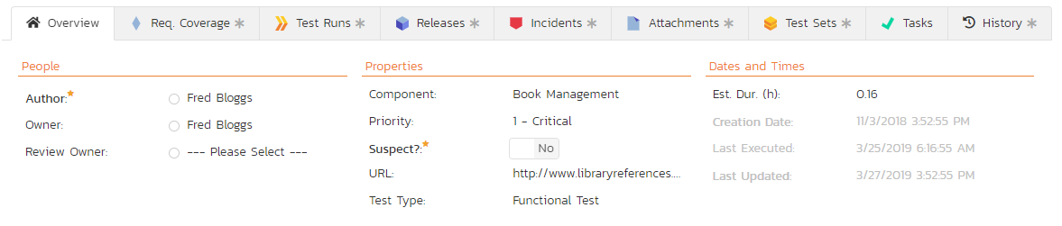

The Detailed Information section contains the long, formatted description of the test case, as well as any rich text custom fields. You can enter rich text or paste in from a word processing program or web page. Clicking on the shaded areas of one of these detailed fields will display the rich text toolbar.

The **Suspect** flag is automatically set on an approved test case, when one of the requirements linking to it changes. This lets you quickly find all the test cases impacted by a specific requirement change. For this to happen the requirement needs to be in an Accepted or later status (i.e. not Rejected, Rejected, Under Review, Obsolete) and the test case needs to be an approved status (i.e. not Draft, Obsolete, Rejected).

### 5.2.1.1. Followers

Using the “Subscribe” button on the toolbar, you can quickly follow the item, and receive updates on certain changes to it. Depending on your role, you may also see a dropdown to this button, which let’s you add another product member as a follower to this item.





You can also quickly see who is following an incident under the “People” section in the Overview tab.



To view information about the follower, or to unfollow them from the item, hover over their avatar to display a user profile card.



### 5.2.2. Overview - Test Steps

This view displays the name of the test case together with all the defined test steps that a tester would need to perform to verify that the functionality works as expected. The list of test steps displays the position number, the description, the expected result, some suggested sample data and the most recent execution status of the individual test step:

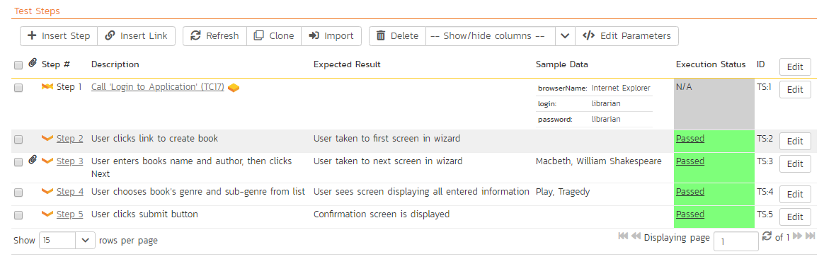

Note: Test steps that are marked with a hyperlink and test case icon (e.g. “Call Login to Application” in the screen shot above) are in fact *linked test cases.* Linked test cases are a useful way of reusing existing test steps from other test cases. For example if you want to have a set of steps be in more than one test case (e.g. a login step) then you would create a separate test case just containing these steps, then have all the other test cases just link to it. This avoids the need to have duplicate test steps throughout the product.

If you click on the step number hyperlink (e.g. Step 2) you will be taken to the test step details page which allows you to perform additional editing of a specific test step as well as attach documents, associate pre-existing incidents and view the change history.

### 5.2.2.1. Insert Step

Clicking on the “Insert Step” button inserts a new test step *before* the currently selected (by means of the check-box) test step. Clicking the “Insert Step” button without selecting a test step will insert a new step at the end of the list. When a new step is inserted, the fields are displayed in “Edit” mode, so the description, expected result and sample data fields are editable, allowing you to enter the data:

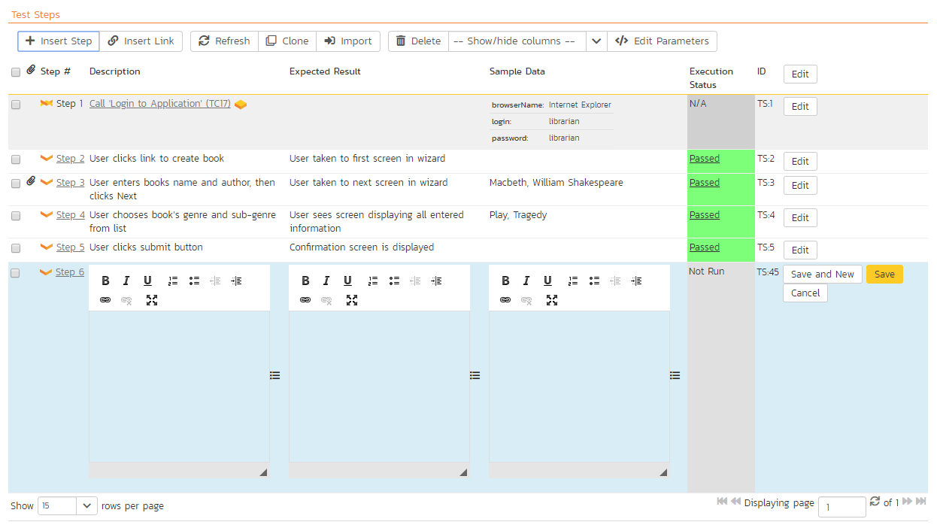

Once you have entered the necessary information, you can click either “Save and New” or “Save” to commit the changes. If you choose “Save and New” another new row will be inserted which is useful if you intend on entering lots of rows at once, whereas clicking “Save” will commit only the current row.

### 5.2.2.2. Insert Link

Clicking on the “Insert Link” button brings up the following dialog box that allows you to either choose an existing test case to be inserted or create a new test case and step with parameters:

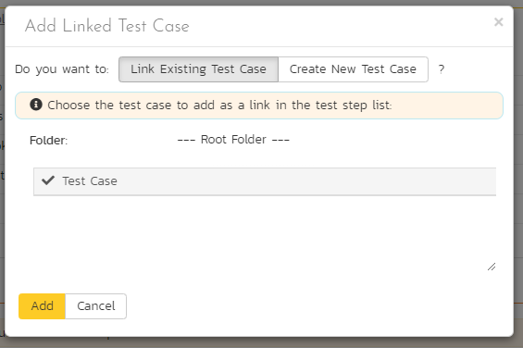

When linking an existing test case, first select its parent folder from the dropdown. Then select the name of the test case you want to insert as a link from the list. If the test case has declared parameters (see the section on Parameters below for more details) you will be given a list of parameters that needed to be filled out.

You need to fill out the values of the parameters for the linked test case and then click the “Add” button to complete the operation. The system will then insert the test case as a link just before the currently selected test step. If no existing test step was selected, the link will be added at the end of the test step list.

If you want to create a test step with specific parameters and parameter values, you can do so by clicking the “Create New Test Case”. This will change the dialog to one where you can assign a folder, name, and parameters to a new test case. On clicking the “Add” button: the new test case is created; a test step is created within that new test case; the parameters specified in the dialog are assigned to that test step, with the values set as the defaults for the step; and the new test case is added as a linked test case in the list of test steps.

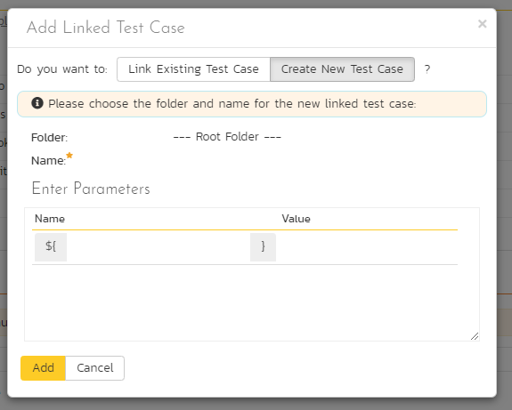

### 5.2.2.3. Delete

Clicking on the “Delete” button deletes the currently selected test steps, and reorders the test step position numbers to close any gaps in numbering.

### 5.2.2.4. Clone

Clicking on the “Clone” button makes a duplicate of the current test step or linked test case and inserts the copied version directly above the original one.

### 5.2.2.5. Refresh

Clicking on the “Refresh” button simply reloads the list of test steps. This is useful if other people are making changes to the test list and you want to make sure that you have the most current version.

### 5.2.2.6. Show / Hide Columns

By default the test step list screen will display the Description, Expected Result and Sample Data fields. However the Expected Result and Sample Data fields are optional and can be hidden if necessary to make more space. If you have configured custom properties for test steps, you can use the Show/Hide features to display one or more of your custom properties instead. These fields will then be editable in this grid-view.

### 5.2.2.7. Editing Test Steps

To modify an existing Test Step you simply need to click on the “Edit” button to the right of the step, or just *double-click* on the cells in the row. That will switch the selected row into Edit mode. The various columns are turned into editable text-boxes, and “Save” and “Cancel” buttons are displayed in the last column:

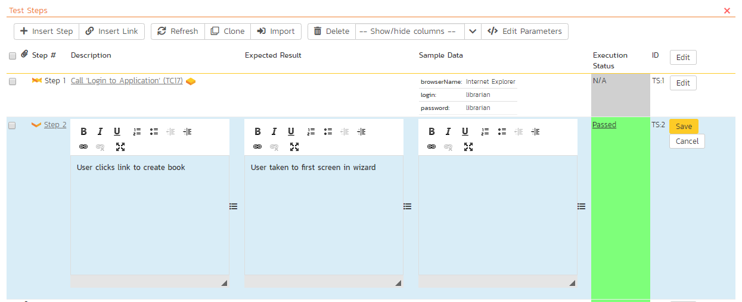

If you click “Edit” on more than one row, the “Save” and “Cancel” buttons are only displayed on the first row, and you can make changes to all the editable rows and then save the changes by clicking the one “Save” button. Also, if you want to make the same change to multiple rows, you can click on the “fill” icon to the right of the editable item, which will propagate the new value to all editable items in the same column. When you have made your changes, you can either click “Save” to commit the changes, or “Cancel” to revert back to the original information.

### 5.2.2.8. Editing Test Links

To modify an existing Test Link you simply need to click on the “Edit” button to the right of the step, or double click on the cells in the row. That will open up the special dialog box used for editing the parameter values associated with a specific linked test case:

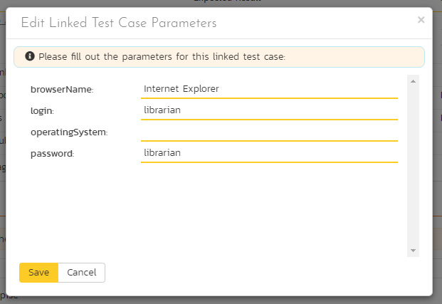

This allows you to edit the parameters being passed from the current test step to the linked test case without having to recreate the test link from scratch. To commit the change click “Save” to close the dialog box, or click “Cancel” to revert back to the original information.

### 5.2.2.9. Moving Test Steps

To move test steps in the list, click on the row you want to move and drag it where you want it moved to within the list of test steps. An empty space will appear to show you where it will be inserted.

### 5.2.2.10. Parameters

Test cases can have parameters associated with them. This enables one test case to be called several times by another test case (as a link) and have different parameters passed in each case, making the operation different. E.g. you could have a generic “login to application” test case that others call as an initial step, which could be provided with different login information depending on the calling test case.

To view / change the parameters associated with the current test case, click on the “Edit Parameters” button in the toolbar and the list of current parameters will be displayed:

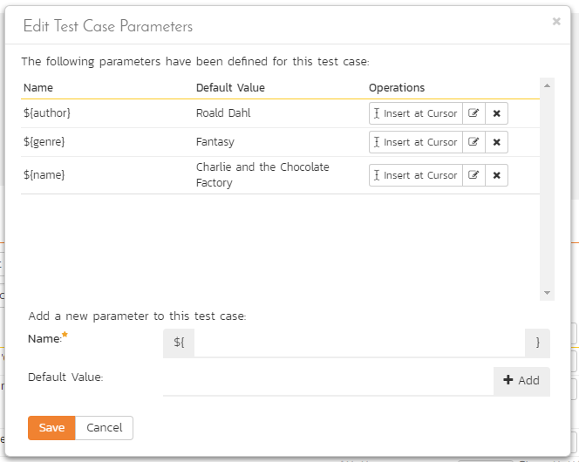

The list of existing parameters is displayed in a list. Beneath this, is a form where you can add a new parameter and default value (used when the test case is run directly rather than being called by another test case). You can delete an existing parameter or copy the parameter token to your computer’s clipboard. If you want to paste the parameter token onto the current page (say into a specific test step), position the cursor where you want and click “Insert at Cursor” This is a quick way to include the parameter and then have it converted into the parameter value during test execution.

### 5.2.3. Overview - Automation

The Automation section displays any automated test scripts associated with the current test case. There are three types of automated test:

* **Attached** – this is when SpiraPlan physically stores the test script as an attachment in the system. This is only available for test automation tools that store their test scripts as plain text files. Examples of such tools are Selenium-RC and Squish.
* **Linked** – this is when SpiraPlan stores the location of the test script stored on the automation host itself or on an external network drive.
* **Repository** – This is a special option only available when using Rapise™, the test automation system from Inflectra. This allows you to store an entire folder of automated test script files in SpiraPlan and have them linked to the test case.

The screenshot below illustrates a sample Rapise automated test script attached to a test case:

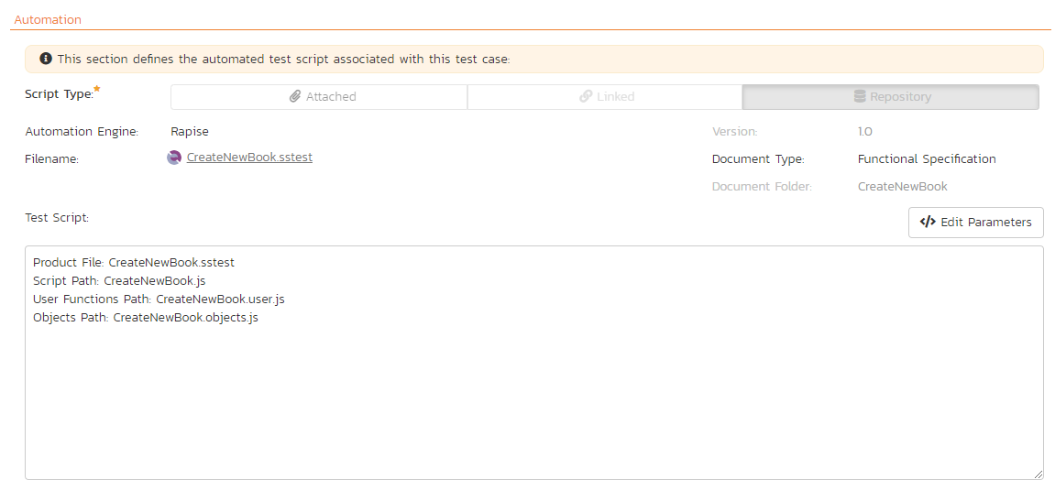

The automation screen includes the following fields that you should populate when using SpiraPlan® to store an automated test script:

* **Automation Engine** – this should be the name of the test automation engine that the test script should be executed with. This list is populated by a system administrator using the administration section of the application (as described in the *SpiraPlan Administration Guide*)
* **Script Type** – This should be set to either “attached” or “linked”. If you choose to attach the test script, the large text box at the bottom will be enabled, allowing you enter/edit the test script directly in SpiraPlan. If you choose linked, the test script is stored externally and SpiraPlan just stores a reference to it. The “repository” option is never selectable within SpiraPlan and will be automatically set by Rapise when it attaches a test script to the test case.
* **Filename** – If you are attaching the test script to the test case then this field just needs to contain the filename of the test script (no folders or path needed), whereas if you are choosing to link the test script, you need to follow the exact format that will be expected by the test automation engine. For details, please refer to the specific test automation engine in the *SpiraTest/Team Automated Test Integration Guide*.
* **Document Type** - This should be set to the document type that you want the test script associated with.
* **Document Folder** - This should be set to the document folder that you want the test script to be stored in. Note that if the script type is repository then the folder is set automatically and cannot be edited by the user.
* **Version** – This should contain the version number of the test script.
* **Test Script** – If you are attaching a test script, this should contain the actual program code for executing the test script. The language and syntax will be dependent on the test automation engine being used. If you are linking the test script, this section will be disabled.
* **Parameters** – You can enter the various test case parameters by clicking on this hyperlink. Most of the automation tools that SpiraPlan integrates with will support the passing of parameter values from SpiraPlan to the automation tool.

### 5.2.4. Overview - Comments

The Comments section allows users to add and view discussions related to the Test Case:

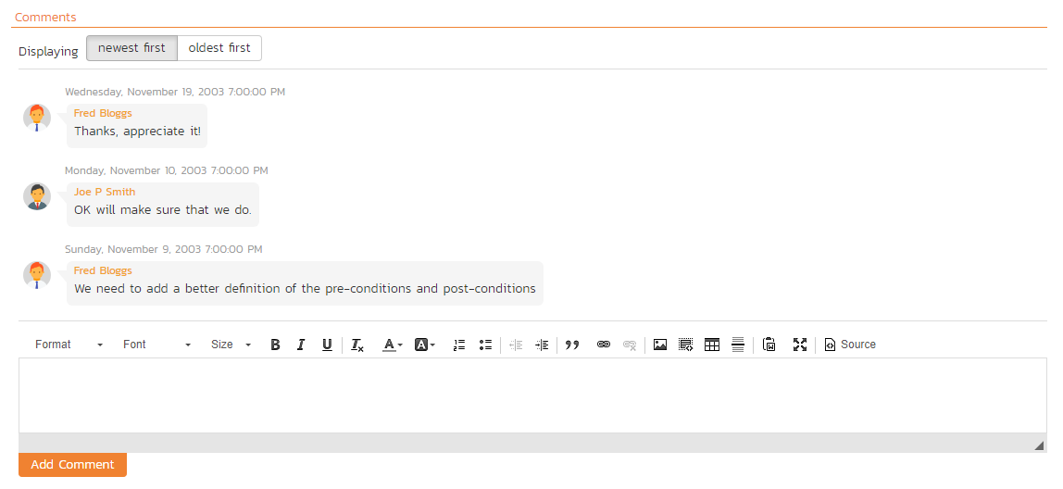

Existing comments are displayed by date (either newest-first or oldest-first) above the text box. To add a comment to the Test Case, enter your text into the textbox, then click the “Add Comment” button.

### 5.2.5. Requirements Coverage

This tab displays the requirements coverage information for the test case in question:

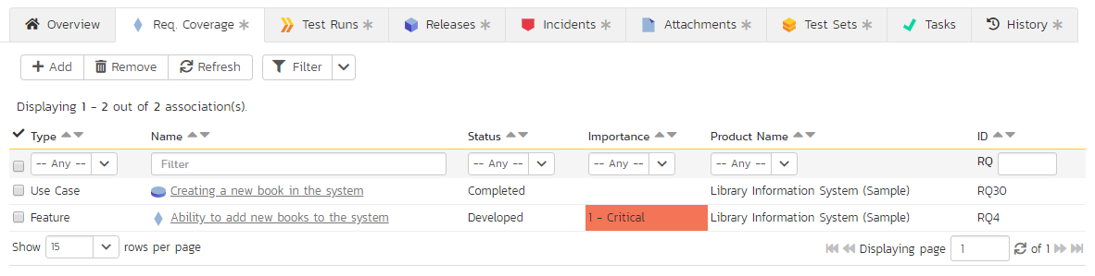

The table shows the requirements, if any, mapped to this test case. Clicking on the hyperlinked names will jump you to the details screen for the item in question.

To map the test case to a new requirement, click the “Add” button to display the add association panel. You can search by the ID (if known) prefixed with the appropriate token (e.g. “RQ:4” to search for requirement 4). You can also browse by package, or search by name. Select the requirements you want and then click the “Save” button”.

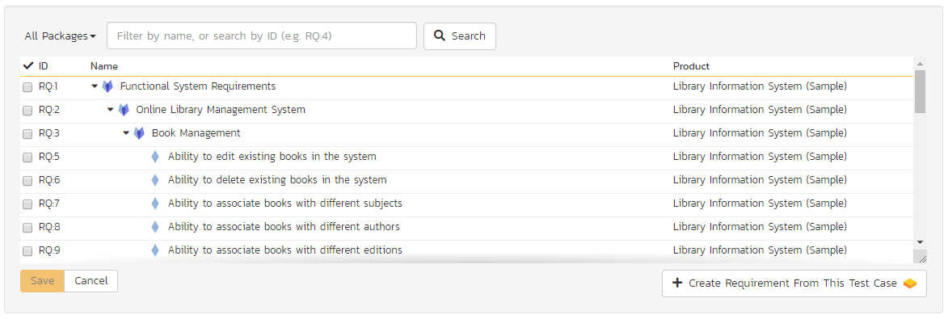

From the same add association panel there is a short to “Create Requirement from This Test Case”. This button will create a new requirement in the list of covered requirements that will be automatically linked to this test case. This is useful when you have created a new test case and want to generate an initial placeholder requirement to be fleshed-out later.

Finally, to remove coverage for this test case, select any of the added requirements (those in the bottom table) and click the “Remove” button.

### 5.2.6. Test Runs

This view displays the name of the test case together with a list of the previous execution runs that the test case has been put through. Each test run is listed together with the date of execution, the name of the test case, the name of the test set (if applicable), the name of the tester, the release/version of the system that the test was executed against, the overall execution status for the test case in that run and a link to the actual test run details (see section 5.6). In addition, you can choose to display any of the custom properties associated with the test run.

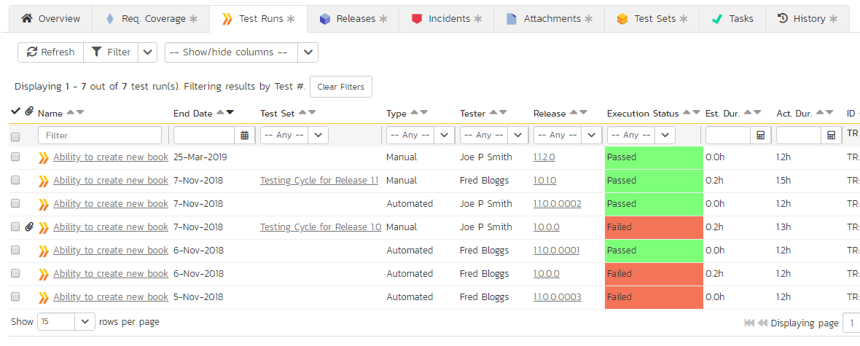

The “show/hide columns” drop-down list allows you to change the fields that are displayed in the test run list as columns. To show a column that is not already displayed, simply select that column from the list of “Show…” column names and to hide an existing column, simply select that column from the list of “Hide…” column names. The displayed columns can be any standard field or custom property.

You can also filter the results by choosing items from the filter options displayed in the sub-header row of each field and clicking the “Filter” button. In addition, you can quickly sort the list by clicking on one of the directional arrow icons displayed in the header row of the appropriate field.

### 5.2.7. Releases

This tab displays the name of the test case together with the release mapping information for the test case in question. It functions in a similar way to the Test Coverage tab described above: the table at the bottom of the panel shows the releases, if any, mapped to this test case. Clicking on the hyperlinked names will jump you to the details screen for the item in question. You can search for and add releases to this list using the “Add” button, or remove them using the “Remove” button.

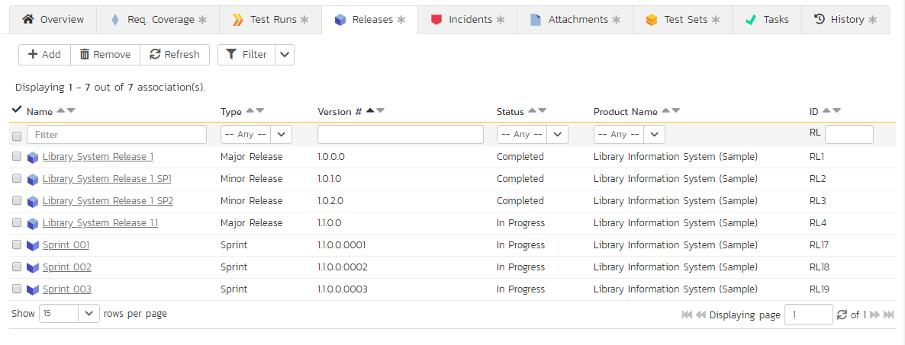

### 5.2.8. Incidents

This tab displays the list of incidents associated with the current test case. The incidents have either been created during an execution of the test case (and are thereby linked to one of the test runs) or manually linked to one of the test steps in the test case.

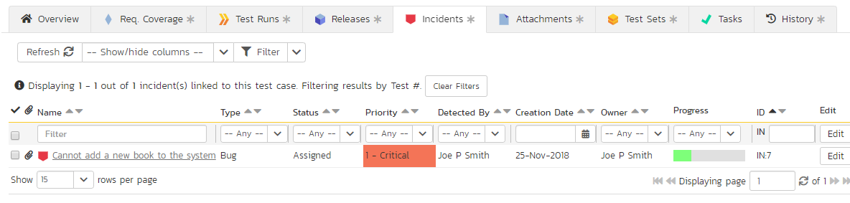

Each incident is listed together with the type, status, priority, name, owner, detector, detection date and a link to the actual incident details. You can customize the fields that are displayed using the “Show/Hide Columns” option. In addition, you can perform the following operations:

* **Refresh** – updates the list of incidents from the server, useful if other people are adding incidents to this release at the same time.
* You can also **filter** the results by choosing items from the filter options displayed in the sub-header row of each field and clicking the “Filter” button. In addition, you can quickly sort the list by clicking on one of the directional arrow icons displayed in the header row of the appropriate field.
* **Edit** – Clicking the “Edit” button to the right of the incident allows you to edit the incident inline.

### 5.2.9. Attachments

In this tab, the main pane displays the list of documents that have been “attached” to the test case. The documents can be in any format, though SpiraPlan® will only display an icon for certain known types.

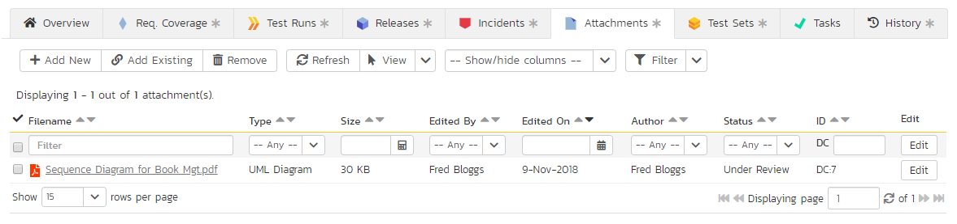

The attachment list includes the filename that was originally uploaded together with the file-size (in KB), name of the person who attached it and the date uploaded. In addition, if you position the pointer over the filename and hold it there for a few seconds, a detailed description is displayed as a tooltip.

To actually view the document, simply click on the filename hyperlink and a new web browser window will open. Depending on the type of file, this window will either display the document or prompt you for a place to save it on your local computer. To delete an existing attachment from a test case, simply click the “Remove” button and the attachment will be removed from the list.

To attach a new document to the test case, you need to first click the “Add New” link to display the new attachment dialog box:



There are three different types of item that can be attached to a test case:

* To upload a file, choose “File” as the type and then click the Browse button and select the file from your local computer, optionally enter a detailed description then click the “Upload” button. The document will be copied from your computer and attached to the artifact.
* To attach a web-link (URL) to the artifact, you need to choose “URL” as the type and then enter the fully qualified URL (e.g. [http://mywebsite.com?Document=1](http://mywebsite.com/?Document=1)), an optional description and then click the “Upload” button to attach the web-link.
* To attach a screenshot to the artifact, you need to choose “Screenshot” as the type and then copy the image to your computer’s clipboard (e.g. on Windows computers, the PRINT SCREEN button captures the current page and adds to the clipboard). Once the image is in the clipboard, paste it into the editor using CTRL+V (or the equivalent keystroke for your operating system) and the item will appear in the preview window. You can then fill in the other fields and click “Upload” to attach the image.

Note: If you are using a non-Windows® computer (e.g. Macintosh®) that doesn’t put file extensions on filenames (e.g. .xls for an Excel sheet) automatically, then you will need to manually add the file extension to the filename before uploading if you want it to be displayed with the correct icon in the attachment list.

You can also associate an existing document (that’s already stored in SpiraTeam) with the test case. To do that, click on the “Add Existing” button to bring up the add file association dialog box:

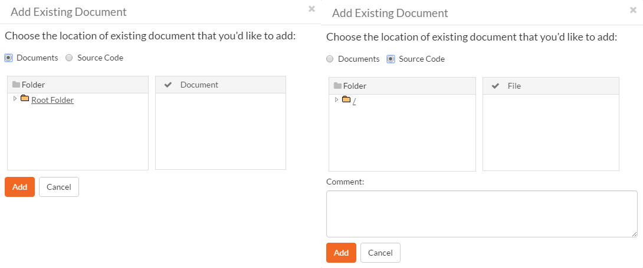

You can then choose to either associate a document stored in the SpiraPlan Documents repository or (in the case of SpiraPlan/SpiraTeam but not SpiraTest) from the linked source code repository. In either case you first select the appropriate folder, and then pick the document(s) from the file list on the right. In the case of a source code file association you can also add a comment.

### 5.2.10. History

In this tab, the main pane displays the list of changes that have been performed on the test case artifact since its creation. An example test case change history is depicted below:

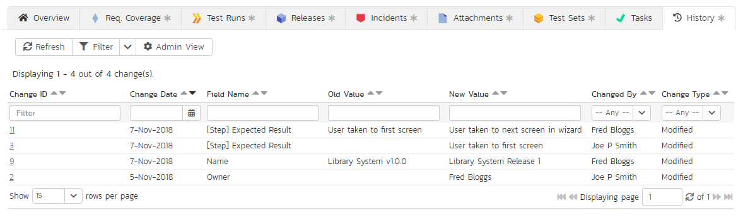

The change history displays the date that each change was made, together with the fields that were changed, the old and new values and the person who made the change. This allows a complete audit trail to be maintained of all changes in the system. In addition, if you are logged in as a product administrator you can also click on the “Admin View” button to navigate to where you can revert any unwanted changes.

### 5.2.11. Test Sets

In this tab, the main pane displays the test sets that contain the current test case. Each test set is listed together with its name, release, the date of last execution, the owner, the status, the execution status, and a link to the actual test set details (see section 5.8). In addition, you can choose to display any of the custom properties associated with the test set.

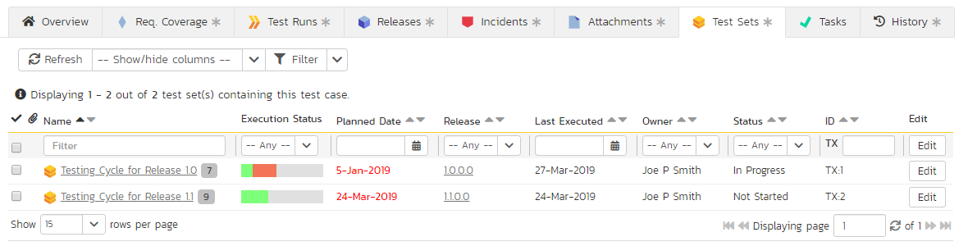

The “show/hide columns” drop-down list allows you to change the fields that are displayed in the test set list as columns. To show a column that is not already displayed, simply select that column from the list of “Show…” column names and to hide an existing column, simply select that column from the list of “Hide…” column names. The displayed columns can be any standard field or custom property.

You can also filter the results by choosing items from the filter options displayed in the sub-header row of each field and clicking the “Filter” button. In addition, you can quickly sort the list by clicking on one of the directional arrow icons displayed in the header row of the appropriate field.

### 5.2.12. Tasks

This tab is only available to SpiraPlan users. It displayes a table view of any tasks that have been associated to the test case. The only way to link a task to a test case is via test execution of a test case with a type set to “Exploratory”.

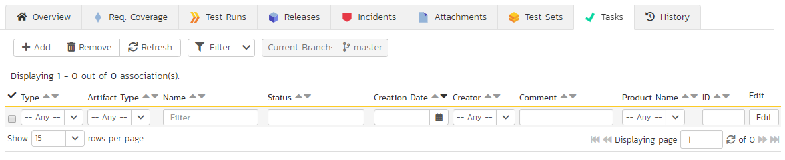

## 5.3. Test Step Details

When you click on one of the hyperlinks next to a test step in the test step list (see above), you will be taken to the test step details screen illustrated below:

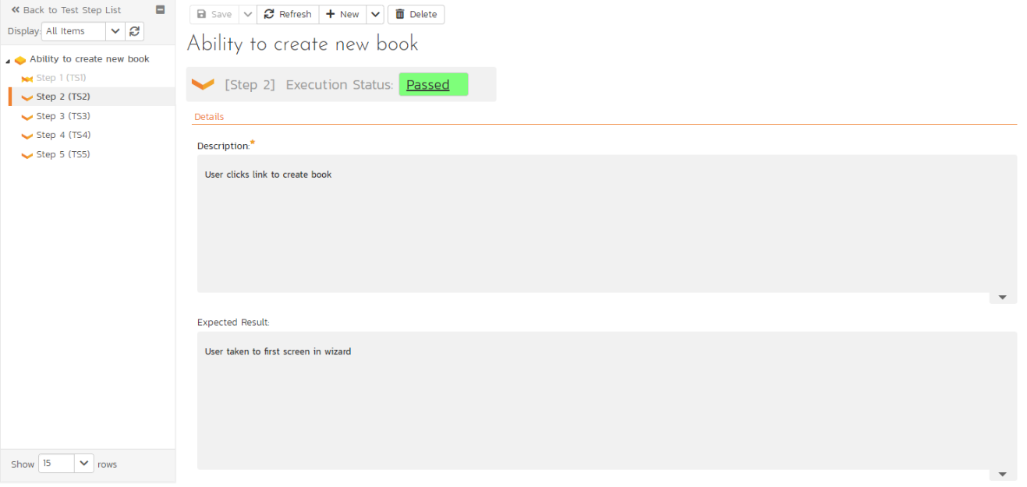

This page is made up of three areas; the left pane is the navigation window, the upper part of the right pane contains the test step detailed information itself, and the bottom part of the right pane contains related information about the test step.

The navigation pane consists of a link that will take you back to the test step list, as well as a list of the peer test steps to the one selected. This latter list is useful as a navigation shortcut; you can quickly view the detailed information of all the peer test steps by clicking on the navigation links without having to first return to the test step list page. You can also switch between seeing the list of test steps with the current filter applier or simply unfiltered.

The top part of the right pane allows you to view and/or edit the details of the particular test step. You can edit the various fields (description, expected result and sample data) and custom properties. Once you are satisfied with them, click any “Save” button on the page to commit the changes. If you want to add a new test step to the test case, you should click “Save and New” from the dropdown menu of the “Save” button at the top of the page instead.

The lower part of the right pane can be switched between four different views by clicking the appropriate tab. Initially the pane will be on “Incidents” tab, but it can be switched to “Attachments”, “History” or “Requirements” tabs if so desired. Each of the views is described separately below.

### 5.3.1. Incidents

In this mode, the main pane displays a list of any incidents that are associated with this test step. They can either be linked indirectly due to being logged during a test run, or directly linked after the fact:

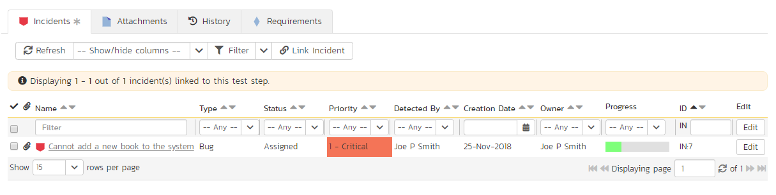

Each incident is listed together with the type, status, priority, name, owner, detector, detection date and a link to the actual incident details. You can customize the fields that are displayed using the “Show/Hide Columns” option. In addition, you can perform the following operations:

* **Refresh** – updates the list of incidents from the server, useful if other people are adding incidents to this release at the same time.
* You can also **filter** the results by choosing items from the filter options displayed in the sub-header row of each field and clicking the “Filter” button. In addition, you can quickly sort the list by clicking on one of the directional arrow icons displayed in the header row of the appropriate field.
* **Edit** – Clicking the “Edit” button to the right of the incident allows you to edit the incident inline directly on this screen.

To create a new association between this test step and an existing incident, click the “Link Incident” button which will display the following panel:

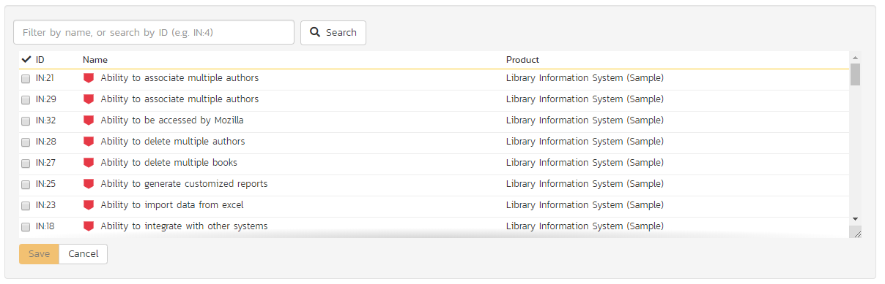

You need to choose the specific incident(s) you want to link to, either by choosing the item from the scrolling selection box, or searching for them by name or ID. Before adding the chosen incidents you can add a comment that explains the rationale for the association.

### 5.3.2. Attachments

This tab displays the list of documents that have been “attached” to the test step. The documents can be in any format, though SpiraPlan® will only display an icon for certain known types.

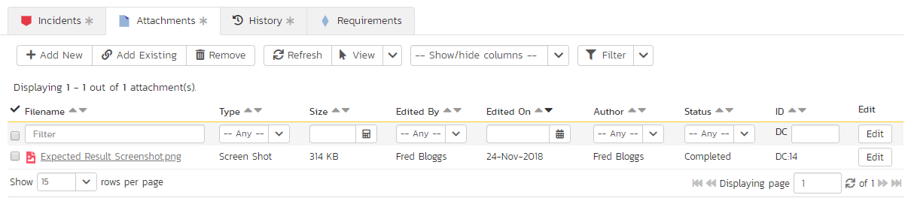

To actually view the document, simply click on the filename hyperlink and a new web browser window will open. Depending on the type of file, this window will either display the document or prompt you for a place to save it on your local computer. To delete an existing attachment from a test case, simply click the “Delete” button and the attachment will be removed from the list.

To attach a new document to the test step, you need to first click the “Add New” link to display the new attachment dialog box:



There are three different types of item that can be attached to a requirement:

* To upload a file, choose “File” as the type and then click the Browse button and select the file from your local computer, optionally enter a detailed description then click the “Upload” button. The document will be copied from your computer and attached to the artifact.
* To attach a web-link (URL) to the artifact, you need to choose “URL” as the type and then enter the fully qualified URL (e.g. [http://mywebsite.com?Document=1](http://mywebsite.com/?Document=1)), an optional description and then click the “Upload” button to attach the web-link.
* To attach a screenshot to the artifact, you need to choose “Screenshot” as the type and then copy the image to your computer’s clipboard (e.g. on Windows computers, the PRINT SCREEN button captures the current page and adds to the clipboard). Once the image is in the clipboard, paste it into the editor using CTRL+V (or the equivalent keystroke for your operating system) and the item will appear in the preview window. You can then fill in the other fields and click “Upload” to attach the image.

Note: If you are using a non-Windows® computer (e.g. Macintosh®) that doesn’t put file extensions on filenames (e.g. .xls for an Excel sheet) automatically, then you will need to manually add the file extension to the filename before uploading if you want it to be displayed with the correct icon in the attachment list.

You can also associate an existing document (that’s already stored in SpiraTeam) with the requirement. To do that, click on the “Add Existing” button to bring up the add file association dialog box:



You can then choose to either associate a document stored in the SpiraPlan Documents repository or (in the case of SpiraPlan/SpiraTeam but not SpiraTest) from the linked source code repository. In either case you first select the appropriate folder, and then pick the document(s) from the file list on the right. In the case of a source code file association you can also add a comment.

### 5.3.3. History

This tab displays the list of changes that have been performed on the test step artifact since its creation. An example test step change history is depicted below:

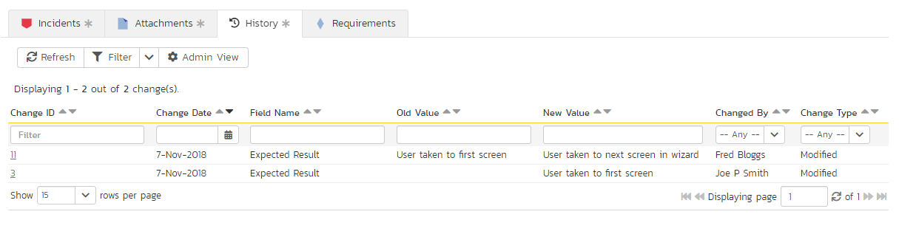

### 5.3.4. Requirements

Normally within SpiraTest, you will link the test cases in a product with your requirements to describe which requirements are covered by each of the test cases. When all of the tests for a requirement pass, the requirement is considered fully tested.

However, in some industries (for example when developing Defense systems) there is an additional requirement to report on the traceability between the individual **test steps** and the requirements. For customers that have such a requirement, this tab lets you associate the current test step with specific requirements.

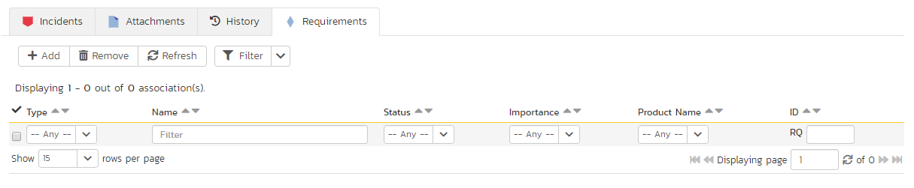

The tab displays a grid containing the requirements already mapped to this test step. You can filter that list by the requirement type, name, status, importance, product name and ID. You can remove an existing requirement by selecting its check box and clicking the ‘Delete’ button. This doesn’t delete the requirement, just removes it from the test step.

Hovering the mouse over the names of the requirements will display a “tooltip” consisting of the requirement name, place in the hierarchy and a detailed description.

To add a new test case to the requirement, click the ‘Add’ button:

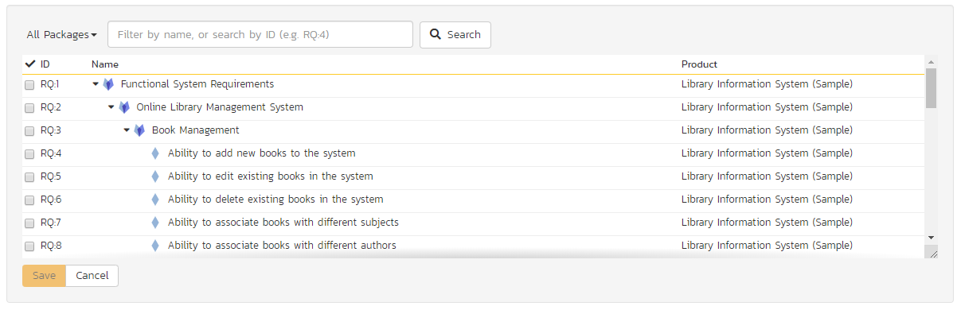

You can search for a requirement by its ID if you know it (make sure to include the “RQ” prefix):

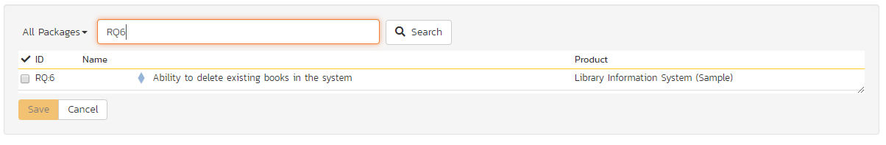

Otherwise, you can search for the requirements by choosing a parent package from the dropdown and/or entering a partial name match:

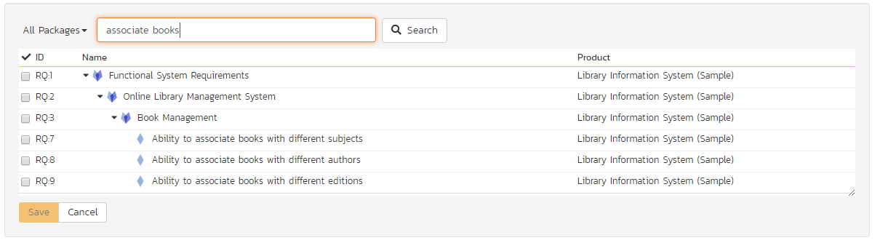

One you have found the desired requirement(s), simply select their check boxes and click the ‘Save’ button to add them to the current test step:

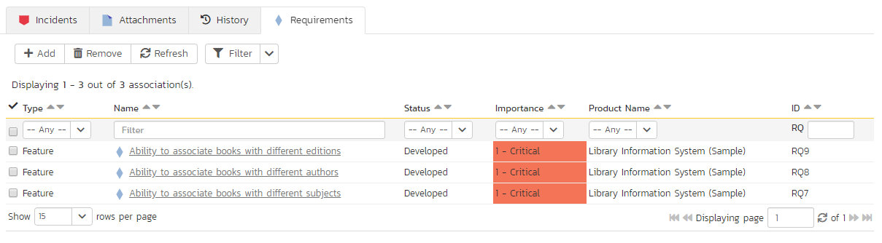

## 5.4. Execute Test Case(s)

This section describes how a tester can follow the steps defined for a series of test cases and record what actually happened in the process. In addition, recorded failures of test cases can be used to automatically generate new incidents that will be added to the incident tracking module (see section 6).

You start test case execution in SpiraPlan by either:

1. selecting test cases or test sets on their respective page(s) and clicking the “Execute” button;
2. clicking the “Execute” button on the test cases / test sets listed on your personalized home page under “My Test Cases” or “My Test Sets”.

If you execute a test set then the values of the selected release and custom list properties for the test run are automatically populated from the test set, whereas if you directly execute a test case itself, those values can be chosen by the tester.

Regardless of the route taken to launch the test execution module, the first screen that will be displayed will look like the following:

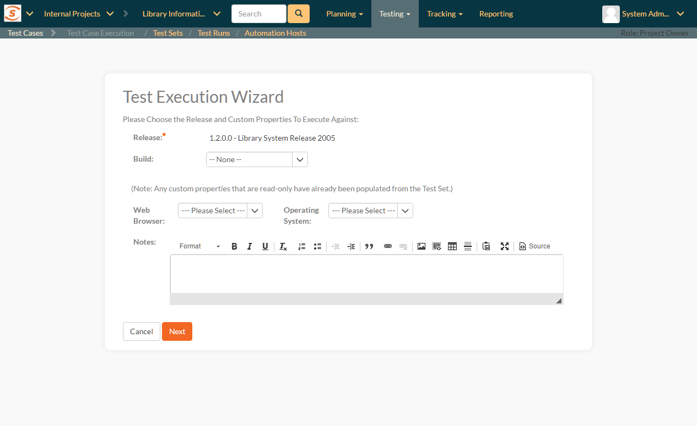

Before actually executing the test scripts, you need to select the release (if not already set) and optionally the specific build of the system that you will be testing against. You can also specify any test run custom properties that have been defined by the product owner. This ensures that the resulting test runs and incidents are associated with the correct release of the system, and that the test runs are mapped to the appropriate custom properties (e.g. operating system, platform, browser, etc.).

If you have not configured any releases for the product, then the release drop-down list will be disabled and the test runs/incidents will not be associated with any particular release. If the test run was launched from a test set, the release and any list custom properties will be pre-populated from the test set itself and will not be changeable on this screen (unless they weren’t set by the test set).

Once you have chosen the appropriate release name and/or custom properties, click the “Next” button to begin executing test steps. By default you will see the default test execution module, shown below.

There is a second test execution view: the exploratory test execution module. This has much in common with standard test execution but differs in a number of important ways. It is discussed in more detail at section 5.4.7. You will automatically see this module if the following three conditions are met;

1. you are executing a single test case (not a test set or a test case as part of a test set);
2. that test case is of type “exploratory”; and
3. you have the necessary permissions (you can create test cases)

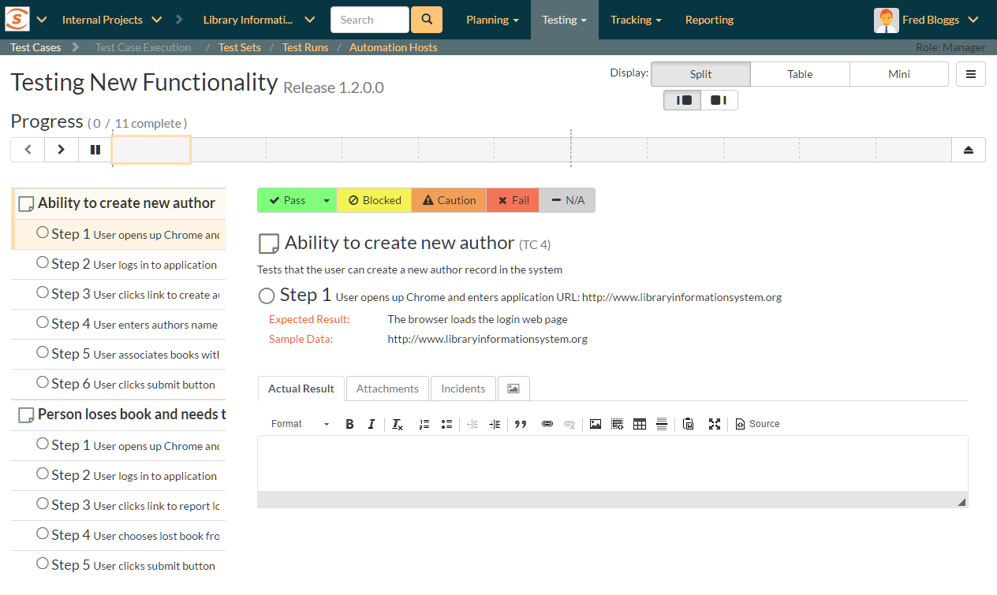

The screen is divided up into three main areas (each is explained in more detail in the sections below):

* **The header area** at the top of the page, which displays the name (if any) of the test run, along with the selected release. This section also contains buttons to control how the “test execution area” looks and functions for the tester.
* **The Progress Bar**, which shows a summary graphical view of the whole test run. The progress bar also has a number of navigation buttons to help you move around the test run, or to leave the test execution page. Between the buttons are indicator blocks. For test runs with relatively few test steps, each indicator block represents a single test step. A tall dotted line is used to indicate the end of one test case and the start of another. When there are many test steps to a test run, each indicator block represents a test case. Hovering over an indicator block will display a tooltip with information about the test step or case represented. The color of the indicator block matches the color of any assigned execution status for the test step or test case (see below).
* The rest of the page contains the “**test execution area**”. This has details about all of the steps in the test run. It can be used to both navigate between test cases and test steps, as well as to actions on any test case or test step (for instance assigning an execution status or logging an incident). This area can look markedly different depending on which display mode a user has selected. However, in every mode, a tester will be able to readily view the name and description of the test step (and at times the parent test case), along with the description of the test step, instructions for carrying out it, and any expected results. The test can then compare the results with those listed as expected. As described below, depending on how the actual system responds, you will use the buttons and fields on the page to record what actually happened.

Note: on first accessing this screen, the user will be given a guided tour of many of the features of this page. This can be accessed at any time via the options menu (discussed below)

### 5.4.1. Display Modes

The display mode toolbar is at the top right of the test execution screen. There are three different display modes. Each display mode has two sub-modes, using simple graphical images to indicate what they do (each pair of buttons to change sub-mode becomes visible on activating a particular display mode).

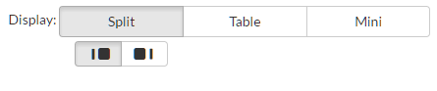

All of these modes affect how the test cases and test steps are displayed in the “test execution area”. The different views have been designed to suit different ways of testing, depending on how your organization works; or the needs of a tester for a particular test.

There are three parts in the “test execution area”, which are visible or hidden depending on the view.

* **Table**: this shows a list of every test case and step in the test run. The level of information it displays depends on the display mode.
* **Inspector**: this is a detailed form containing full information about a single test step (and its associated test case as needed). It also always shows the full set of actions that can be taken on that step
* **Iframe**: if you are testing an internal website (or external site that allows access via iframes) you can access it directly from this iframe browser. This allows you to have the test execution page and what you are testing open in the same web browser tab.

There are three main display modes:

* **Split mode**: shows a simplified list of test steps on the left (in the table) and full details about the currently selected test step on the right (in the inspector). The sub modes in the split view either show a narrow table and wide inspector, or a wide table and narrow inspector.



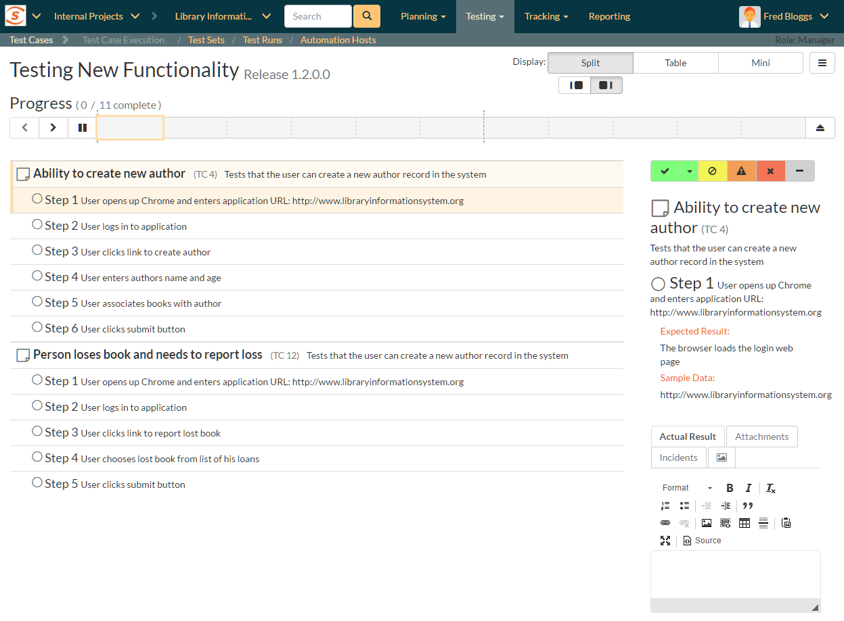

* **Table mode**: in this mode the table takes up the full width of the “test execution area”, with both the inspector and iframe completely hidden. The list of test cases and steps displays all the information about each—the same information as is shown in the inspector. This view makes it easy to quickly scan through a number of test steps and take quick actions on many steps in sequence. The sub-modes in this view either expand or collapse any fields with more than one line or text in them. This is helpful to give either a very detailed or summary view to the table. Note too that every field that takes up more than one line will have a little expand or collapse button to its left, allowing for control of individual fields as needed.

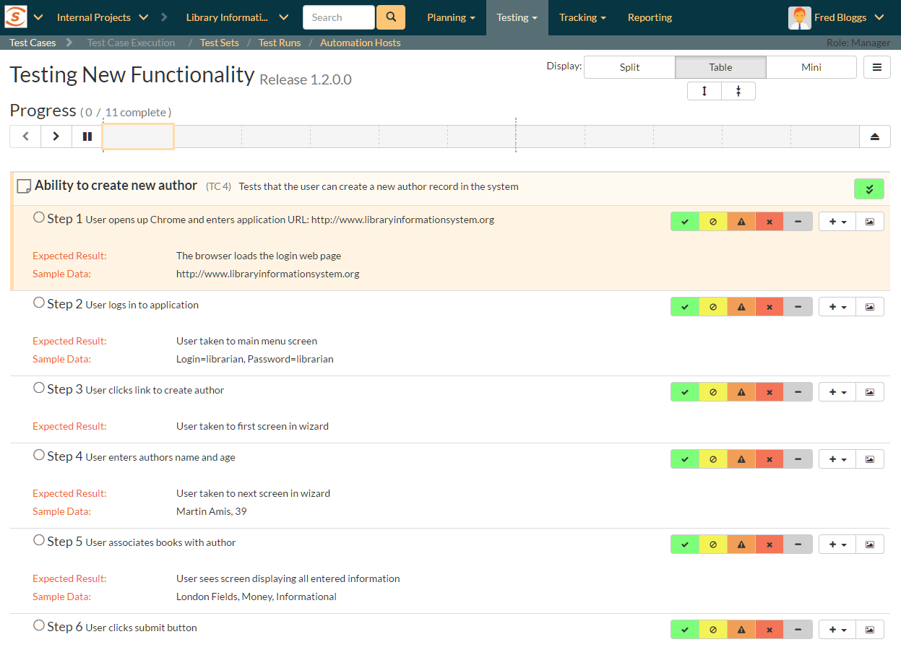

* **Mini mode**: this mode fills the entire “test execution area” with the inspector, or a combination of the inspector and iframe. The table is completely hidden in this mode. The mini mode is designed to help you maximize space for the inspector or to allow you to test a website in the embedded mini browser (in the iframe) right next to a narrow inspector.

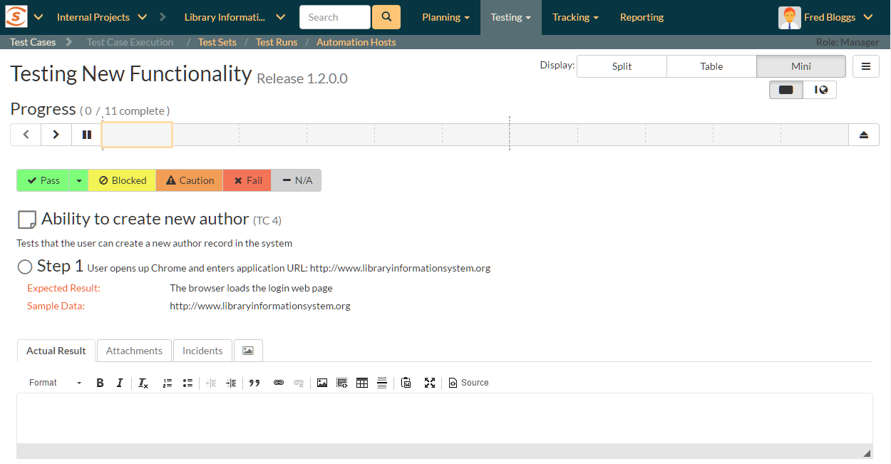

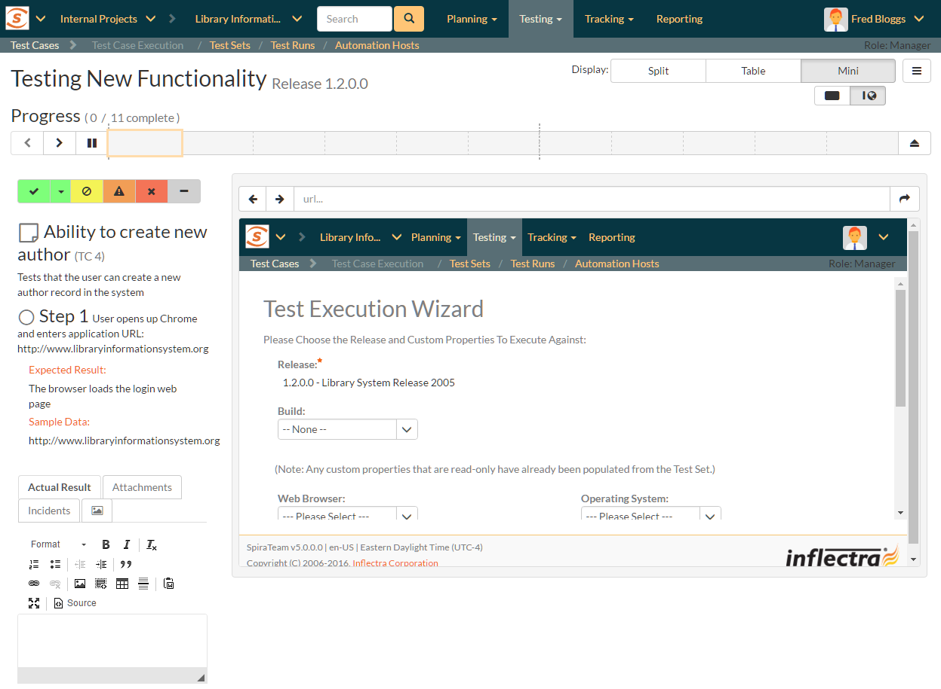

### 5.4.2. Navigating Around a Test Run

There are several ways to move through the different cases and steps of a particular test run. In the default “split” mode you are guided through a test run in order, however at any time, in any display mode, you can easily and quickly move steps. Note that if you click on a test case, the first test step in that test case will be selected as well.

* **Using the progress bar buttons**: the left-hand side of the progress bar has three buttons: backward, forward, and play/pause (the last of these is discussed in more detail below). Clicking on the backward or forward buttons will move to the previous or next progress bar indicator block (and the associated test step or test case).

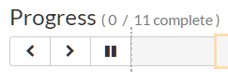

* **Using the progress bar indicator blocks:** clicking on any indicator block will immediately focus the test execution area on that test step or test case.
* **Using the table**: when the table view is visible (in either split mode or table mode) clicking on any item will immediately focus the test execution area on that test step or test case.
* **Progressing through steps using the inspector**: when the inspector is visible (in split or mini display mode), on properly setting a status for a test step (see 5.4.3 for further details), the next test step is automatically loaded into the inspector. If you were on step 3 of 5, you would be moved to step 4. If you were on the last step of a test case, you will be moved to the next test case, if one is available.
* **Pause/Play button**: the time spent on every test step is recorded, by default, during test execution. This allows an accurate assessment of exactly how long a test run took to complete and these timing details are saved with the test run and its results. If you wish to pause the behind-the-scenes timer (for instance if taking a break) click the pause/play button. To resume the time click it again.

The currently selected progress bar indicator block will be outlined with a peach border. The currently selected test case and test step on the table view will be indicated with a peach bar along their left edge, and will also be highlighted in a light peach.

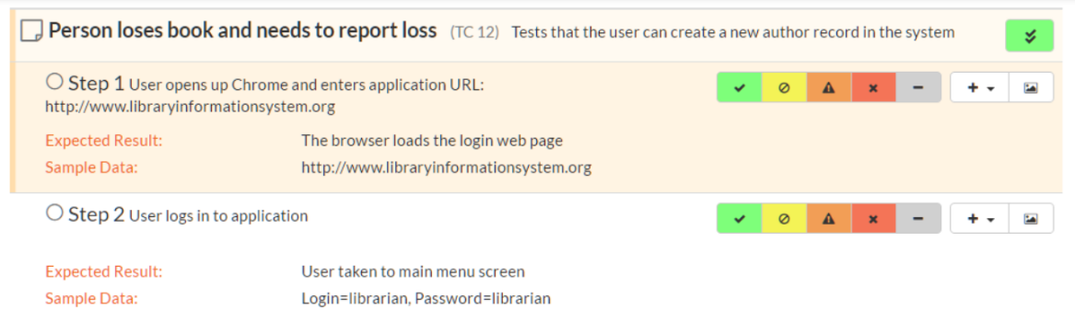

### 5.4.3. Viewing and Recording Execution Details

There is a small icon to the left of each test step title and test case title. For test steps this is a circle, for test cases a square note. Once a status has been recorded for a test step (or once a test case has been assigned a status based on the statuses of its test steps) these icons will be filled with a visual indicator of its current status. The icons both become colored and are given a small symbol, based on the status. In the inspector view the associated button to that status has a gray bar beneath it.

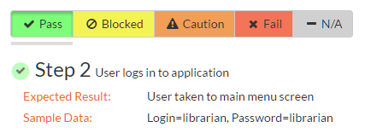

The same colors and symbols used to show a status are used on the buttons to record a status. The colors and symbols used are: green / tick = “Passed”; yellow / stop sign = “Blocked”; orange / warning triangle = “Caution”, red / cross = “Failed”, gray / dash = “Not Run”.

Depending on the display mode and device, the buttons may show the text name of the status along with the symbol (see examples below—the top button set is that on the inspector, the bottom from the table (when the display mode is set to table).

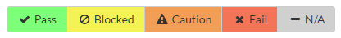

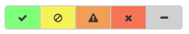

The various statuses when recorded against test steps will appear as below, respectively:

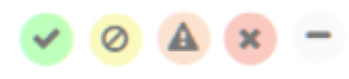

You will notice that softer shades are used above compared to the buttons. Similarly soft shades are also used on the progress bar indicator blocks, as shown below.



The status of a test case is determined by its test steps. If any of the steps are marked as “Caution”, “Blocked”, or “Fail” then the overall test case is marked with the most severe status of those statuses applied to any of the test steps from “Caution”, to “Blocked”, to “Fail” (e.g. if one is marked as “Caution, the test case will be marked “Caution”; but if one is marked as “Caution”, and another “Blocked”, the case will be marked “Blocked). If *all* the test steps passed, or if steps are marked either passed or “N/A”, then the overall test case is marked as “Passed”; any other case results in the test case being marked as “Not Run”.

If the expected results are indeed observed, then you simply need to click the “Pass” button to mark the test step as passed, and advance to the next test step, or if all the steps have passed, you can click “Pass All” to pass all the steps at once.

On the inspector, the “Pass All” button is visible via a dropdown to the right of the “Pass” button whenever the parent test case information is also displayed with the test step (typically only for the first step in a test case). This is illustrated in the screen shot below:

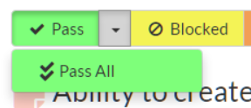

When in the table display mode, the “Pass All” button is shown on the right-hand side of the test case row, as illustrated below:



* Below the main pane there are two optional sections. The first one allows you to log an incident in the system associated with the test step. For failures this will typically be used to log a bug relating to the failure. However even if you pass a step you can still log an incident, which may be useful for logging non-critical cosmetic items that are not serious enough for a failure to be recorded. This tab also displays any pre-existing incidents that were associated with the test step being viewed.
* The second tab displays a list of attachments that are related to the current test case and/or test step. This list initially contains any documents that have been attached to either the test case in general or the test step in particular. However as you perform the testing, you can attach additional documents to this list that are relevant to the test results (e.g. screenshots of an error page); these attached documents will be associated with both the test run itself and any incidents that are created.

Once all the test steps have passed, you will be automatically be taken to the first step in the next test; if it is the last test case being executed, the <Finish> button will be displayed instead.

If the actual results differ from those expected, you need to enter a description of the actual result observed and click one of the “Fail”, “Blocked”, “Caution”, or “N/A” buttons. Unlike the “Pass” button, if you don’t enter a description for the actual result, the system will display an error message and re-prompt you again for input.

In the inspector, the actual results text box is shown in the first tab below the information provided to the tester for a test step, as illustrated below:

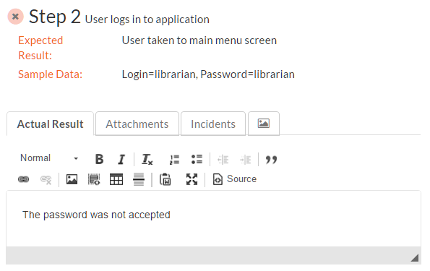

In the table display mode, previously entered actual results are always visible (below the information provided to the tester for a test step). On attempting to mark a step as anything other than “Pass” the actual results text box will automatically be displayed.

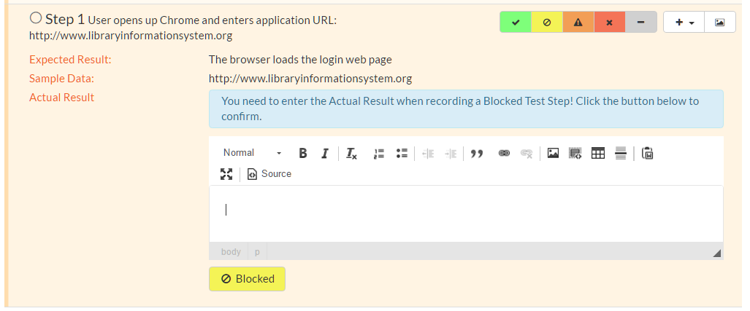

You can also choose to manually show the actual results text box by selecting “Actual Result” option from the “+” dropdown menu.

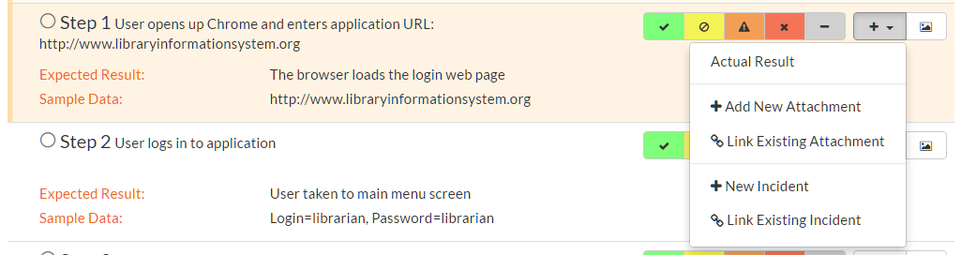

### 5.4.4. Saving Screenshots to a Test Step

Often, testers will want to provide visual documentation of what they have found during the testing process. A screenshot of what they are testing is a great way to do this. To add a screenshot to the results of a test step, first copy your screenshot to the clipboard. Next, paste the screenshot into the actual results text box.

### 5.4.5. Recording Extra Information

In addition to logging the result of a test step, you can optionally choose to generate a new incident at the point of logging the execution status of a test step. When the incident form is visible (see below) enter a name, type, priority, severity (and any custom properties) for the new incident *before* clicking an execution status button. The other information needed for the new incident is automatically populated from the test step details. The newly created incident will also be linked to the test step, allowing traceability from within the incidents module. The functionality for managing incidents is described in more detail in section 6.

If the inspector is visible, go to the “Incidents” tab. This will show any already linked incidents, show a detailed form for creating a new incident.

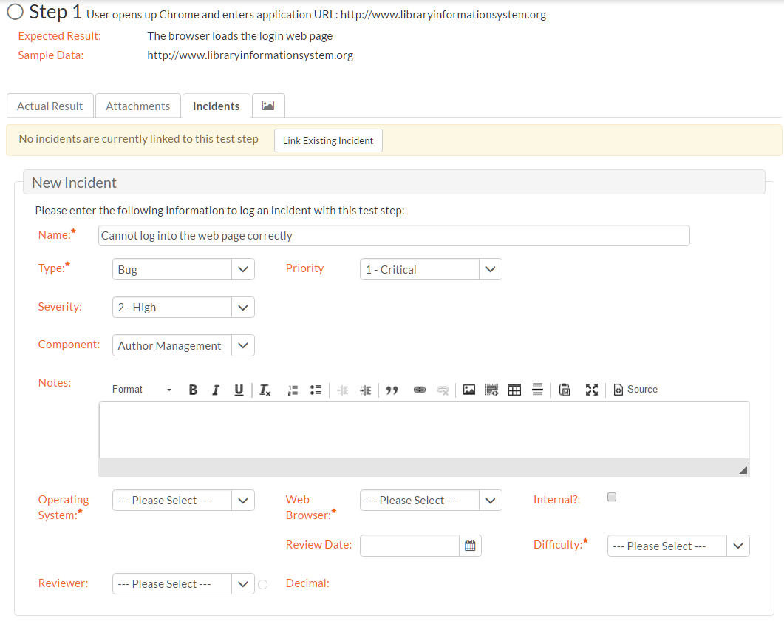

You can instead link the test step to an existing incident (by clicking the “Link Existing Incident” button). The following popup will be displayed, where you can either enter an incident ID (if known), or choose one from the list.

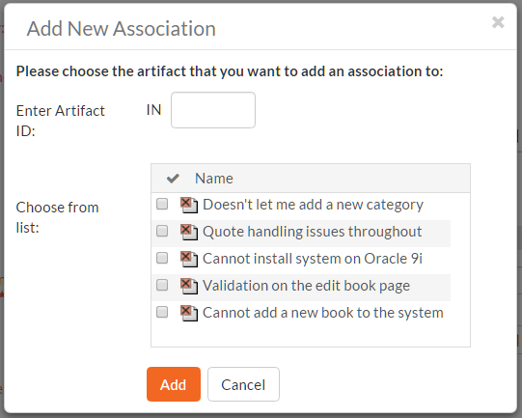

When in the table display mode, open the “+” dropdown menu to show options to either add a new incident or link an existing incident. Click on the option required to display the appropriate popup. Note that on clicking “Add” the incident will be immediately linked to the selected test step.

If you need to attach documents to the test run (in addition to any screenshots), you can either attach a new or link an existing document. From the inspector, go to the “Attachments” tab to see any documents already linked, or to add a document as needed. In the table display mode, select either “Add New Attachment” or “Link Existing Attachment” from the “+” dropdown menu. See section 5.2.9 for additional information about how to the different available options (e.g. either upload a document, url link, or screenshot, or to link a document or from source code).

### 5.4.5. Leaving the Test Execution Page

If you are not able complete the whole test run in a single session, click the “Leave” button on the right of the progress bar—shown with an eject symbol (see below). This will return you to the page where you began the execution from. You can resume testing at a later date by locating the test run on your ‘My Page’ under ‘My Pending Test Runs’ and choosing to resume testing. Note that the system will remember every result you have logged, along with the last test step you were working so you can pick up right where you left off.

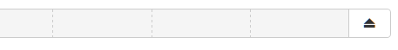

Once either all steps in a test have an execution status recorded, or at least one step in each test case has been recorded with any status other than “Pass” the test run can be finished. An orange button at the far right of the progress bar with a stop symbol will appear (see below). Clicking this button will save and archive the entire test run (so it can no longer be amended) and the page will automatically exit the test execution page.

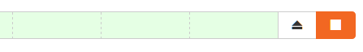

### 5.4.6. Extra Test Execution Options

There are a number of ways that some users may wish to alter the test execution page, depending on how they work. Options to change this are available from the menu button to the right of the display buttons.

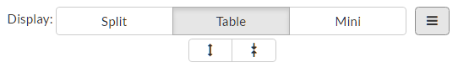

The following actions are available from this dropdown menu:

* **Refresh**: this simply reloads the test run data. This is useful if other people are working on different test cases within the same test run and you want to make sure that you have the most current information about the statuses they have recorded.
* **Always show test case**: by default, the inspector only shows the test case details when the first test step of a test case is displayed. Checking this item will mean that the test case details will be shown on every test step.
* **Show custom properties**: by default, only a handful of system fields are shown for the test case and test step. If your organization places important and relevant information into custom fields as well, you can check this item to make them visible in the inspector for every case and step. Note that these fields will not be visible in the table display mode.
* **Show guided tour**: if you missed or want to revisit the visual guided tour of the test execution page, click this button to run the tour again.

### 5.4.7. Exploratory Test Execution

As mentioned above, there are a number of conditions that must be satisfied for a test to run in exploratory mode. Exploratory testing is designed for relatively experienced testers and rather than to record the results of a pre-determined set of steps, to instead adjust and create the testing sequence during the act of testing itself. During exploratory testing test steps can be added, removed, edited, moved freely, at any time.

Care must therefore be taken that this form of testing and of recording the results of a test are used appropriately. The conditions set by the system are one means of limiting its use.

When starting exploratory testing the main screen will resemble the one below. Note that it looks broadly similar to that for standard test execution and is made up of three different areas:

1. a list of test steps on the left;
2. details about the currently selected step on the right; and
3. information at the top of the page about the test run itself (it’s name and description, release, and how many steps it contains), along with a mini toolbar. In exploratory testing there is no progress bar, or options to layout the page in different views.

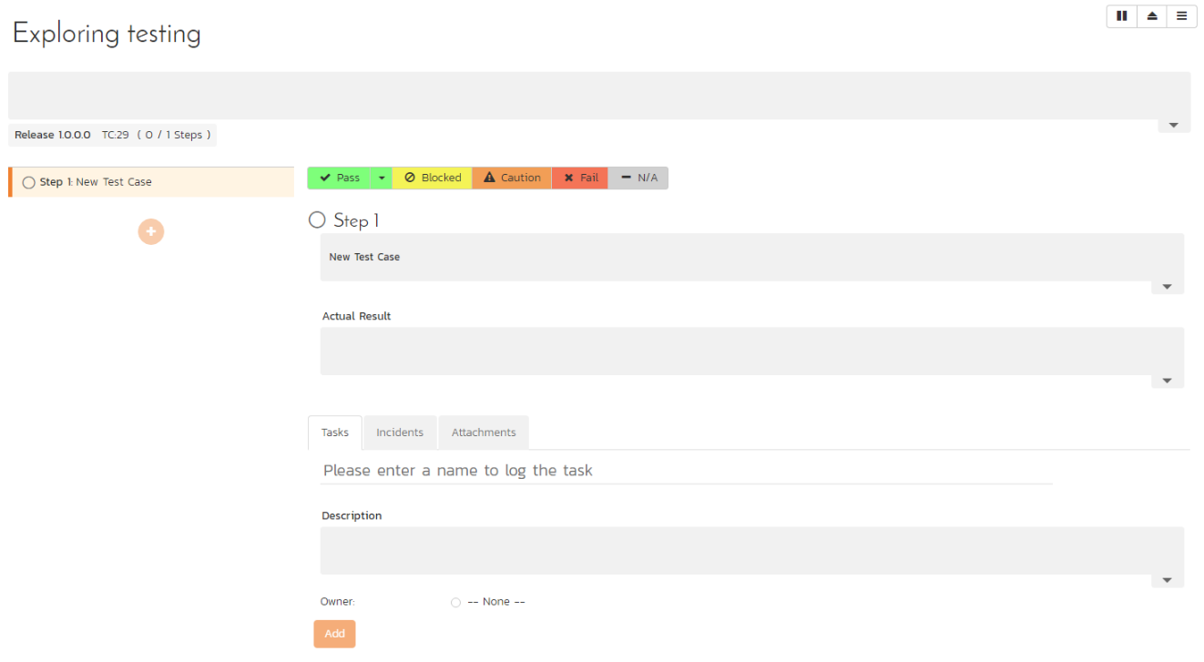

All fields in the right hand details area, or the top part of the page can often be edited. Their contents and associated label will be grayed out if they are read only fields (for instance if they are information from a custom property). To edit a field, click on it, change the text as required, then click out of the field. The information will be automatically saved. Note that any test steps that come from a link test case will be read only and as such their contents cannot be edited, nor can they be deleted.

Just like with normal test execution, you can navigate between steps using the list of steps on the left; and steps can be passed, or failed using the execution status toolbar on the right hand section of the page. The unique actions you can take on test steps (besides editing their fields) are below:

1. **add a step**: click on the plus button beneath the list of test steps on the left
2. **clone an existing step**: when you hover a test step in the list, you will see a button appear on its right. Click on this to show a mini menu with an option to clone the step. This will create a clone, at the bottom of the list of test steps, with a blank actual result

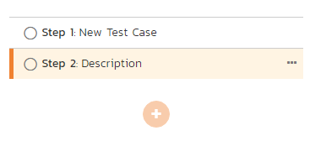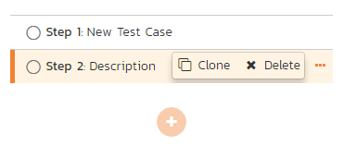

1. **delete an existing step**: if you have more than one test step, any editable test step can be deleted. Click on the button for that step (as explained above) and click delete from the mini menu.
2. **move an existing step**: to move an editable step click and drag it to the desired location in the test step list.

Below the main detailed section there are two or three tabs. SpiraTest users will only see two tabs – incidents and attachements. SpiraPlan users will additionally see a tasks tab. The incident and attachment tabs function identically to normal test execution.

The task tab allows the tester to quickly create tasks based on their exploratory testing, and optionally assign them to a user involved in the product. These tasks are attached to the test run as a whole, so any previously entered tasks will be visible even when changing steps. Creating a task is a light touch way of communicating with others about your findings and alerting them that some work is likely required to fix or clarify a feature. It is quicker to enter and manage than an incident.

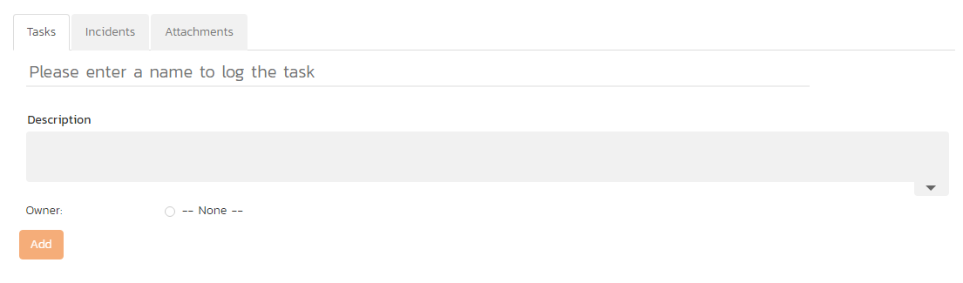

Tasks are shown as a list of cards with their left edge showing their priority by color. On creation a task’s status will be gray – showing that no priority has yet been set. The title of the task can be clicked to open the details page for that task.

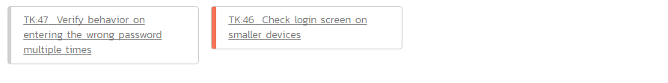

The toolbar at the top right of the page has a number of buttons:

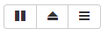

1. **Pause/Play button**: the time spent on every test step is recorded, by default, during test execution. This allows an accurate assessment of exactly how long a test run took to complete and these timing details are saved with the test run and its results. If you wish to pause the behind-the-scenes timer (for instance if taking a break) click the pause/play button. To resume the time click it again.
2. **Leave button**: as with normal test execution, if you are not able complete the exploratory test in a single session, click the “Leave” button—shown with an eject symbol. You can resume testing at a later date by locating the test run on your ‘My Page’ under ‘My Pending Test Runs’ and choosing to resume testing. Note that the system will remember every result you have logged, along with the last test step you were working so you can pick up right where you left off.
3. **Finish button**: once either all steps in a test have an execution status recorded, or at least one step has been recorded with any status other than “Pass” the test run can be finished. An orange with a stop symbol will appear (see below). Clicking this button will give you two options. “Update Test Case” will update the test case execution status, and also change its name, description, and test steps to reflect those on this page (adding, deleting, moving, editing as necessary). “Just Finish” will only change the execution status of the test case only—leaving all details of the test case unchanged. Either option will archive the entire test run (so it can no longer be amended) and the page will automatically exit the test execution page.

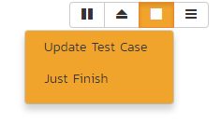

1. **Options**: the right most button on the toolbar gives additional options for customizing the page. Specifically a user can decide what fields they wish to show or hide based on how they prefer to work in exploratory testing mode. Additionally this menu let’s you revisit the introductory tour shown the first time the page is visited.

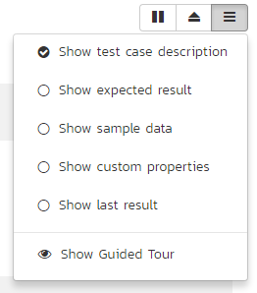

## 5.5. Test Run List

When you click on the Testing > Test Runs global navigation link, you will be taken to the test run list screen illustrated below:

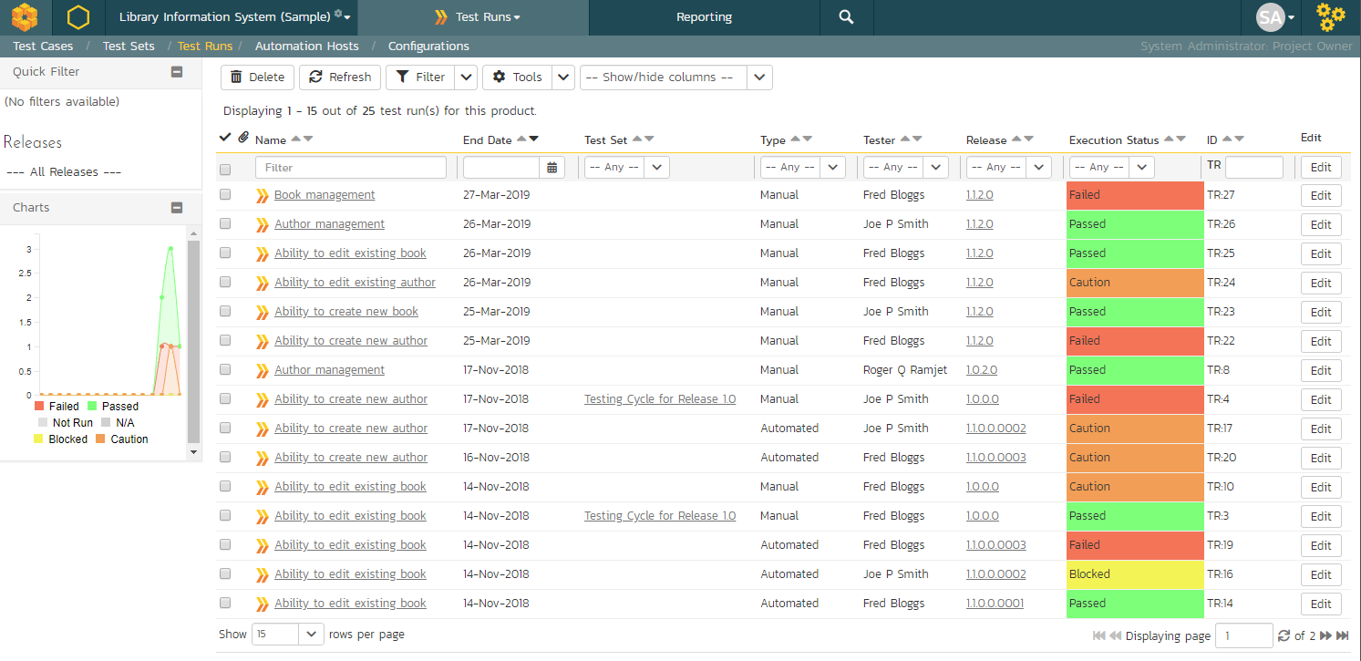

The test run list screen displays all the individual test executions performed in the current product, in a filterable, sortable grid. The grid displays the test run number together with fields such as execution status, name, assigned tester, execution date, test set, specified release, etc. The choice of columns displayed is configurable per-user, per-product, giving extensive flexibility when it comes to viewing and searching test runs.

In addition, you can view a more detailed description of the test run by hovering over the test run name hyperlink to display a “tooltip”. If you click on this test run hyperlink, you will be taken to the test run details page described in the next section. Clicking on any of the pagination links at the bottom of the page will advance you to the next set of test runs in the list according to the applied filter and sort-order. There is also a drop-down-list at the bottom of the page which allows you to specify how many rows should be displayed in each page, helping accommodate different user preferences.

### 5.5.1. Refresh

Clicking on the “Refresh” button simply reloads the test run list. This is useful as other people may be completing test runs, and after stepping away from the computer for a short-time, you can click this button to make sure you are viewing the most current test run list for the product.

### 5.5.2. Show / Hide Columns

This drop-down list allows you to change the fields that are displayed in the test run list as columns for the current product. To show a column that is not already displayed, simply select that column from the list of “Show…” column names and to hide an existing column, simply select that column from the list of “Hide…” column names. This is stored on a per-product basis, so you can have different display settings for each product that you are a member of. The fields can be any of the built-in fields or any of the custom properties set up by the product owner.

### 5.5.3. Sorting and Filtering

You can easily filter and sort the list of test runs. To filter the list by any of the visible fields, you simply choose an item from the appropriate drop-down list, and for the other fields, you enter a free-text phrase then click <Filter> or press the <ENTER> key to apply the different filters. Note that the name field is searched using a “LIKE” comparison, so that searching for “database” would include any item with the word database in the name.

To change the column that is sorted, or to change the direction of the current sort, simply click on the up/down arrow icon in the appropriate column. The currently sorted column is indicated by the darker arrow. In the screen-shot above, we have filtered on test runs that have failed, sorted in order of increasing release version number.

Clicking on Filter > Clear Filter removes any set filters and expands the test run list to display all test runs for the current product, and clicking on Filter > Save Filter allows you to save the filter to your ‘My Page’ for use in the future. The list of saved filters can also be retrieved by clicking Filter > Retrieve Filter.

As a shortcut, the left hand panel includes a set of **Quick Filters** that can be applied in a single-click:

* **The topmost section** – This displays any saved requirement filters created by the current user alongside any ‘shared’ filters. The latter are marked with an icon showing a group of people.
* **Releases** – This section lists the releases and sprints defined for the current product. Clicking on any of the releases or sprints in the list will filter the requirements by that release/sprint.

### 5.5.4. Printing Items

To quickly print a single test run or list of test runs you can select the items’ checkboxes and then click the Print icon. This will display a popup window containing a printable version of the selected items.

## 5.6. Test Run Details

When you click on any of the individual test runs in the test run list, you are taken to the Test Run details page (not to be confused with the Test Case details page) shown below:

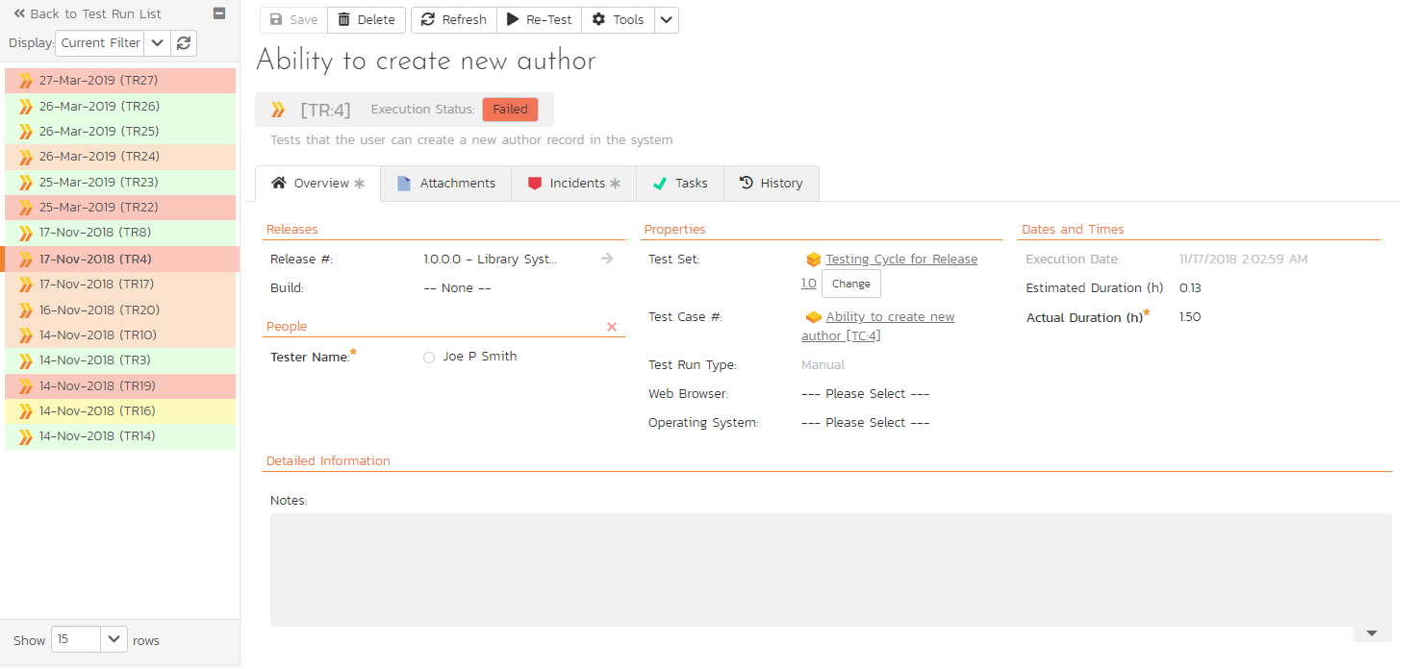

This page consists of three panes:

1. The left hand navigation pane displays a list of related test runs with a color indicator for their current execution status. The display dropdown will let you choose whether the list contains test runs that are for the same release, test case or test set, or are just a filtered/unfiltered list based on your last search in the main test run list page.
2. The top right area shows headline information about the test run details of the test run itself
3. The main pane on the right displays tabs for detailed information about the test run, and its associations. The overview tab is initially loaded and shows the name, description, release, test set, estimated and actual duration, tester name, test run type, automation host fields, along with others, including custom fields. Underneath this is shown the list of test run steps, and any console output from a test automation engine such as Rapise, NUnit, JUnit, QTP, or Selenium.

### 5.6.1. Re-running a Test

There is a button on the main test run toolbar called ‘Re-Test”. If you click this button, SpiraPlan will launch the test execution wizard for this specific test case, with current release and/or test set already selected for you. This is a handy way of quickly re-running a failed test that has been addressed by the developers.

### 5.6.2. Editing a Test Run

When reviewing the test run, you may find that you need to change the results of the test run (e.g. the user selected the wrong release or custom property value). Many of the fields are editable at a later date, and to make changes, just modify the appropriate fields and click any “Save” button.

### 5.6.3. Deleting the Test Run

If you need to delete a test run that was erroneously captured, all you need to do is click on the link to access the invalid test run and then click the “Delete” button to remove it from the system. This will then force the system to update the status of the test case itself from the other logged test runs.

### 5.6.4. Test Run Steps

In the case of a manual test run, this section displays all the steps of the test case *as they appeared during the test run in question.* This means that if the test steps were changed after running the test, the list here will reflect the original information.

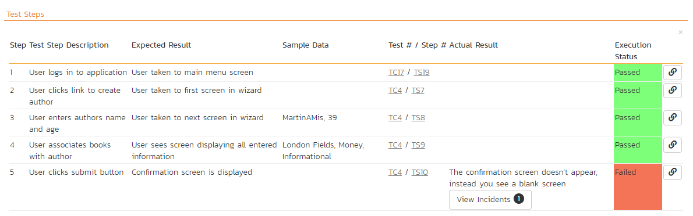

Each test run step is displayed along with the description, expected result, suggested sample data, a link back to the current version of the test step in question, the actual result and the execution status for this step *in this particular test run*. Where an actual result was recorded, an additional “View Incidents” button will be displayed. This allows you to view any incidents that are associated with this particular test run step:

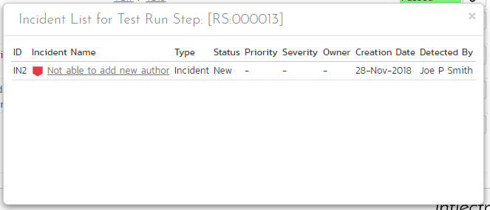

Clicking on the link will open up a popup dialog box that displays a list of all the incidents associated with the selected test run step. Each of the incidents listed will reflect the most up-to-date information regarding that incident, including its type, status, priority, name, assigned owner, detection date and who first detected it. Clicking on the incident name will take you to the details page for that incident, which is described in section 6.2.

### 5.6.5. Console Output

In the case of an automated test run, this tab will display the details of the test run as reported from the test runner application. These details will vary depending on the type of automated tool being used, but typically they include the name of the automated test runner, the number of assertions raised, the name of the corresponding test case in the tool, the status of the test run and a detailed error message, and the stack-trace in the case of a failure. An example test run as reported from the NUnit automated test runner is illustrated below:

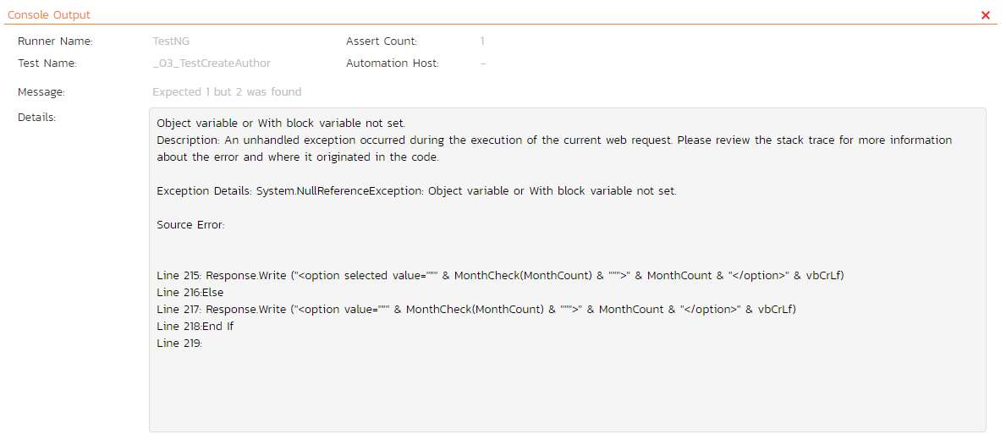

Details on how to use SpiraPlan® in conjunction with an automated testing tool are provided in the *SpiraPlan® Automated Testing Integration Guide,* which can be downloaded from the Inflectra® website.

### 5.6.6. Attachments

This tab shows the list of documents that have been “attached” to the test run. The documents can be in any format, though SpiraPlan® will only display the icon for certain known types.

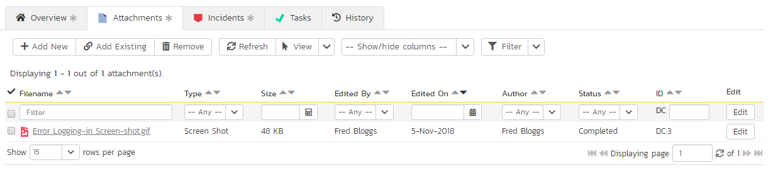

The attachment list includes the filename that was originally uploaded together with the file-size (in KB), name of the person who attached it and the date uploaded. In addition, if you position the pointer over the filename and hold it there for a few seconds, a detailed description is displayed as a tooltip.

To view the document, click on the filename hyperlink and a new web browser window will open. Depending on the type of file, this window will either display the document or prompt you for a place to save it on your local computer. To remove an existing attachment from a test run, check its checkbox then click the “Remove” button and the attachment will be removed from the list.

To attach a new document or web link to the test run, you need to click on the “Add New” hyperlink to open the “Add Attachment” dialog box. There are three different types of item that can be attached to a test run:

* To upload a file, choose “File” as the type and then click the “Browse” button and select the file from your local computer, optionally enter a detailed description then click the “Upload” button. The document will be copied from your computer and attached to the artifact.
* To attach a web-link (URL) to the artifact, you need to choose “URL” as the type and then enter the fully qualified URL (e.g. [http://mywebsite.com?Document=1](http://mywebsite.com/?Document=1)), an optional description and then click the <Upload> button to attach the web-link.
* To attach a screenshot to the artifact, you need to choose “Screenshot” as the type and then copy the image to your computer’s clipboard (e.g. on Windows computers, the PRINT SCREEN button captures the current page and adds to the clipboard). Once the image is in the clipboard, paste it into the editor using CTRL+V (or the equivalent keystroke for your operating system) and the item will appear in the preview window. You can then fill in the other fields and click “Upload” to attach the image.

Note: If you are using a non-Windows® computer (e.g. Macintosh®) that doesn’t put file extensions on filenames (e.g. .xls for an Excel sheet) automatically, then you will need to manually add the file extension to the filename before uploading if you want it to be displayed with the correct icon in the attachment list.

You can also associate an existing document (that’s already stored in SpiraTeam) with the test run. To do that, click on the “Add Existing” button to bring up the add file association dialog box. You can then choose to either associate a document stored in the SpiraPlan Documents repository or (in the case of SpiraPlan/SpiraTeam but not SpiraTest) from the linked source code repository. In either case you first select the appropriate folder, and then pick the document(s) from the file list on the right. In the case of a source code file association you can also add a comment.

### 5.6.7. Incidents

This tab displays the list of incidents associated with the current test run. The incidents will have been logged during the creation of the test run and will be linked to one of the steps in the test run:

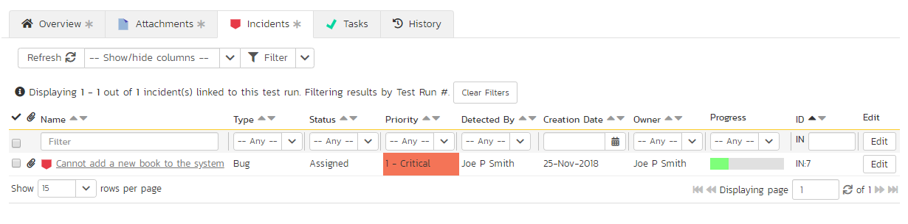

Each incident is listed together with the type, status, priority, name, owner, detector, detection date and a link to the actual incident details. You can customize the fields that are displayed using the “Show/Hide Columns” option. In addition, you can perform the following operations:

* **Refresh** – updates the list of incidents from the server, useful if other people are adding incidents to this release at the same time.
* You can also **filter** the results by choosing items from the filter options displayed in the sub-header row of each field and clicking the “Filter” button. In addition, you can quickly sort the list by clicking on one of the directional arrow icons displayed in the header row of the appropriate field.
* **Edit** – Clicking the “Edit” button to the right of the incident allows you to edit the incident inline directly on this screen.

### 5.6.8. Tasks

This tab is only visible to users of SpiraPlan. It shows the list of tasks associated with the current test run. Tasks can only be added to a test run created from an exploratory test case. These tasks will have been logged during the execution of the test.

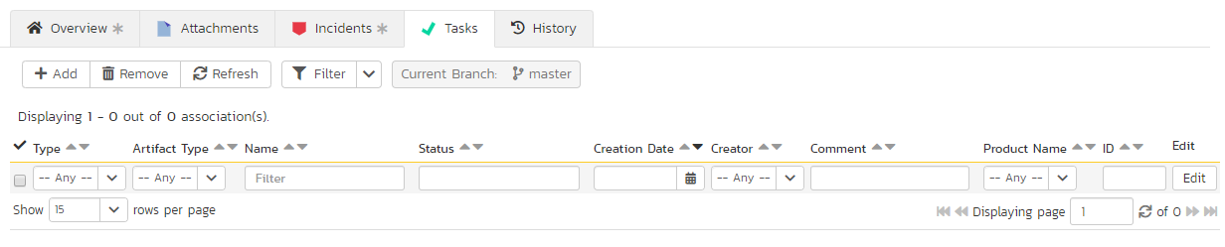

### 5.6.9. History

This tab displays the list of changes, if any, that have been performed on the requirement artifact since its creation. An example requirement change history is depicted below:

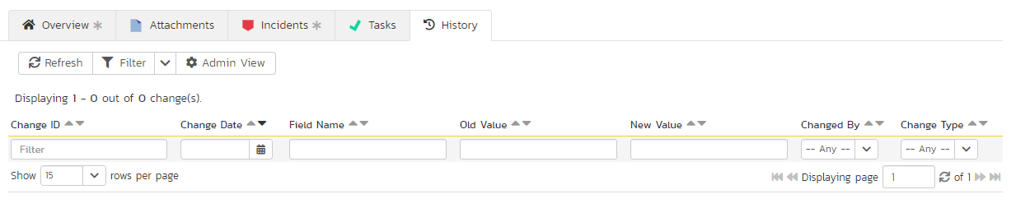

The change history displays the date that each change was made, together with the fields that were changed, the old and new values and the person who made the change. This allows a complete audit trail to be maintained of all changes in the system. In addition, if you are logged in as a product administrator you can also click on the “Admin View” button to revert any unwanted changes.

## 5.7. Test Set List

As well as being able to organize test cases into folders, you can also create separate groupings of test cases called test sets which can then be assigned to testers as a package. To view the list of test sets for a product, click on Testing > Test Sets in the global navigation:

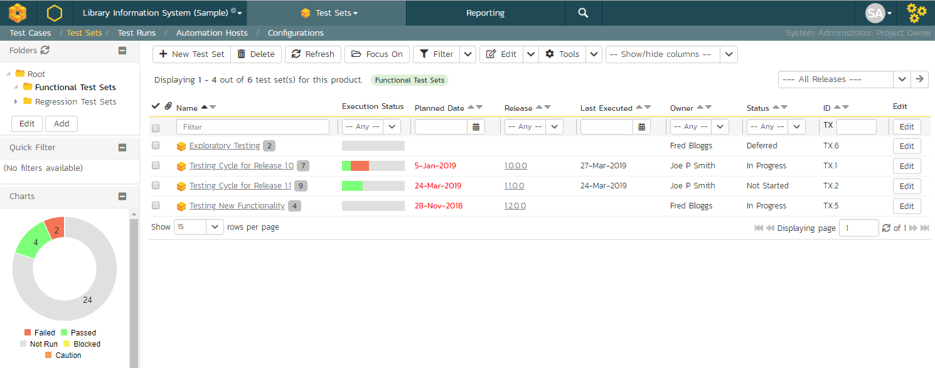

The test set list consists of hierarchical list of all the test sets in the current product organized into folders. The structure is very similar to the folder structure in Microsoft Windows® Explorer, and users will find this very familiar and intuitive to use. A folder tree is on the left hand side—with triangle icons to expand / collapse each folder. Contents of the selected folder (the one marked in bold on the folder tree) are shown on the right hand side.

When you create a new product, this list will initially be empty, and you will have to use the “New Test Set” button to start adding test sets to the system.

Each test set is listed along with the number of test cases contained (in parenthesis), the aggregate execution status of the contained test cases (using a graphical bar-chart), the date that the test set has been scheduled to be executed (planned date), the date that it was last executed, the person currently assigned to execute the test set, the status and the test set id. Clicking on a test set’s hyperlink will take you to the test set details page for the item in question.

Note: the test set status is separate from the execution status of the individual test cases and represents where the test set is in its lifecycle:

* **Not Started** – The test set has been assigned to a tester or automation host and no testing has been performed.
* **In Progress** – The test set has been assigned to a tester or automation host and the testing is in progress.
* **Completed** – The test set was previously assigned, but has now been completed, with all test cases having an execution status recorded and the tester having clicked the Finish button in the test execution wizard.
* **Blocked** – The tester or automation host was unable to execute the assigned test set because of a failure external to the actual test case.
* **Deferred** – The test set was previously assigned, but: execution had not been completed (at least one test case does not have a recorded execution status); and the Tester deleted the Pending Test Run entry from their My Page.

### 5.7.1. Delete

Clicking on the “Delete” button deletes the currently selected test sets. It will delete the association between the test set and its contained test cases, but it will not delete the test cases themselves.

### 5.7.2. Refresh

Clicking on the “Refresh” button simply reloads the list of test sets. This is useful if other people are making changes to the test set list and you want to make sure that you have the most current version.

### 5.7.3. Focus On

The “Focus On” button is a useful when you have performed a filter on the list of test sets and then wish to quickly navigate to the folder of a particular test set shown in the list. After selecting a test set, clicking the button will move the left hand folder tree to the folder that contains the selected test set. It will also change the list view on the right to show all of the test sets within that folder (i.e. the selected test set and its siblings).

### 5.7.4. Edit

Each test set in the list has an “Edit” button in its right-most column. When you click this button, *double-click* on any of the cells in the row, or select a row and click the “Edit” button in the toolbar at the top of the page. This will change the item from “View” mode to “Edit” mode. The various columns are made editable, and “Save” and “Cancel” buttons are displayed in the last column:

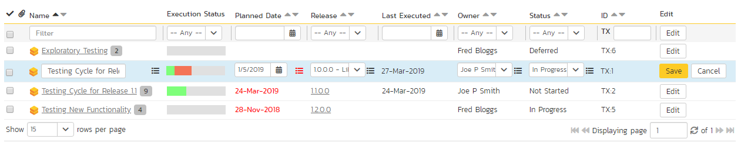

If you click “Edit” on more than one row, the “Save” and “Cancel” buttons are only displayed on the first row, and you can make changes to all the editable rows and then update the changes by clicking the one “Save” button. Also, if you want to make the same change to multiple rows (e.g. to change the owner of five test sets from “Fred Bloggs” to “Joe Smith”), you can click on the “fill” icon to the right of the editable item, which will propagate the new value to all editable items in the same column.

If you want to edit lots of items, first select their checkboxes and then click the “Edit” button on the same row as the Filters and it will switch all the selected items into edit mode.

When you have made your updates, you can either click “Save” to commit the changes, or “Cancel” to revert back to the original information. Alternatively, pressing the <ENTER> key will commit the changes and pressing the <ESCAPE> key will cancel the changes.

### 5.7.5. Show / Hide Columns

This drop-down list allows you to change the fields that are displayed in the test set list as columns for the current product. To show a column that is not already displayed, simply select that column from the list of “Show…” column names and to hide an existing column, simply select that column from the list of “Hide…” column names. This is stored on a per-product basis, so you can have different display settings for each product that you are a member of. The fields can be any of the built-in fields or any of the custom properties set up by the product owner.

### 5.7.6. Filtering

You can easily filter the list of test sets. To filter the list by any of the displayed columns, you either choose an item from the appropriate drop-down list or enter a free-text phrase (depending on the type of field) then click “Filter” or press the <ENTER> key to apply the different filters. Note that the Name field is searched using a “LIKE” comparison, so that searching for “database” would include any item with the word database in the name. The other free-text fields need to be exact matches (e.g. dates, test set numbers). In the screen-shot below, we are filtering on test sets that contain at least one failed test case.

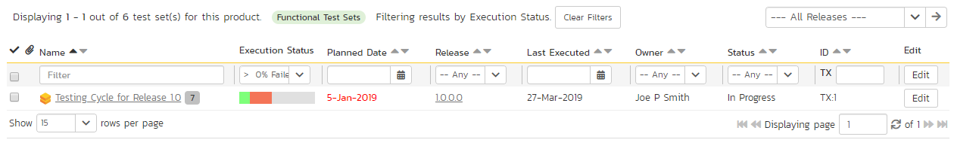

In addition, if you have a set of filters that you plan on using on a regular basis, you can choose the option Filter > Save Filter to add the current filter to the list of saved filters that appear on your ‘My Page’. The list of saved filters can also be retrieved by clicking Filter > Retrieve Filter.

Because the same test set can be run against more than one release, sometimes you want to see the execution information for the displayed test sets for different releases. If you select a release or sprint from the dropdown marked “All Releases” on the right above the table, then the execution information for that specific release will be displayed. If the dropdown is set to "all releases", then it shows only the most recent execution information. In both cases, all test sets (as per any filter) are listed.

### 5.7.7. Copying Test Sets

To copy one or more test sets, simply select the check-boxes of the test sets you want to copy and then select the Edit > Copy Items menu option. This will copy the current test set selection to the clipboard. Then select the place where you want the test sets to be inserted and choose the Edit > Paste Items option.

The test sets will now be copied into the destination you specified. The name of the copied test sets will be prefixed with “Copy of…” to distinguish them from the originals.

### 5.7.8. Moving Test Sets

There are two options for moving test sets or folders:

1. Click on the test set/folder you want to move in the right hand list and drag it to the folder in the left hand folder tree you want it moved to. The background of the new folder will change to show where it will be inserted:

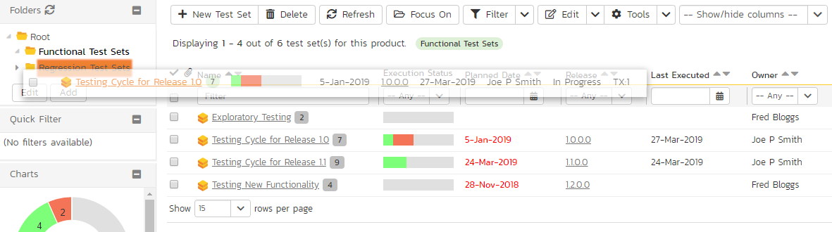

Once you have the test set/folder positioned at the correct place that you want it inserted, just release the mouse button. To move multiple items simply select their checkboxes and then drag-and-drop one of the selected items.

1. Alternatively you can simply select the check-boxes of the test sets you want to move and then select the Edit > Cut Items menu option. This will cut the current test set selection to the clipboard. Then select the place where you want the test cases to be inserted and choose the Edit > Paste Items option. The test sets will now be moved into the destination specified.

### 5.7.9. Printing or Exporting Items

To quickly print a single test set, test set folder or list of test sets you can select the items’ checkboxes and then click Tools > Print Items. This will display a popup window containing a printable version of the selected items.

Alternatively you can save the selected items into a number of formats, available via the Tools dropdown.

### 5.7.10. Right-Click Context Menu

SpiraPlan® provides a shortcut – called the *context menu* - for accessing some of the most commonly used functions, so that you don’t need to move your mouse up to the toolbar each time. To access the context menu, right-click on any of the rows in the test set list and the following menu will be displayed:

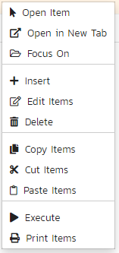

You can now choose any of these options as an alternative to using the icons in the toolbar.

## 5.8. Test Set Details

When you click on a test set item in the test set list described in the previous section, you are taken to the test set details page illustrated below:

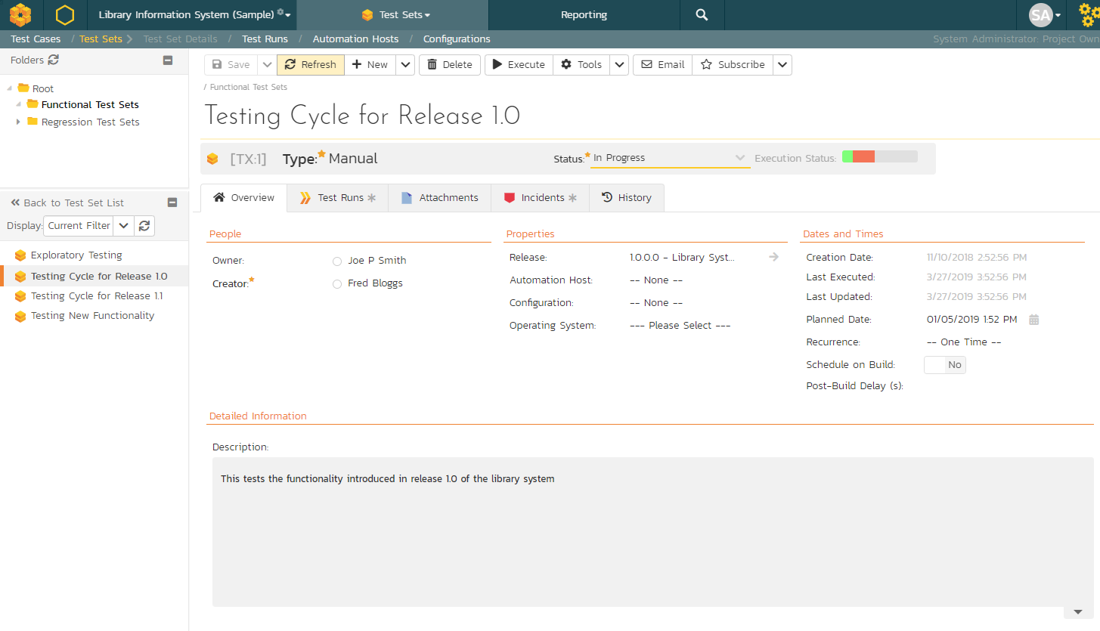

This page is made up of *three* areas;

1. the left pane displays the test set folders and list navigation;
2. the right pane’s header, which displays: the operations toolbar; the editable name of the selected test set; and the info bar (with a shaded background), which also contains the workflow status transitions (see below); and
3. the right pane’s tabbed interface with rich information related to the test set.

The navigation pane consists of a link that will take you back to the test set list, as well as a list of the peer test sets to the one selected. This latter list is useful as a navigation shortcut; you can quickly view the detailed information of all the peer test sets by clicking on the navigation links without having to first return to the test sets list page. The navigation list can be switched between three different modes:

* The list of test sets matching the current filter
* The list of all test sets, irrespective of the current filter
* The list of test sets assigned to the current user

If you are editing an existing item, the fields that are available and the fields that are required will depend on your stage in its workflow. The types of change allowed and the email notifications that are sent will depend on how your product administrator has setup the system for you. Administrators should refer to the *SpiraPlan Administration Guide* for details on configuring workflows to meet their needs.

Depending on the user’s role and whether they are listed as the owner or author of the test case, displayed in the info bar beneath the test case name is the current workflow status and an “operations” button which, when clicked, will show a set of allowed workflow operations. These workflow transitions allow the user to move the item from one status to another.

The top part of the right pane allows you to view and/or edit the details of the particular test set. You can edit the name and once you are satisfied any changes to the test set, click the “Save” button at the top of the page to commit the changes (or the options available via the save dropdown). In addition you can delete the current artifact by choosing “Delete”, discard any changes made by clicking “Refresh”, create a duplicate of the current artifact by clicking “Clone”, or export to a number of files formats or print it via one of the options in the Tools dropdown menu.

The “Execute” button allows you to execute all the tests in the set against the release specified in the test set.

Using the “Email” button on the toolbar, you can send an email containing details of the requirement to an email address or another user on the system:

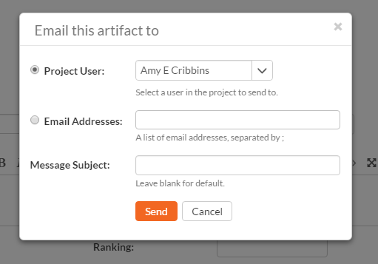

You can specify the subject line for the email, and either a list of email addresses, separated by semicolons, or an existing product user .The content of the email is specified in the System Administration – Notification Templates.

To be notified of any changes made to the current artifact via email, click the “Subscribe” button. If you already subscribed, the button will instead let you “Unsubscribe” to stop receiving emails about that particular artifact.

The lower part of the right pane can be switched between different views by clicking the appropriate tab. Initially the pane will be in “Overview” mode, but it can be switched to “Test Runs”, “Attachments”, “Incidents” and “History” modes if so desired. Each of the views is described separately below.

### 5.8.1. Overview – Details

The top part of this tab displays the various standard fields and custom properties associated with the test set. Fields (both standard and custom) are grouped under the collapsible headings (marked by orange text and underline) in the screenshot below. For instance, all fields regarding dates are grouped together in the “Dates and Times” area.

The Detailed Information section contains the long, formatted description of the test case, as well as any rich text custom fields. You can enter rich text or paste in from a word processing program or web page. Clicking on the shaded areas of one of these detailed fields will display the rich text toolbar.

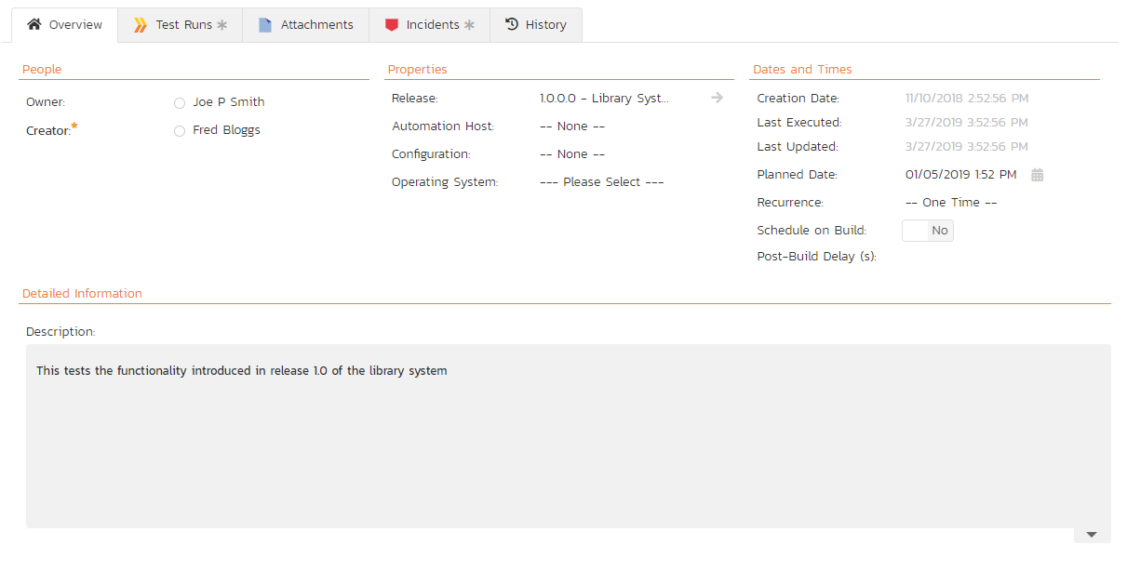

Test Sets can be specified as being either for “Manual” or “Automated” test runs (via the “Type” field. If you choose Manual, then the test set can be executed by a tester from their “My Page.” However if you choose “Automated”, the test set will be executed by the automation host you specified. In this case, the *planned date* *and time* will be used by the automated test engine to know when to execute the automated test scripts. For manual test sets, only the date component is used. In addition, you can specify a *recurrence schedule* for the test set by changing the recurrence dropdown from “One Time” to “Hourly”, “Daily”, etc. so that SpiraPlan executes the same test set according to the specified frequency. The “Planned Date” field lets you specify the date and time to execute the test using the popup time picker.

The **Schedule on Build** field will tell SpiraTest to automatically set the Planned Date to the current date/time plus the **Post Build Wait Time** offset (in seconds) whenever a new build is performed against the release or sprint that the test set is scheduled for. This allows you to automatically run a set of regression tests immediately after a build is completed.

If you have **test configuration sets** defined in your product, you can assign them to a specific Test Set and use them for both manual and automated testing by setting the **Configuration** dropdown value. If you have a test configuration associated with the test set, when you execute the test set, SpiraPlan will generate a test run entry for each of the test configuration entries multiplied by each of the test cases in the set.

The Description section contains the long, formatted description of the test set. You can enter rich text or paste in from a word processing program or web page.

### 5.8.2. Overview - Followers

Using the “Subscribe” button on the toolbar, you can quickly follow the item, and receive updates on certain changes to it. Depending on your role, you may also see a dropdown to this button, which let’s you add another product member as a follower to this item.





You can also quickly see who is following an incident under the “People” section in the Overview tab.



To view information about the follower, or to unfollow them from the item, hover over their avatar to display a user profile card.



### 5.8.3. Overview - Comments

The Comments section allows users to add and view discussions relating to the test set:



Existing comments are displayed by date (either newest-first or oldest-first) above the text box. To add a comment to the Test Set, enter your text into the textbox, then click the “Add Comment” button.

### 5.8.4. Overview - Parameters

As discussed in section 5.2.2.10. test cases can have parameters associated with them. This enables one test case to be called several times and have different parameters passed in each case, making the operation different. E.g. you could have a generic “login to application” test case that others call as an initial step, which could be provided with different login information depending on the calling test case. In addition these parameters may be used by certain test automation engines.

The Parameters section on the test set page lets you set a shared value for all of the parameters contained within the different test cases of the test set. The screenshot below shows that there are three parameters contained in the test cases that have been set at the test set level. In this example, every case that has a Parameter called ‘browserName’ will have its value set to ‘Safari’. This is a quick way of setting values for many test cases at once. Test Set Values will override any default values of a Parameter (defined for each specific test case).

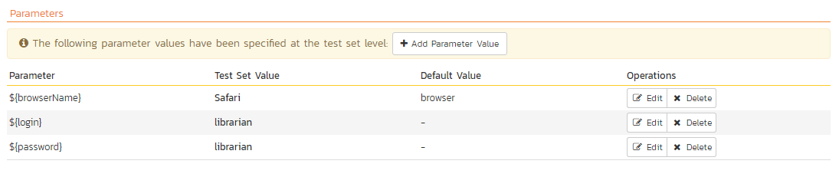

You can add any additional Parameters not already set by clicking on the “Add Parameter Value” button. In this example, you can see that one of the parameters not yet set is called ‘url’.

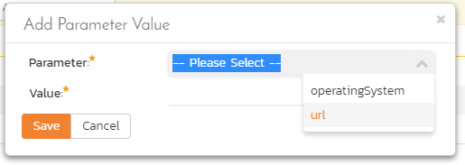

You can also delete an existing Parameter specified for the whole test set by clicking the “Delete” button in the Operations column of the Parameter in question. Clicking the “Edit” button will let you alter the Test Set Value.

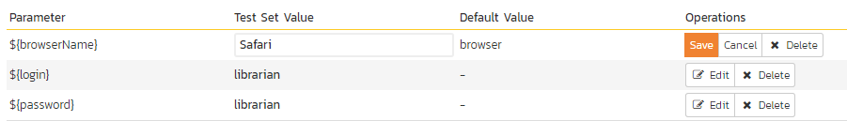

Note that the Default Value is derived from the test cases that use a specific Parameter. It is shown in this table for information only—to help testers know what value will be run in the absence of specifying a Test Set Value.

### 5.8.5. Overview - Test Cases

This section displays the list of test cases contained within the test set. You can add, remove, reposition and remove test cases from the list. The execution status displayed next to each test case is the most recent execution status of the test case *when run in the context of the current test set*.

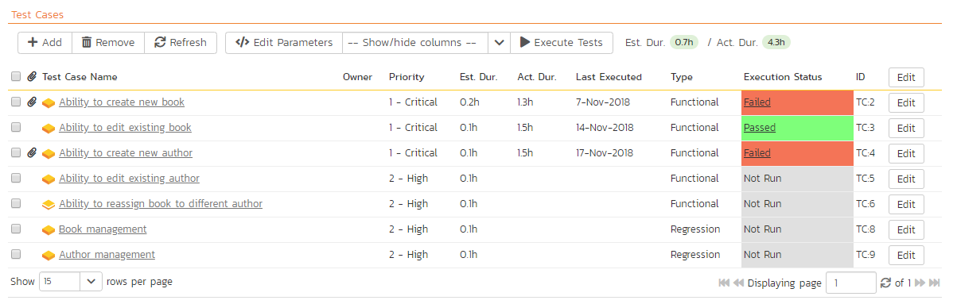

To move the test cases, click the test case icon and drag it to the appropriate position in the list.

To modify an existing Test Case click the “Edit” button in the right-most column, or *double-click* on the cells in the row. That will switch the selected row into Edit mode. The owner field can then be set at the test case level. This is useful in situations where you want the different test cases in the set to be executed by different testers (e.g. in integrated, scenario tests)

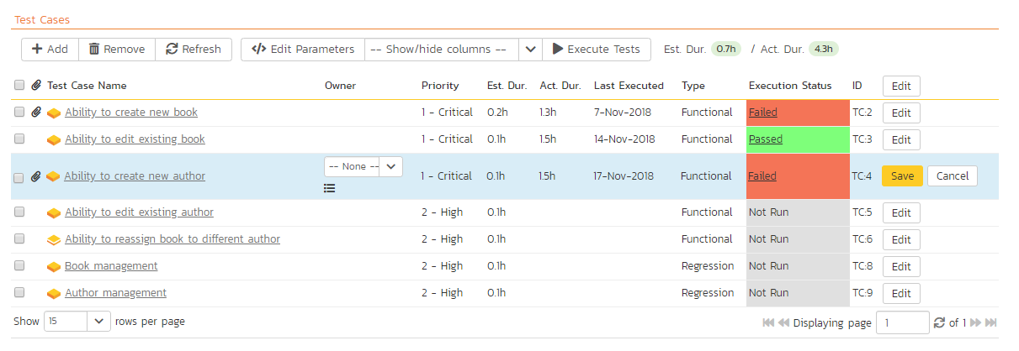

To add a new test case to the Test Set, click on the “Add” button to display the panel:

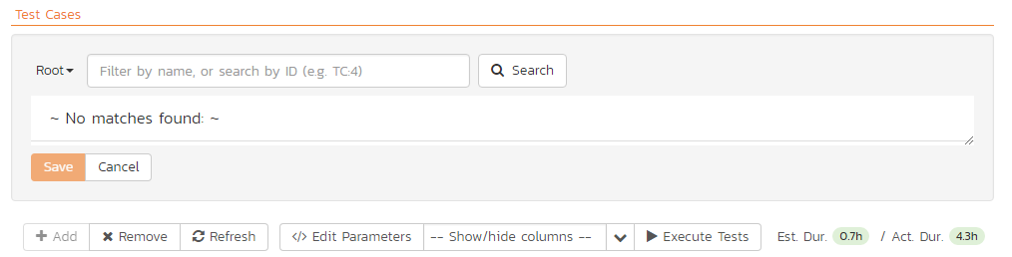

First, select the folder containing the test cases desired. You can then select the checkboxes of the individual test cases that you want to add to the test set (note: clicking the checkbox in the header row of the table will select ever test case in the currently selected folder). Once you have selected the desired items, click the “Save” button to add them to the test set.

As discussed above in section 5.8.4, test cases can have parameters defined with specific values. These are created on the Test Case details page (see section 5.2.2.10.). If you need to specify different values for a parameter for different test cases in the test set, you can override both any default parameter values and any test set parameter values. To do so, click “Edit Parameters” for the required test case in this view. You can do this by either select the checkbox of a test set and click “Edit Parameters” at the top of the section, or right-click on the test case and choose “Edit Parameters”:

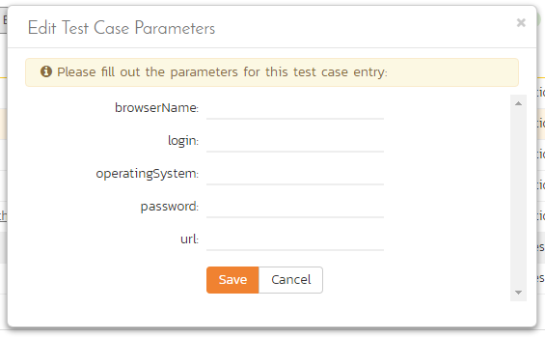

You can then specify the values of the parameters that the test set will pass to this specific test case. Once you have entered / modified the values, click “Save” to commit the changes.

### 5.8.6. Overview - Comments

The Comments section allows users to add and view discussions related to the Test Set:

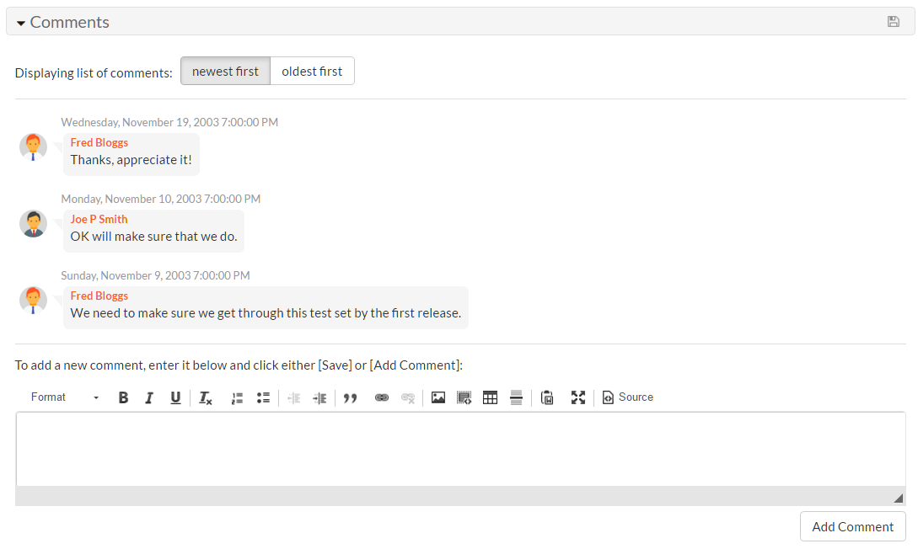

Existing comments are displayed by date (either newest-first or oldest-first) above the text box. To add a comment to the Test Set, enter your text into the textbox, then click the “Add Comment” button.

### 5.8.7. Test Runs

This tab displays the list of all the test runs executed against the test set. Each test run is listed together with the date of execution, the name of the test case, the name of the tester, the release/version of the system that the test was executed against, the overall execution status for the test case in that run and a link to the actual test run details (see section 5.6). In addition, you can choose to display any of the custom properties associated with the test run.

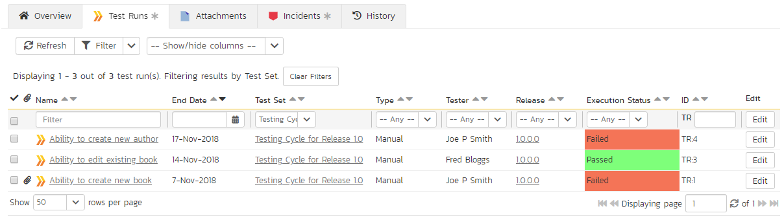

The “Show/hide columns” drop-down list allows you to change the fields that are displayed in the test run list as columns. To show a column that is not already displayed, simply select that column from the list of “Show…” column names and to hide an existing column, simply select that column from the list of “Hide…” column names. The displayed columns can be any standard field or custom property.

You can also filter the results by choosing items from the filter options displayed in the sub-header row of each field and clicking the “Filter” button. In addition, you can quickly sort the list by clicking on one of the directional arrow icons displayed in the header row of the appropriate field.

### 5.8.8. Attachments

This tab displays the list of documents that have been “attached” to the test set. The documents can be in any format, though SpiraPlan® will only display the icon for certain known types.

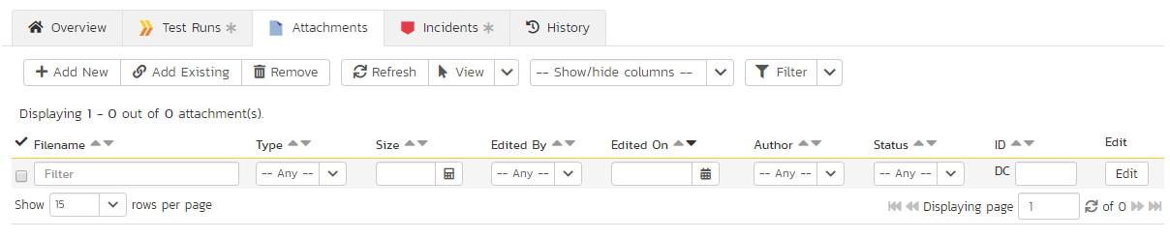

The attachment list includes the filename that was originally uploaded together with the file-size (in KB), name of the person who attached it and the date uploaded. In addition, if you position the pointer over the filename and hold it there for a few seconds, a detailed description is displayed as a tooltip.

To actually view the document, click on the filename hyperlink and a new web browser window will open. Depending on the type of file, this window will either display the document or prompt you for a place to save it on your local computer. To remove an existing attachment from a test set, select an attachment using the checkbox and click the “Remove” button. The attachment will be removed from the list.

To attach a new document to the test set, you need to first click the “Add New” link to display the new attachment dialog box:



There are three different types of item that can be attached to a requirement:

* To upload a file, choose “File” as the type and then click the Browse button and select the file from your local computer, optionally enter a detailed description then click the “Upload” button. The document will be copied from your computer and attached to the artifact.
* To attach a web-link (URL) to the artifact, you need to choose “URL” as the type and then enter the fully qualified URL (e.g. [http://mywebsite.com?Document=1](http://mywebsite.com/?Document=1)), an optional description and then click the “Upload” button to attach the web-link.
* To attach a screenshot to the artifact, you need to choose “Screenshot” as the type and then copy the image to your computer’s clipboard (e.g. on Windows computers, the PRINT SCREEN button captures the current page and adds to the clipboard). Once the image is in the clipboard, paste it into the editor using CTRL+V (or the equivalent keystroke for your operating system) and the item will appear in the preview window. You can then fill in the other fields and click “Upload” to attach the image.

Note: If you are using a non-Windows® computer (e.g. Macintosh®) that doesn’t put file extensions on filenames (e.g. .xls for an Excel sheet) automatically, then you will need to manually add the file extension to the filename before uploading if you want it to be displayed with the correct icon in the attachment list.

You can also associate an existing document (that’s already stored in SpiraTeam) with the test set. To do that, click on the “Add Existing” button to bring up the add file association dialog box:



You can then choose to either associate a document stored in the SpiraPlan Documents repository or (in the case of SpiraPlan/SpiraTeam but not SpiraTest) from the linked source code repository. In either case you first select the appropriate folder, and then pick the document(s) from the file list on the right. In the case of a source code file association you can also add a comment.

### 5.8.9. Incidents

This tab displays the list of incidents associated with the current test set. Each incident will either have been: created during the execution of a test case in the test set (and are thereby linked to one of the test runs); or manually linked to one of the test steps in a test case of the set.

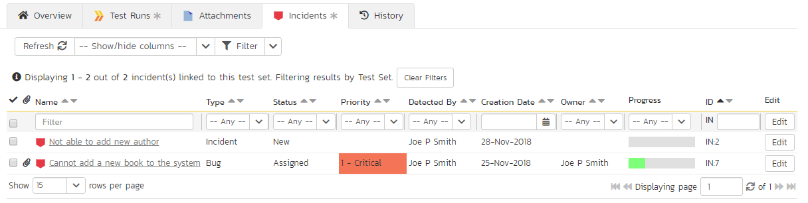

### 5.8.10. History

This tab displays the list of changes that have been performed on the test set artifact since its creation. The change history displays the date that each change was made, together with the fields that were changed, the old and new values and the person who made the change. This allows a complete audit trail to be maintained of all changes in the system. In addition, if you are logged in as a product administrator you can also click on the “Admin View” button to revert any unwanted changes.

## 5.9. Automation Host List

This section outlines how to use the Automation Host Management features of SpiraPlan® to manage the different host systems that will be running automated tests in your environment. Typically when scheduling automated tests you will want to execute the same tests on multiple computers running different environments.

SpiraPlan allows you to build a master list of automation hosts in each product, which can be used to schedule test sets containing automated test cases against. Please refer to the Test Set section of this manual for more information on managing and scheduling test sets.

When you click on the Testing > Automation Hosts global navigation link, you will initially be taken to the automation host list screen illustrated below:

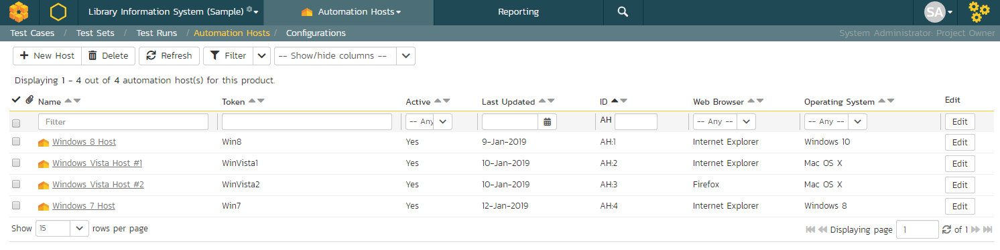

The automation host list screen displays all the automation hosts entered for the current product, in a filterable, sortable grid. The grid displays the automation host ID together with fields such as name, description, last updated date, token, and any custom properties. The choice of columns displayed is configurable per-user, per-product, giving extensive flexibility when it comes to viewing and searching automation hosts.

In addition, you can view a more detailed description of the automation host by positioning the mouse pointer over the host name hyperlink and waiting for the popup “tooltip” to appear. If you click on the host name hyperlink, you will be taken to the automation host details page described in section 5.10. Clicking on any of the pagination links at the bottom of the page will advance you to the next set of hosts in the list according to the applied filter and sort-order. There is also a drop-down-list at the bottom of the page which allows you to specify how many rows should be displayed in each page, helping accommodate different user preferences.

One special column that is unique to automation hosts is the “Token” field. This needs to contain a short textual identifier that uniquely identifies each automation host in the product. This will be used by each host computer to identify itself to SpiraPlan.

### 5.9.1. Sorting and Filtering

You can easily filter and sort the list of automation hosts. To filter the list by one of the displayed fields, you simply choose an item from the appropriate drop-down list or enter a free-text phrase then click “Filter” or press the <ENTER> key to apply the different filters. Note that the name field is searched using a “LIKE” comparison, so that searching for “database” would include any item with the word database in the name. The other freetext fields need to be exact matches (e.g. dates, automation host numbers).

To change the column that is sorted, or to change the direction of the current sort, simply click on the up/down arrow icon in the appropriate column. The currently sorted column is indicated by the darker arrow.

Clicking on Filter > Clear Filter removes any set filters and expands the host list to display all automation hosts in the current product, and clicking on Filter > Save Filter allows you to save the filter to your ‘My Page’ for use in the future. The list of saved filters can also be retrieved by clicking Filter > Retrieve Filter.

### 5.9.2. New Host

Clicking on the “New Host” button adds a new automation host to the bottom of the automation host list with a default name and token.

### 5.9.3. Delete

Clicking on the “Delete” button deletes the automation hosts whose check-boxes have been selected in the host list.

### 5.9.4. Refresh

Clicking on the “Refresh” button reloads the list of automation hosts; this is useful when new hosts are being added by other users, and you want to make sure you have the most up-to-date list displayed.

### 5.9.5. Show / Hide Columns

This drop-down list allows you to change the fields that are displayed in the host list as columns for the current product. To show a column that is not already displayed, simply select that column from the list of “Show…” column names and to hide an existing column, simply select that column from the list of “Hide…” column names. This is stored on a per-product basis, so you can have different display settings for each product that you are a member of. The fields can be any of the built-in fields or any of the custom properties set up by the product owner.

### 5.9.6. Edit

Each automation host in the list has an “Edit” button in its right-most column. When you click this button or just *double-click* on any of the cells in the row, you change the item from “View” mode to “Edit” mode. The various columns are made editable, and “Save” and “Cancel” buttons are displayed in the last column.

If you click “Edit” on more than one row, the “Save” and “Cancel” buttons are only displayed on the first row, and you can make changes to all the editable rows and then update the changes by clicking the one “Save” button. Also, if you want to make the same change to multiple rows (e.g. to change five automation hosts from Active = No to Active = Yes), you can click on the “fill” icon to the right of the editable item, which will propagate the new value to all editable items in the same column.

If you want to edit lots of items, first select their checkboxes and then click the “Edit” button on the same row as the Filters and it will switch all the selected items into edit mode.

When you have made your updates, you can either click “Save”to commit the changes, or “Cancel” to revert back to the original information. Alternatively, pressing the <ENTER> key will commit the changes and pressing the <ESCAPE> key will cancel the changes.

## 5.10. Automation Host Details

When you click on an automation host entry in the host list, you are taken to the automation host details page illustrated below:

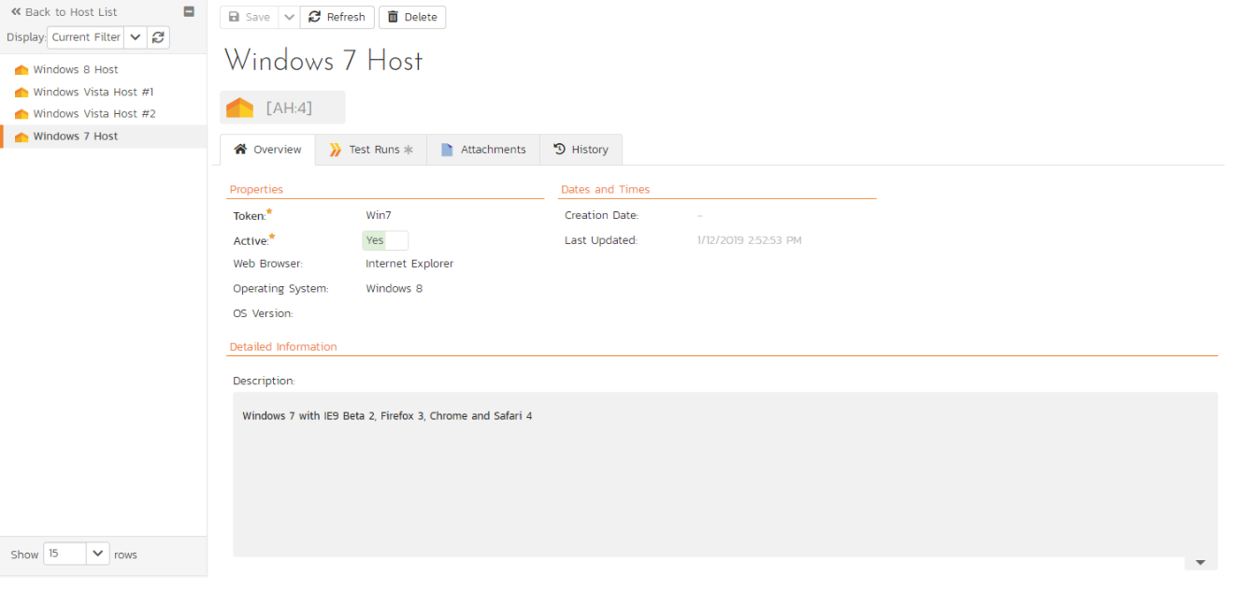

This page is made up of three areas; the left pane is the navigation window, the upper part of the right pane contains the automation host name and ID, and the bottom part of the right pane displays different information associated with the automation host.

The navigation pane consists of a link that will take you back to the host list, as well as a list of the peer automation hosts to the one selected. This latter list is useful as a navigation shortcut; you can quickly view the peer hosts by clicking on the navigation links without having to first return to the host list page. The navigation list can be switched between two different modes:

* The list of hosts matching the current filter
* The list of all hosts, irrespective of the current filter

The top part of the right pane allows you to view and/or edit the details of the particular automation host. You can edit the various fields (name, description, token, etc.) and custom properties. Once you are satisfied with the changes, click either the “Save” button or the alternative options from the “Save” dropdown list. In addition you can delete the current automation host by clicking “Delete”, or discard any changes made by clicking “Refresh”.

### 5.10.1. Overview

This tab shows the fields and description associated with the automation host. Standard and custom fields are grouped by type (eg all date and time fields are grouped together).

### 5.10.2. Test Runs

This tab displays the list of all the test runs executed against the automation host. Each test run is listed together with the date of execution, the name of the test case, the name of the tester, the release/version of the system that the test was executed against, the name of the test set (if applicable), the overall execution status for the test case in that run and a link to the actual test run details (see section 5.6). In addition, you can choose to display any of the custom properties associated with the test run.

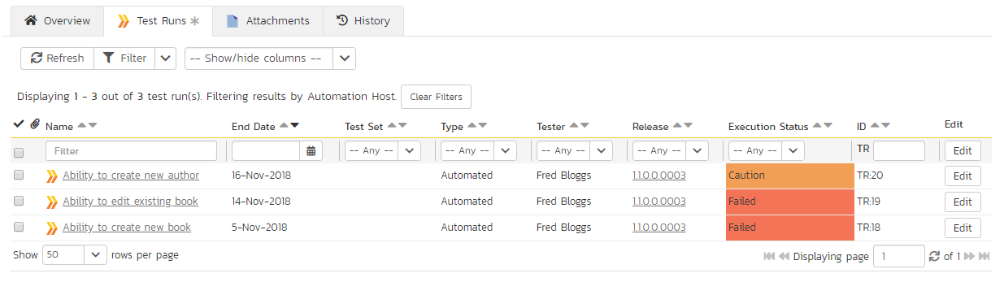

The “Show/hide columns” drop-down list allows you to change the fields that are displayed in the test run list as columns. To show a column that is not already displayed, simply select that column from the list of “Show…” column names and to hide an existing column, simply select that column from the list of “Hide…” column names. The displayed columns can be any standard field or custom property.

You can also filter the results by choosing items from the filter options displayed in the sub-header row of each field and clicking the “Filter” button. In addition, you can quickly sort the list by clicking on one of the directional arrow icons displayed in the header row of the appropriate field.

### 5.10.3. Attachments

In this tab, the main pane displays the list of documents that have been “attached” to the automation host. The documents can be in any format, though SpiraPlan® will only display an icon for certain known types.

The attachment list includes the filename that was originally uploaded together with the file-size (in KB), name of the person who attached it and the date uploaded. In addition, if you position the pointer over the filename and hold it there for a few seconds, a detailed description is displayed as a tooltip.

To actually view the document, simply click on the filename hyperlink and a new web browser window will open. Depending on the type of file, this window will either display the document or prompt you for a place to save it on your local computer. To delete an existing attachment from a test case, simply click the “Remove” button and the attachment will be removed from the list.

To attach a new document to the test case, you need to first click the “Add New” link to display the new attachment dialog box:



There are three different types of item that can be attached to an incident:

* To upload a file, choose “File” as the type and then click the Browse button and select the file from your local computer, optionally enter a detailed description then click the “Upload” button. The document will be copied from your computer and attached to the artifact.
* To attach a web-link (URL) to the artifact, you need to choose “URL” as the type and then enter the fully qualified URL (e.g. [http://mywebsite.com?Document=1](http://mywebsite.com/?Document=1)), an optional description and then click the “Upload” button to attach the web-link.
* To attach a screenshot to the artifact, you need to choose “Screenshot” as the type and then copy the image to your computer’s clipboard (e.g. on Windows computers, the PRINT SCREEN button captures the current page and adds to the clipboard). Once the image is in the clipboard, paste it into the editor using CTRL+V (or the equivalent keystroke for your operating system) and the item will appear in the preview window. You can then fill in the other fields and click “Upload” to attach the image.

Note: If you are using a non-Windows® computer (e.g. Macintosh®) that doesn’t put file extensions on filenames (e.g. .xls for an Excel sheet) automatically, then you will need to manually add the file extension to the filename before uploading if you want it to be displayed with the correct icon in the attachment list.

You can also associate an existing document (that’s already stored in SpiraTeam) with the automation host. To do that, click on the “Add Existing” button to bring up the add file association dialog box:



You can then choose to either associate a document stored in the SpiraPlan Documents repository or (in the case of SpiraPlan/SpiraTeam but not SpiraTest) from the linked source code repository. In either case you first select the appropriate folder, and then pick the document(s) from the file list on the right. In the case of a source code file association you can also add a comment.

### 5.10.4. History

In this mode, the main pane displays the list of changes that have been performed on the automation host artifact since its creation. The change history displays the date that each change was made, together with the fields that were changed, the old and new values and the person who made the change. This allows a complete audit trail to be maintained of all changes in the system. In addition, if you are logged in as a product administrator you can also click on the “Admin View” button to revert any unwanted changes.

## 5.11. Test Configurations List

This section outlines how to use the Test Configuration features of SpiraPlan® to create and manage different configurations of parameters that tests (both manual and automated) can be run against. This offers tools to quickly create every combination of different parameters.

When you click on the Testing > Test Configuration global navigation link, you will initially be taken to the test configuration list screen illustrated below:

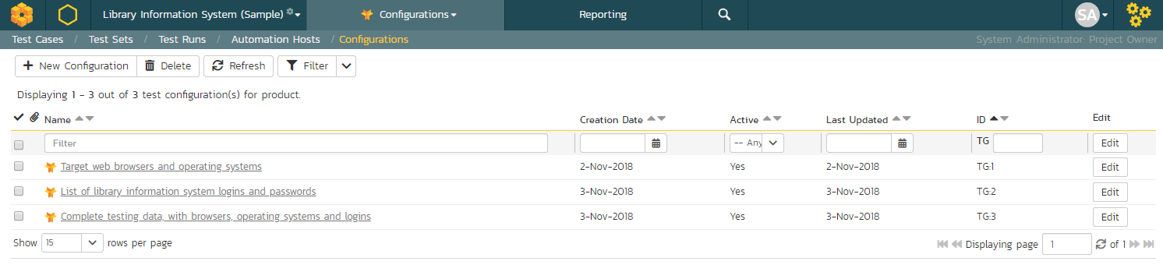

The test configuration list screen displays all the test configurations for the current product, in a filterable, sortable grid. The grid displays the name, creation date, last updated date, ID, and whether the test configuration is active.

In addition, you can view a more detailed description of the test configuration by positioning the mouse pointer over the host name hyperlink and waiting for the popup “tooltip” to appear. If you click on the host name hyperlink, you will be taken to the test configuration details page described in section 5.12. Clicking on any of the pagination links at the bottom of the page will advance you to the next set of hosts in the list according to the applied filter and sort-order. There is also a drop-down-list at the bottom of the page which allows you to specify how many rows should be displayed in each page, helping accommodate different user preferences.

### 5.11.1. Sorting and Filtering

You can easily filter and sort the list of automation hosts. To filter the list by one of the displayed fields, you simply choose an item from the appropriate drop-down list or enter a free-text phrase then click “Filter” or press the <ENTER> key to apply the different filters. Note that the name field is searched using a “LIKE” comparison, so that searching for “database” would include any item with the word database in the name. The other freetext fields need to be exact matches (e.g. dates, test configuration numbers).

To change the column that is sorted, or to change the direction of the current sort, simply click on the up/down arrow icon in the appropriate column. The currently sorted column is indicated by the darker arrow.

Clicking on Filter > Clear Filter removes any set filters.

### 5.11.2. New Test Configuration

Clicking on the “New Configuration” button adds a new test configuration to the bottom of the list with a default name.

### 5.11.3. Delete

Clicking on the “Delete” button deletes the test configurations whose check-boxes have been selected in the host list.

### 5.11.4. Refresh

Clicking on the “Refresh” button reloads the list of test configurations; this is useful when new configurations are being added by other users, and you want to make sure you have the most up-to-date list displayed.

### 5.11.5. Edit

Each test configuration in the list has an “Edit” button in its right-most column. When you click this button or just *double-click* on any of the cells in the row, you change the item from “View” mode to “Edit” mode. The various columns are made editable, and “Save” and “Cancel” buttons are displayed in the last column.

If you click “Edit” on more than one row, the “Save” and “Cancel” buttons are only displayed on the first row, and you can make changes to all the editable rows and then update the changes by clicking the one “Save” button. Also, if you want to make the same change to multiple rows (e.g. to change five test configurations from Active = No to Active = Yes), you can click on the “fill” icon to the right of the editable item, which will propagate the new value to all editable items in the same column.

If you want to edit lots of items, first select their checkboxes and then click the “Edit” button on the same row as the Filters and it will switch all the selected items into edit mode.

When you have made your updates, you can either click “Save”to commit the changes, or “Cancel” to revert back to the original information. Alternatively, pressing the <ENTER> key will commit the changes and pressing the <ESCAPE> key will cancel the changes.

## 5.12. Test Configuration Details

When you click on a test configuration entry in the list, you are taken to the test configuration details page illustrated below:

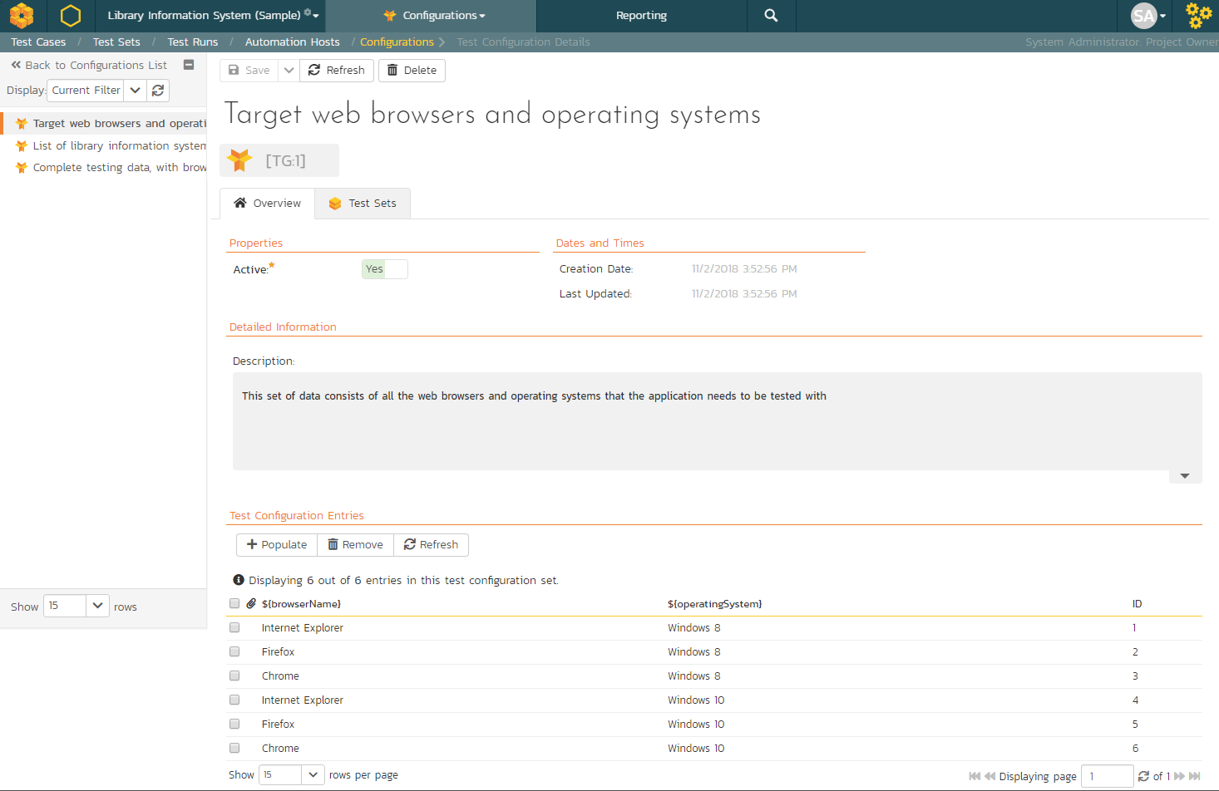

This page is made up of three areas; the left pane is the navigation window, the upper part of the right pane contains the test configuration name and ID, and the bottom part of the right pane displays different information associated with the test configuration.

The navigation pane consists of a link that will take you back to the test configuration list, as well as a list of the peer test configurations to the one selected. This latter list is useful as a navigation shortcut; you can quickly view the peer configurations by clicking on the navigation links without having to first return to the list page. The navigation list can be switched between two different modes:

* The list of configurations matching the current filter
* The list of all configurations, irrespective of the current filter

The right pane allows you to view and/or edit the details of the particular test configuration. You can edit the various fields (name, description, etc.) and custom properties. Once you are satisfied with the changes, click either the “Save” button or the alternative options from the “Save” dropdown list. In addition you can delete the current automation host by clicking “Delete”, or discard any changes made by clicking “Refresh”.

### 5.12.1. Overview

This tab shows the fields and description associated with the test configuration. Standard and custom fields are grouped by type (eg all date and time fields are grouped together).

### 5.12.2. Overview – Test Configuration Entries

This section shows the list of all entries from this test configuration, and that would be used by a test set to populate parameters. Each row represents a single unique combination of the parameters (shown on the header row of the table).

Entries can be reordered by dragging and drop one row or more. Individual entries can also be removed by checking the checkbox for that entry and then clicking “Remove” button.

To create new entries, first click the “Populate” button. This will display the following panel:

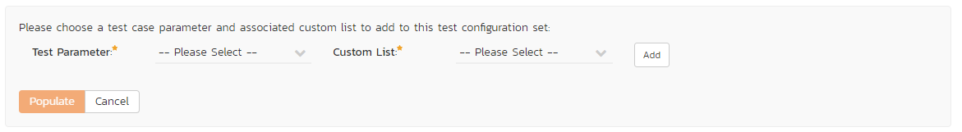

You must select a parameter from the left dropdown (which contains a list of all parameters defined in test cases in the current product), and a custom list with which to populate the parameter. Then click the “Add” button. For instance, the screenshot below would create a configuration using every operating system defined by the custom list “Operating System” and assigning these to the parameter called “operatingSystem.”

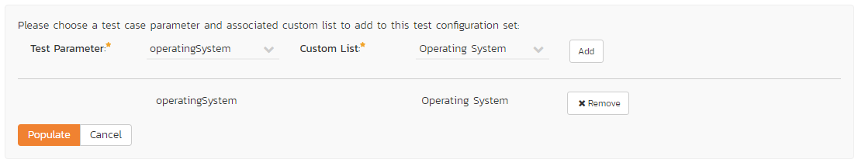

Note: Custom lists are usually used in SpiraPlan for custom fields on various artifacts. However, you can create custom lists that are solely for the purpose of test configurations, should you so wish – for instance, to contain a list of usernames.

Once you are happy with the lists and parameters selected, click the “Populate” button. This will overwrite all existing entries in this test configuration. It will create every combination based on the lists specified. So if you select two parameters, each with a list that has ten items, one hundred entries will be created in the test configuration.

### 5.12.3. Test Sets

This tab displays the list of all the test sets that are using the test configuration. Each test set is listed together with its name, release, the date of last execution, the owner, the status, the execution status, and a link to the actual test set details. In addition, you can choose to display any of the custom properties associated with the test set.

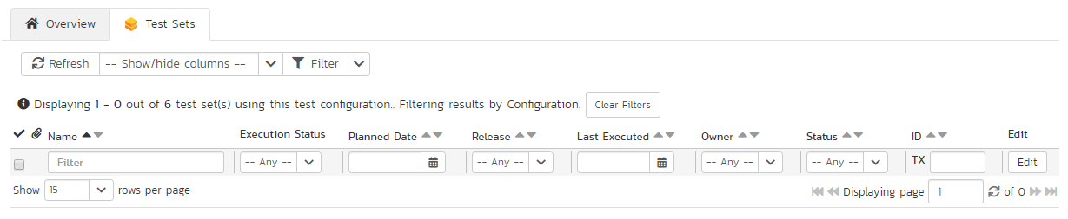

The “Show/hide columns” drop-down list allows you to change the fields that are displayed in the test set list as columns. To show a column that is not already displayed, simply select that column from the list of “Show…” column names and to hide an existing column, simply select that column from the list of “Hide…” column names. The displayed columns can be any standard field or custom property.

You can also filter the results by choosing items from the filter options displayed in the sub-header row of each field and clicking the “Filter” button. In addition, you can quickly sort the list by clicking on one of the directional arrow icons displayed in the header row of the appropriate field.

# 6. Incident Tracking

This section outlines how the incident/defect tracking features of SpiraPlan® can be used to manage key product artifacts during the software development lifecycle. In addition to managing the defects raised during the execution of test cases in the test management module, the Incident Tracker is also a powerful risk/issue/bug tracking system in its own right. When coupled with the product dashboard (see section 3.4) it is a powerful tool for representing all the key risks and issues associated with a product in a single, graphical format.

Unlike a standalone bug/issue tracking tool however, you can trace the incidents/defects back to the test case and the underlying requirement that generated them, giving the product manager unprecedented power in analyzing the “in-process” quality of a system during its lifecycle. This power is clearly illustrated in the “Requirement Incident Count” pane in the Product Home dashboard (see section 3.4.4).

## 6.1. Incident List

When you click on the Tracking > Incidents global navigation link, you will initially be taken to the incidents list screen illustrated below:

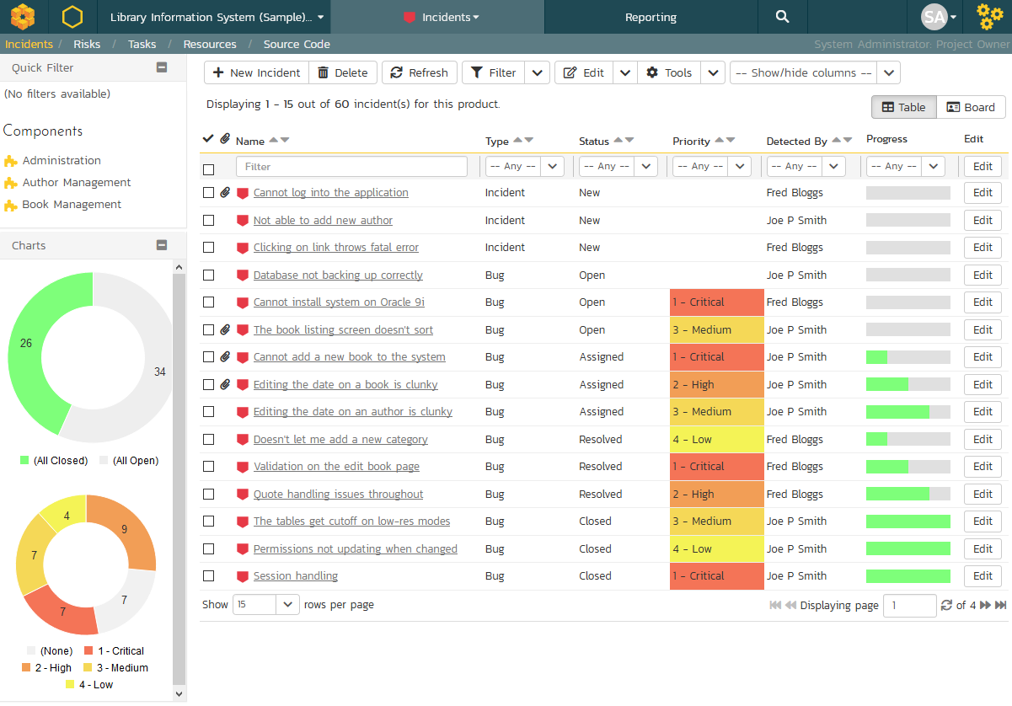

The incident list screen displays all the incidents entered for the current product, in a filterable, sortable grid. The grid displays the incident number together with fields such as incident type (bug, issue, risk, etc.), status (new, open, etc.), priority, name, assigned owner, detection date, detector, closed date, etc. The choice of columns displayed is configurable per-user, per-product, giving extensive flexibility when it comes to viewing and searching incidents.

The sidebar on the left gives you quick access to saved filters, along with some useful charts to get an at-a-glance view of incidents for this product.

In addition, you can view a more detailed description of the incident (along with a resolution if any) by positioning the mouse pointer over the incident name hyperlink and waiting for the popup “tooltip” to appear. If you click on the incident name hyperlink, you will be taken to the incident details page described in section 6.2. Clicking on any of the pagination links at the bottom of the page will advance you to the next set of incidents in the list according to the applied filter and sort-order. There is also a drop-down-list at the bottom of the page which allows you to specify how many rows should be displayed in each page, helping accommodate different user preferences.

### 6.1.1. Sorting and Filtering

You can easily filter and sort the list of incidents as illustrated in the screen-shot below:

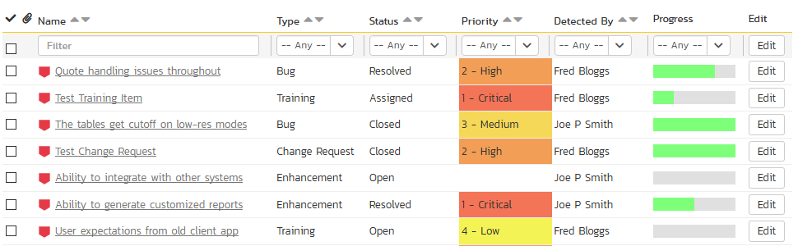

To filter the list by incident type, status, priority, owner or detector name, you simply choose an item from the appropriate drop-down list, and for the other fields, you enter a free-text phrase then click “Filter” or press the <ENTER> key to apply the different filters. Note that the name field is searched using a “LIKE” comparison, so that searching for “database” would include any item with the word database in the name. The other freetext fields need to be exact matches (e.g. dates, incident numbers). There are also several aggregate filters that are used to filter on multiple values at once (e.g. filtering status on (All Open) will return any incident that is in one of the open statuses – new, open, assigned, reopen).

To change the column that is sorted, or to change the direction of the current sort, simply click on the up/down arrow icon in the appropriate column. The currently sorted column is indicated by the darker arrow. In the screen-shot above, we are filtering on type=bug and sorting by decreasing priority.

Clicking on Filter > Clear Filter removes any set filters and expands the incident list to display all incidents for the current product, and clicking on Filter > Save Filter allows you to save the filter to your ‘My Page’ for use in the future. The list of saved filters can also be retrieved by clicking Filter > Retrieve Filter.

As a shortcut, the left hand panel includes a set of **Quick Filters** that can be applied in a single-click:

* The topmost section displays any saved incident filters created by the current user or that are shared with the current user (the former are designated with an icon representing a single person, the latter a group of people)
* **Components** – This section lists the components defined for the current product. Clicking on any of the components in the list will filter the incidents to only show those that are associated with the selected component.
* **Releases** – This section lists the releases and sprints defined for the current product. Clicking on any of the releases or sprints in the list will filter the incident by that **resolved release/sprint**.

### 6.1.2. New Incident

Clicking on the “New Incident” button takes you to the new incident screen. This is essentially the same screen as the incident details screen shown in section 6.2 except, depending on how the workflow has been configured for your product, certain fields may be disabled. For more details on setting and up configuring workflow for your product, please refer to the *SpiraTest Administration Guide*.

### 6.1.3. Delete

Clicking on the “Delete” button deletes the incidents whose check-boxes have been selected in the incident list.

### 6.1.4. Refresh

Clicking on the “Refresh” button simply reloads the list of incidents; this is useful when new incidents are being added by other users, and you want to make sure you have the most up-to-date list displayed.

### 6.1.5. Show / Hide Columns

This drop-down list allows you to change the fields that are displayed in the incident list as columns for the current product. To show a column that is not already displayed, simply select that column from the list of “Show…” column names and to hide an existing column, simply select that column from the list of “Hide…” column names. This is stored on a per-product basis, so you can have different display settings for each product that you are a member of. The fields can be any of the built-in fields or any of the custom properties set up by the product owner.

### 6.1.6. Edit

Each incident in the list has an “Edit” button display in its right-most column. When you click this button or just *double-click* on any of the cells in the row, you change the item from “View” mode to “Edit” mode. The various columns are made editable, and “Save” and “Cancel” buttons are displayed in the last column:

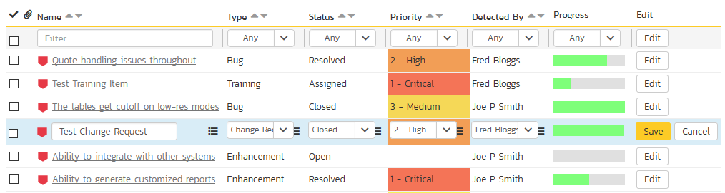

If you click “Edit” on more than one row, the “Save” and “Cancel” buttons are only displayed on the first row, and you can make changes to all the editable rows and then update the changes by clicking the one “Save” button. Also, if you want to make the same change to multiple rows (e.g. to change five incidents from “Resolved” status to “Closed”), you can click on the “fill” icon to the right of the editable item, which will propagate the new value to all editable items in the same column.

If you want to edit lots of items, first select their checkboxes and then click the “Edit” button on the same row as the Filters and it will switch all the selected items into edit mode.

When you have made your updates, you can either click “Save” to commit the changes, or “Cancel” to revert back to the original information. Alternatively, pressing the <ENTER> key will commit the changes and pressing the <ESCAPE> key will cancel the changes.

### 6.1.7. Cloning Incidents

To create a clone of an existing incident or set of incidents, simply select the check-boxes of the incidents you want to copy and then click “Clone”. This will make a copy of the current incident with its name prefixed ‘Copy of ….’ to distinguish itself from the original. Any file attachments will also be copied along with the incident itself.

### 6.1.8. Exporting Incidents

To export an incident or set of incidents from the current product to another product in the system, select the check-boxes of the incident(s) you want to export and then click the Tools > “Export to Product”. This will then bring up a list of possible destination products:

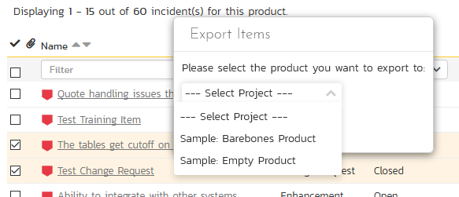

Once you have chosen the destination product and clicked the “Export” button, the incidents will be exported from the current product to the destination product. Any file attachments will also be copied to the destination product along with the incidents.6.1.9. Creating Requirement from Incidents

Sometimes you may have a situation where an enhancement has been logged in the incident tracker and now that it has been approved, it needs to be converted into a formal requirement so that test cases and tasks can be generated from it. To aid this process, there is a shortcut that allows you to create new requirement from selected incidents and have it be automatically added to the requirements list. When that is performed an association is automatically added that links this new requirement to the original incident.

To activate this feature, select the checkboxes of the incidents you want to convert and then click Tools > Convert Into Requirements.

### 6.1.9. Printing Items

To quickly print a single incident or list of incidents you can select the items’ checkboxes and then click Tools > Print Items. This will display a popup window containing a printable version of the selected items. You can also save the report in a variety of common formats from the same Tools menu.

## 6.2. Incident Details

When you click on an incident item in the incident list, or click the “New Incident” button (as described in section 6.1), you are taken to the incident details page illustrated below:

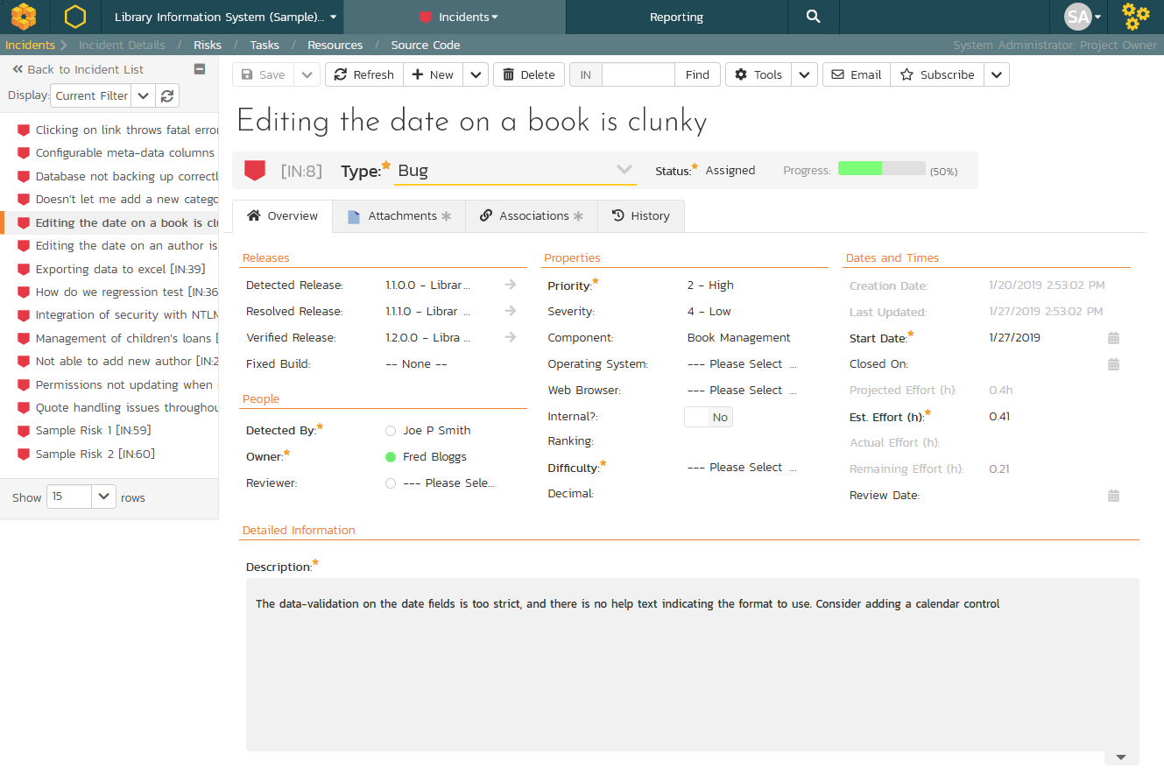

This page is made up of three areas:

* the left pane is the navigation window where you can quickly jump to other incidents;
* the upper part of the right pane contains the incident name and key information about it (it’s ID number, and what type of incident it is), as well as the current status (see below); and
* the bottom part of the right pane displays different information associated with the incident across a number of tabs.

The navigation pane consists of a link that will take you back to the incidents list, as well as a list of the peer incidents to the one selected. This latter list is useful as a navigation shortcut; you can quickly view the peer incidents by clicking on the navigation links without having to first return to the incidents list page. The navigation list can be switched between four different modes:

* The list of incidents matching the current filter
* The list of all incidents, irrespective of the current filter
* The list of incidents assigned to the current user
* The list of incidents detected/found by the current user

In addition to the left hand navigation, you can enter a specific incident number in the text-box in the toolbar and click the “Find” button. In the same toolbar, there is also a shortcut for creating a copy of the current by clicking the “Clone” button.

### 6.2.1. Editing an Existing Incident

If you are editing an existing incident, the fields that are available and the fields that are required will depend on your stage in the incident workflow. For example an open incident might not require a “Resolved Version” whereas a resolved incident may well. The types of change allowed and the email notifications that are sent will depend on how your product administrator has setup the system for you. Administrators should refer to the *SpiraPlan Administration Guide* for details on configuring the incident workflows to meet their needs.

Depending on the user’s role and whether they are listed as the owner or detector of the incident or not, the dropdown next to the incident’s current status shows the allowed workflow operations:

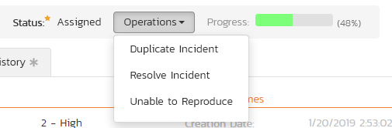

These workflow transitions allow the user to move the incident from one status to another. For example when the incident is in the Assigned status, you will be given the options to:

* **Resolve the Incident** – changes status to “Resolved”
* **Unable to Reproduce** – changes the status to “Not Reproducible”
* **Duplicate Incident** - changes the status to “Duplicate”

After changing the status of the incident by clicking on the link, you can then fill in the additional fields that are now enabled and/or required. Once you’ve made the changes to the appropriate incident fields, you can click “Save” or one of the options from the “Save” dropdown list to commit the changes or “Refresh” to discard the changes and reload the incident from the database.

Please note that if digital signatures have been enabled for a particular workflow operation (and therefore a digital signature is required to confirm the status change. Workflow operations requiring a digital signature are marked with a padlock icon as in the example below:

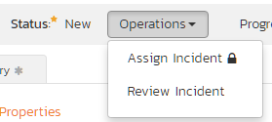

On attempting to save changes made after clicking a workflow operation that requires a digital signature you will be presented with a popup similar to the one below (which is for a requirement):



You can print the current incident by clicking Tools > Print, which will display a printable version of the page in a separate window. Alternatively, you can export the incident to a number of formats by selecting the appropriate option from the Tools menu.

### 6.2.2. Inserting a New Incident

If you are creating a new incident, the fields that are available and the fields that are required will depend on how your product has been for configured. For example, some products may require that all incidents be started with Status=New and Type=Incident, others may allow you to specify the incident type. The types of change allowed will depend on how your product administrator has setup the system for you. Administrators should refer to the *SpiraPlan Administration Guide* for details on configuring the incident workflows to meet their needs.

Once you’ve filled out the appropriate incident fields, you can either click “Save” or one of the options from the “Save” dropdown list to commit the changes or click on “Back to Incident List” to discard the insertion and return back to the incident list.

### 6.2.3. Overview - Comments

The Comments section allows users to add and view discussions related to the incident:

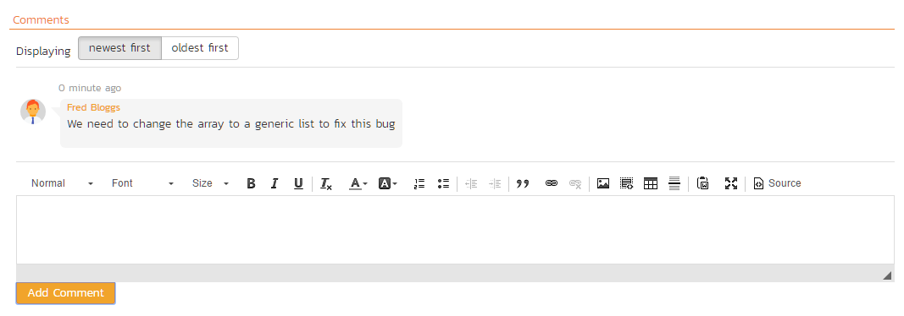

Existing comments are displayed by date (either newest-first or oldest-first) above the text box. To add a comment to the incident, enter your text into the textbox, then click the “Add Comment” button to save.

### 6.2.4. Overview – Dates and Times

This section displays the general schedule and completion status of the specific incident. You can enter/edit the start-date, closed-date (i.e. the due-date), estimate, actual and remaining effort. From these values, the system will display the calculated percent completion, progress indicator and producted final effort. Any custom date fields set up by the system administrator or product owner will also appear in this section (as shown below with the Review Date field).

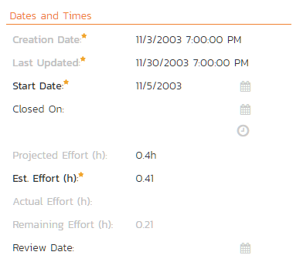

### 6.2.5. Attachments

In this tab, the lower section of the screen displays the list of documents, screenshots or web links (URLs) that have been “attached” to the incident. The documents can be in any format, though SpiraPlan® will only display the icon for certain known types.

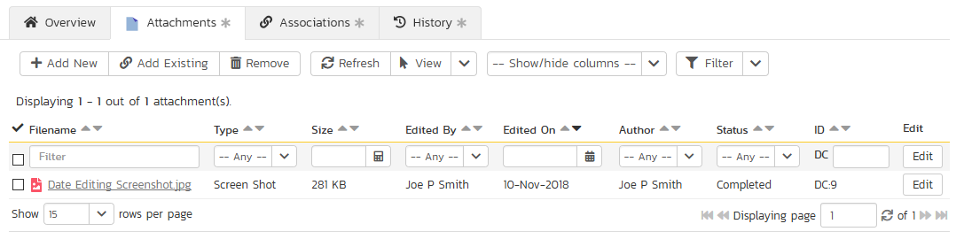

The attachment list includes the filename that was originally uploaded together with the file-size (in KB), name of the person who attached it and the date uploaded. In addition, if you position the pointer over the filename and hold it there for a few seconds, a detailed description is displayed as a tooltip.

To actually view the document, simply click on the filename hyperlink and a new web browser window will open. Depending on the type of file, this window will either display the document or prompt you for a place to save it on your local computer. To delete an existing attachment from an incident, click the “Remove” button and the attachment will be removed from the list.

To attach a new document to the incident, you need to first click the “Add New” link to display the new attachment dialog box:



There are three different types of item that can be attached to an incident:

* To upload a file, choose “File” as the type and then click the Browse button and select the file from your local computer, optionally enter a detailed description then click the “Upload” button. The document will be copied from your computer and attached to the artifact.
* To attach a web-link (URL) to the artifact, you need to choose “URL” as the type and then enter the fully qualified URL (e.g. [http://mywebsite.com?Document=1](http://mywebsite.com/?Document=1)), an optional description and then click the “Upload” button to attach the web-link.
* To attach a screenshot to the artifact, you need to choose “Screenshot” as the type and then copy the image to your computer’s clipboard (e.g. on Windows computers, the PRINT SCREEN button captures the current page and adds to the clipboard). Once the image is in the clipboard, paste it into the editor using CTRL+V (or the equivalent keystroke for your operating system) and the item will appear in the preview window. You can then fill in the other fields and click “Upload” to attach the image.

Note: If you are using a non-Windows® computer (e.g. Macintosh®) that doesn’t put file extensions on filenames (e.g. .xls for an Excel sheet) automatically, then you will need to manually add the file extension to the filename before uploading if you want it to be displayed with the correct icon in the attachment list.

You can also associate an existing document (that’s already stored in SpiraTeam) with the incident. To do that, click on the “Add Existing” button to bring up the add file association dialog box:



You can then choose to either associate a document stored in the SpiraPlan Documents repository or (in the case of SpiraPlan/SpiraTeam but not SpiraTest) from the linked source code repository. In either case you first select the appropriate folder, and then pick the document(s) from the file list on the right. In the case of a source code file association you can also add a comment.

### 6.2.6. History

This tab displays the list of changes that have been performed on the incident artifact since its creation. An example incident change history is depicted below:

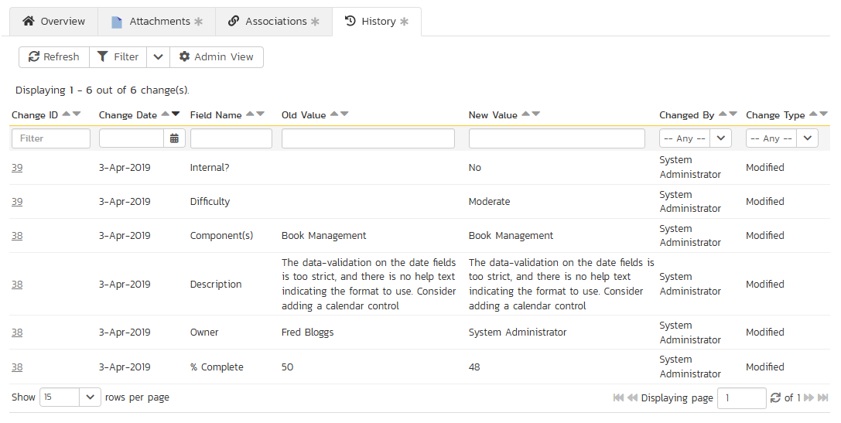

The change history displays the date that each change was made, together with the fields that were changed, the old and new values and the person who made the change. This allows a complete audit trail to be maintained of all changes in the system.

### 6.2.7. Associations

This tab displays a list of any requirements, tasks, test runs, test steps or other incidents that are associated with this incident:

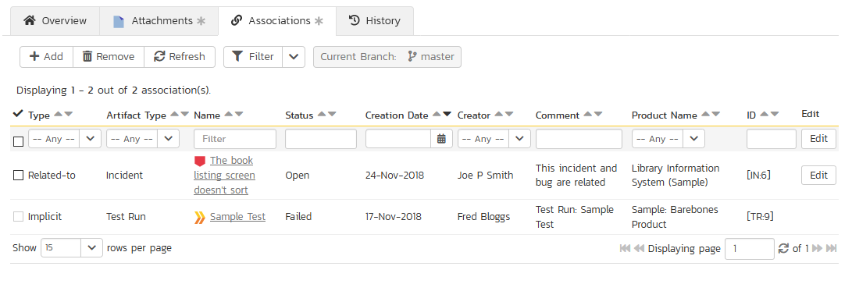

The incidents and tasks in this list are ones that a user has decided are relevant to the current one and has created a direct link between them. In the case of requirements and test cases, the association can be either due to the creator of an incident directly linking the incident to the requirement or test step, or it can be the result of a tester executing a test-run and creating an incident during the test run. In this latter case, the check-box to the left of the association will be unavailable as the link is not editable.

Each association is displayed with the type of association (related-to, vs. a dependency), name of the artifact being linked-to, type of artifact (requirement, incident, etc.), the name of the person who created the association, a comment that describes why the association was made, and the product of the linked artifact. In the case of an indirect association due to a test run, the comment will contain the name of the test run.

You can perform the following actions on an association from this screen:

* **Delete** – removes the selected association to the other artifact. This will only delete the association, not the linked artifact itself.
* **Refresh** – updates the list of associations from the server, useful if other people are adding associations to this incident at the same time.
* **Filter / Apply Filter** – Applies the entries in the filter boxes to the list of associations
* **Clear Filter** – Clears the current filter, so that all associations for the current incident are shown.
* **Edit** – Clicking the “Edit” button to the right of the associations allows you to edit the association type and comment fields inline directly on this screen.

To create a new association, click the “Add” button to display the “Add New Association” panel:

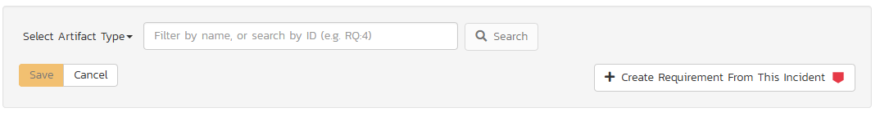

Once you have selected the appropriate artifact type, you will then be able to browse or search for the specific artifact you want to link to. You can also enter the ID of the artifact directly (if known). In either case you can also add a comment that explains the rationale for the association. If you’re adding an association to a test step, the test steps are grouped in their test cases. You can browse the list of test cases within each test case folder.

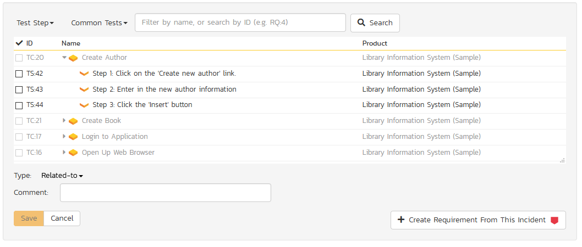

### 6.2.8. Creating a Requirement from an Incident

Sometimes you may have a situation where an enhancement has been logged in the incident tracker and now that it has been approved, it needs to be converted into a formal requirement so that test cases and tasks can be generated from it. To aid this process, there is a button on the Associations tab that allows you to create a new requirement from the current incident and have it be automatically added to the requirements list. When that is performed an association is automatically added that links this new requirement to the original incident.

### 6.2.9. Emailing the Incident

Using the “Email” button on the toolbar, you can send an email containing details of the incident to an email address or another user on the system:



You can specify the subject line for the email, and either a list of email addresses, separated by semicolons, or an existing product user. The content of the email is specified in the System Administration – Notification Templates.

To be notified of any changes made to the current artifact via email, click the “Subscribe” button. If you already subscribed, the button will instead let you “Unsubscribe” to stop receiving emails about that particular artifact.

### 6.2.10. Incident Followers

Using the “Subscribe” button on the toolbar, you can quickly follow the incident, and receive updates on certain changes to it. Depending on your role, you may also see a dropdown to this button, which let’s you add another product member as a follower to this incident.





You can also quickly see who is following an incident under the “People” section in the Overview tab.



To view information about the follower, or to unfollow them from the incident, hover over their avatar to display a user profile card.



## 6.3. Incident Board

The incident board is an alternative to the incident list page (described in section 6.1) designed to let you view the incidents planned for the current product. You can access this feature by clicking on the **Board** icon in the top-right of the Incidents list page. You can switch back to the Incident list page by clicking on the **Table** view.

The incident board has the following different display modes:

* All Releases
  + By Release
  + By Priority
  + By Status
  + By Person
* Release
  + By Sprint
  + By Priority
  + By Status
  + By Person
* Sprint
  + By Priority
  + By Status
  + By Person

Each of these views is described below:

### 6.3.1. Incidents – By Priority

This view is designed to let you see the list of planned incidents organized by priority. Each of the possible priority values is displayed on the left-hand side and the incidents displayed in the same row on the right:

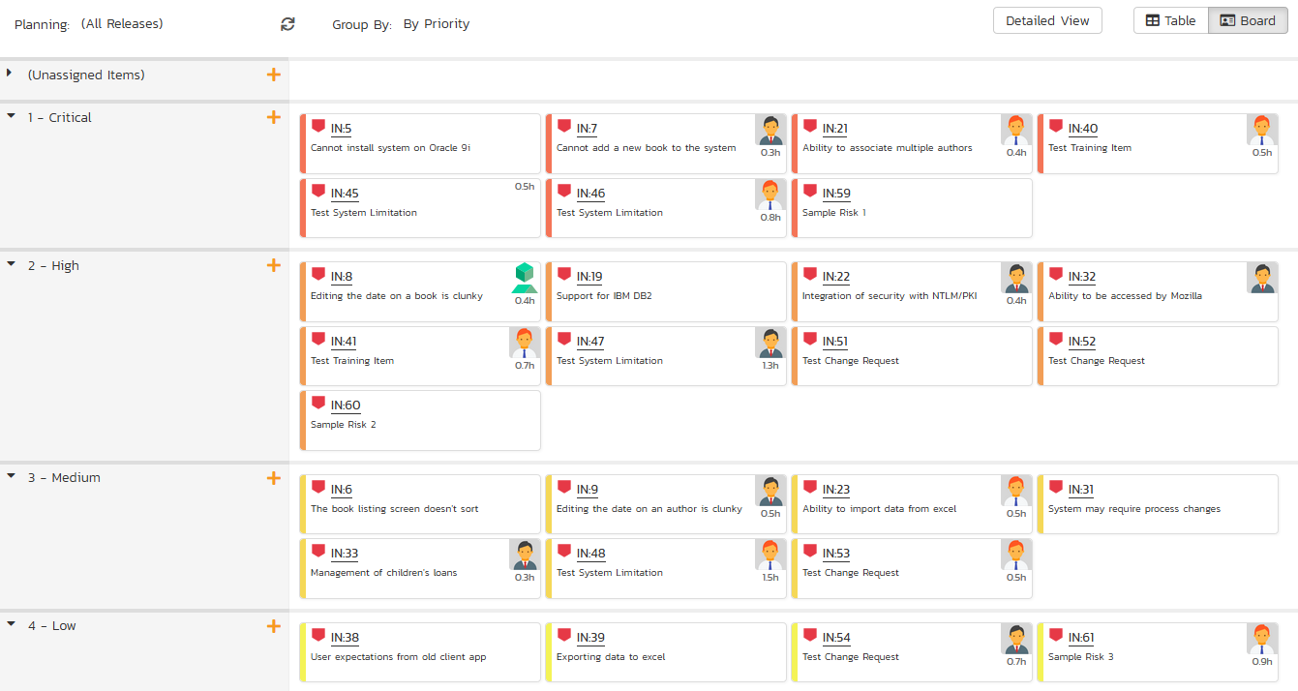

The top section will contain the list of incidents that are not assigned a priority, with the other sections containing the incidents that have been assigned to the specific priority.

### 6.3.2. Incidents – By Status

This view is designed to let you see the incidents in the current product / release / sprint organized by their status. Each incident status (not started, in progress, completed, blocked, deferred) is displayed as a heading, with the incidents displayed in the same column underneath:

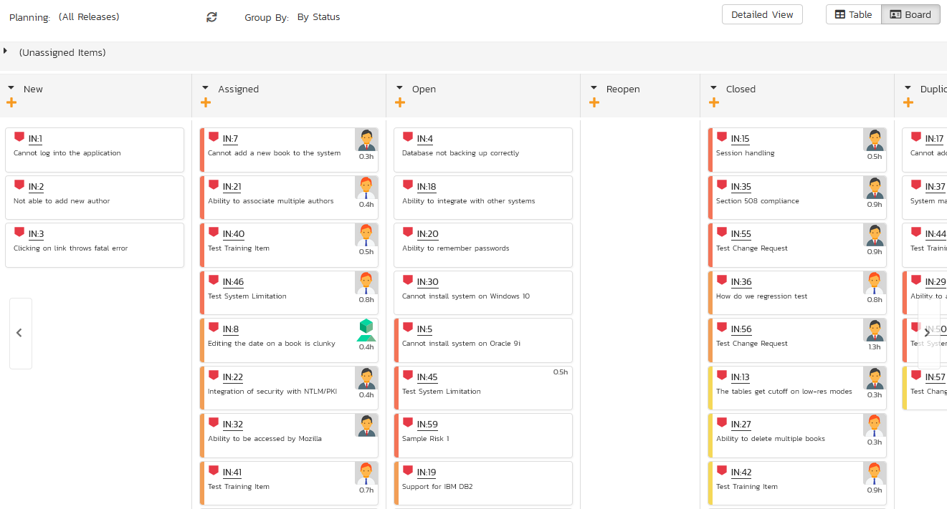

You can click on the expand/collapse icons to hide any resources that are not relevant.

Depending on the view (all releases, release, or sprint), there may be sections with the release and sprint name. You can drag and drop the incidents between statuses or to/from the release/sprint backlog. Any incidents not assigned to a release/sprint will be listed in the (Unassigned Items) section at the top.

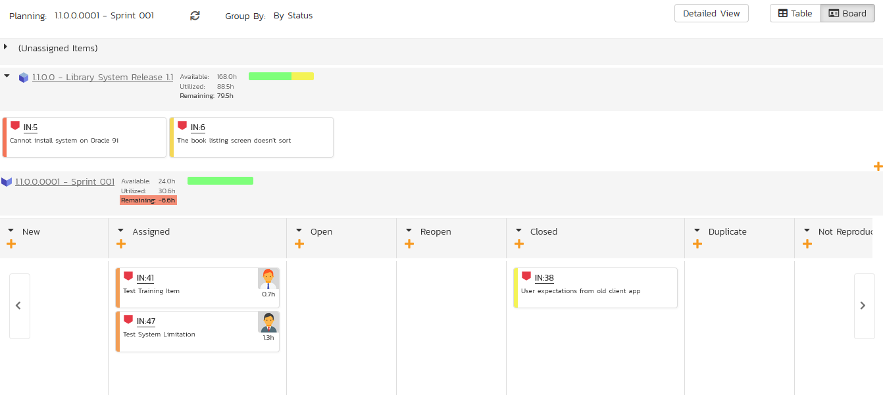

### 6.3.4. Incidents - By Person

This view is designed to let you see the incidents in the current product / release / sprint organized by resource / person. Each of the users that is a member of the current product is displayed as a heading, with the incidents displayed in the same column underneath:

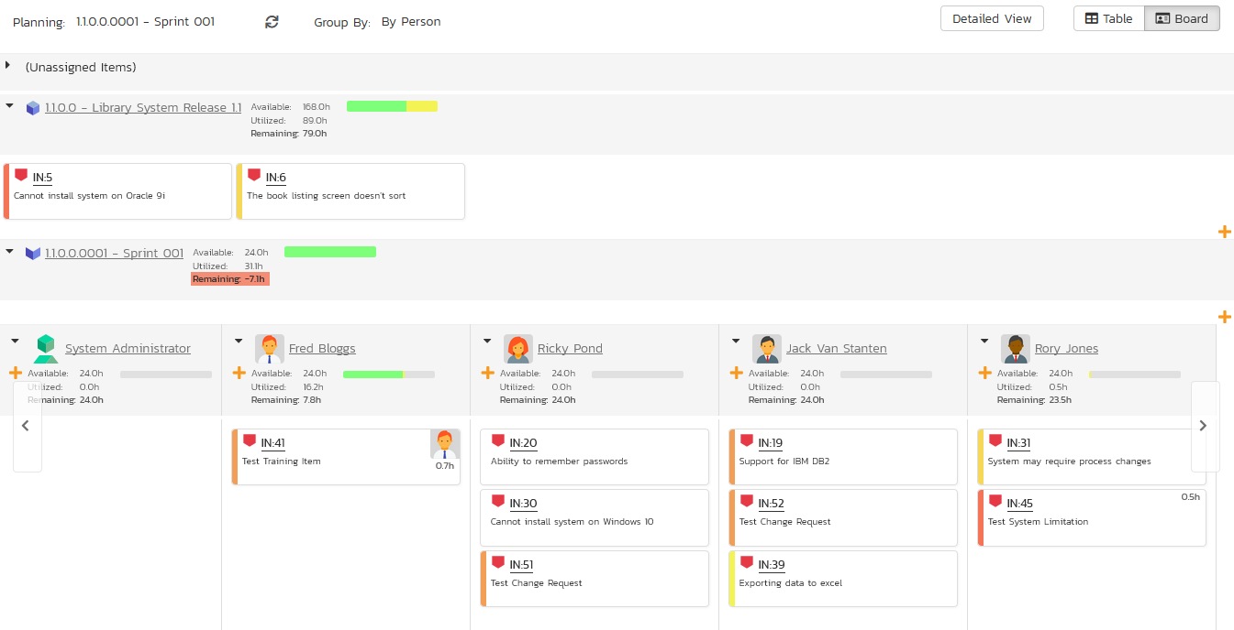

You can click on the expand/collapse icons to hide any resources that are not relevant. The system will display a progress bar for each resource to illustrate the allocation for that resource. Any resource that has a progress bar that is completely green has been fully scheduled and should not have any additional incidents assigned. If the progress bar for that resource turns red, it means that they have been over-scheduled and you need to reassign some of the incidents.

Depending on the view (all releases, release, or sprint), there may be sections with the release and sprint name; they contain incidents that are scheduled for the current release or sprint but have not yet been assigned to a resource. You can drag and drop the incidents between resources or to/from the release/sprint backlog. Any incidents not assigned to a resource and release/sprint will be listed in the (Unassigned Items) section at the top.

### 6.3.4. Incidents - By Release

This view is only available when you are displaying the incident board for ‘all releases’. Each of the active releases defined for the current product is displayed as a heading, with the incidents displayed in the same column underneath

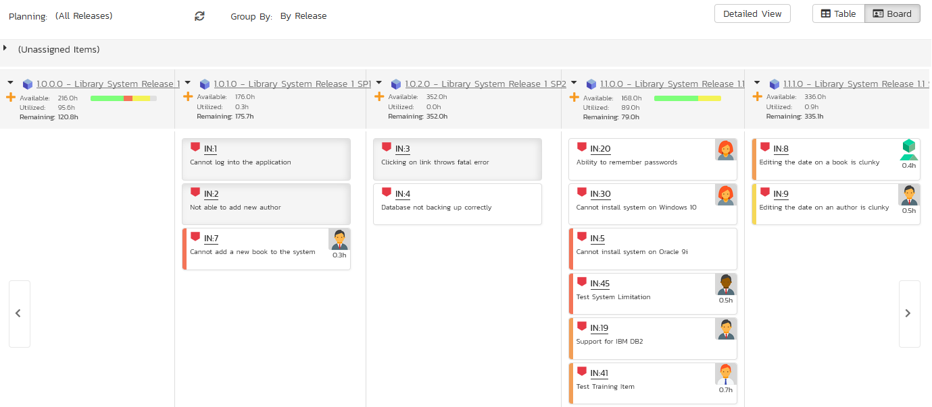

You can drag and drop the incidents between the different releases. Once the incident has been added to the release, the utilized effort for the release will increase, and the available effort will decrease by the same amount.

Note: The system will allow you to assign more incidents to a release than it is possible to complete, however this will result in a negative value for ‘available effort’. If this happens, the “Available Effort” value will be displayed in red, and you need to rebalance the items, extend the release length or add product personnel resources to the release.

Clicking on the release hyperlinks in the headers will switch the incident board into the release view.

### 6.3.4. Incidents - By Sprint

This view is only available when you are displaying the incident board for a specific release. Each of the sprints defined for the current release is displayed as a heading, with the incidents displayed in the same column underneath. This view is commonly used in **Scrum** products:

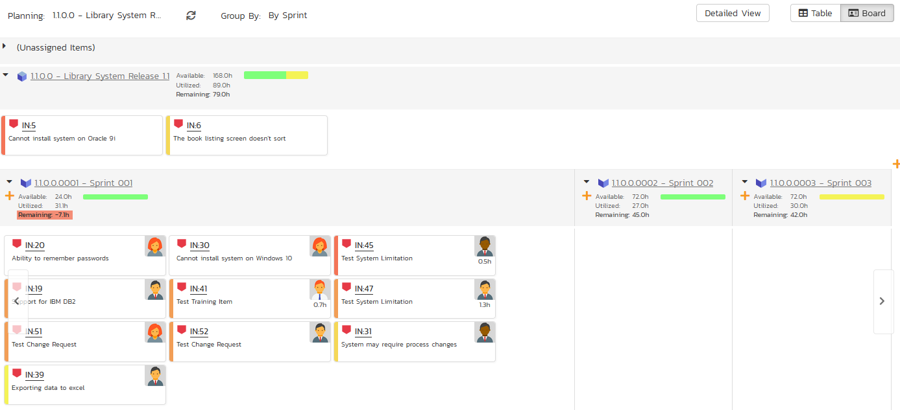

You can drag and drop the incidents between the different sprints. Once the incident has been added to the sprint, the utilized effort for the sprint will increase, and the available effort will decrease by the same amount.

Note: The system will allow you to assign more incidents to a sprint than it is possible to complete, however this will result in a negative value for ‘available effort’. If this happens, the “Available Effort” value will be displayed in red, and you need to rebalance the items, extend the sprint length or add product personnel resources to the sprint.

Clicking on the sprint hyperlinks in the headers will switch the incident board into the sprint view.

# 7. Release Management

This section outlines how to use the Release Management features of SpiraPlan® to manage different versions of the system being tested in a particular product. This is an optional feature of the system, and you can manage the testing for a product successfully without tracking individual releases. Typically, when you develop a system, it is important to ensure that features introduced in successive versions do not impair existing functionality - this is known as *regression testing*.

In such situations, you will want to be able to execute the same set of test scripts against multiple versions of the system and be able to track failures by version. A feature that works correctly in version 1.0 may fail in version 1.1, and the maintenance team may be testing the existing lifecycle of v1.0 in parallel with the development team testing v1.1. Therefore, by developing a master set of releases/versions in the Release Management module, you can have the different testing teams correctly assign their testing actions to the appropriate version.

There are two types of release artifact in SpiraPlan® - major product releases that are displayed with the blue release icon and represent major versions of the system, and release Sprints (aka builds) that are displayed with a yellow icon and represent intermediate builds/sprints of the system. *Note: Sprints can be contained within a Release, but not the other way round.*

The main differences between releases and sprints are as follows:

* Releases are independent versions of the system being tested and as such, you can map a requirement directly to a release, indicating the release of the system that the requirement will be fulfilled in.
* When you report on a release (e.g. on the product home or in one of the reports) any child sprints are automatically taken into account, and test runs and incidents that are related to the child builds/sprints will get included in the release reports. Child releases on the other hand are not aggregated up into the parent release.

## 7.1. Release List

When you click on the Planning > Releases global navigation link, you will initially be taken to the release list screen illustrated below:

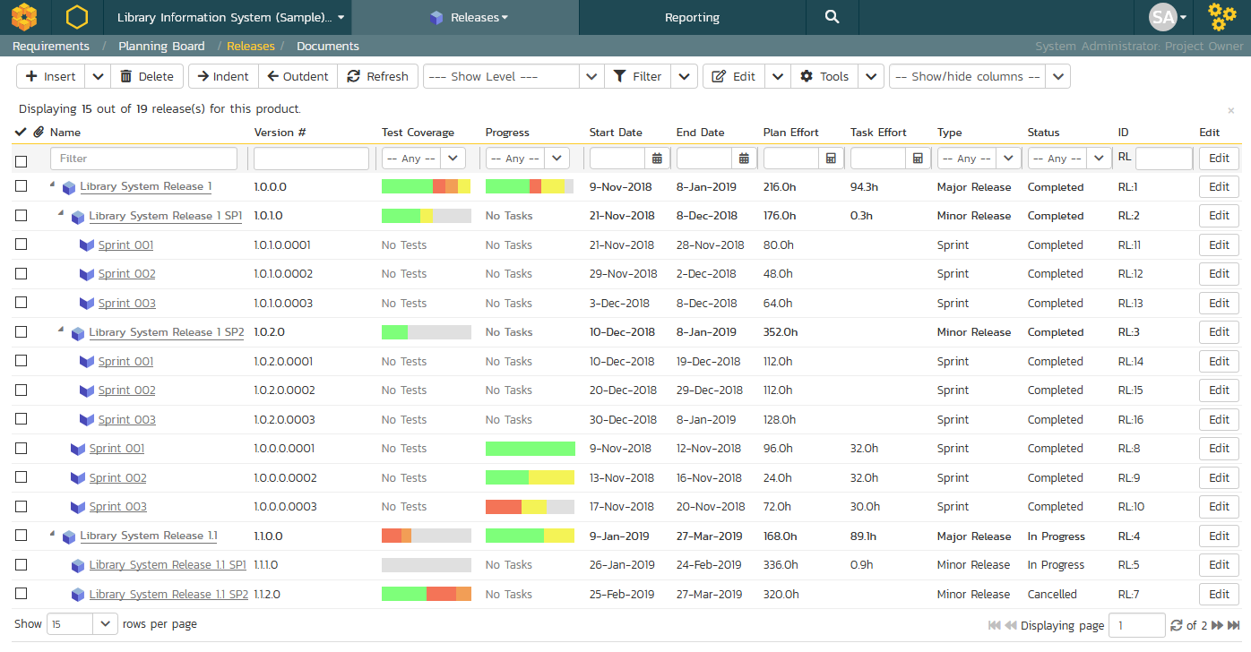

The release list will contain all the releases and sprints associated with current product. When you create a new product, this list will initially be empty, and you will have to use the “Insert” button to start adding releases and sprints to the product. The hierarchical organization of releases in the list is configurable, so you can organize the various releases in the way that makes most sense for a particular product. Typically you have the major releases as the top-level items, with sub-releases, builds and sprints as the lower-level items.

All of the releases in the list have a release-name, together with the assigned version number for that release, the start-date and end-date for the release, the number of estimated product personnel working on that release, the planned effort for the release, the total effort currently scheduled (as tasks), the available effort for new tasking, the release id, the type of each release, its status, and a set of custom properties defined by the product owner.

For those releases that have test cases mapped against them, the execution status of the various test cases associated with the release is displayed in aggregate for each item as a graphical bar diagram. If you position the mouse over the execution status indicator you will see the detailed execution information displayed as a tooltip.

For those releases that have at least one requirement task associated with them, they will display a block graph that illustrates the relative numbers of task that are on-schedule (green), late-starting (yellow), late-finishing (red) or just not-started (grey). These values are weighted by the effort of the task, so that larger, more complex tasks will be change the graph more than the smaller tasks. To determine the exact task progress information, position the mouse pointer over the bar-chart and the number of associated tasks, along with the details of how many are in each status will be displayed as a “tooltip”.

Clicking on a release’s hyperlink will take you to the release details page for the item in question (see section 7.2).

### 7.1.1. Filtering

You can easily filter the list of releases as illustrated in the screen-shot below:

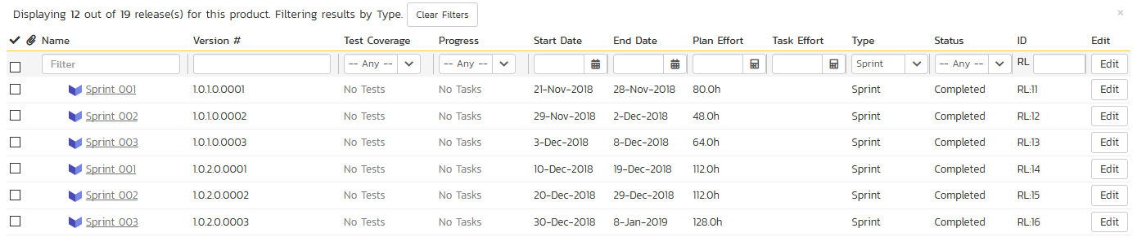

To filter the list by any of the displayed columns, you either choose an item from the appropriate drop-down list or enter a free-text phrase (depending on the type of field) and click “Filter” or press the <ENTER> key. Note that the name field is searched using a “LIKE” comparison, so that searching for “database” would include any item with the word database in the name. The other freetext fields need to be exact matches (e.g. dates, release numbers). Clicking on Filter > Clear Filters clears all the set filters and displays all the releases for the product.

In addition, if you have a set of filters that you plan on using on a regular basis, you can choose the option Filter > Save Filter to add the current filter to the list of saved filters that appear on your ‘My Page’. The list of saved filters can also be retrieved by clicking Filter > Retrieve Filter.

### 7.1.2. Insert

The “Insert” button has an attached dropdown menu that allows you to choose whether to insert a release or sprint (if you just click “Insert” it defaults to inserting a release). In either case, it will insert the new release / sprint *above* the currently selected item – i.e. the one whose check-box has been selected, at the same level in the hierarchy. If you want to insert a release/sprint below a summary item, you need to insert it first, then indent it with the “Indent” button. If you insert a release without first selecting an existing release from the list, the new release will simply be inserted at the end of the list.

Once the new release has been inserted, the item is switched to “Edit” mode so that you can change the default name, active flag, version number and creator.

### 7.1.3. Delete

Clicking on the “Delete” button deletes all the releases whose check-boxes have been selected. If any of the releases have child releases/sprint, then the child releases and sprints are also deleted.

### 7.1.4. Indent

Clicking on the “Indent” button indents all the releases whose check-boxes have been selected. Note: you cannot indent a release or sprint if it is *below* a sprint, as sprints are not allowed to have child items.

### 7.1.5. Outdent

Clicking on the “Outdent” button de-indents all the releases whose check-boxes have been selected.

### 7.1.6. Refresh

Clicking on the “Refresh” button simply reloads the release list. This is useful as other people may be modifying the list of releases at the same time as you, and after stepping away from the computer for a short-time, you should click this button to make sure you are viewing the most current release list for the product.

### 7.1.7. Edit

Each release/sprint in the list has an “Edit” button display in its right-most column. When you click this button or click on any of the cells in the row, you change the item from “View” mode to “Edit” mode. The various columns are made editable, and “Save” “Cancel” buttons are displayed in the last column:

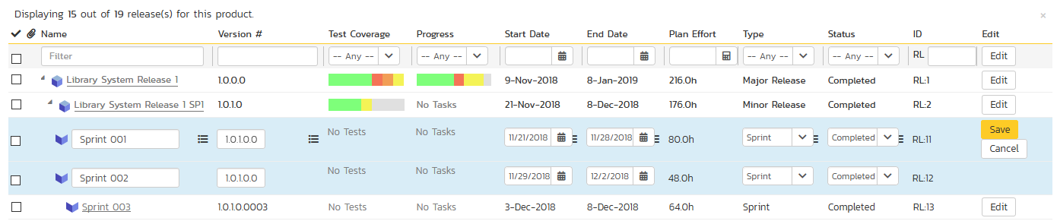

If you click “Edit” on more than one row, the “Save” and “Cancel” buttons are only displayed on the first row, and you can make changes to all the editable rows and then update the changes by clicking the one “Save” button. Also, if you want to make the same change to multiple rows (e.g. to change five releases from “active” to “inactive”), you can click on the “fill” icon to the right of the editable item, which will propagate the new value to all editable items in the same column.

If you want to edit lots of items, first select their checkboxes and then click the “Edit” button on the same row as the Filters and it will switch all the selected items into edit mode.

When you have made your updates, you can either click “Save” to commit the changes, or “Cancel” to revert back to the original information. Alternatively, pressing the <ENTER> key will commit the changes and pressing the <ESCAPE> key will cancel the changes.

### 7.1.8. Show Level

Choosing an indent level from the ‘Show Level’ drop down box allows you to quickly and easily view the entire release list at a specific indent level. For example you may want to see all releases drilled-down to the *third* level of detail. To do this you would simply choose ‘Level 3’ from the list, and the releases will be expanded / collapsed accordingly.

### 7.1.9. Show / Hide Columns

This drop-down list allows you to change the fields that are displayed in the release list as columns for the current product. To show a column that is not already displayed, simply select that column from the list of “Show…” column names and to hide an existing column, simply select that column from the list of “Hide…” column names. This is stored on a per-product basis, so you can have different display settings for each product that you are a member of. The fields can be any of the built-in fields or any of the custom properties set up by the product owner.

### 7.1.10. Copying Releases/Sprints

To copy a release/sprint or set of releases/sprints, simply select the check-boxes of the release/sprint you want to copy and then select the Edit > Copy Items menu option. This will copy the current release/sprint selection to the clipboard. Then you should select the place where you want the releases/sprints to be inserted and choose the Edit > Paste Items option.

The releases/sprints will now be copied into the destination location you specified. The name of the copied releases/sprints will be prefixed with “Copy of…” to distinguish them from the originals. Note that copied releases/sprints will also include the test mapping information from the originals.

### 7.1.11. Moving Releases/Sprints

To move a release/sprint in the hierarchy, there are two options:

1. Click on the release/sprint you want to move and drag the icon to the location you want it moved. An empty space will appear to show you where it will be inserted. Once you have the requirement positioned at the correct place that you want it inserted, just release the mouse button. To move multiple items simply select their checkboxes and then drag-and-drop one of the selected items
2. Alternatively you can simply select the check-boxes of the release/sprint you want to move and then select the Edit > Cut Items menu option. This will cut the current release/sprint selection to the clipboard. Then you should select the place where you want the release/sprint to be inserted and choose the Edit > Paste Items option. The release/sprint will now be moved into the destination location you specified.

### 7.1.12. Exporting Releases/Sprints

To export releases/sprints from the current product to another product in the system, select the check-boxes of the releases/sprints you want to export and then click the Tools > Export to Product item. This will then bring up a list of possible destination products:

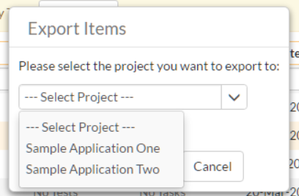

Once you have chosen the destination product and clicked the “Export” button, the releases/sprints will be exported from the current product to the destination product. Any file attachments will also be copied to the destination product along with the release/sprint.

### 7.1.13. Creating Test Sets from Releases

As a shortcut you can click the Tools > Create Test Set option to create a new test set for each of selected releases. The created test sets will include all of the test cases associated with a release. This is useful in regression testing when you have created a new release and want to be able to quickly assign a tester to ensure that all the functionality in the release works as expected.

### 7.1.14. Printing or Saving Items

To quickly print a single release/sprint or list of releases/sprints you can select the items’ checkboxes and then click Tools > Print Items. This will display a popup window containing a printable version of the selected items. You can also save the report in a variety of common formats from the same Tools menu.

### 7.1.15. Right-Click Context Menu

SpiraPlan® provides a shortcut – called the *context menu* - for accessing some of the most commonly used functions, so that you don’t need to move your mouse up to the toolbar each time. To access the context menu, right-click on any of the rows in the release list and the following menu will be displayed:

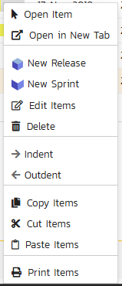

You can now choose any of these options as an alternative to using the icons in the toolbar

## 7.2. Release Details

When you click on release item in the release list described in section 7.1, you are taken to the release details page illustrated below:

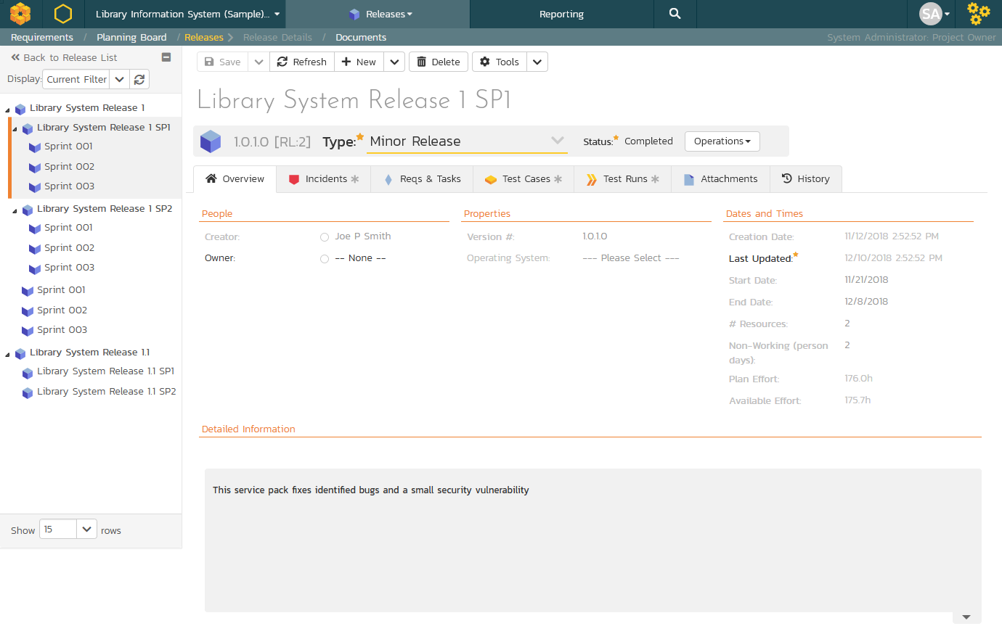

This page is made up of *three* areas;

1. the left pane displays the releases list navigation;
2. the right pane’s header, which displays: the operations toolbar; the editable name of the selected release; and the info bar (with a shaded background), which also contains the workflow status transitions (see below); and
3. the right pane’s tabbed interface with rich information related to the release.

Please note that on smaller screen sizes the navigation pane is not displayed. While the navigation pane has a link to take you back to the releases list, on mobile devices a ‘back’ button is shown on the left of the operations toolbar.

The navigation pane can be collapsed by clicking on the “-“ button, or expanded by clicking anywhere on the gray title area. On desktops the user can also control the exact width of the navigation pane by dragging and dropping a red handle that appears on hovering at the rightmost edge of the navigation pane.

The navigation pane consists of a link that will take you back to the release list, as well as a list of the other releases in the current product. This latter list is useful as a navigation shortcut; you can quickly view the test run information of all the other releases by clicking on the navigation links without having to first return to the release list page. The navigation list can be switched between two different modes:

* The list of releases matching the current filter
* The list of all releases, irrespective of the current filter

If you are editing an existing item, the fields that are available and the fields that are required will depend on your stage in its workflow. The types of change allowed and the email notifications that are sent will depend on how your product administrator has setup the system for you. Administrators should refer to the *SpiraPlan Administration Guide* for details on configuring workflows to meet their needs.

Depending on the user’s role and whether they are listed as the owner or author of the requirement, displayed in the info bar beneath the requirement name is the current workflow status and an “operations” button which, when clicked, will show a set of allowed workflow operations.

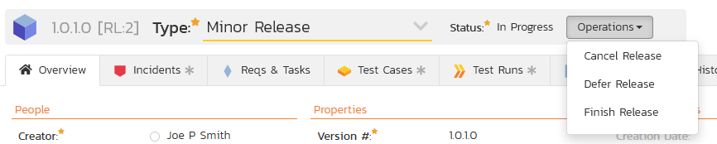

Releases can have the following statuses: planned, in progress, completed, closed, deferred, and cancelled. Note that releases marked as closed, deferred, or cancelled cannot be associated with other artifacts – for example an incident’s resolved release cannot by a cancelled release.

Workflow transitions allow the user to move the item from one status to another. For example when the release is in the In Progress status, you will be given the options to:

* **Cancel Release** – changes status to “Cancelled”
* **Defer Release** – changes the status to “Deferred”
* **Finish Release** - changes the status to “Completed”

Please note that if digital signatures have been enabled for a particular workflow operation (and therefore a digital signature is required to confirm the status change. Workflow operations requiring a digital signature are marked with a padlock icon as in the example below:

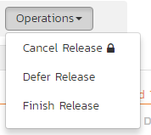

On attempting to save changes made after clicking a workflow operation that requires a digital signature you will be presented with a popup similar to the one below (which is for a requirement):



The top part of the right pane allows you to view and/or edit the details of the particular release. In addition you can delete the current artifact by choosing “Delete”, discard any changes made by clicking “Refresh”, or print or export it by clicking one of the options from the Tools dropdown menu. The lower part of the right pane can be in one of eight possible modes that can be selected: “Overview”, “Incidents”, “Reqs & Tasks”, “Test Cases”, “Test Runs”, “Attachments”, and “History”. Each of the different views is described separately below.

Using the “Email” button on the toolbar, you can send an email containing details of the release to an email address or another user on the system:



You can specify the subject line for the email, and either a list of email addresses, separated by semicolons, or an existing product user .The content of the email is specified in the System Administration – Notification Templates.

To be notified of any changes made to the current artifact via email, click the “Subscribe” button. If you already subscribed, the button will instead let you “Unsubscribe” to stop receiving emails about that particular artifact. Depending on your role, you may also see a dropdown arrow to the right of this button. This will let you subscribe others in the product to this artifact.

The bottom part of the right pane can be switched between six views: “Overview”, “Incidents”, “Requirements and Tasks”, “Test Cases”, “Test Runs”, “Attachments”, and “History”, each of which will be described in more detail below.

### 7.2.1. Overview – Details

The Overview tab is divided into a number of different sections. Each of these can be collapsed or expanded by clicking on the title of that section. It displays the description, fields and comments associated with the requirement.

The top part of this tab displays the various standard fields and custom properties associated with the requirement. Fields (both standard and custom) are grouped under the collapsible headings (marked by orange text and underline) in the screenshot below. For instance, all fields regarding dates are grouped together in the “Dates and Times” area.

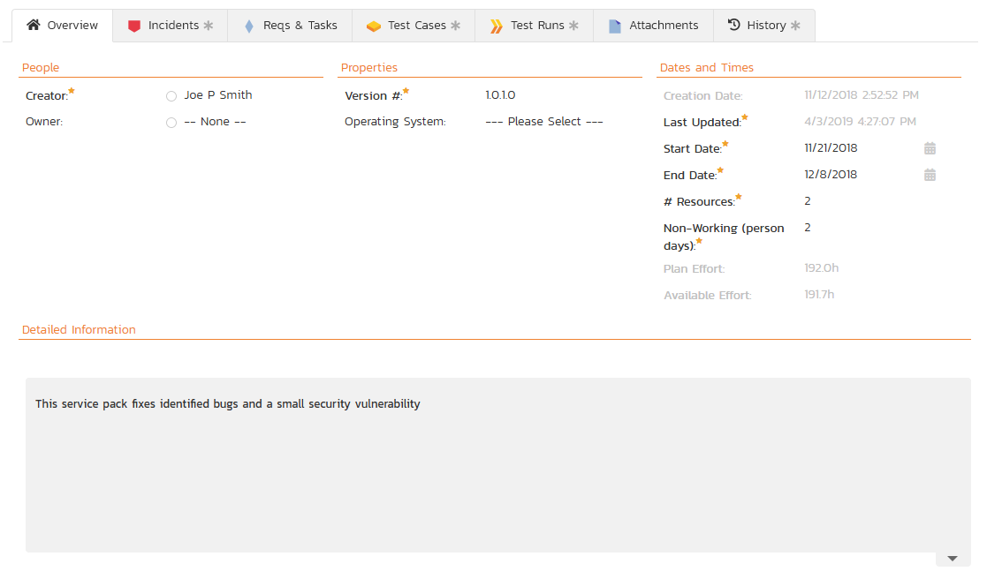

When you make changes to the release/sprint’s start-date, end-date, number of product personnel resources, or number of non-working *person* days, the system will automatically calculate how many hours of effort (planned effort) are available in the release/sprint for assigning tasks. As you begin assigning tasks – either through the Tasks tab or the Sprint Planning screen – the total estimated effort of the tasks is subtracted from this planned effort to give the “available effort”.

### 7.2.1.1. Followers

Using the “Subscribe” button on the toolbar, you can quickly follow the item, and receive updates on certain changes to it. Depending on your role, you may also see a dropdown to this button, which let’s you add another product member as a follower to this item.





You can also quickly see who is following an incident under the “People” section in the Overview tab.



To view information about the follower, or to unfollow them from the item, hover over their avatar to display a user profile card.



### 7.2.1.2. Overview – Detailed Information

The Detailed Information section contains the long, formatted description of the requirement, as well as any rich text custom fields. You can enter rich text or paste in from a word processing program or web page into these fields. Clicking on the shaded areas of one of these detailed fields will display the rich text toolbar.

### 7.2.2. Overview - Comments

The Comments tab shows the current discussion thread for this release:



All existing comments are listed in order by entered date (either newest-first or oldest-first). To create a new comment, enter the text into the text box, and then click the “Add Comment” button.

### 7.2.3. Overview - Builds

This section displays the list of builds associated with the current release/sprint. Each build is listed together with its name, creation date, status (whether the build succeeded or failed), and last updated date. Clicking on the hyperlink for the build name will open up the Build Details page which is described in section 7.3 of this manual.

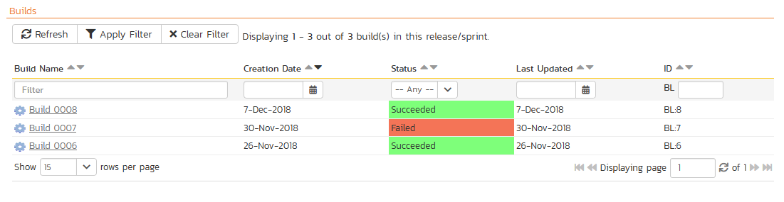

You can also filter the results by choosing items from the filter options displayed in the sub-header row of each field and clicking the “Apply Filter” button. In addition, you can quickly sort the list by clicking on one of the directional arrow icons displayed in the header row of the appropriate field.

### 7.2.4. Incidents

This tab displays the incidents associated with the selected release. The incident list can be one of three modes:

* Detected in this Release – this will display a list of all the incidents that were detected during the testing of the selected release. This is useful in determining if there are open incidents associated with a release that need to be dealt with.
* Resolved in this Release – This will display a list of all the incidents that have been reportedly resolved in this release. This is useful for double-checking that all the resolved incidents for a release have indeed been fixed.
* Verified in this Release – This will display a list of the incidents that have been verified as being fixed in this release. This is useful for generating release notes for a specific release indicating what changes and enhancements have been made in the release.

Regardless of the mode, each incident is listed together with the type, status, priority, name, owner, detector, detection date and a link to the actual incident details (see section 6.2):

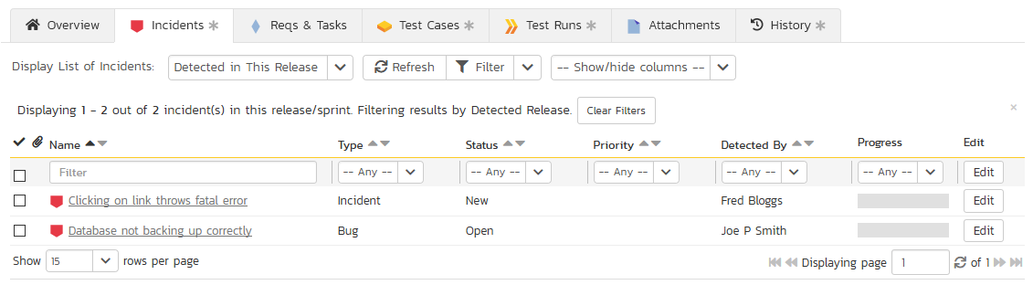

To change between the three modes outlined above, select the desired mode from the drop-down list contained within the header of the incident list table.

You can perform the following actions:

* **Refresh** – updates the list of incidents from the server, useful if other people are adding incidents to this release at the same time.
* You can **filter** the results by choosing items from the filter options displayed in the sub-header row of each field and clicking the “Filter” button. In addition, you can quickly sort the list by clicking on one of the directional arrow icons displayed in the header row of the appropriate field.
* **Edit** – Clicking the “Edit” button to the right of the incident allows you to edit the incident inline directly on this screen. This functionality is limited to product owners.
* **Show/Hide Columns** – Allows you to choose which incident columns are visible

### 7.2.5. Reqs & Tasks

This tab displays the list of requirements and their associated child tasks that need to be completed for the release/sprint to be completed:

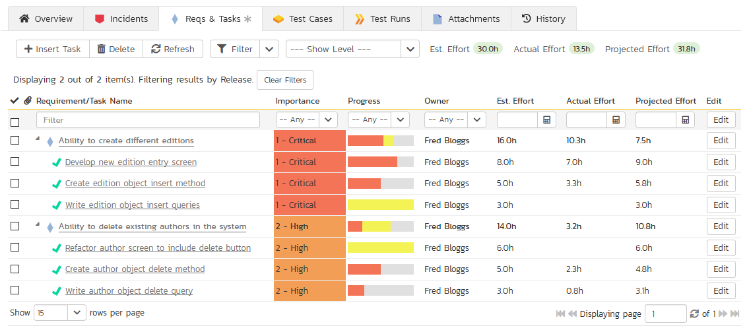

Each of the requirements and associated tasks is displayed together with its name, description (by hovering the mouse over the name), priority, progress indicator, current owner, estimated effort, actual effort, producted effort and numeric task identifier. Clicking on a requirement will bring up the requirement details page (see section 4.2). Clicking the triangle by a requirement will expand/collapse its list of tasks. Clicking on a task name will bring up the Task Details page which is described in more detail in section 8.2. This allows you to edit the details of an existing task.

You can perform the following actions on a task from this screen:

* **Insert Task** – inserts a new task in the task list under the specified requirement, with a default set of values. The task will be associated with the specified requirement and current release/sprint. If no requirement is selected, the task will only be associated with the current release/sprint
* **Delete** – deletes the task from the product.
* **Refresh** – updates the list of requirements and tasks from the server, useful if other people are adding requirements and/or tasks to this release/sprint at the same time.
* You can **filter** the results by choosing items from the filter options displayed in the sub-header row of each field and clicking the “Filter” button. In addition, you can quickly sort the list by clicking on one of the directional arrow icons displayed in the header row of the appropriate field.
* **Edit** – Clicking the “Edit” button to the right of the requirement or task allows you to edit the item inline directly on this screen. Only columns visible will be editable.
* **Show Level** – Allows you to quickly expand/collapse all the requirements in the list.

### 7.2.6. Test Cases

This tab shows the test coverage information for the release in question:

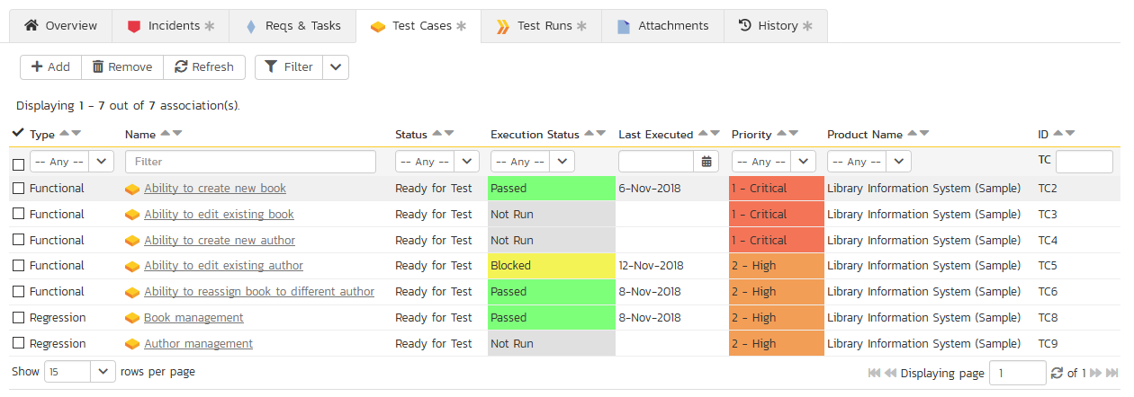

The tab displays a grid containing the test cases already mapped to this release. You can filter that list by the test case type, name, status, execution status, execution date, priority, product name and ID. You can remove an existing test case by selecting its check box and clicking the ‘Delete’ button. This doesn’t delete the test case, just removes it from the release.

Hovering the mouse over the names of the test cases will display a “tooltip” consisting of the test case name, place in the folder structure and a detailed description.

To add a new test case to the release, simply click on the ‘Add’ button:

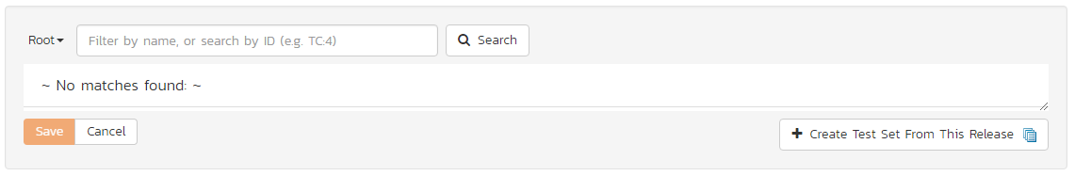

You can search for a test case by its ID if you know it (make sure to include the “TC” prefix):

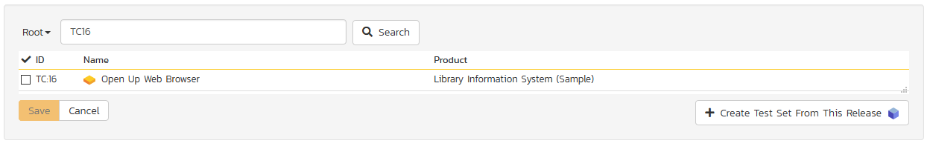

Otherwise, you can search for the test cases by choosing a folder from the dropdown and/or entering a partial name match:

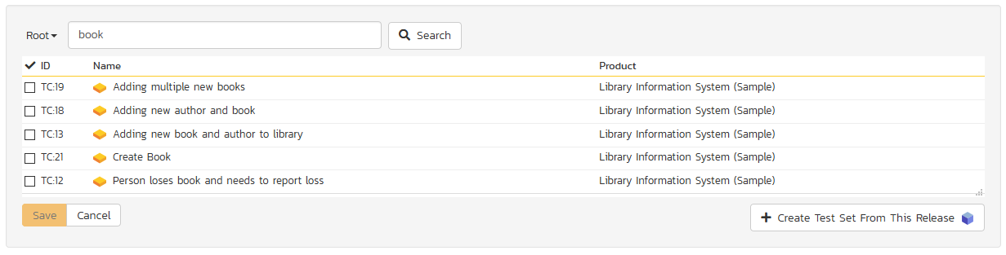

One you have found the desired test case(s), simply select their check boxes and click the ‘Save’ button to add them to the current release.

Finally, as a shortcut you can click the “Create Test Set from This Release” link to create a new test set from this release, that will include all of the test cases associated with this release. This is useful in regression testing when you have created a new release and want to be able to quickly assign a tester to ensure that all the functionality in the release works as expected.

### 7.2.7. Test Runs

This view displays the list of all the test runs executed against the release. Each test run is listed together with the date of execution, the name of the test case, the name of the tester, the release/version of the system that the test was executed against, the name of the test set (if applicable), the overall execution status for the test case in that run and a link to the actual test run details (see section 5.6). In addition, you can choose to display any of the custom properties associated with the test run.

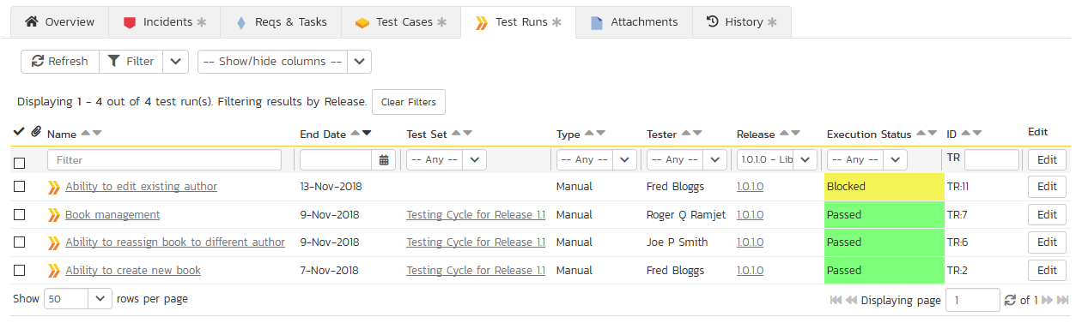

The “Show/hide columns” drop-down list allows you to change the fields that are displayed in the test run list as columns. To show a column that is not already displayed, simply select that column from the list of “Show…” column names and to hide an existing column, simply select that column from the list of “Hide…” column names. The displayed columns can be any standard field or custom property.

You can also filter the results by choosing items from the filter options displayed in the sub-header row of each field and clicking the “Filter” link. In addition, you can quickly sort the list by clicking on one of the directional arrow icons displayed in the header row of the appropriate field.

### 7.2.8. Attachments

In this mode, the lower section of the screen displays the list of documents that have been “attached” to the release. The documents can be in any format, though SpiraPlan® will only display the icon for certain known types.

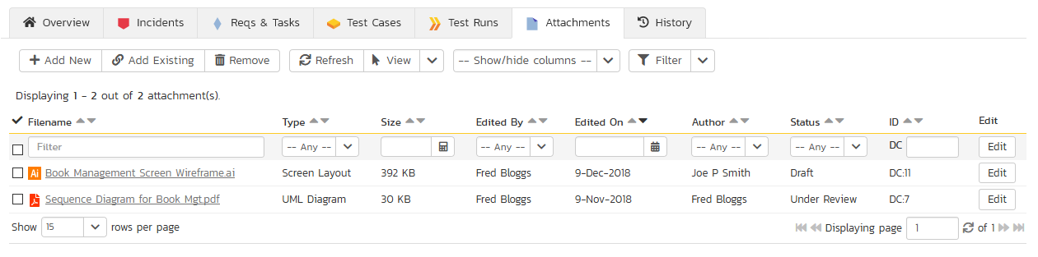

The attachment list includes the filename that was originally uploaded together with the file-size (in KB), name of the person who attached it and the date uploaded. In addition, if you position the pointer over the filename and hold it there for a few seconds, a detailed description is displayed as a tooltip.

To actually view the document, simply click on the filename hyperlink and a new web browser window will open. Depending on the type of file, this window will either display the document or prompt you for a place to save it on your local computer. To delete an existing attachment from an incident, click the “Remove” button and the attachment will be removed from the list.

To attach a new document to the release, you need to first click the “Add New” link to display the new attachment dialog box:



There are three different types of item that can be attached to a release:

* To upload a file, choose “File” as the type and then click the Browse button and select the file from your local computer, optionally enter a detailed description then click the “Upload” button. The document will be copied from your computer and attached to the artifact.
* To attach a web-link (URL) to the artifact, you need to choose “URL” as the type and then enter the fully qualified URL (e.g. [http://mywebsite.com?Document=1](http://mywebsite.com/?Document=1)), an optional description and then click the “Upload” button to attach the web-link.
* To attach a screenshot to the artifact, you need to choose “Screenshot” as the type and then copy the image to your computer’s clipboard (e.g. on Windows computers, the PRINT SCREEN button captures the current page and adds to the clipboard). Once the image is in the clipboard, paste it into the editor using CTRL+V (or the equivalent keystroke for your operating system) and the item will appear in the preview window. You can then fill in the other fields and click “Upload” to attach the image.

Note: If you are using a non-Windows® computer (e.g. Macintosh®) that doesn’t put file extensions on filenames (e.g. .xls for an Excel sheet) automatically, then you will need to manually add the file extension to the filename before uploading if you want it to be displayed with the correct icon in the attachment list.

You can also associate an existing document (that’s already stored in SpiraTeam) with the incident. To do that, click on the “Add Existing” button to bring up the add file association dialog box:



You can then choose to either associate a document stored in the SpiraPlan Documents repository or (in the case of SpiraPlan/SpiraTeam but not SpiraTest) from the linked source code repository. In either case you first select the appropriate folder, and then pick the document(s) from the file list on the right. In the case of a source code file association you can also add a comment.

### 7.2.9. View History

In this mode, the main pane displays the list of changes that have been performed on the release artifact since its creation. An example release change history is depicted below:

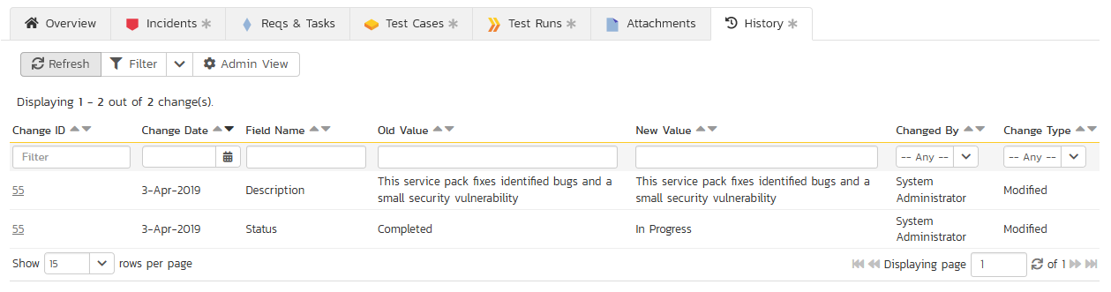

The change history displays the date that each change was made, together with the fields that were changed, the old and new values and the person who made the change. This allows a complete audit trail to be maintained of all changes in the system. In addition, if you are logged in as a product administrator you can also click on the “Admin View” button to revert any unwanted changes.

## 7.3. Build Details

When you click on a build entry in the build list, you are taken to the build details page illustrated below:

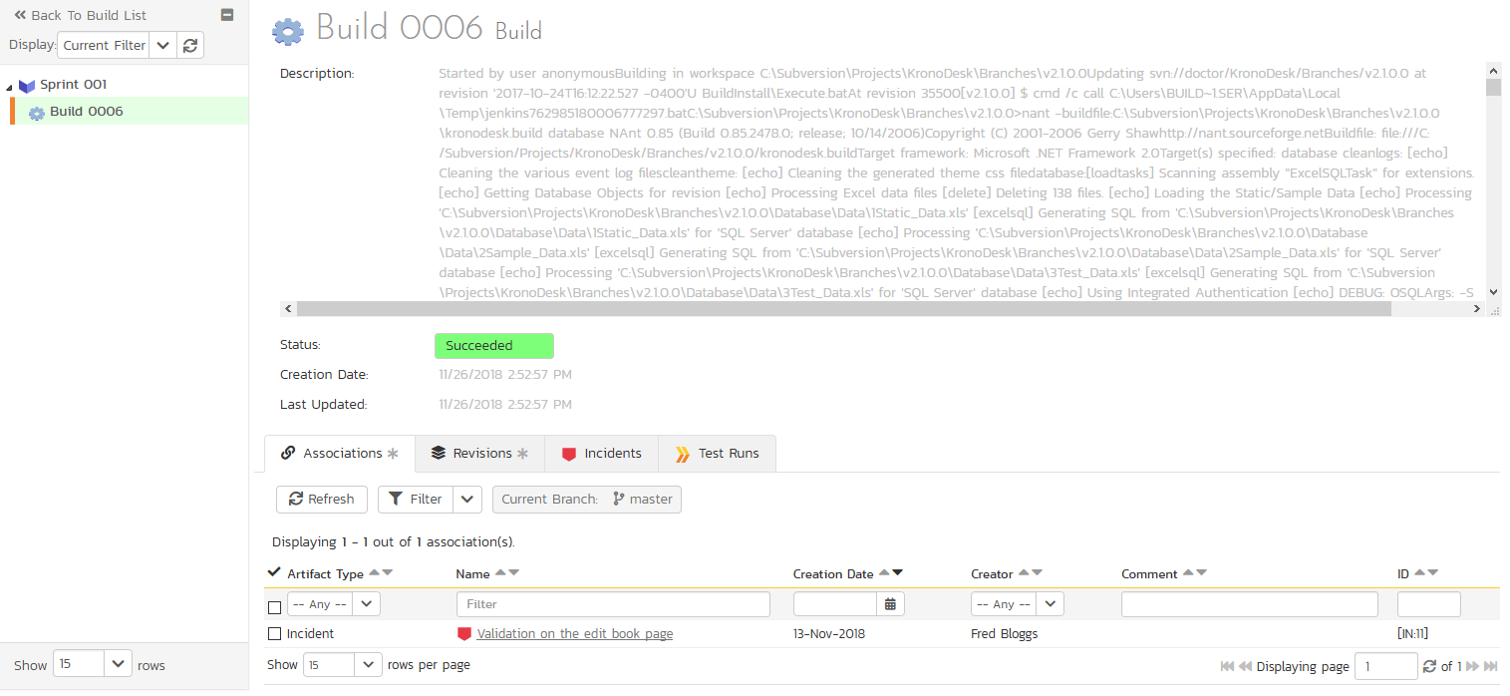

This page is made up of three areas; the left pane is the navigation window, the upper part of the right pane contains the build detailed information itself, and the bottom part of the right pane displays different information associated with the build.

The navigation pane consists of a link that will take you back to the build list, as well as a list of the other builds that belong to the same release/sprint as the current one. The top part of the right pane allows you to view the details of the build including a detailed description of why it succeeded or failed. Since builds are populated from an external Continuous Integration server the build information will always be read-only inside the SpiraPlan user interface.

The lower part of the right pane contains tabs that can display different information associated with the build. Each of the tabs – “Associations”, “Incidents”, “Revisions”, and “Test Runs” - is described separately below.

### 7.3.1. Associations

This tab displays a list of SpiraPlan artifacts that have been associated with any of the source code revisions (see section 7.4.3 below) that were included in the current build:

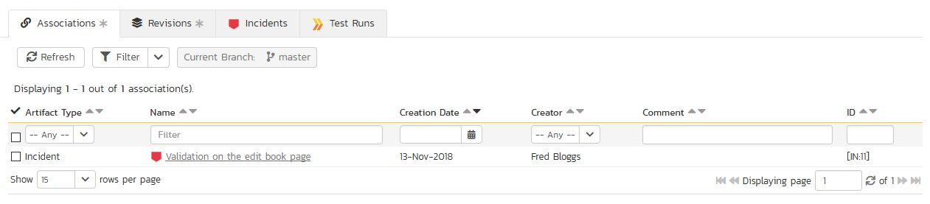

### 7.3.2. Revisions

This tab displays a list of the source code revisions that were included in the current build. The grid can be sorted and filtered by using the appropriate controls:

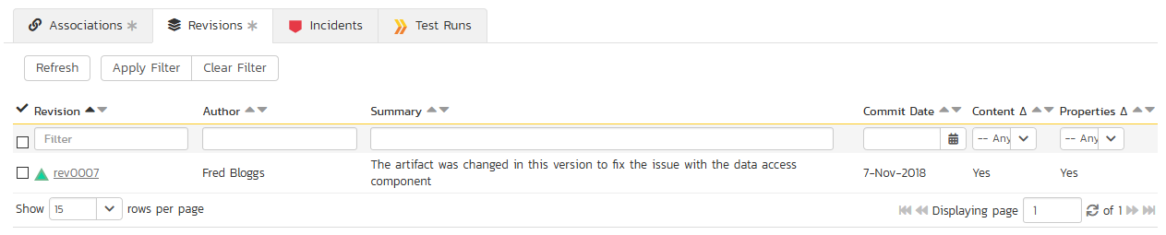

### 7.3.3. Incidents

This tab displays the list of incidents that have been fixed in the current build. The grid can be sorted and filtered by using the appropriate controls:

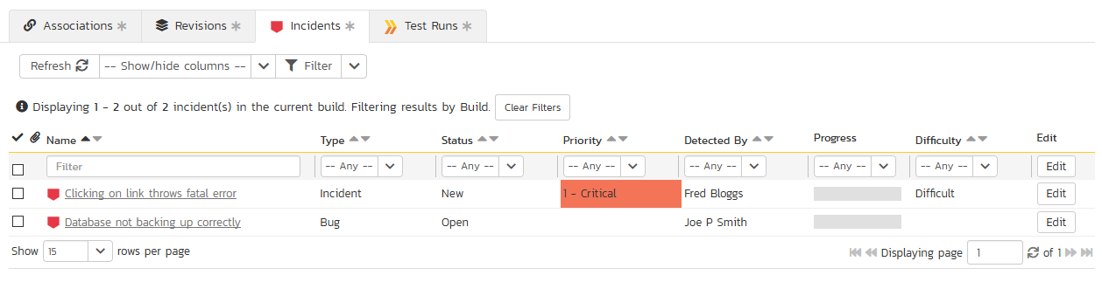

### 7.3.4. Test Runs

This tab displays a list of all the tests that have been executed against the current build. The grid can be sorted and filtered by using the appropriate controls:

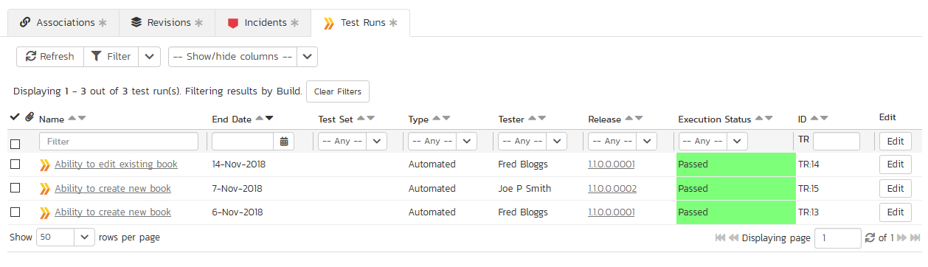

# 8. Task Tracking

This section outlines how you can use the Task Tracking features of SpiraPlan® and SpiraPlan® to view and manage the discrete activities that each member of the development team would need to carry out for the requirement to be fulfilled. Each task can be assigned to an individual user as well as associated with a particular release or sprint. The system can then be used by the product manager to track the completion of the different tasks to determine if the product is on schedule.

The tasks can be organized into different folders as well as categorized by different types (development, testing, infrastructure, etc.), each of which can have its own *workflow* which defines the process by which the task changes status during the product lifecycle.

## 8.1. Task List

When you click on the Tracking > Tasks global navigation link, you will initially be taken to the tasks list screen illustrated below:

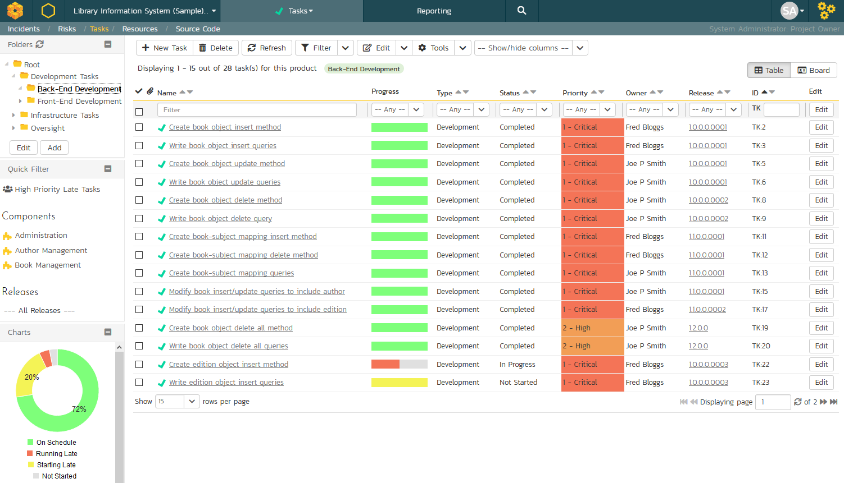

The task list screen displays all the tasks entered for the current product by folder, in a filterable, sortable grid. The grid displays the task number together with fields such as priority, name, assigned owner, start date, end date, scheduled release, etc. The choice of columns displayed is configurable per-user, per-product, giving extensive flexibility when it comes to viewing and searching tasks.

In addition, you can view a more detailed description of the task by positioning the mouse pointer over the task name hyperlink and waiting for the popup “tooltip” to appear. If you click on the task name hyperlink, you will be taken to the task details page described in section 8.2. Clicking on any of the pagination links at the bottom of the page will advance you to the next set of tasks in the list according to the applied filter and sort-order. There is also a drop-down-list at the bottom of the page which allows you to specify how many rows should be displayed in each page, helping accommodate different user preferences.

One special column that is unique to tasks is the ‘progress indicator’. This illustrates graphically both the percentage completion of the task and also if the task is either starting late or finishing late. The following table illustrates the different type of status that can be conveyed by the indicator:

|  |  |
| --- | --- |
| Indicator Display | Progress Description |
|  | Task has not yet started, but the scheduled start date is still in the future. |
|  | Task has not yet started, and the start date has elapsed. This is considered a ‘Late Starting Task’ |
|  | Task has started, and is approximately 25% complete. The scheduled end date is still in the future. |
|  | Task has started, and is approximately 50% complete. However the scheduled end date has elapsed already. This is a considered a ‘Late Finishing Task’. |
|  | Task has been 100% completed. |

Essentially, the gray section of the bar indicates the % of the task yet to be completed, and the green/red section of the bar indicates the % of the task that has already been completed. If the bar changes from green to red it means that the end date has been reached and the task is not yet complete, and if the background changes from gray to yellow it means that the task has not yet started, but the scheduled start date has passed.

### 8.1.1. Task Folders

SpiraPlan lets you group product tasks into different folders to make organization easier. In the left-hand **Quick Filters** panel, the system displays the various task folders defined in the product:

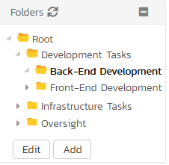

If you are a product administrator, you will see the ‘Edit’ and ‘Add’ buttons beneath the folder tree, this lets you add, edit and delete task folders in the product. To add a new folder, click the ‘Add’ button:

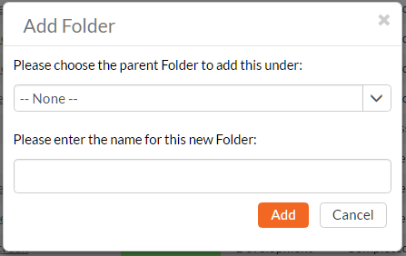

Choose the parent folder that you want to add the new folder under (or None if you are adding a new top-level folder) from the dropdown list and then enter the name of the new folder. Then click ‘Add’ to save the new folder.

To edit or delete an existing folder, simply click the “Edit” button to switch the folder tree to edit mode. To edit or delete a specific folder, click on the “Edit” button next to the folder:

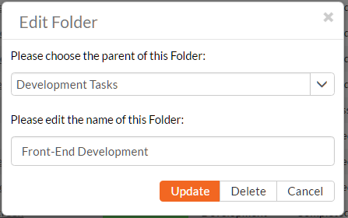

You can change the parent folder and/or name of the folder and click “Update” to commit the change or click “Delete” to delete the folder entirely.

To move a task / tasks between folders, click and drag the relevant task/tasks from the table on the right, and drag them over the desired folder in the tree view on the left. The destination folder will be highlighted to show where the task will be placed.

### 8.1.2. Sorting and Filtering

You can easily filter and sort the list of tasks as illustrated in the screen-shot below:

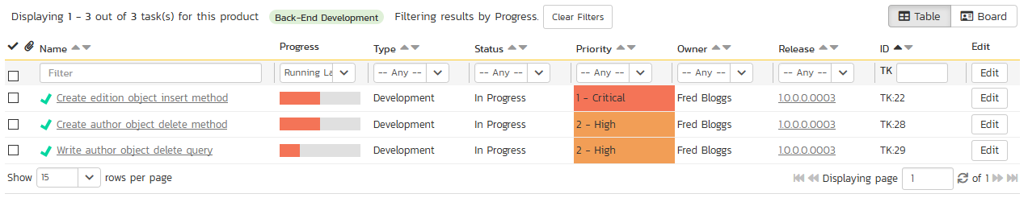

To filter the list by progress, status, priority, owner or release, you simply choose an item from the appropriate drop-down list, and for the other fields, you enter a free-text phrase and click “Filter” or press the <ENTER> key to apply. Note that the name field is searched using a “LIKE” comparison, so that searching for “database” would include any item with the word database in the name. The other freetext fields need to be exact matches (e.g. dates, task numbers).

To change the column that is sorted, or to change the direction of the current sort, simply click on the up/down arrow icon in the appropriate column. The currently sorted column is indicated by the darker arrow. In the screen-shot above, we have filtered on tasks that are finishing late, sorted in order of decreasing priority.

Clicking on Filter > Clear Filter removes any set filters and expands the task list to display all tasks for the current product, and clicking on Filter > Save Filter allows you to save the filter to your ‘My Page’ for use in the future. The list of saved filters can also be retrieved by clicking Filter > Retrieve Filter.

As a shortcut, the left hand panel includes a set of **Quick Filters** that can be applied in a single-click:

* The topmost section displays any **saved filters** created by the current user or that are shared with the current user (the former are designated with an icon representing a single person, the latter a group of people)
* **Components** – This section lists the components defined for the current product. Clicking on any of the components in the list will filter the tasks to only show those that belong to the selected component. Tasks are linked to components indirectly through their associated requirement.
* **Releases** – This section lists the releases and sprints defined for the current product. Clicking on any of the releases or sprints in the list will filter the requirements by that release/sprint.

### 8.1.3. New Task

Clicking on the “New Task” button creates a new task in the grid with an initial set of information. You can click on the name of the task to edit its information.

### 8.1.4. Delete

Clicking on the “Delete” button deletes the tasks whose check-boxes have been selected in the task list.

### 8.1.5. Refresh

Clicking on the “Refresh” button simply reloads the list of tasks; this is useful when new tasks are being added by other users, and you want to make sure you have the most up-to-date list displayed.

### 8.1.6. Show / Hide Columns

This drop-down list allows you to change the fields that are displayed in the task list as columns for the current product. To show a column that is not already displayed, simply select that column from the list of “Show…” column names and to hide an existing column, simply select that column from the list of “Hide…” column names. This is stored on a per-product basis, so you can have different display settings for each product that you are a member of. The fields can be any of the built-in fields or any of the custom properties set up by the product owner.

### 8.1.7. Edit

Each task in the list has an “Edit” button display in its right-most column. When you click this button or just click on any of the cells in the row, you change the item from “View” mode to “Edit” mode. The various columns are made editable, and “Save” “Cancel” buttons are displayed in the last column:

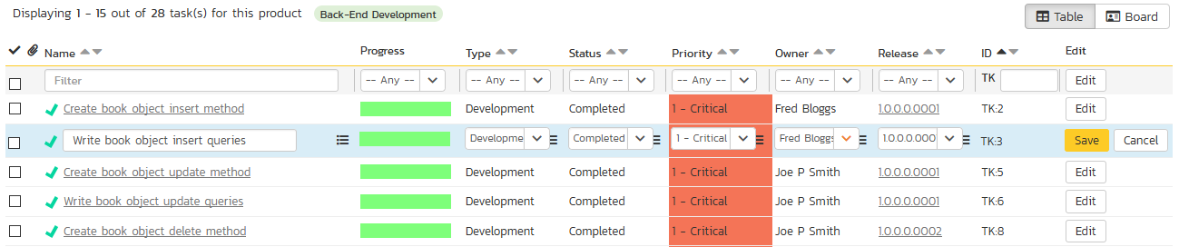

If you click “Edit” on more than one row, the “Save” and “Cancel” buttons are only displayed on the first row, and you can make changes to all the editable rows and then update the changes by clicking the one “Save” button. Also, if you want to make the same change to multiple rows (e.g. to change five tasks from “Not Started” status to “In Progress”), you can click on the “fill” icon to the right of the editable item, which will propagate the new value to all editable items in the same column.

If you want to edit lots of items, first select their checkboxes and then click the “Edit” button on the same row as the Filters and it will switch all the selected items into edit mode.

When you have made your updates, you can either click “Save” to commit the changes, or “Cancel” to revert back to the original information. Alternatively, pressing the <ENTER> key will commit the changes and pressing the <ESCAPE> key will cancel the changes.

### 8.1.8. Duplicating Tasks

To create a clone of a task or set of tasks, select the check-boxes of the tasks you want to clone and then click “Clone”. This will make a clone of the current task in the current folder with its name prefixed ‘Copy of ….’ to distinguish itself from the original. Any file attachments will also be copied along with the task itself.

### 8.1.9. Exporting Tasks to Another Product

To export a task or set of tasks from the current product to another product in the system, select the check-boxes of the task(s) you want to export and then click Tools > Export to Product. This will bring up a list of possible destination products:

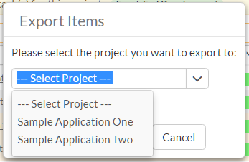

Once you have chosen the destination product and clicked the “Export” button, the tasks will be exported from the current product to the destination product. Any file attachments will also be copied to the destination product along with the tasks.

### 8.1.10. Printing and Saving Items

To quickly print a single task or list of tasks you can select the items’ checkboxes and then click Tools > Print Items. This will display a popup window containing a printable version of the selected items. You can also save the report in a variety of common formats from the same Tools menu.

## 8.2. Task Details

When you click on a task item in the lists displayed on either the main task list page or on the requirement / release details pages, you are taken to the task details page illustrated below:

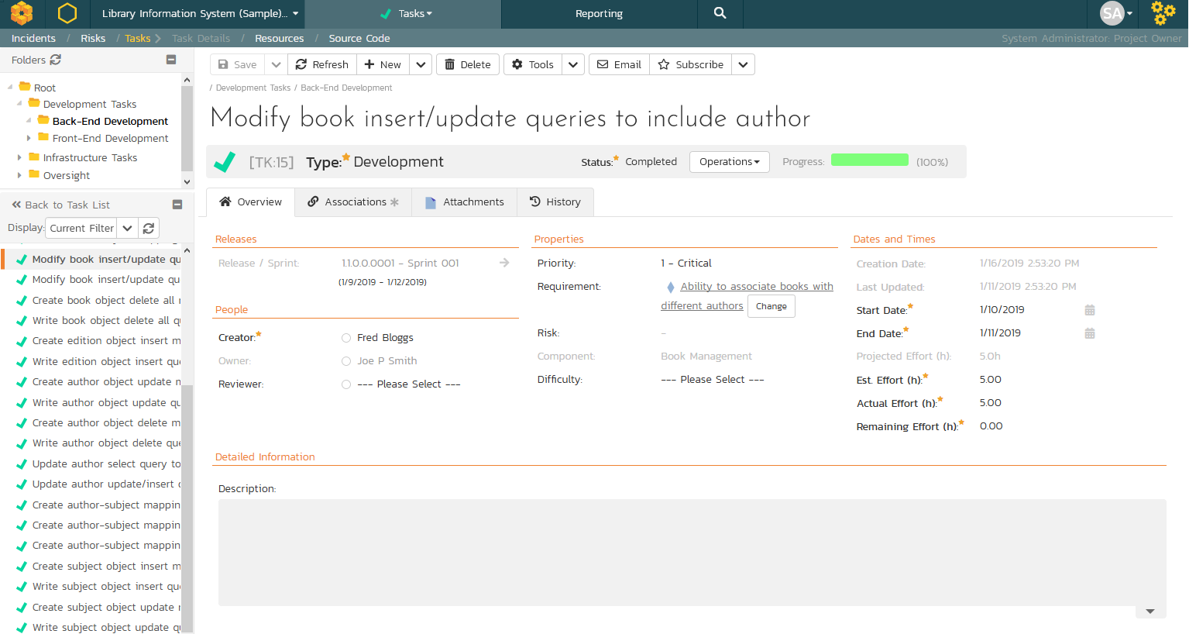

This page is made up of *three* areas;

1. the left pane displays the tasks list navigation;
2. the right pane’s header, which displays: the operations toolbar; the editable name of the selected task; and the info bar (with a shaded background), which also contains the workflow status transitions (see below); and
3. the right pane’s tabbed interface with rich information related to the task.

Please note that on smaller screen sizes the navigation pane is not displayed. While the navigation pane has a link to take you back to the tasks list, on mobile devices a ‘back’ button is shown on the left of the operations toolbar.

The navigation pane can be collapsed by clicking on the “-“ button, or expanded by clicking anywhere on the gray title area. On desktops the user can also control the exact width of the navigation pane by dragging and dropping a red handle that appears on hovering at the rightmost edge of the navigation pane.

The navigation pane consists of a link that will take you back to the task list, as well as a list of tasks, and another list of the other related tasks, nested under their parent task. This latter list is useful as a navigation shortcut; you can quickly view the peer tasks by clicking on the navigation links without having to first return to the tasks list pages. The navigation list can be switched between five different modes:

* **Current Filter -** The list of tasks matching the current filter organized by task folder
* **All Items** - The list of all tasks, irrespective of the current filter, organized by task folder
* **Assigned** - The list of tasks assigned to the current user grouped by their parent requirement
* **For Release** - The list of tasks assigned to the current release or sprint, grouped under that parent release/sprint.
* **For Requirement** – The list of tasks associated to the same requirement as the current task as well as other tasks at the same level in the requirement hierarchy.

On the main right hand side of the page, which of the fields for the currently selected task are available and which are required will depend on your stage in the task workflow. For example, a completed task might not require a “Release” whereas an In Progress task could well do. The types of change allowed and the fields that are enabled/visible/required will depend on how your product administrator has set up the system for you. Administrators should refer to the *SpiraPlan Administration Guide* for details on configuring the task workflows to better meet their needs.

Depending on the user’s role and whether they are listed as the owner or author of the task, displayed in the info bar beneath the task name is the current workflow status and an “operations” button which, when clicked, will show a set of allowed workflow operations:

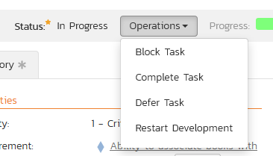

These workflow transitions allow the user to move the item from one status to another. For example when the task is in the In Progress status, you will be given the options to:

* **Block Task** – changes status to “Blocked”
* **Complete Task** – changes the status to “Completed”
* **Defer Task** – changes the status to “Deferred”
* **Restart Development** – changes the status to “Not Started”

Please note that if digital signatures have been enabled for a particular workflow operation (and therefore a digital signature is required to confirm the status change. Workflow operations requiring a digital signature are marked with a padlock icon as in the example below:

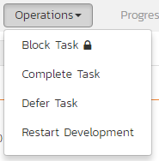

On attempting to save changes made after clicking a workflow operation that requires a digital signature you will be presented with a popup similar to the one below (which is for a requirement):



Once you’ve made the changes to the appropriate task fields, you can either click “Save” or one of the options from the “Save” dropdown to commit the changes, or “Refresh” to discard the changes and reload the task from the database. In addition you can print or export the current task to a number of common formats via the Tools menu.

To send the task to a colleague click the email button:

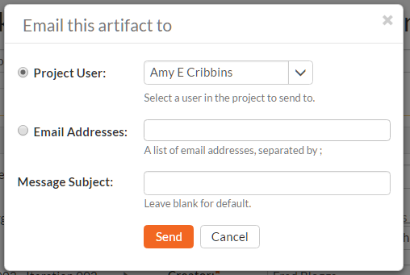

You can specify the subject line for the email, and either a list of email addresses, separated by semicolons, or an existing product user .The content of the email is specified in the System Administration – Notification Templates.

The lower part of the right pane can be in one of *four* possible tabs that can be selected: “Overview Properties”, “Attachments”, “History” and “Associations”. Each of the different views is described separately below.

### 8.2.1. Overview – Details

The Overview tab is divided into a number of different sections. Each of these can be collapsed or expanded by clicking on the title of that section. It displays the description, fields and comments associated with the task.

The top part of this tab displays the various standard fields and custom properties associated with the task. Fields (both standard and custom) are grouped under the collapsible headings (marked by orange text and underline) in the screenshot below. For instance, all fields regarding dates are grouped together in the “Dates and Times” area.

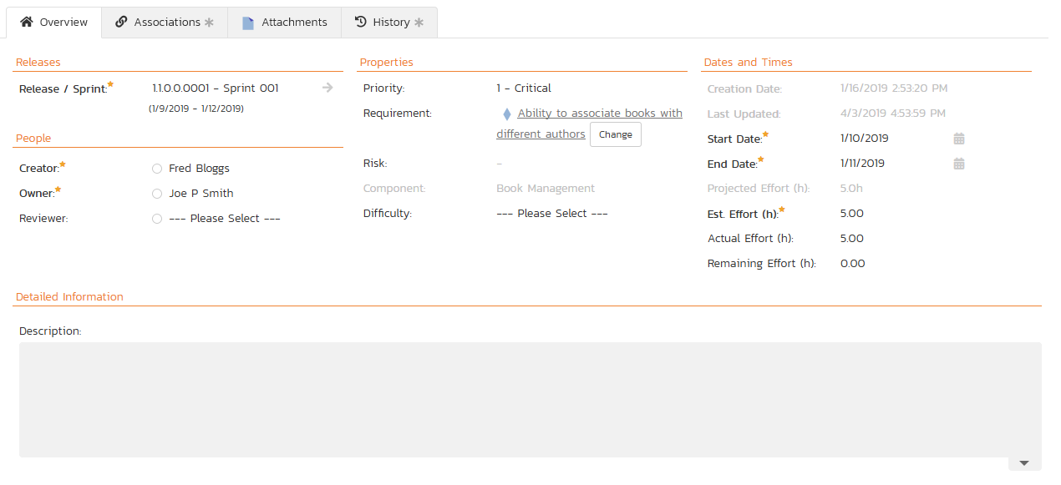

### 8.2.1.1. Effort Fields

You can enter/edit the start-date, end-date (i.e. the due-date), estimated, actual and remaining effort. From this the system will calculate the progress, percentage complete and producted final effort.

The different effort values mean the following:

* **Estimated Effort** – This is the original estimate for how long the task would take to complete.
* **Actual Effort** – This is the current amount of effort that has been expended in completing the task. This does not indicate the completion progress
* **Remaining Effort** – This is the estimate for how it will take from the current state to complete the task. The % complete is calculated from this value in conjunction with the estimated effort:  
  % Complete = 100% - (Remaining Effort / Estimated Effort)
* **Producted Effort** – This is value that the system is producting it will take to complete the task. This is calculated from the Actual Effort and Remaining Effort:  
    
  Producted Effort = (Actual Effort + Remaining Effort)

**Note**: If the actual effort is not specified, the producted effort will be the same as the estimated effort.

**Note:** if the task is currently assigned to a release or sprint, the start-date and end-date of the task must lie within the date-range of the parent release/sprint. If your task looks like it will not be completed in the available timeframe, you will need to contact the product manager to get them to either extend the date-range of the task, or consider moving the task to the next sprint.

### 8.2.1.2. Followers

Using the “Subscribe” button on the toolbar, you can quickly follow the item, and receive updates on certain changes to it. Depending on your role, you may also see a dropdown to this button, which let’s you add another product member as a follower to this item.





You can also quickly see who is following an incident under the “People” section in the Overview tab.



To view information about the follower, or to unfollow them from the item, hover over their avatar to display a user profile card.



### 8.2.2. Overview – Comments

The comments tab will display the comments associated with the task:

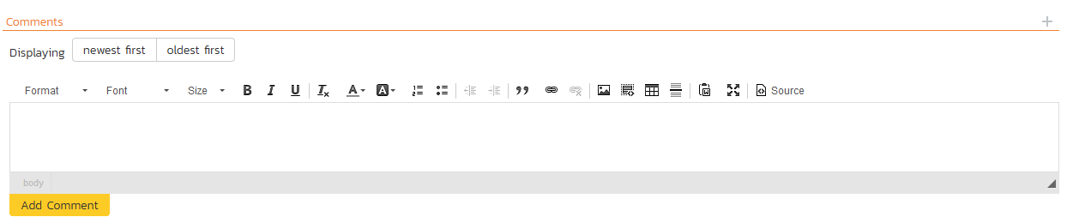

All existing comments are displayed in date entered underneath the textbox. To enter a new comment, enter the text into the textbox, and then click the “Add Comment” button.

### 8.2.3. Attachments

This tab displays the list of documents that have been “attached” to the task. The documents can be in any format, though SpiraPlan® will only display the icon for certain known types.

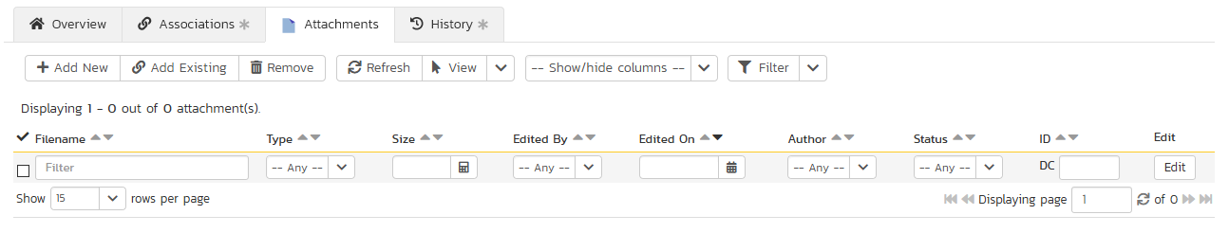

The attachment list includes the filename that was originally uploaded together with the file-size (in KB), name of the person who attached it and the date uploaded. In addition, if you position the pointer over the filename and hold it there for a few seconds, a detailed description is displayed as a tooltip.

To actually view the document, simply click on the filename hyperlink and a new web browser window will open. Depending on the type of file, this window will either display the document or prompt you for a place to save it on your local computer. To remove an existing attachment from a task, click the “Remove” button and the attachment will be removed from the list.

To attach a new document or web link to the task, you need to click the “Add New” button to open the “Add Attachment” dialog box. There are three different types of item that can be attached to a task:

* To upload a file, choose “File” as the type and then click the Browse button and select the file from your local computer, optionally enter a detailed description then click the “Upload” button. The document will be copied from your computer and attached to the artifact.
* To attach a web-link (URL) to the artifact, you need to choose “URL” as the type and then enter the fully qualified URL (e.g. [http://mywebsite.com?Document=1](http://mywebsite.com/?Document=1)), an optional description and then click the “Upload” button to attach the web-link.
* To attach a screenshot to the artifact, you need to choose “Screenshot” as the type and then copy the image to your computer’s clipboard (e.g. on Windows computers, the PRINT SCREEN button captures the current page and adds to the clipboard). Once the image is in the clipboard, paste it into the editor using CTRL+V (or the equivalent keystroke for your operating system) and the item will appear in the preview window. You can then fill in the other fields and click “Upload” to attach the image.

Note: If you are using a non-Windows® computer (e.g. Macintosh®) that doesn’t put file extensions on filenames (e.g. .xls for an Excel sheet) automatically, then you will need to manually add the file extension to the filename before uploading if you want it to be displayed with the correct icon in the attachment list.

You can also associate an existing document (that’s already stored in SpiraTeam) with the task. To do that, click the “Add Existing” button to bring up the add file association dialog box. You can then choose to either associate a document stored in the SpiraPlan Documents repository or (in the case of SpiraPlan/SpiraTeam but not SpiraTest) from the linked source code repository. In either case you first select the appropriate folder, and then pick the document(s) from the file list on the right. In the case of a source code file association you can also add a comment.

### 8.2.4. History

This tab displays the list of changes that have been performed on the task since its creation. An example task change history is depicted below:

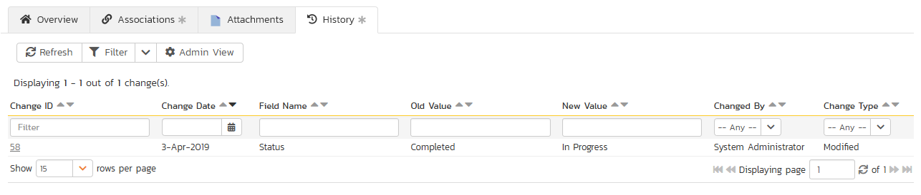

The change history displays the date that each change was made, together with the fields that were changed, the old and new values and the person who made the change. This allows a complete audit trail to be maintained of all changes in the system. In addition, if you are logged in as a product administrator you can also click on the “Admin View” hyperlink to revert any unwanted changes.

### 8.2.5. Associations

In this mode, the main pane displays a list of any incidents, source code revisions or other tasks that are associated with this task:

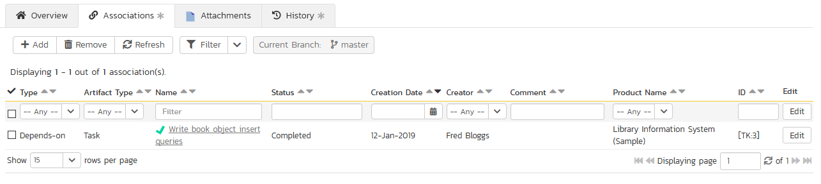

Each association is displayed with the type of association (related-to, vs. a dependency), name of the artifact being linked-to, type of artifact (task, incident, etc.), the name of the person who created the association, and a comment that describes why the association was made.

You can perform the following actions:

* **Remove** – removes the selected association to the other artifact. This will only delete the association, not the linked artifact itself.
* **Refresh** – updates the list of associations from the server, useful if other people are adding associations to this task at the same time.
* **Apply Filter** – Applies the entries in the filter boxes to the list of associations
* **Clear Filters** – Clears the current filter, so that all associations for the current task are shown.
* **Edit** – Clicking the “Edit” button to the right of the associations allows you to edit the association type and comment fields inline directly on this screen.

To create a new association, click the “Add” button to display the add association panel:



If you know the ID of the item you want to associate, you can enter its ID prefixed by the appropriate token (“TK” for task or “IN” for incident):

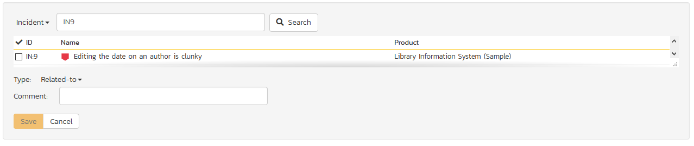

Otherwise you should choose the Artifact Type. You can narrow down your search by entering a keyword.

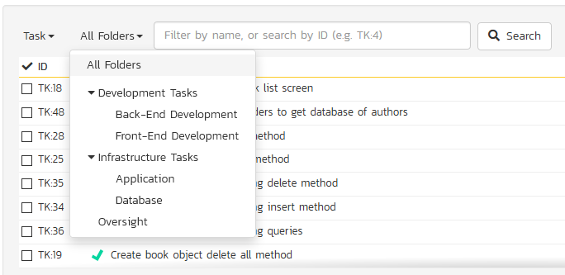

Once you have a list of artifacts, you should select the checkboxes of the items you want to associate with the current task and click the ‘Save’ button.

You can add a comment that explains the rationale for the association and choose the type of association being created:

* **Related-to:** this is used to specify that the two artifacts are simply related
* **Depends-on:** this is used to specify that the current artifact has a dependency on the one being linked to.

## 8.3. Task Board

The task board is an alternative to the task list page (described in section 8.1) designed to let you view the tasks planned for the current product. You can access this feature by clicking on the **Board** icon in the top-right of the Tasks list page. You can switch back to the Task list page by clicking on the **Table** view.

The task board has the following different display modes:

* All Releases
  + By Release
  + By Priority
  + By Status
  + By Person
* Release
  + By Sprint
  + By Priority
  + By Status
  + By Person
* Sprint
  + By Priority
  + By Status
  + By Person

Each of these views is described below:

### 8.3.1. Tasks – By Priority

This view is designed to let you see the list of planned tasks organized by priority. Each of the possible priority values is displayed on the left-hand side and the tasks displayed in the same row on the right:

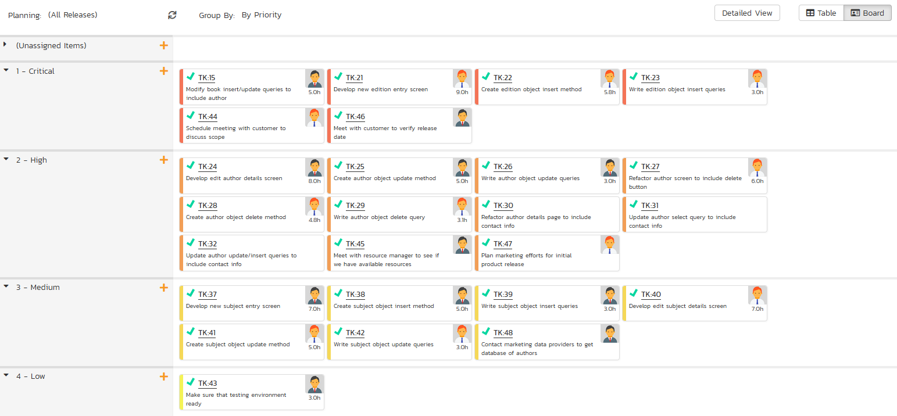

The top section will contain the list of tasks that are not assigned a priority, with the other sections containing the tasks that have been assigned to the specific priority.

### 8.3.2. Tasks – By Status

This view is designed to let you see the tasks in the current product / release / sprint organized by their status. Each task status (not started, in progress, completed, blocked, deferred) is displayed as a heading, with the tasks displayed in the same column underneath:

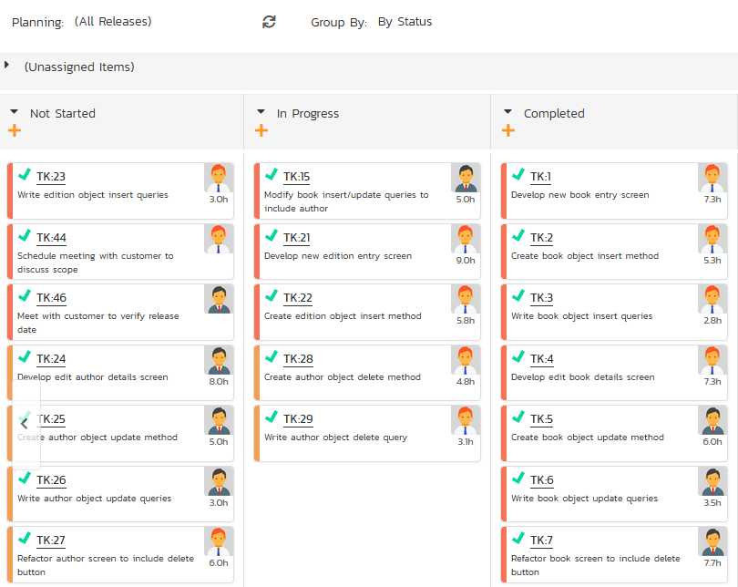

You can click on the expand/collapse icons to hide any resources that are not relevant.

Depending on the view (all releases, release, or sprint), there may be sections with the release and sprint name. You can drag and drop the tasks between statuses or to/from the release/sprint backlog. Any tasks not assigned to a release/sprint will be listed in the (Unassigned Items) section at the top.

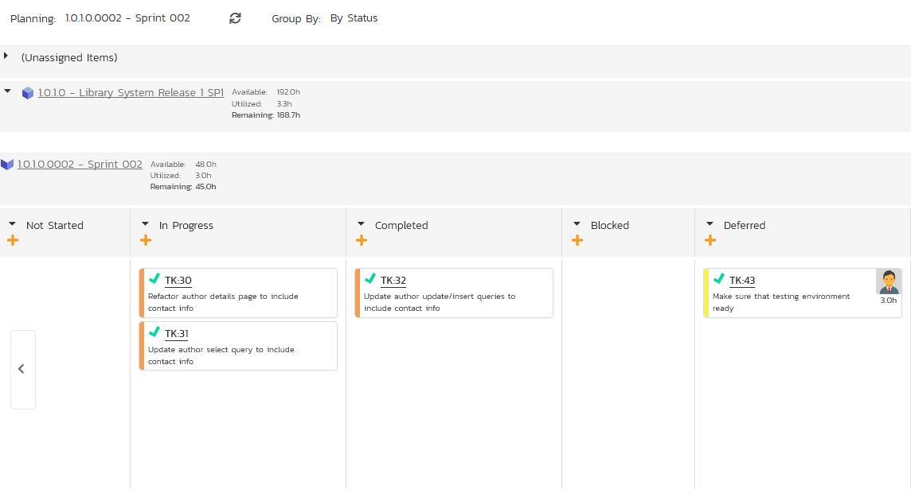

### 8.3.4. Tasks - By Person

This view is designed to let you see the tasks in the current product / release / sprint organized by resource / person. Each of the users that is a member of the current product is displayed as a heading, with the tasks displayed in the same column underneath. This view is often called the **Task Board**:

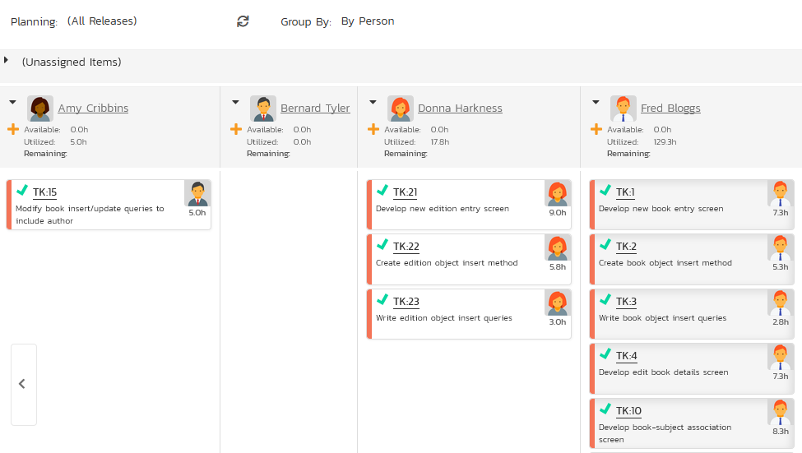

You can click on the expand/collapse icons to hide any resources that are not relevant. The system will display a progress bar for each resource to illustrate the allocation for that resource. Any resource that has a progress bar that is completely green has been fully scheduled and should not have any additional tasks assigned. If the progress bar for that resource turns red, it means that they have been over-scheduled and you need to reassign some of the tasks.

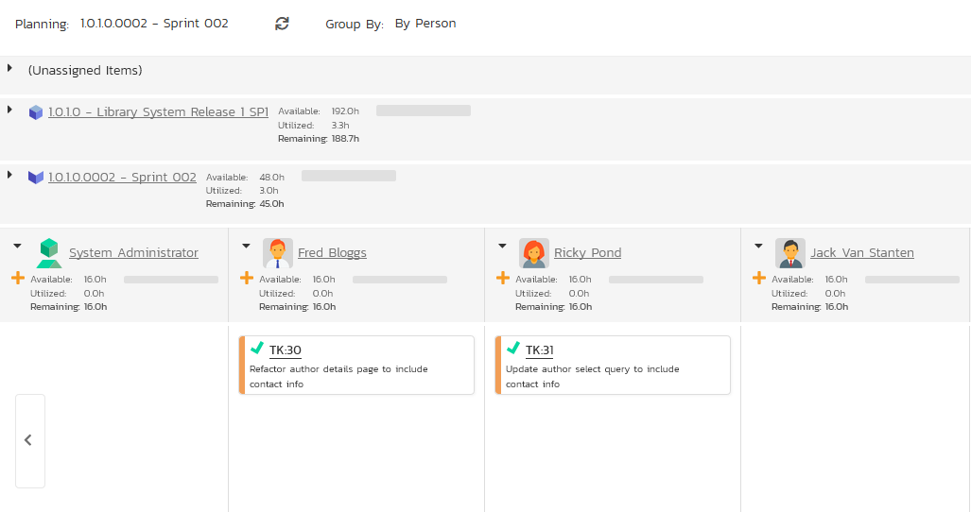

Depending on the view (all releases, release, or sprint), there may be sections with the release and sprint name; they contain tasks that are scheduled for the current release or sprint but have not yet been assigned to a resource. You can drag and drop the tasks between resources or to/from the release/sprint backlog. Any tasks not assigned to a resource and release/sprint will be listed in the (Unassigned Items) section at the top.

### 8.3.4. Tasks - By Release

This view is only available when you are displaying the task board for ‘all releases’. Each of the active releases defined for the current product is displayed as a heading, with the tasks displayed in the same column underneath

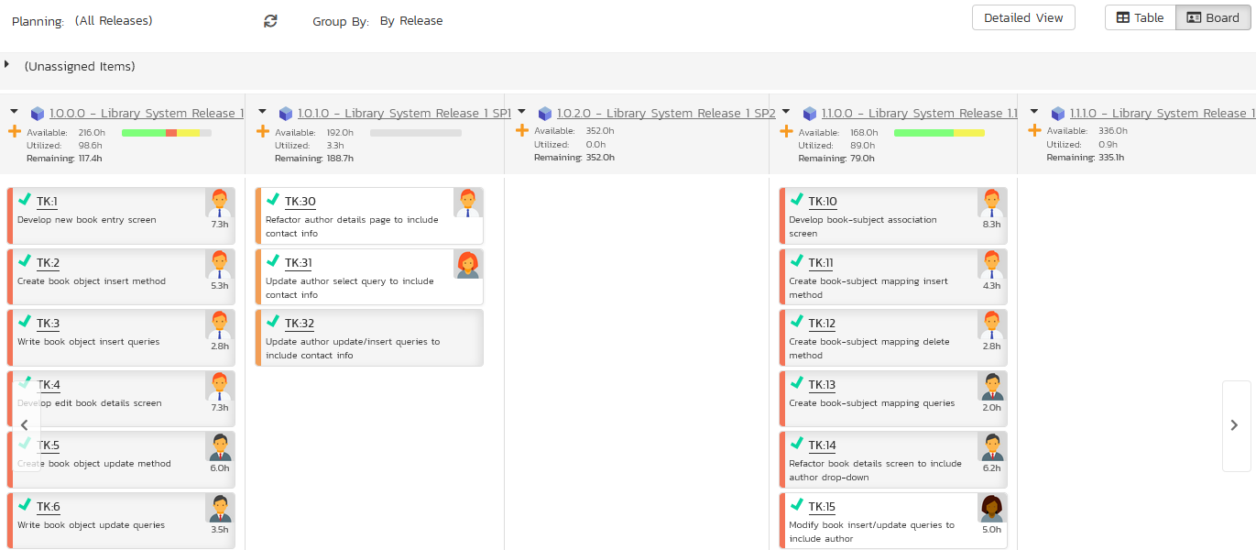

You can drag and drop the tasks between the different releases. Once the task has been added to the release, the utilized effort for the release will increase, and the available effort will decrease by the same amount.

Note: The system will allow you to assign more tasks to a release than it is possible to complete, however this will result in a negative value for ‘available effort’. If this happens, the “Available Effort” value will be displayed in red, and you need to rebalance the items, extend the release length or add product personnel resources to the release.

Clicking on the release hyperlinks in the headers will switch the task board into the release view.

### 8.3.4. Tasks - By Sprint

This view is only available when you are displaying the task board for a specific release. Each of the sprints defined for the current release is displayed as a heading, with the tasks displayed in the same column underneath. This view is commonly used in **Scrum** products:

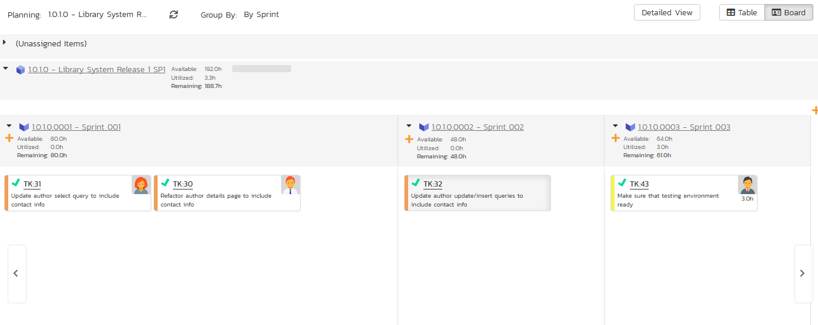

You can drag and drop the tasks between the different sprints. Once the task has been added to the sprint, the utilized effort for the sprint will increase, and the available effort will decrease by the same amount.

Note: The system will allow you to assign more tasks to a sprint than it is possible to complete, however this will result in a negative value for ‘available effort’. If this happens, the “Available Effort” value will be displayed in red, and you need to rebalance the items, extend the sprint length or add product personnel resources to the sprint.

Clicking on the sprint hyperlinks in the headers will switch the task board into the sprint view.

# 9. Resource Tracking

This section outlines how you can use the Resource Tracking features of SpiraPlan® and SpiraTeam® to view the total workload for each of the product personnel resources assigned to a specific product. This allows you to verify that the work is evenly distributed amongst the product members and that no individual resource is overloaded.

When you click Tracking > Resources on the global navigation bar, you will initially be taken to the product resources list screen illustrated below:

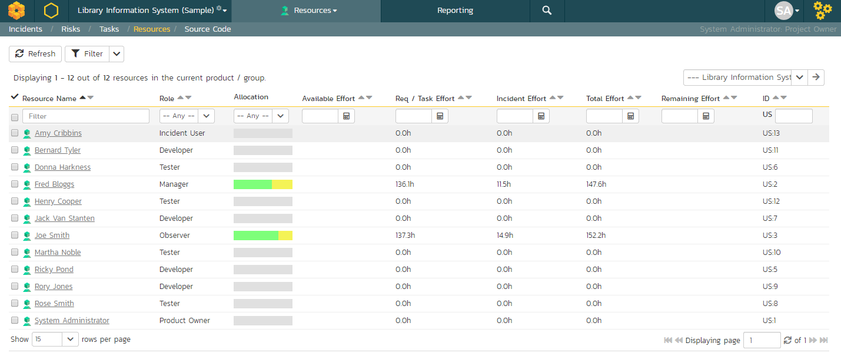

This screen lists all the personnel (product resources) that belong to the current product together with the total value of the producted effort of all the work assigned to them, the available effort based on the length of the current release/sprint, and the remaining effort (the difference between the previous two values). The effort is shown for tasks and incidents as well as a total of the two together.

Using the dropdown on the far right, you can display the workload:

* For the product as a whole (as above).
* For a specific release (including all child sprints)
* For a specific sprint

You can also display the workload for the entire program by selecting the program from the product/program selector from the navigation bar

There is a colored progress bar column called “Allocation” that graphically illustrates the % of the person’s available effort that has been scheduled. If a person is over-scheduled, this bar will turn red. In addition, if any product resources have been assigned more work that they have time to complete during the length of the release/sprint, the background color of the remaining effort value will be also be colored in red, indicating that you need to offload some of the work to other product resources.

Clicking on a resource name will take you to the Resource Details page.

## 9.1 Resource Details

The resource details page will show you what artifacts a resource has been assigned, and time values for the items. A small panel on the left will show current configured values for the product for # of hours per workday, # of days per week, and how many non-work hours per month there are.

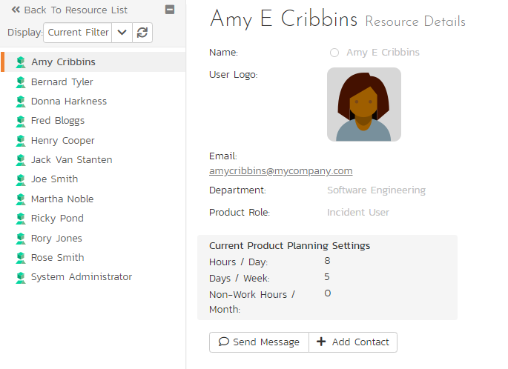

There are two options related to the instant messenger beneath the user’s avatar. When you click the “Send Message” button it will open up a new instant message window to start a conversation with the selected resource. If the resource is not a contact of the current user, clicking the “Add Contact” button adds the selected resource to the user’s ‘My Contacts’ list on the ‘My Page’ dashboard. Similarly if the resource is already a contact of the current user, clicking ‘Remove Contact’ will remove the resource as a contact.

Tabs along the bottom will show assigned requirements and tasks, incidents, test cases, test sets and recent actions. The views for each item are a subset of available columns, to show progress and completion information for all items listed. Clicking on an artifact’s name will take you to the artifact details page. The data in all of these tabs can be filtered by all releases, by a release and its children, or by a specific sprint.

### 9.1.1. Reqs & Tasks

This tab displays the list of requirements and child tasks that are assigned to the current resource:

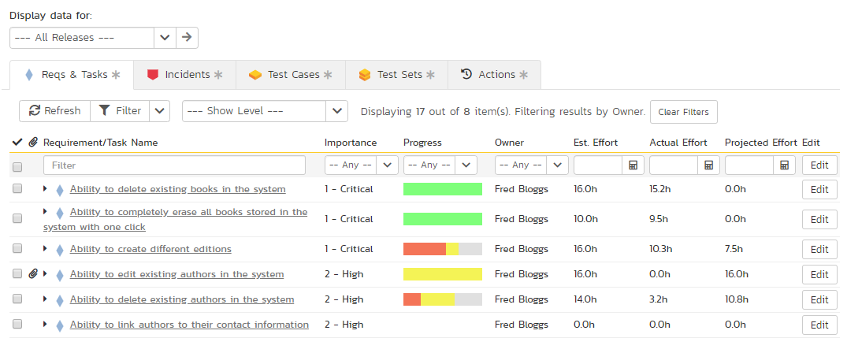

### 9.1.2. Incidents

This tab displays the list of incidents that are assigned to the current resource:

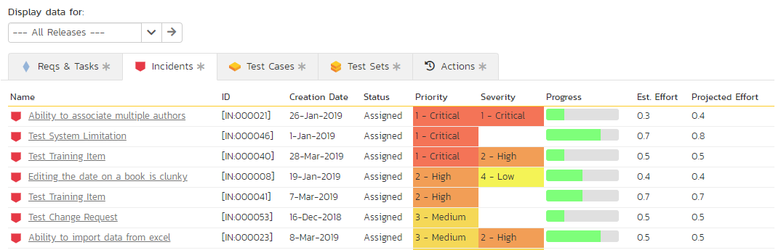

### 9.1.3. Test Cases

This tab displays the list of test cases that are assigned to the current resource:

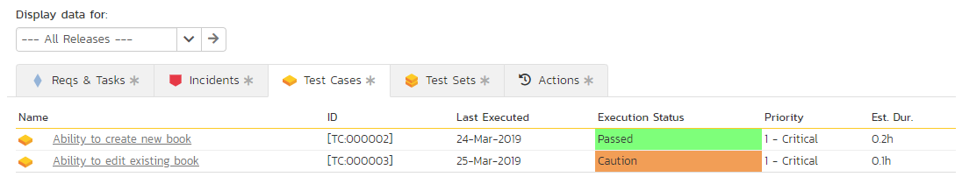

### 9.1.4. Test Sets

This tab displays the list of test sets that are assigned to the current resource:

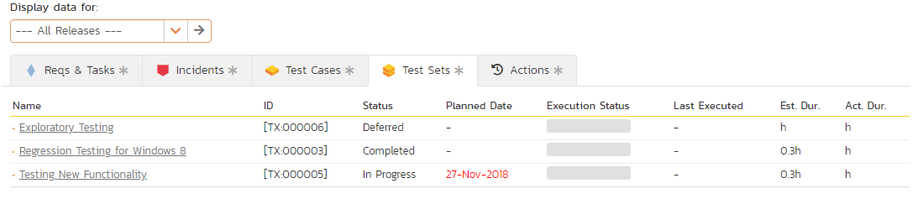

### 9.1.5. Actions

This tab displays the list of recent actions make by the user in the product. It lets you quickly see all the changes they have made:

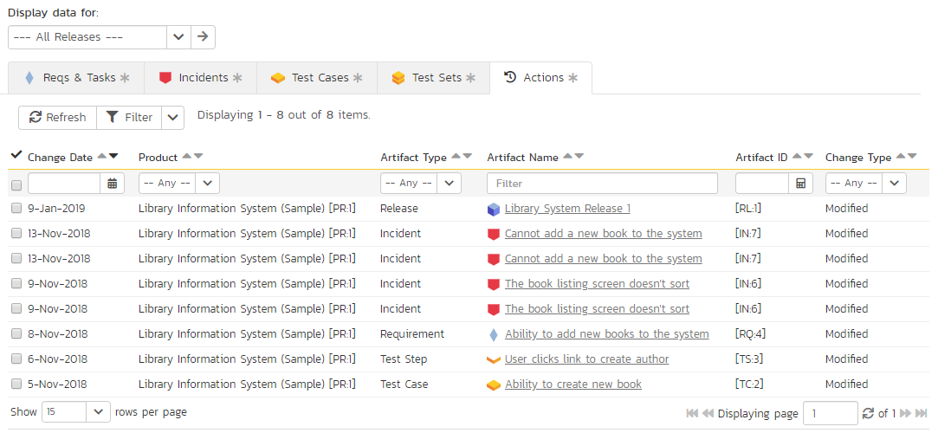

This can be useful when auditing the changes made by a specific user.

# 10. Document Management

This section outlines the document management features of SpiraPlan® that can be used to upload, manage and share documents between the different members of the product. This module includes support for uploading files and URLs, versioning of documents, the ability to organize into folders and categorize and search using meta-tags.

In addition the document management features are fully integrated into the rest of the system, so that documents attached to other artifacts (e.g. requirements, test cases, etc.) are automatically connected to the product documentation repository.

## 10.1. Document List

When you click Product Home > Documents on the global navigation bar, you will initially be taken to the product documents list screen illustrated below:

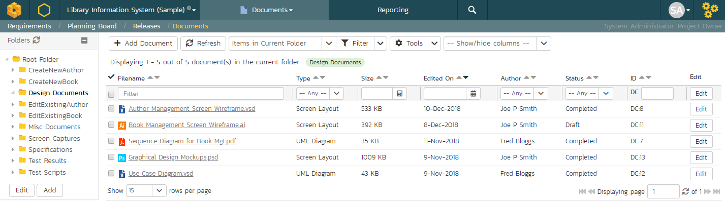

This screen consists of three main sections:

* The top left-hand pane displays a hierarchical list of the various folders that have been setup for the current product. Clicking on the triangle icon will expand the child folders and clicking on the name of the folder will display the list of documents in the folder in the main pane to the right.
* The main right-hand pane displays a list of all the documents contained within the currently selected folder. This list can be filtered and sorted, and you can choose how many rows of documents to display on the page at one time.
* The bottom left-hand pane contains the “Tag Cloud”. This is a list of all the tag names associated with documents in the product. The size of the font is proportional to the number of documents associated with the tag. Clicking on a tag name will automatically filter the list of documents to find items that contain the selected tag.

The main toolbar contains icons for all the operations that can be performed on the document list. You can add documents to the current folder, delete existing documents from the product, refresh the list of documents, export documents to another product, apply a filter, and clear the current filter. In addition there is the option to either display just the documents in the current folder or all documents in all folders. The latter is useful when you want to search for a specific document by keyword or tag name.

### 10.1.1. Add New Document

To attach a new document to the incident, you need to first click the “Add New” button to display the new attachment dialog box:



There are three different types of item that can be attached to an incident:

* To upload a file, choose “File” as the type and then click the Browse button and select the file from your local computer, optionally enter a detailed description then click the “Upload” button. The document will be copied from your computer and attached to the artifact.
* To attach a web-link (URL) to the artifact, you need to choose “URL” as the type and then enter the fully qualified URL (e.g. [http://mywebsite.com?Document=1](http://mywebsite.com/?Document=1)), an optional description and then click the “Upload” button to attach the web-link.
* To attach a screenshot to the artifact, you need to choose “Screenshot” as the type and then copy the image to your computer’s clipboard (e.g. on Windows computers, the PRINT SCREEN button captures the current page and adds to the clipboard). Once the image is in the clipboard, paste it into the editor using CTRL+V (or the equivalent keystroke for your operating system) and the item will appear in the preview window. You can then fill in the other fields and click “Upload” to attach the image.

Note: If you are using a non-Windows® computer (e.g. Macintosh®) that doesn’t put file extensions on filenames (e.g. .xls for an Excel sheet) automatically, then you will need to manually add the file extension to the filename before uploading if you want it to be displayed with the correct icon in the attachment list.

### 10.1.2. View Document Information

When you hover the mouse pointer over any of the documents displayed in the document list, an information panel will be displayed that contains the name, description, version, document type and meta-tags of the document.

You can click on the document URL to actually open the document itself in a new window, click on the meta-tag links to find related documents that contain the same meta-tag, or click on “View Details” to see more information regarding the document, including an ability to edit its meta-information and see the different versions of the document.

### 10.1.3. Edit Document Folders

If you are a product administrator, you will see the “Edit” and “Add” buttons beneath the folder tree:

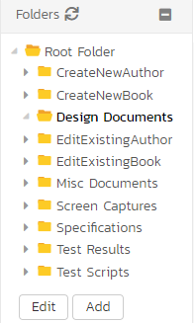

This lets you add, edit and delete task folders in the product. To add a new folder, click the “Add” button:

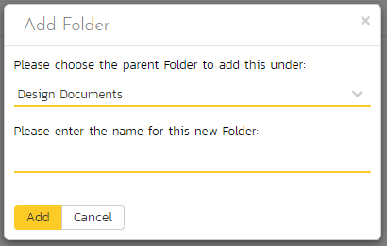

Choose the parent folder that you want to add the new folder under (or None if you are adding a new top-level folder) from the dropdown list and then enter the name of the new folder. Then click ‘Add’ save the new folder.

To edit or delete an existing folder, click the ‘Edit’ button to switch the folder tree to edit mode:

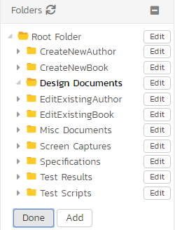

To edit or delete a specific folder, click on the ‘Edit’ button next to the folder:

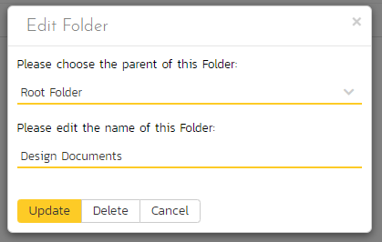

You can change the parent folder and/or name of the folder and click “Update” to commit the change or click “Delete” to delete the folder entirely (including its contents).

## 10.2. Document Details

When you click on an item in the document list described above, you are taken to the document details page illustrated below:

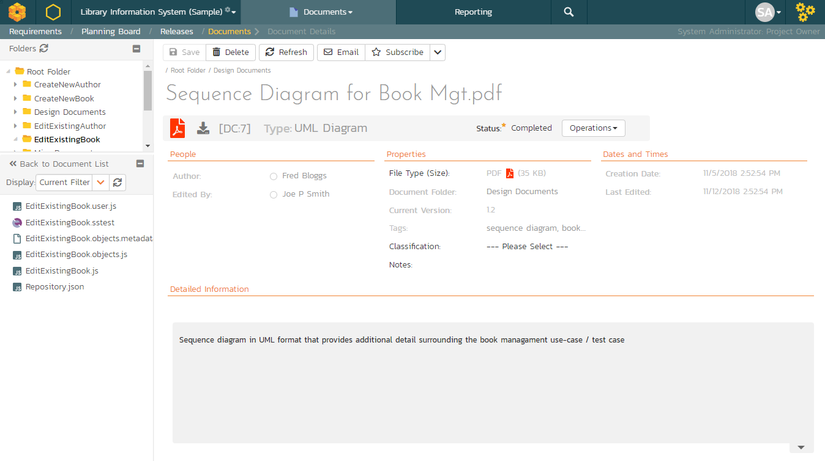

This page is made up of *three* areas;

1. the left pane displays the documents list navigation;
2. the right pane’s header, which displays: the operations toolbar; the editable name of the selected document; and the info bar (with a shaded background), which also contains the workflow status transitions (see below); and
3. the right pane’s tabbed interface with rich information related to the document, including, where available, a preview of the document, the list of document versions, the list of artifacts that the document is associated with, and history of changes made to the document).

Please note that on smaller screen sizes the navigation pane is not displayed. While the navigation pane has a link to take you back to the documents list, on mobile devices a ‘back’ button is shown on the left of the operations toolbar.

The navigation pane can be collapsed by clicking on the “-“ button, or expanded by clicking anywhere on the gray title area. On desktops the user can also control the exact width of the navigation pane by dragging and dropping a red handle that appears on hovering at the rightmost edge of the navigation pane.

The navigation pane consists of a link that will take you back to the product document list, as well as a list of other documents in the current folder. This latter list is useful as a navigation shortcut; you can quickly view the detailed information of all the peer documents by clicking on the navigation links without having to first return to the main document list page.

Depending on the user’s role and whether they are listed as the owner or author of the document, displayed in the info bar beneath the document name is the current workflow status and an “operations” button which, when clicked, will show a set of allowed workflow operations:

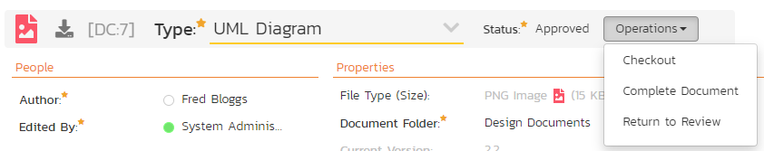

These workflow transitions allow the user to move the document from one status to another. For example, when the document is in the Approved status, you will be given the options to:

* **Checkout** – changes status to “Checked Out”
* **Complete Document** – changes the status to “Completed”
* **Return to Review** - changes the status to “Under Review”

After changing the status of the document by clicking on the workflow link, you can then fill in the additional fields that are now enabled and/or required. Once you’ve made the changes to the appropriate document fields, you can click “Save” to commit the changes or “Refresh” to discard the changes and reload the document from the database.

Please note that if digital signatures have been enabled for a particular workflow operation (and therefore a digital signature is required to confirm the status change. Workflow operations requiring a digital signature are marked with a padlock icon:



On attempting to save changes made after clicking a workflow operation that requires a digital signature you will be presented with the following popup:



Using the “Email” button on the toolbar, you can send an email containing details of the requirement to an email address or another user on the system:

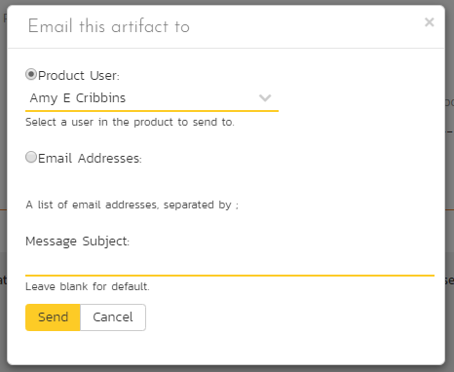

You can specify the subject line for the email, and either a list of email addresses, separated by semicolons, or an existing product user .The content of the email is specified in the System Administration – Notification Templates.

To be notified of any changes made to the current artifact via email, click the “Subscribe” button. If you already subscribed, the button will instead let you “Unsubscribe” to stop receiving emails about that particular artifact. Depending on your role, you may also see a dropdown arrow to the right of this button. This will let you subscribe others in the product to this artifact.

The top part of the main pane allows you to view and/or edit the details of the particular document. You can edit the various fields (name, description, etc.) and once you are satisfied with them, click one of the “Save” buttons to commit the changes. In addition, you can delete the current document by choosing “Delete”, or discard any changes made by clicking “Refresh”.

The lower part of the main pane can be switched between four different views by clicking the appropriate tab. Initially the pane will be in “Versions” mode. The functionality in each of these views is described below.

### 10.2.1. Preview

This tab displays a preview of the currently active version of the document. Previews are shown for a number of file types, notably plain text or code files, and images.

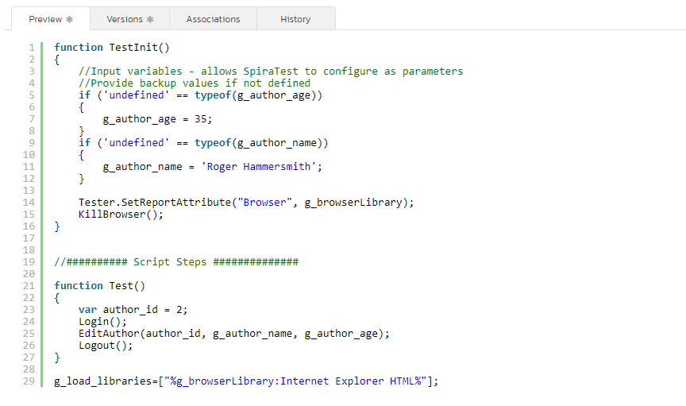

If a format cannot be previewed (for example a PDF or Microsoft Word document), the following message is displayed:



### 10.2.2. Document Versions

This view displays the list of different versions that exist for the current document. When you initially create a new document there will be only a single version (e.g. v1.0), however as revisions are made to the document, rather than having to create a whole new document, you can just upload the new revision as a new version (e.g. v1.1) and it will be added to the list of versions.

Each version in the list is displayed with its name, a description of what changed in the version, the version number assigned to the revision, the file-size, who uploaded the new version and a link to actually open the new version:

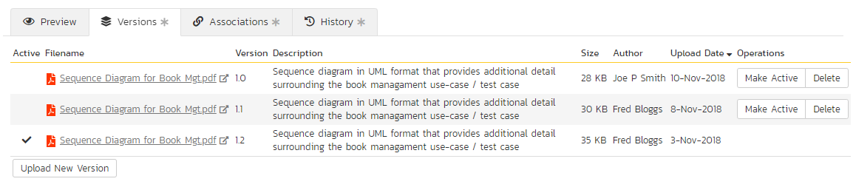

On this page, you have the option to delete an existing version, make a different version the active one (the one that users see when they view the document list and click on the link) and upload a new revision. To upload a new version, click on the ‘Upload New Version’ hyperlink:

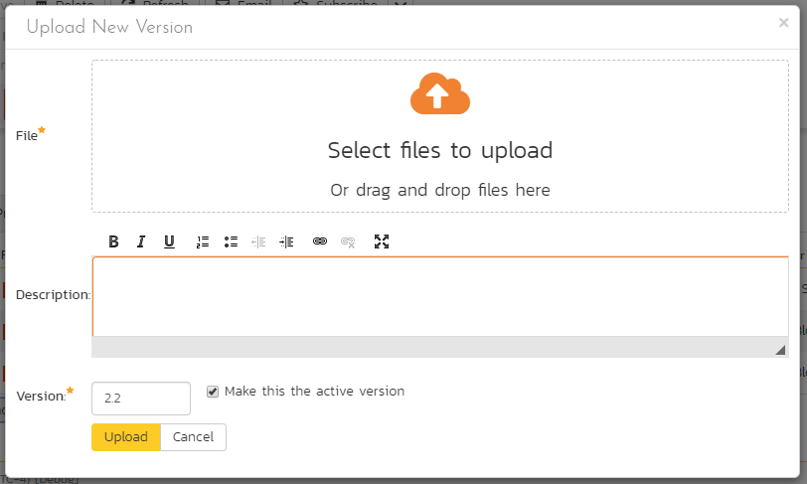

In the popup dialog, you need to drag the file to be uploaded onto the upload icon (or click on the icon to browse to the file), enter a description of the changes made, a new version number and whether the new version should be made the active one, then click the [Upload] button to confirm the changes.

Note: This option is only available for File attachments. To change a URL attachment, you can simply edit the Filename field directly.

### 10.2.3. Document Associations

This view displays a list of the artifacts in the current product that are associated with the current document. If you originally uploaded the document as an attachment to a requirement, test case, etc. then an initial association will be already listed, otherwise it will be empty.

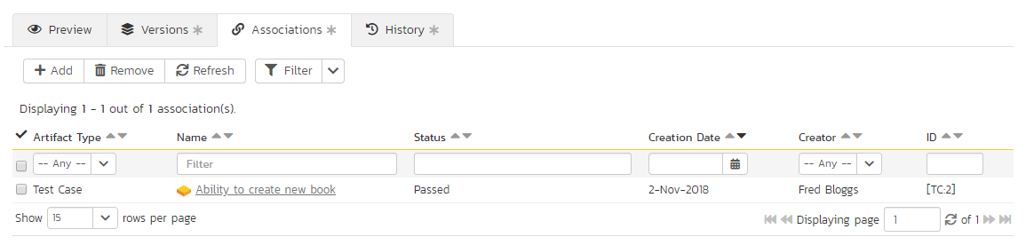

From this screen you can either remove an existing artifact association or add a new association from the current document to a pre-existing artifact in the system. To add the association, click on the **Add** button in the toolbar:

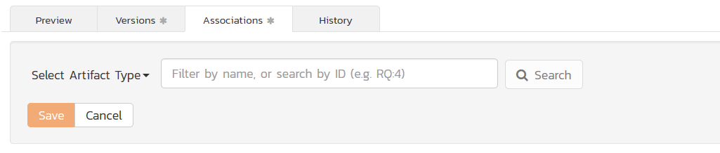

Then, you need to select the type of artifact being associated (requirement, test case, incident, etc.) and then enter in the name or ID (with the artifact prefix) of the artifact to search on:

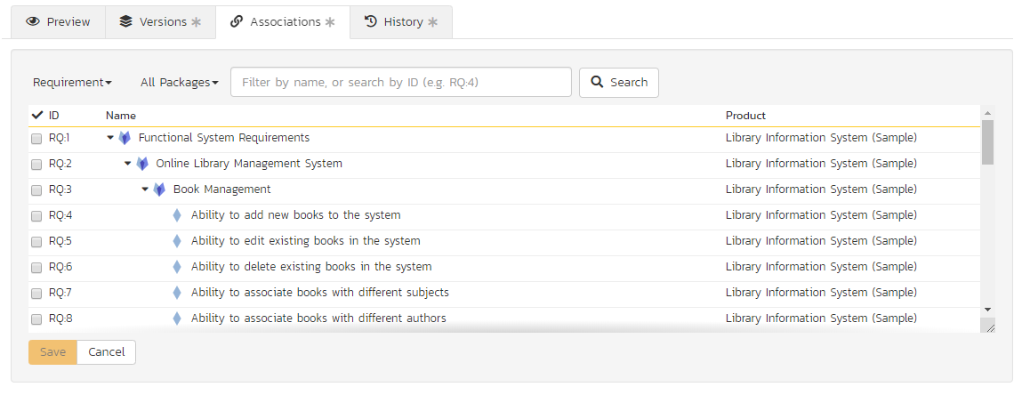

Once you have selected the items you want to associate, simply click the ‘Save’ button to associate them with the current document.

### 10.2.4. History

This tab displays the list of changes that have been performed on the document since its creation.

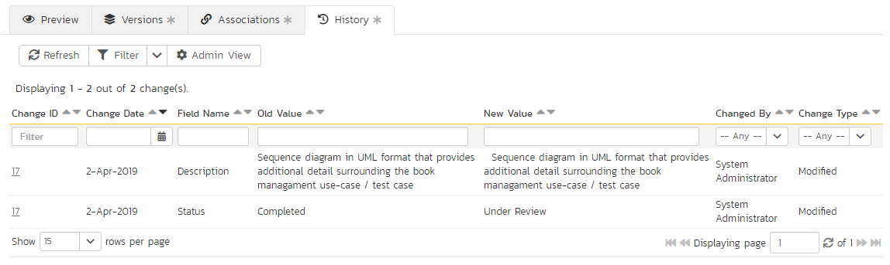

The change history displays the date that each change was made, together with the fields that were changed, the old and new values and the person who made the change. This allows a complete audit trail to be maintained of all changes in the system. In addition, if you are logged in as a product administrator you can also click on the “Admin View” hyperlink to revert any unwanted changes.

# 11. Reports Center

This section describes the reporting features of SpiraPlan®, including an overview of each of the report types that are available. When you click on the “Reports” tab on the global navigation bar, you will initially be taken to the reports home page illustrated below:

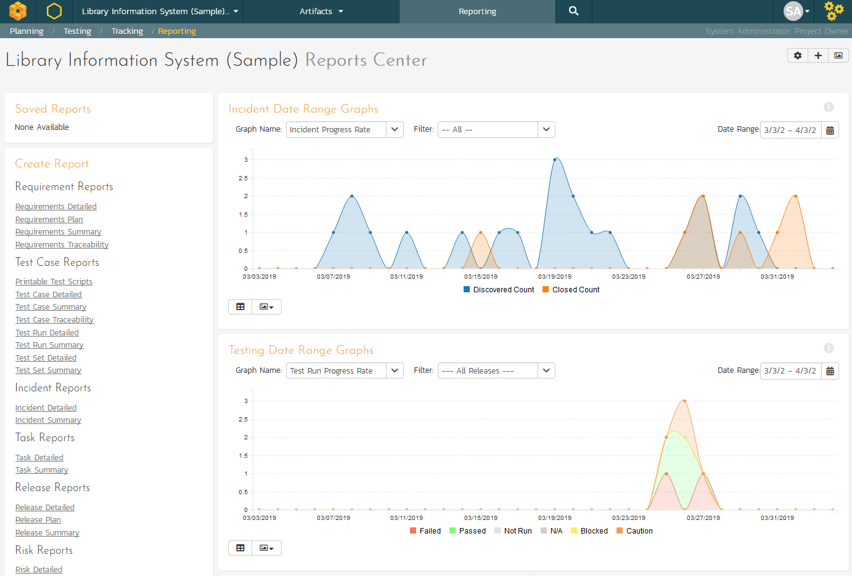

This page consists of three main areas:

* The top left-hand pane displays a list of any reports that have either been saved by the currently logged in user, or those reports created by other members of the product, that have been marked (by that user) as ‘shareable’.
* The bottom left-hand main pane displays a list of the printable reports available in the system, categorized by the artifact they primarily relate to (requirements, test cases, incidents and releases). Clicking on any of the report hyperlinks will take you to the configuration page for the report in question (see section 11.1 below for details).
* The right-hand pane is a dashboard that contains the set of graph widgets configured by the current user. By default the dashboard will display: the Incident Progress Rate, Test Run Progress Rate, Requirement Summary, Test Case Summary, Incident Aging and Task Burndown.

In addition to the graphs displayed by default, you can click on the “Add Items” buttons to add additional graphs to the reporting dashboard:

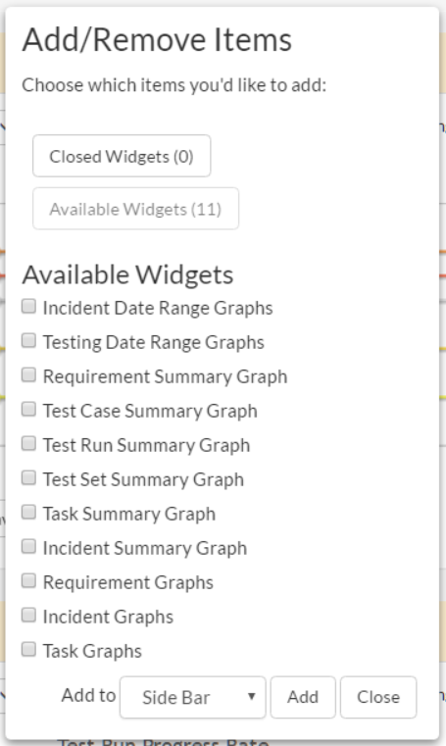

Each of the graphs is described in more detail in sections 11.7 – 11.9.

## 11.1. Reports Configuration

The configuration page for each report differs slightly, but the general format is illustrated below (please note all sections are shown in orange text with a line beneath and are shown here in the collapsed state – click the orange text to expand the section):

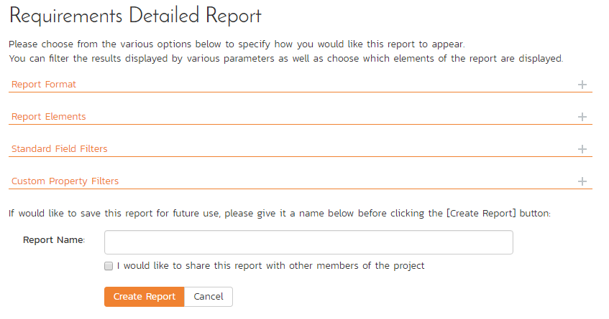

You can configure the reports in the following ways:

* **Report Format** – This allows you to specify the display format of the report. Depending on the specific report, they can be displayed as a web-page (HTML), downloaded as a Microsoft Word document, downloaded as a Microsoft Excel spreadsheet or downloaded as a Microsoft Product file. In addition there is a raw-XML format that allows you to export the underlying report data into any external reporting system that supports XML import.

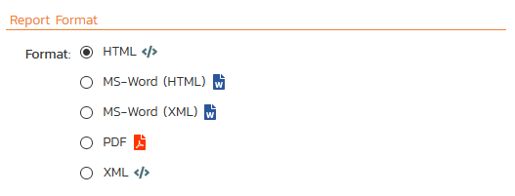

* **Report Elements** – This allows you to determine which types of information to include in the report. This varies by report type, but includes the dependent items related to the artifact being reported on (attachments, test steps, coverage, history, etc.)

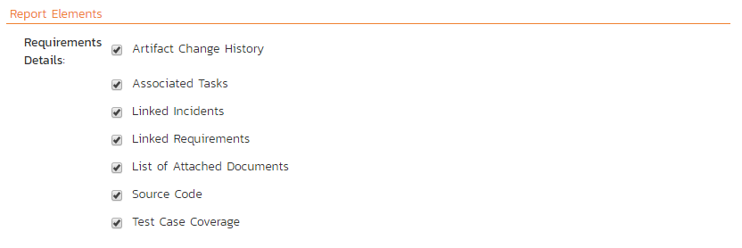

* **Standard Field Filters** – This allows you to constrain the range of data being reported on, based on the various fields associated with the artifact in question. These filters are typically selections from multi-valued-dropdown lists and date-ranges.

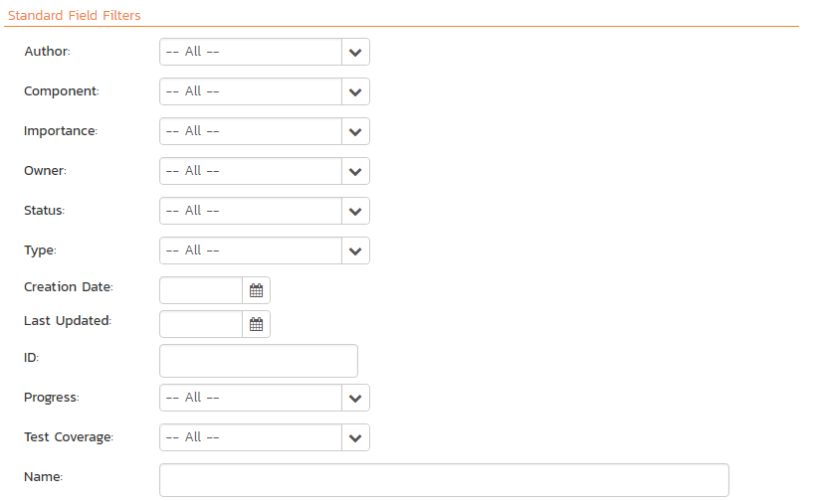

* **Custom Property Filters** – This allows you to constrain the range of data being reported on, based on the custom fields associated with the artifact by your product administrator. These filters can be either freetext or drop-down lists.

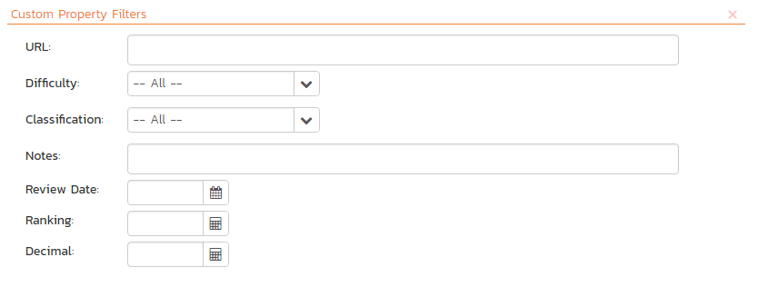

* **Sort Options** - This option is only available for the non-hierarchical data reports (i.e. for test cases, test sets, test runs, incidents and tasks) and allows you to specify the sort order of the results returned in the report. For the hierarchical-data based reports the sort order is always the order of the hierarchy.

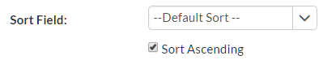

* **Report Name** – If you would like to save the report configuration so that you can quickly re-run it at a later date, you just need to enter a name for the report and indicate (by selecting the checkbox or not) whether you want this report to be private or shared by all members of the product.

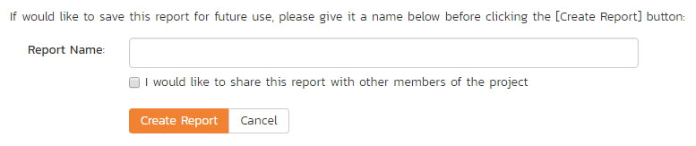

Once you have selected the format, elements and filters, clicking the “Create Report” button launches the report in a new window. Each of the reports is described in sections 11.2 – 11.6 below:

## 11.2. Requirement Reports

### 11.2.1. Requirements Summary Report

This report displays all of the requirements defined for the current product in the order they appear in the requirements list. The requirement's details and coverage status are displayed in a summary list form:

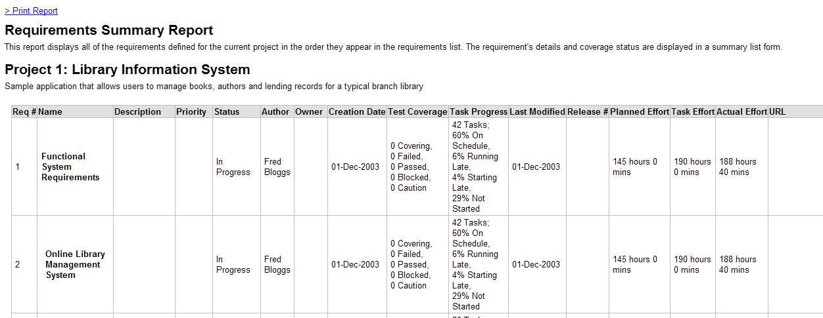

### 11.2.2. Requirements Detailed Report

This printable report displays all of the requirements defined for the current product in the order they appear in the requirements list. For each individual requirement, the name, priority, author, status and coverage status are displayed, along with tables containing the list of covering test cases, linked incidents/requirements, associated tasks, attached documents, and the change history:

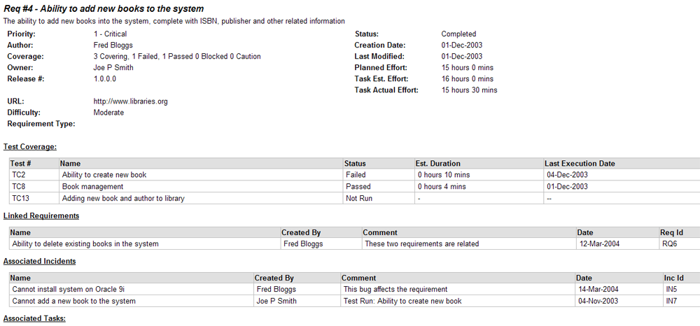

### 11.2.3. Requirements Plan

This report displays a complete work breakdown structure of the product from a requirements perspective, including all requirements and tasks organized by schedule:

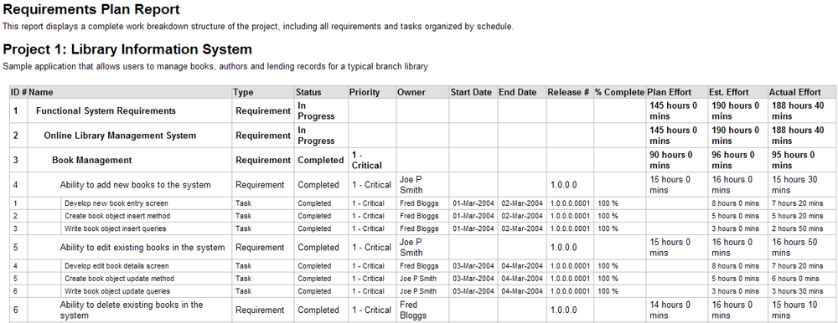

### 11.2.4. Requirements Traceability Matrix

This report displays a matrix of the requirements in the system with their list of covering test cases and associated, mapped requirements:

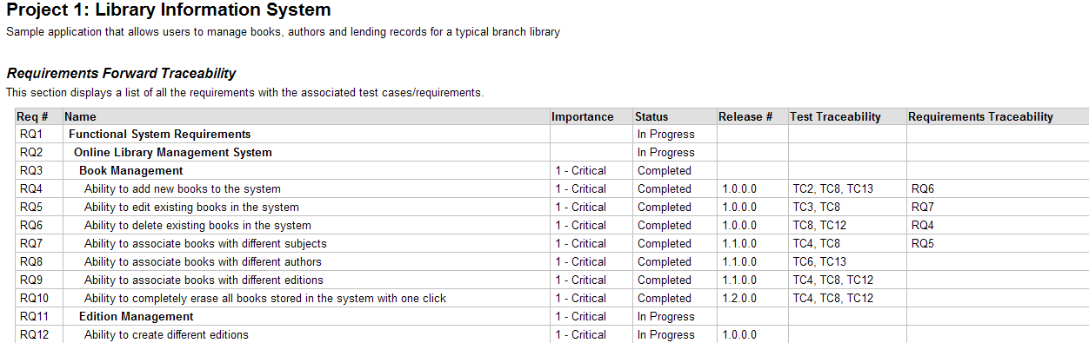

## 11.3. Test Case Reports

### 11.3.1. Test Case Summary Report

This report displays all of the test cases defined for the current product in the order they appear in the test case list. The test case's details and execution status are displayed in a summary grid form with the test steps optionally displayed:

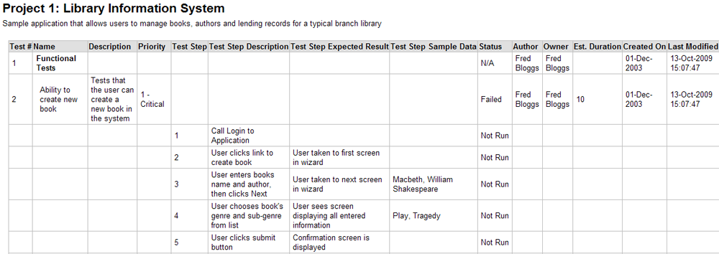

### 11.3.2. Test Case Detailed Report

This report displays all of the test cases defined for the current product in the order they appear in the test case list. The test case's details and execution status are displayed, along with sub-tables containing the list of test steps, test runs, attached documents, the change history, and a list of any associated open incidents:

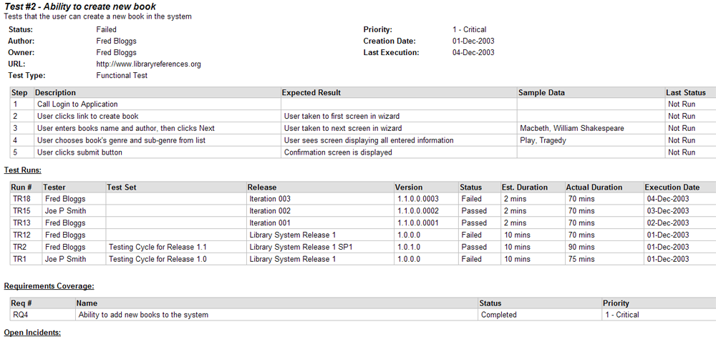

### 11.3.3. Test Set Summary Report

This report displays all of the test sets defined for the current product in the order they appear in the test set list. The test set's details and execution status are displayed in a summary list form:

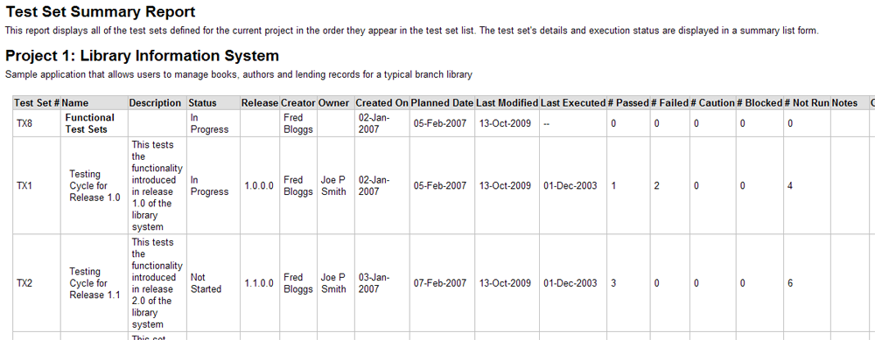

### 11.3.4. Test Set Detailed Report

This report displays all of the test sets defined for the current product in the order they appear in the test set list. The test set's details and execution status are displayed, along with sub-tables containing the list of test cases, test runs, attached documents, and the change history:

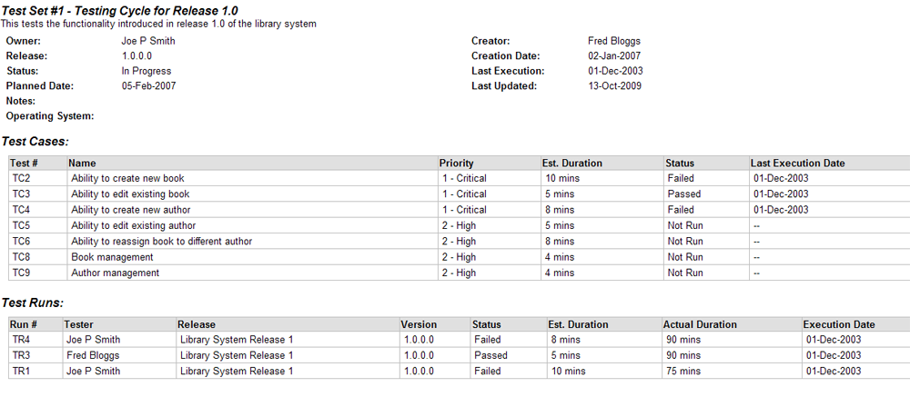

### 11.3.5. Printable Test Scripts

This printable report is useful when you want to be able to conduct the testing activities offline on paper, or when testers need paper copies of the test script in addition to using the online test execution wizard.

In either case, this report simply displays all of the test cases defined for the current product in the order they appear in the test case list together with their detailed test steps and a list of any attached documents.

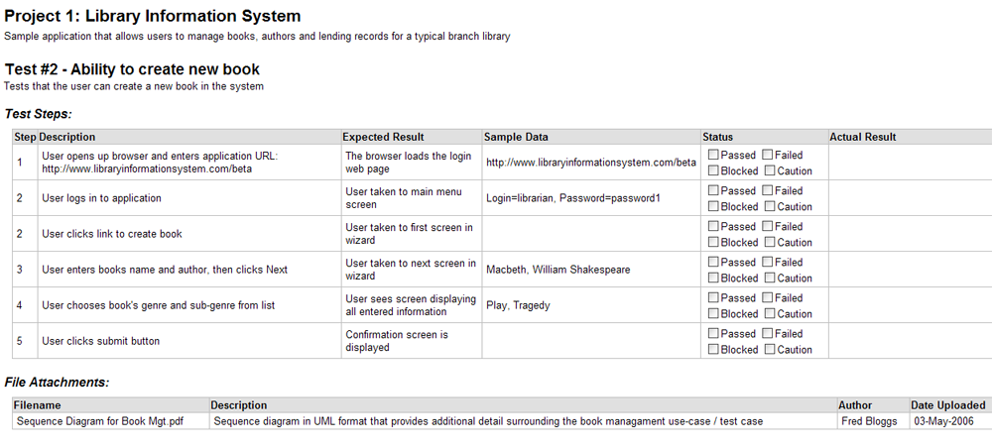

### 11.3.6. Test Run Summary Report

This report displays all of the test runs defined for the current product. The test run's details and execution status are displayed in a summary grid form:

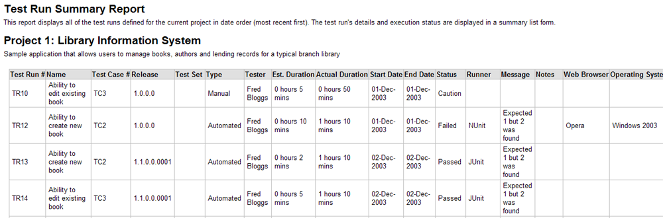

### 11.3.7. Test Run Detailed Report

This report displays all of the test runs defined for the current product in date order (most recent first). The test run's details and execution status are displayed, along with sub-tables containing the list of test run steps, and a list of any associated open incidents:

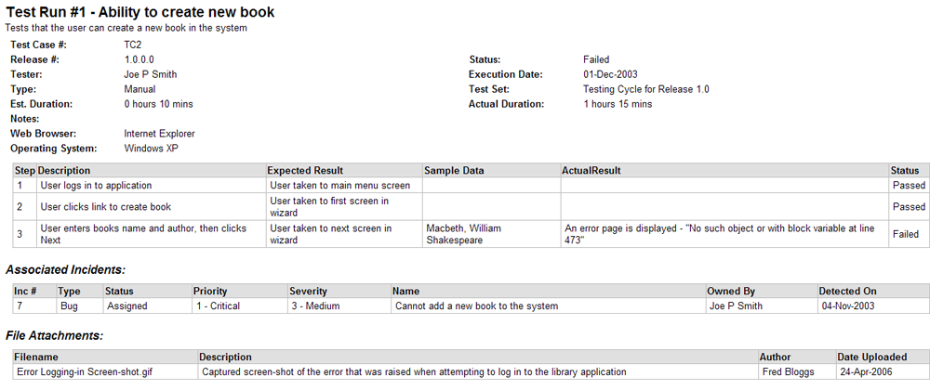

### 11.3.8. Test Case Traceability

This report displays a matrix of the test cases in the system with the list of mapped releases, incidents and test sets:

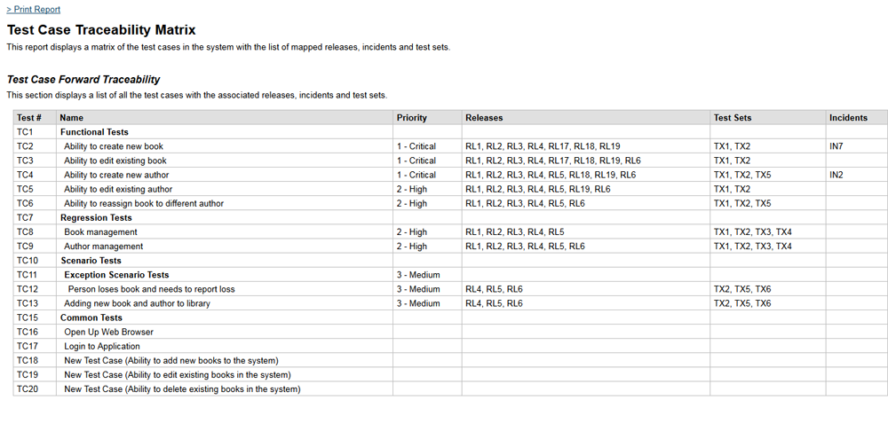

## 11.4. Incident Reports

### 11.4.1. Incident Summary Report

This report displays all of the incidents tracked for the current product. The incident's details are displayed in a summary list form:

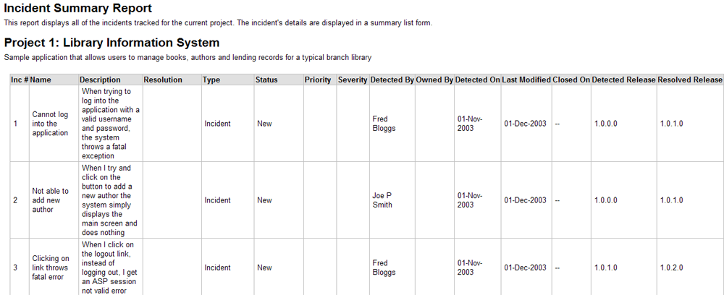

### 11.4.2. Incident Detailed Report

This printable report displays all of the incidents tracked for the current product sorted by incident number. For each individual incident, the name, type, priority, status, opener, owner and close date are displayed, along with tables containing the detailed description and resolutions as well as a tabular list of attached documents, linked requirements/incidents and the change history:

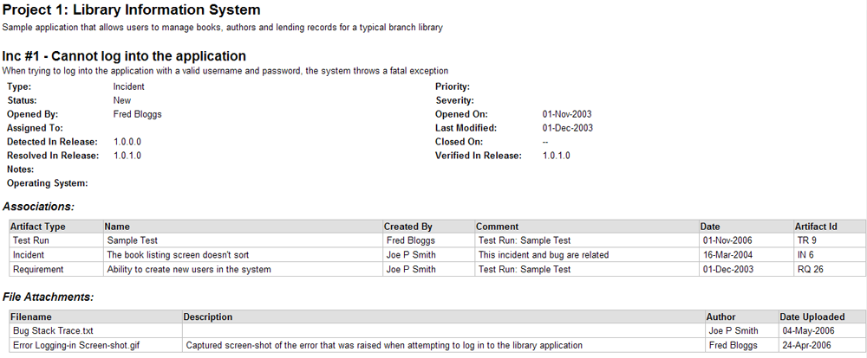

## 11.5. Task Reports

### 11.5.1. Task Summary Report

This report displays all of the tasks tracked for the current product. The task's details are displayed in a summary list form:

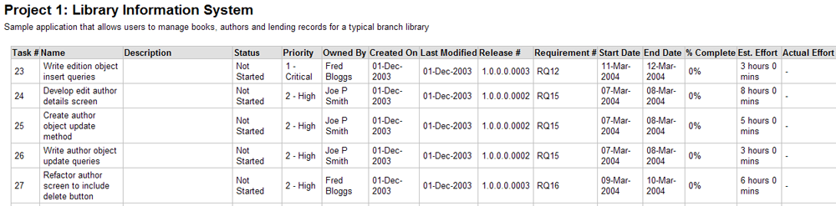

### 11.5.2. Task Detailed Report

This report displays all of the tasks tracked for the current product. The task's details are displayed, along with a tabular list of attached documents and the change history:

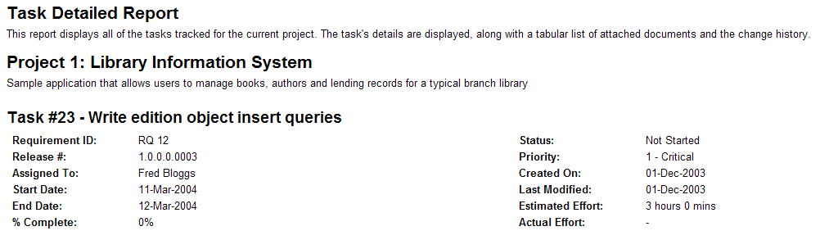

## 11.6. Release Reports

### 11.6.1. Release Summary Report

This report displays all of the releases and sprints defined for the current product in the order they appear in the release/sprint hierarchy. The release's details are displayed in a summary list form:

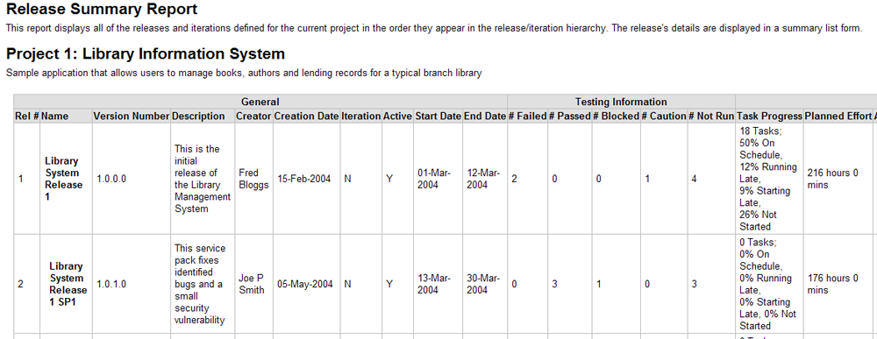

### 11.6.2. Release Detailed Report

This report displays all of the releases and sprints defined for the current product in the order they appear in the release/sprint hierarchy. The release's details are displayed, along with sub-tables containing the list of requirements added, mapped test cases, test runs executed, incidents resolved, attached documents, scheduled tasks and the change history:

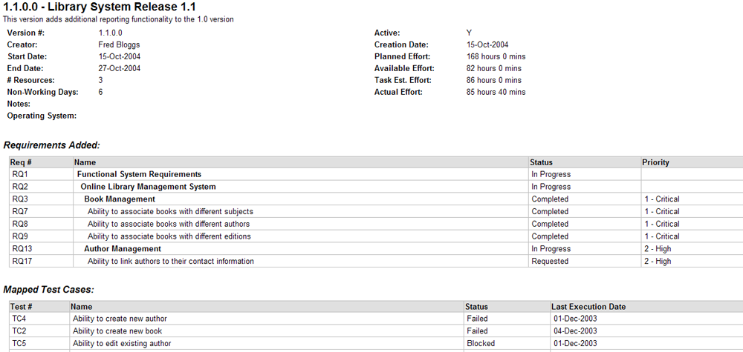

### 11.6.3. Release Plan Report

This report displays a complete work breakdown structure of the product from a release perspective, including all releases, sprints, requirements, tasks and incidents organized by schedule:

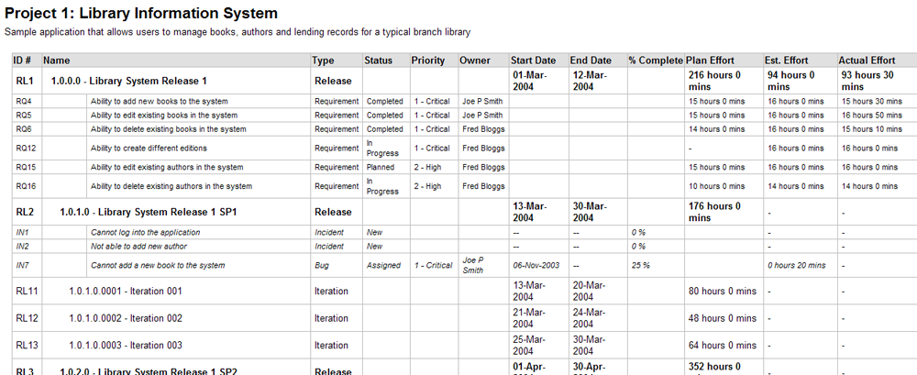

## 11.7. Summary Graphs

### 11.7.1. Requirements Summary Graph

The requirements summary graph shows how many requirements are currently in a product. The number of requirements is displayed according to the criteria that you specify. You can specify the type of data displayed along the x-axis, and the requirement information which is used to group the data. When you first open the graph you will be asked to pick the field that you would like to display on the x-axis and the field that you would like to group the data by. Once you have chosen the appropriate fields the graph will be displayed:

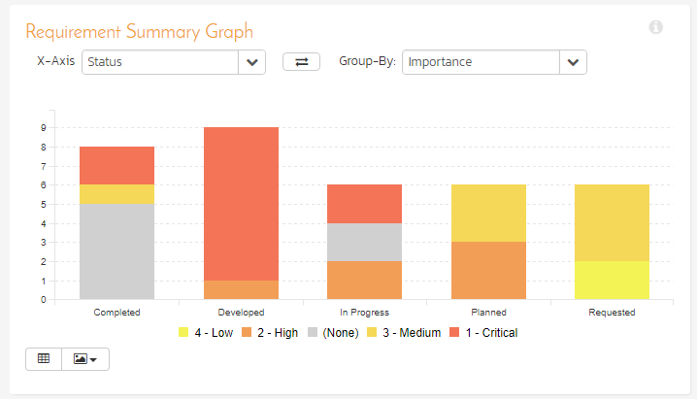

In this version of the report, the x-axis represents the requirements’ status, and the individual bars are grouped by requirement importance. Each data-value can be viewed by positioning the mouse pointer over the bar, and a “tooltip” will pop-up listing the actual data value.

Clicking on the “Display Data Grid” button will display the underlying data that is being used to generate the graph:

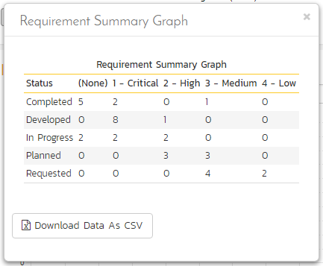

Clicking on the “Download Data as CSV” button will export the datagrid into Comma Separated Values (CSV) format that can be opened in MS-Excel. Some browsers also support the ability to save the graph as an image file (JPEG, PNG and GIF formats).

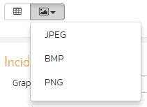

### 11.7.2. Test Case Summary Graph

The test case summary graph shows how many test cases are currently in a product. The number of test cases is displayed according to the criteria that you specify. You can specify the type of data displayed along the x-axis, and the test case information which is used to group the data. When you first open the graph you will be asked to pick the field that you would like to display on the x-axis and the field that you would like to group the data by. Once you have chosen the appropriate fields the graph will be displayed:

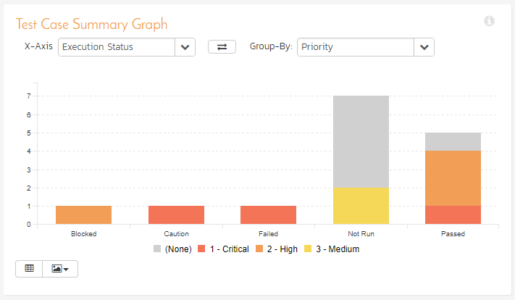

In this version of the report, the x-axis represents the test case execution status, and the individual bars are grouped by test case priority. Each data-value can be viewed by positioning the mouse pointer over the bar, and a “tooltip” will pop-up listing the actual data value. Clicking on the “Display Data Grid” button will display the underlying data that is being used to generate the graph. In addition, clicking on the “Download Data as CSV” button will export the datagrid into Comma Separated Values (CSV) format that can be opened in MS-Excel. Some browsers also support the ability to save the graph as an image file (JPEG, PNG and GIF formats).

### 11.7.3. Test Run Summary Graph

The test run summary graph shows how many test runs are currently in a product. The number of test runs is displayed according to the criteria that you specify. You can specify the type of data displayed along the x-axis, and the test run information which is used to group the data. When you first open the graph you will be asked to pick the field that you would like to display on the x-axis and the field that you would like to group the data by. Once you have chosen the appropriate fields the graph will be displayed:

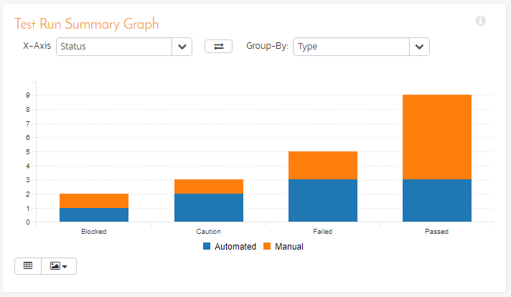

In this version of the report, the x-axis represents the test run execution status, and the individual bars are grouped by test run type. Each data-value can be viewed by positioning the mouse pointer over the bar, and a “tooltip” will pop-up listing the actual data value. Clicking on the “Display Data Grid” button will display the underlying data that is being used to generate the graph. In addition, clicking on the “Download Data as CSV” button will export the datagrid into Comma Separated Values (CSV) format that can be opened in MS-Excel. Some browsers also support the ability to save the graph as an image file (JPEG, PNG and GIF formats).

### 11.7.4. Incident Summary Graph

The incident summary graph shows how many incidents are currently in a product. The number of incidents is displayed according to the criteria that you specify. You can specify the type of data displayed along the x-axis, and the incident information which is used to group the data. When you first open the graph you will be asked to pick the field that you would like to display on the x-axis and the field that you would like to group the data by. Once you have chosen the appropriate fields the graph will be displayed:

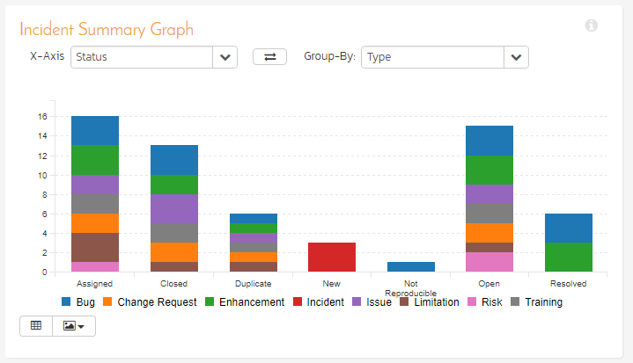

In this version of the report, the x-axis represents the incidents’ status, and the individual bars are grouped by the type of incident. Each data-value can be viewed by positioning the mouse pointer over the bar, and a “tooltip” will pop-up listing the actual data value. Clicking on the “Display Data Grid” button will display the underlying data that is being used to generate the graph. In addition, clicking on the “Download Data as CSV” button will export the datagrid into Comma Separated Values (CSV) format that can be opened in MS-Excel. Some browsers also support the ability to save the graph as an image file (JPEG, PNG and GIF formats).

### 11.7.5. Task Summary Chart

The task summary graph shows how many tasks are currently in a product. The number of tasks is displayed according to the criteria that you specify. You can specify the type of data displayed along the x-axis, and the task information which is used to group the data. When you first open the graph you will be asked to pick the field that you would like to display on the x-axis and the field that you would like to group the data by. Once you have chosen the appropriate fields the graph will be displayed:

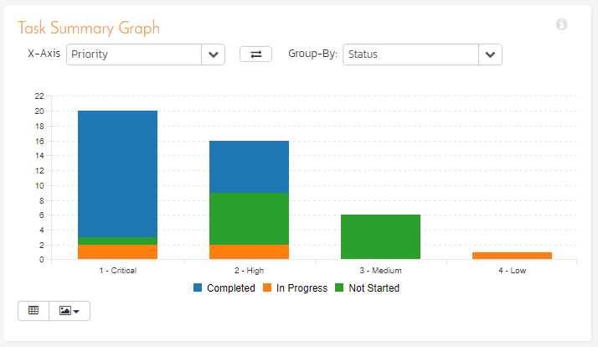

In this version of the report, the x-axis represents the tasks’ priority, and the individual bars are grouped by the status of task. Each data-value can be viewed by positioning the mouse pointer over the bar, and a “tooltip” will pop-up listing the actual data value. Clicking on the “Display Data Grid” button will display the underlying data that is being used to generate the graph. In addition, clicking on the “Download Data as CSV” button will export the datagrid into Comma Separated Values (CSV) format that can be opened in MS-Excel. Some browsers also support the ability to save the graph as an image file (JPEG, PNG and GIF formats).

### 11.7.6. Test Set Summary Graph

The test set summary graph shows how many test set are currently in a product. The number of test sets is displayed according to the criteria that you specify. You can specify the type of data displayed along the x-axis, and the test set information which is used to group the data. When you first open the graph you will be asked to pick the field that you would like to display on the x-axis and the field that you would like to group the data by. Once you have chosen the appropriate fields the graph will be displayed:

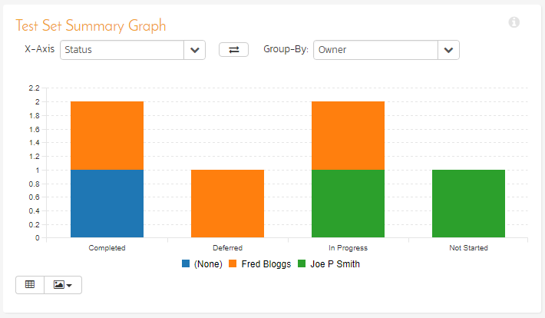

In this version of the report, the x-axis represents the test set status, and the individual bars are grouped by the name of the tester (owner). Each data-value can be viewed by positioning the mouse pointer over the bar, and a “tooltip” will pop-up listing the actual data value. Clicking on the “Display Data Grid” button will display the underlying data that is being used to generate the graph. In addition, clicking on the “Download Data as CSV” button will export the datagrid into Comma Separated Values (CSV) format that can be opened in MS-Excel. Some browsers also support the ability to save the graph as an image file (JPEG, PNG and GIF formats).

## 11.8. Snapshot Graphs

### 11.8.1. Requirements Coverage Graph

The requirements coverage graph shows how many requirements are currently in a product, according to their test coverage status.

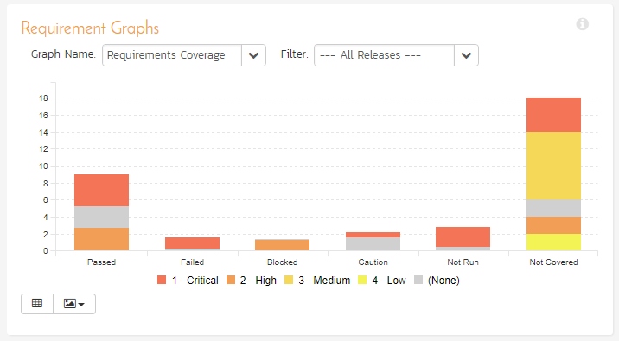

The x-axis of the report represents the various test execution statuses that a requirement can have as its coverage status (plus the Not-Covered status), and the individual bars are grouped by the requirements importance. Each data-value can be viewed by positioning the mouse pointer over the bar, and a “tooltip” will pop-up listing the actual data value.

Clicking on the “Display Data Grid” button will display the underlying data that is being used to generate the graph. You can also filter the graph to just display data for a specific release/sprint as well as for the product as a whole. In addition, clicking on the “Download Data as CSV” button will export the datagrid into Comma Separated Values (CSV) format that can be opened in MS-Excel. Some browsers also support the ability to save the graph as an image file (JPEG, PNG and GIF formats).

### 11.8.2. Requirements Burndown Graph

The Requirements Burndown graph shows the remaining number of story points that needs to be completed for each release/sprint in the product with separate lines for the estimated and ideal burndown. In addition, the graph includes bars for the completed number of story points in each time period on the x-axis:

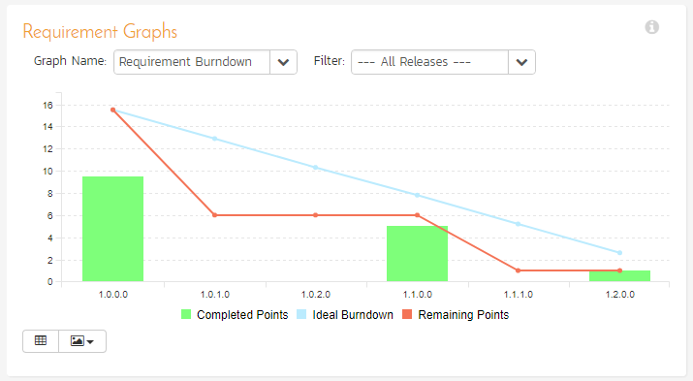

The y-axis of the graph displays the total remaining number of story points that needs to be done (the actual burndown), with a blue line indicating the ideal burndown. In addition, there are bars displayed at each interval of the x-axis that shows the completed number of story points for that interval.

The x-axis can be configured to display three different levels of granularity:

* **All Releases** – This shows the total remaining number of story points that needs to be done for each of the releases in the product
* **Specific Release** – This shows the total remaining number of story points that needs to be done for each of the sprints in the selected release
* **Specific Sprint** – This shows the total remaining number of story points that needs to be done for each working day in the date-range covered by the selected sprint.

Clicking on the “Display Data Grid” button will display the underlying data that is being used to generate the graph. In addition, clicking on the “Download Data as CSV” button will export the datagrid into Comma Separated Values (CSV) format that can be opened in MS-Excel. Some browsers also support the ability to save the graph as an image file (JPEG, PNG and GIF formats).

### 11.8.3. Requirements Burnup Graph

The Requirements Burnup graph shows the cumulative number of story points outstanding for each release/sprint in the product with separate lines for the estimated and ideal burnup. In addition, the graph includes bars for the number of completed story points in each time period on the x-axis.

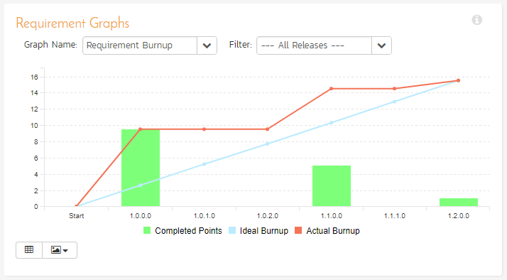

The y-axis of the graph displays the cumulative increase in number of story points for the product (the actual burnup), with a blue line indicating the ideal burnup. In addition, there are bars displayed at each interval of the x-axis that shows the number of completed story points for that interval.

The x-axis can be configured to display three different levels of granularity:

* **All Releases** – This shows the increase in number of story points for each of the releases in the product
* **Specific Release** – This shows the increase in number of story points for each of the sprints in the selected release
* **Specific Sprint** – This shows the increase in number of story points for each working day in the date-range covered by the selected sprint.

Clicking on the “Display Data Grid” button will display the underlying data that is being used to generate the graph. In addition, clicking on the “Download Data as CSV” button will export the datagrid into Comma Separated Values (CSV) format that can be opened in MS-Excel. Some browsers also support the ability to save the graph as an image file (JPEG, PNG and GIF formats).

### 11.8.4. Requirements Velocity Graph

The Requirements Velocity graph shows the total number of story points that have been completed (or planned to be completed) in a particular release, sprint or time-period (called the velocity). The actual velocity is displayed along with the overall average velocity (in blue) and the rolling average velocity (in green):

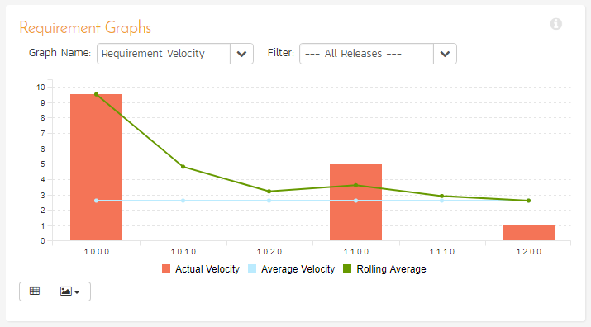

The y-axis of the graph displays the total number of story points, and the x-axis can be configured to display three different levels of granularity:

* **All Releases** – This shows the total number of story points for each of the releases in the product
* **Specific Release** – This shows the total number of story points for each of the sprints in the selected release
* **Specific Sprint** – This shows the total number of story points for each working day in the date-range covered by the selected sprint.

Clicking on the “Display Data Grid” button will display the underlying data that is being used to generate the graph. In addition, clicking on the “Download Data as CSV” button will export the datagrid into Comma Separated Values (CSV) format that can be opened in MS-Excel. Some browsers also support the ability to save the graph as an image file (JPEG, PNG and GIF formats).

### 11.8.5. Incident Aging Graph

The incident aging chart displays the number of days incidents have been left open in the system. The chart is organized as a stacked histogram, with the count of incidents on the y-axis and different age intervals on the x-axis. Each bar-chart color represents a different incident priority, giving a product manager a snapshot view of the age of open product incidents by priority.

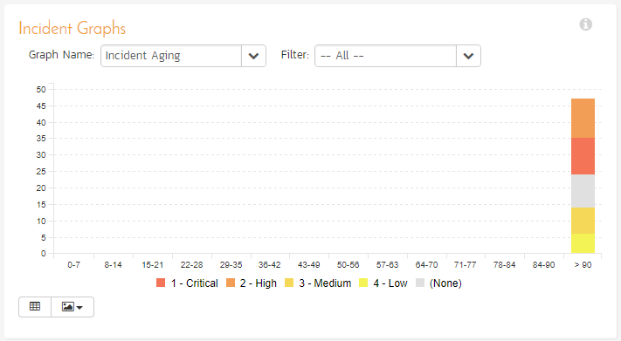

This report can be filtered by the type of incident, so for example you can see the aging of just bugs, or just issues for the product in question. Clicking on the “Display Data Grid” button will display the underlying data that is being used to generate the graph. In addition, clicking on the “Download Data as CSV” button will export the datagrid into Comma Separated Values (CSV) format that can be opened in MS-Excel. Some browsers also support the ability to save the graph as an image file (JPEG, PNG and GIF formats).

### 11.8.6. Incident Turnaround Time Graph

The incident turnaround time chart displays the number of days incidents have taken to be closed (from the time they were first raised) in the system. The chart is organized as a stacked histogram, with the count of incidents on the y-axis and different turnaround time intervals on the x-axis. Each bar-chart color represents a different incident priority, giving a product manager a snapshot view of the turnaround time of product incidents by priority.

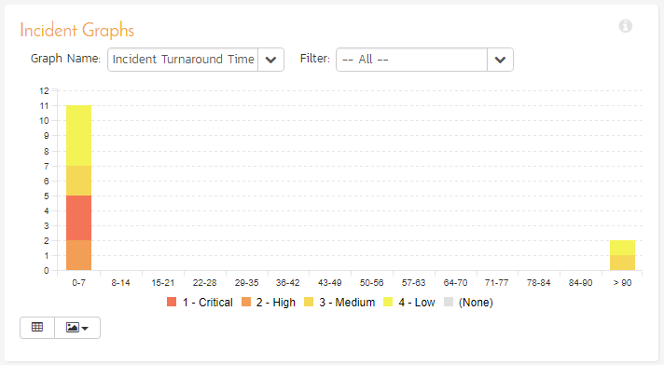

This report can be filtered by the type of incident, so for example you can see the turnaround time of just bugs, or just issues for the product in question. Clicking on “Display Data Grid” button will display the underlying data that is being used to generate the graph. In addition, clicking on the “Download Data as CSV” button will export the datagrid into Comma Separated Values (CSV) format that can be opened in MS-Excel. Some browsers also support the ability to save the graph as an image file (JPEG, PNG and GIF formats).

### 11.8.7. Task Velocity Chart

The Task Velocity graph shows the total estimated and actual effort (in number of hours) delivered in each product release and/or sprint:

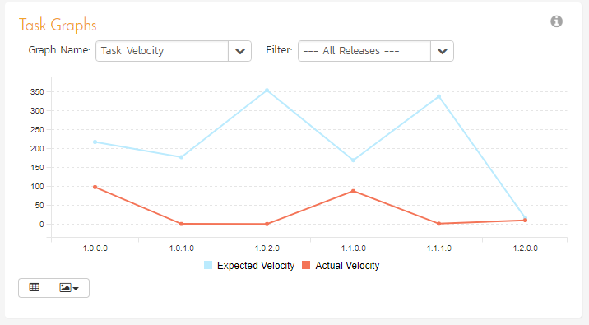

The y-axis of the graph displays the total estimated and actual effort delivered (in hours), and the x-axis can be configured to display three different levels of granularity:

* **All Releases** – This shows the total estimated and actual effort for each of the releases in the product
* **Specific Release** – This shows the total estimated and actual effort for each of the sprints in the selected release
* **Specific Sprint** – This shows the total estimated actual effort for each working day in the date-range covered by the selected sprint.

Clicking on the “Display Data Grid” button will display the underlying data that is being used to generate the graph. In addition, clicking on the “Download Data as CSV” button will export the datagrid into Comma Separated Values (CSV) format that can be opened in MS-Excel. Some browsers also support the ability to save the graph as an image file (JPEG, PNG and GIF formats).

### 11.8.8. Task Burnup Chart

The Task Burnup graph shows the cumulative amount of work outstanding for each release/sprint in the product with separate lines for the estimated and ideal burnup. In addition, the graph includes bars for the remaining and completed effort in each time period on the x-axis.

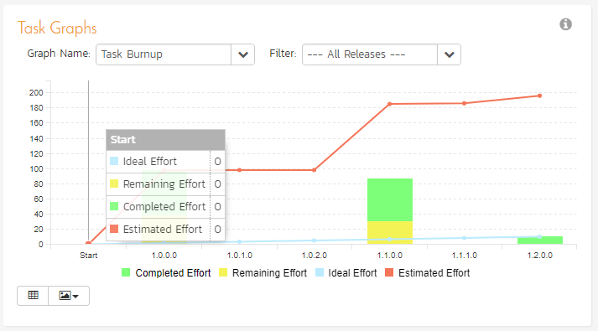

The y-axis of the graph displays the cumulative increase in work (in hours) for the product (the actual burnup), with a blue line indicating the ideal burnup. In addition, there are bars displayed at each interval of the x-axis that shows the remaining effort and completed effort for that interval.

The x-axis can be configured to display three different levels of granularity:

* **All Releases** – This shows the increase in work for each of the releases in the product
* **Specific Release** – This shows the increase in work for each of the sprints in the selected release
* **Specific Sprint** – This shows the increase in work for each working day in the date-range covered by the selected sprint.

Clicking on the “Display Data Grid” button will display the underlying data that is being used to generate the graph. In addition, clicking on the “Download Data as CSV” button will export the datagrid into Comma Separated Values (CSV) format that can be opened in MS-Excel. Some browsers also support the ability to save the graph as an image file (JPEG, PNG and GIF formats).

### 11.8.9. Task Burndown Chart

The Task Burndown graph shows the remaining work (in hours) that needs to be done for each release/sprint in the product with separate lines for the estimated and ideal burndown. In addition, the graph includes bars for the remaining and completed effort in each time period on the x-axis.

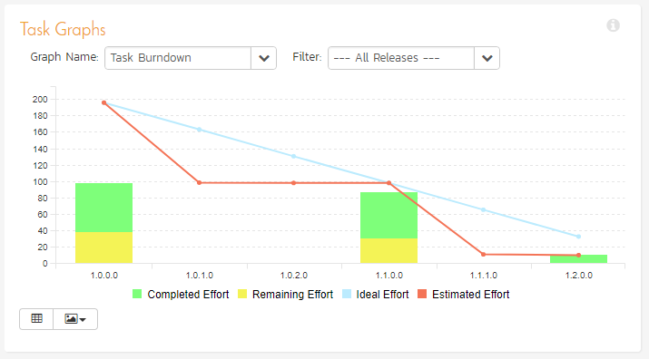

The y-axis of the graph displays the total remaining work that needs to be done (the actual burndown), with a blue line indicating the ideal burndown. In addition, there are bars displayed at each interval of the x-axis that shows the remaining effort and completed effort for that interval.

The x-axis can be configured to display three different levels of granularity:

* **All Releases** – This shows the total remaining work that needs to be done for each of the releases in the product
* **Specific Release** – This shows the total remaining work that needs to be done for each of the sprints in the selected release
* **Specific Sprint** – This shows the total remaining work that needs to be done for each working day in the date-range covered by the selected sprint.

Clicking on the “Display Data Grid” button will display the underlying data that is being used to generate the graph. In addition, clicking on the “Download Data as CSV” button will export the datagrid into Comma Separated Values (CSV) format that can be opened in MS-Excel. Some browsers also support the ability to save the graph as an image file (JPEG, PNG and GIF formats).

## 11.9. Date-Range Graphs

### 11.9.1. Test Run Progress Rate Graph

The test run progress rate graph shows how many tests have been executed during a period of time, and what execution status was recorded. The report can be displayed for a specific date-range and for the entire product or for a specific release/sprint:

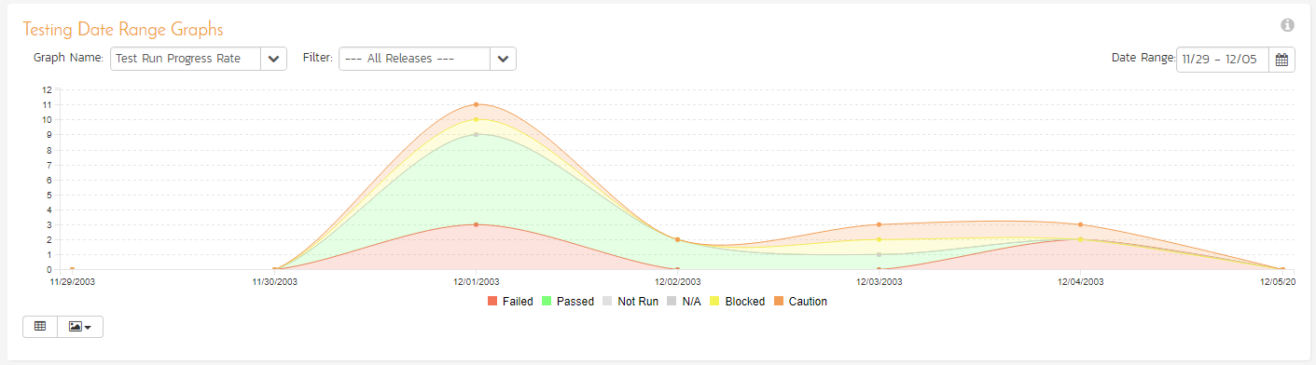

In this version of the report, the y-axis represents the number of test runs executed in each 24 hour period, and the x-axis represents a specific week in the time-span. Each data-bar can be viewed by positioning the mouse pointer over the point, and a “tooltip” will pop-up listing the actual data value. You can filter the report by the release/sprint that the test run was executed against, and also change the date range. If you choose a smaller date-range, the x-axis will switch from weekly to daily and if you choose a larger date-range, the x-axis will switch to monthly.

Clicking on the “Display Data Grid” button will display the underlying data that is being used to generate the graph. In addition, clicking on the “Download Data as CSV” button will export the datagrid into Comma Separated Values (CSV) format that can be opened in MS-Excel. Some browsers also support the ability to save the graph as an image file (JPEG, PNG and GIF formats).

### 11.9.2. Test Case Progress Rate Graph

This graph displays the number of test case executions for the specified date range for that specific date interval. That means it will display for each day, the total number of test cases executed ignoring the status from any previous days. Any test cases not executed that day will be considered “not run” and will appear in the “not run” category. For example, if you have 10 test cases created on day 1 you will see 10 test cases “not run” on day 1. On day 2, you execute 5 test cases and fail them all, you will now see 5 test cases failed and 5 not run. On day 3, you execute 3 of the previous 5 test cases and pass them. You will now see 3 test cases passed, 0 failed and 7 not run.

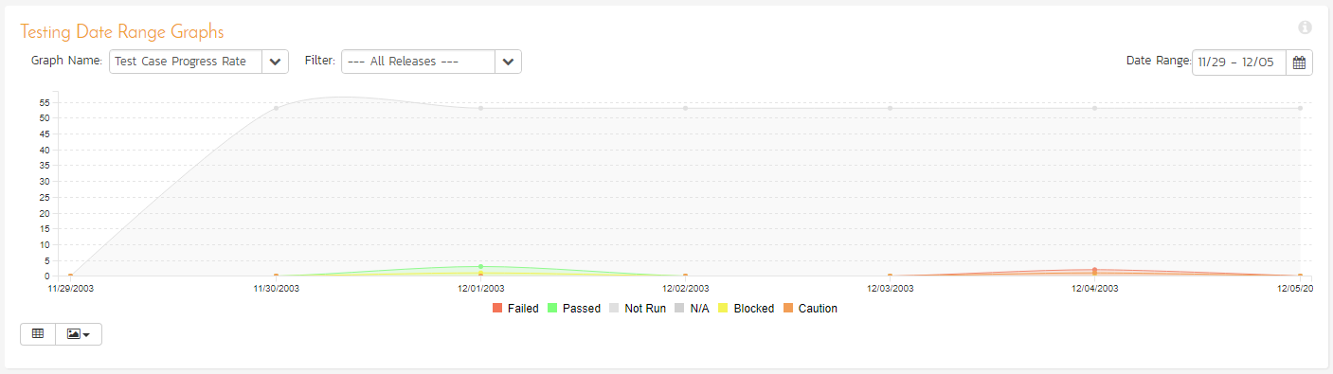

### 11.9.3. Test Case Cumulative Progress Graph

This graph displays the number of test case executions cumulatively over the specified date range. That means it will display for each day, the total number of test cases executed plus the status from any previous days that have not been changed. Any test cases not executed up to that point will be considered “not run” and will appear in the “not run” category. For example, if you have 10 test cases created on day 1 you will see 10 test cases “not run” on day 1. On day 2, you execute 5 test cases and fail them all, you will now see 5 test cases failed and 5 not run. On day 3, you execute 3 of the previous 5 test cases and pass them. You will now see 3 test cases passed, 2 failed and 5 not run.

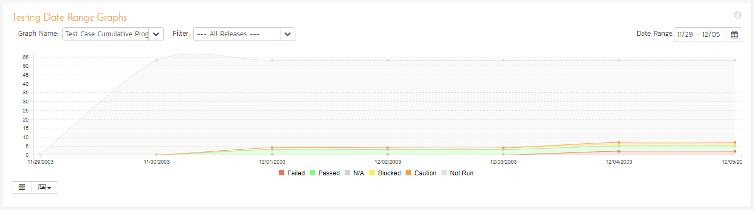

### 11.9.4. Incident Progress Rate Graph

The incident progress rate chart displays the total number of incidents created and closed over a particular date-range, either for all incident types or for a specific incident type:

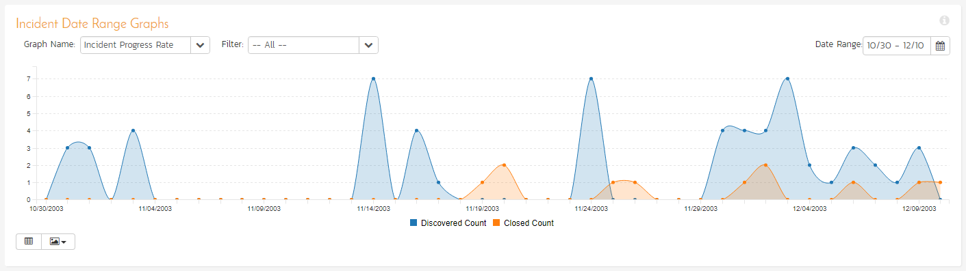

In this version of the report, the y-axis represents the number of incidents (either created or closed in a 24 hour period), and the x-axis represents a specific day in the time-span. Each data-point can be viewed by positioning the mouse pointer over the point, and a “tooltip” will pop-up listing the actual data value. You can filter the report by the type of incident, and also change the date range (e.g. displaying only the bugs for the date range). If you choose a smaller date-range, the x-axis will switch from weekly to daily and if you choose a larger date-range, the x-axis will switch to monthly.

Clicking on the “Display Data Grid” button will display the underlying data that is being used to generate the graph. In addition, clicking on the “Download Data as CSV” button will export the datagrid into Comma Separated Values (CSV) format that can be opened in MS-Excel. Some browsers also support the ability to save the graph as an image file (JPEG, PNG and GIF formats).

### 11.9.5. Cumulative Incident Count Graph

The cumulative incident count chart displays the cumulative total number of incidents logged in the system for the current product over a particular date-range, either for all incident types or for a specific incident type. The report displays two data series, one illustrating the total count of all incidents, the other the total count of all *open incidents* (i.e. with status not set to fixed or closed):

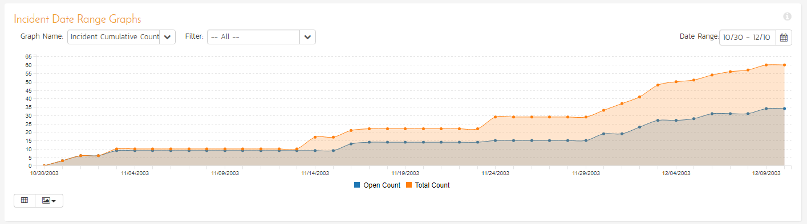

In this version of the report, the y-axis represents the number of incidents, and the x-axis represents a specific week in the time-span. Each data-point can be viewed by positioning the mouse pointer over the point, and a “tooltip” will pop-up listing the actual data value. You can also filter the type of incident being reported, as well as change the date interval. If you choose a smaller date-range, the x-axis will switch from weekly to daily and if you choose a larger date-range, the x-axis will switch to monthly.

Clicking on the “Display Data Grid” button will display the underlying data that is being used to generate the graph. In addition, clicking on the “Download Data as CSV” button will export the datagrid into Comma Separated Values (CSV) format that can be opened in MS-Excel. Some browsers also support the ability to save the graph as an image file (JPEG, PNG and GIF formats).

### 11.9.6. Open Incident Count Graph

The open incident count chart displays the net number of open incidents in the system for the current product over a particular date-range categorized by incident priority, either for all incident types or for a specific incident type. For this chart, “open” is defined as any incident with an empty “Closed On” date. The incident status is not used for this chart.

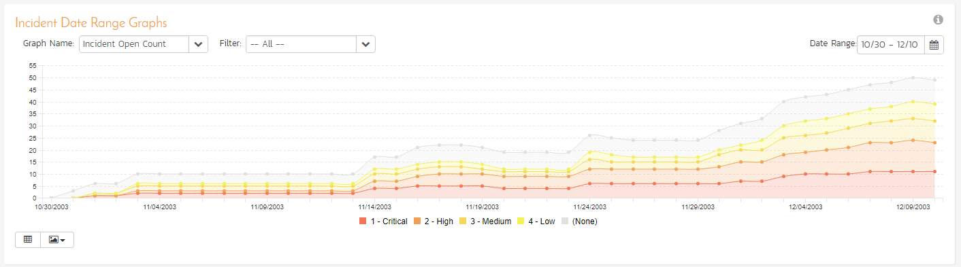

In this version of the report, the y-axis represents the number of incidents, and the x-axis represents a specific week in the time-span. The exact count of each bar in the stacked histogram can be viewed by positioning the mouse pointer over the bar, and a “tooltip” will pop-up listing the actual data value. You can also filter the type of incident being reported, as well as change the date interval. If you choose a smaller date-range, the x-axis will switch from weekly to daily and if you choose a larger date-range, the x-axis will switch to monthly.

Clicking on the “Display Data Grid” button will display the underlying data that is being used to generate the graph. In addition, clicking on the “Download Data as CSV” button will export the datagrid into Comma Separated Values (CSV) format that can be opened in MS-Excel. Some browsers also support the ability to save the graph as an image file (JPEG, PNG and GIF formats).

### 11.9.7. Incident Count by Status Graph

The incident status count chart displays the number of open incidents in the system for the current product over a particular date-range categorized by incident status, either for all incident types or for a specific incident type. For this chart, “open” is defined as any incident with an empty “Closed On” date. The incident status is not used for this chart.

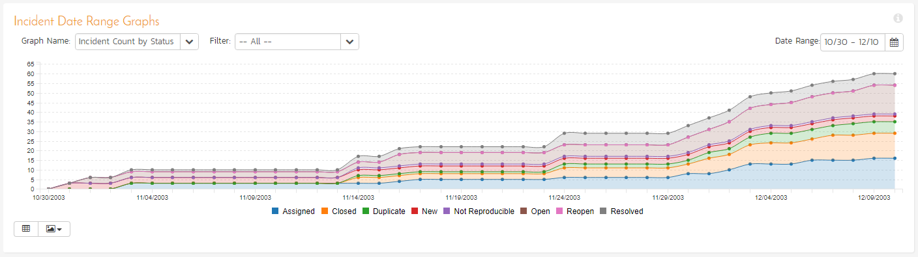

In this version of the report, the y-axis represents the number of incidents, and the x-axis represents a specific week in the time-span. The exact count of each bar in the stacked histogram can be viewed by positioning the mouse pointer over the bar, and a “tooltip” will pop-up listing the actual data value. You can also filter the type of incident being reported, as well as change the date interval. If you choose a smaller date-range, the x-axis will switch from weekly to daily and if you choose a larger date-range, the x-axis will switch to monthly.

Clicking on the “Display Data Grid” button will display the underlying data that is being used to generate the graph. In addition, clicking on the “Download Data as CSV” button will export the datagrid into Comma Separated Values (CSV) format that can be opened in MS-Excel. Some browsers also support the ability to save the graph as an image file (JPEG, PNG and GIF formats).

## 11.10 Custom Graphs

These are the graphs that a SpiraPlan administrator has created in the Administration section of the system and published for use by end users. They rely on specific ESQL data queries, so the data represented will depend on the query created by the administrator.

To add a custom graph to your reports dashboard, click on the **Add Items** icon and choose Custom Graphs:

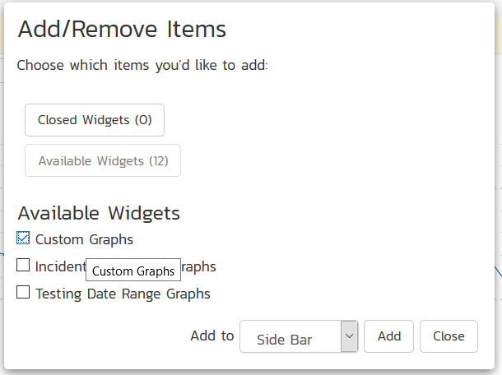

Once you add the Custom Graphs widget to your dashboard, you will see the following:

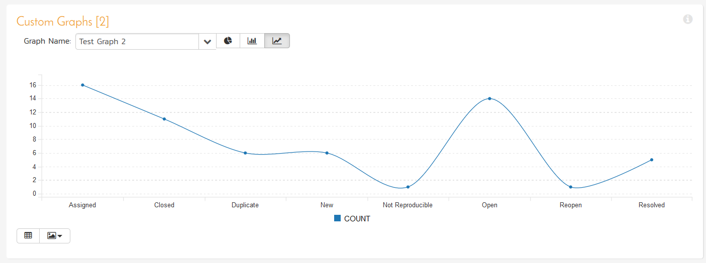

You can change which custom graph will be used in this widget by simply changing the values in the dropdown list:

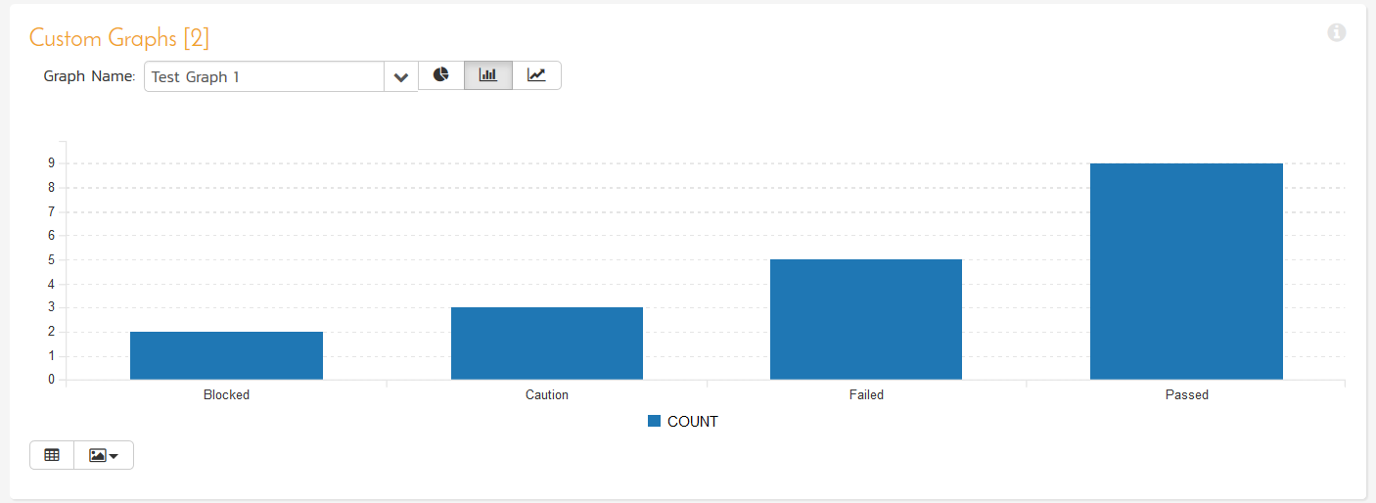

You can also change the graph display between the three display types: donut, bar, and line. The donut style of graph is only available for reports with a single data series:

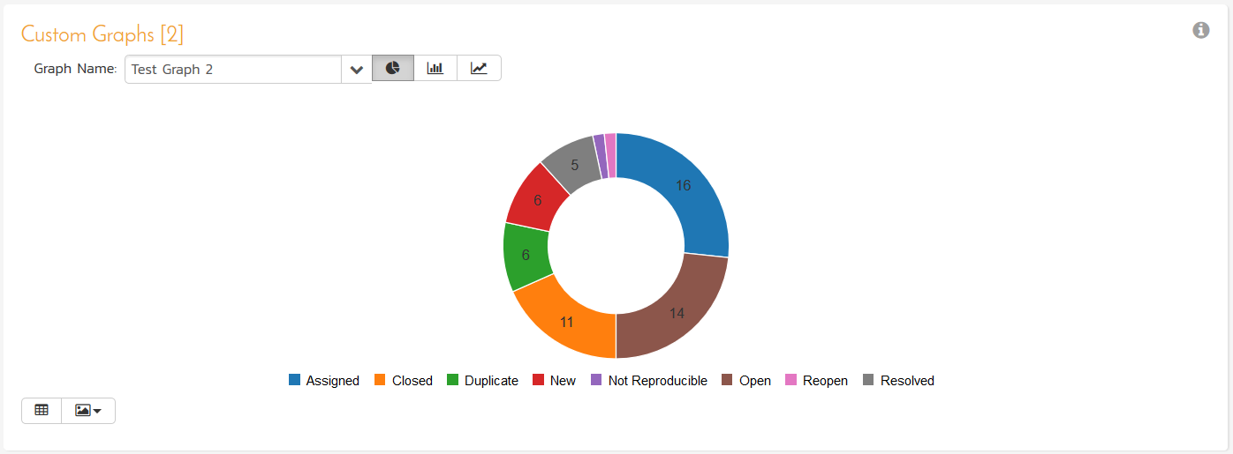

Clicking on the “Data Grid” icon will display the underlying data that is being used to generate the graph.

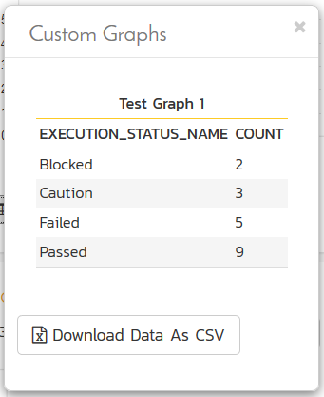

In addition, clicking on the “Download Data as CSV” button will export the data grid into Comma Separated Values (CSV) format that can be opened in MS-Excel.

Some browsers also support the ability to save the graph as an image file (JPEG, PNG and GIF formats).

## 11.11. Risk Reports

### 11.11.1. Risk Summary Report

This report displays all of the risks tracked for the current project. The risks are displayed, along with a tabular list of mitigations, tasks, comments, attached documents, and change history:

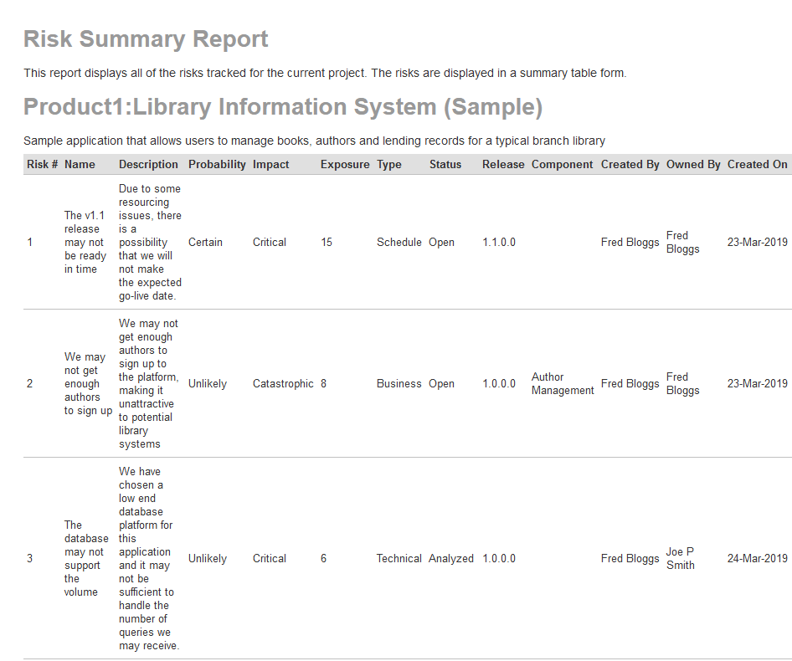

### 11.11.2. Risk Detailed Report

This report displays all of the risks tracked for the current project. The risks are displayed in a summary table form:

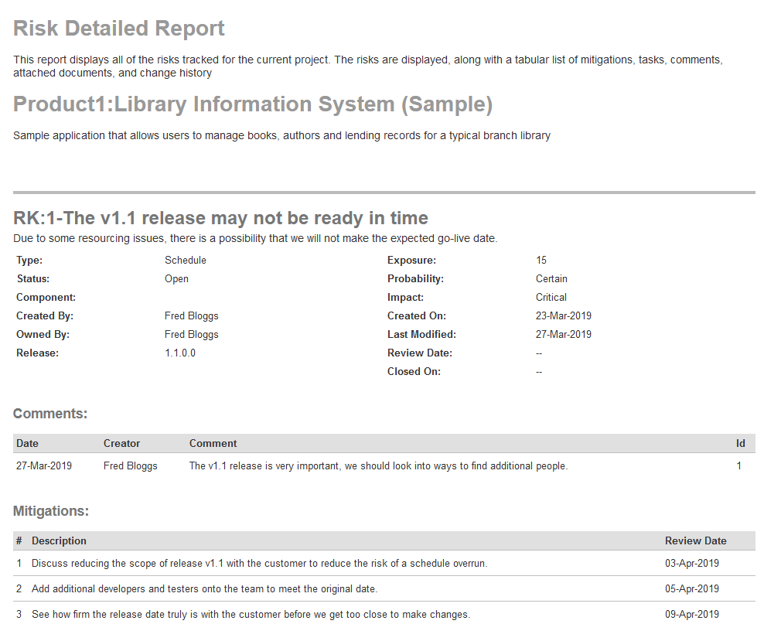

# 12. Source Code

This section outlines the source code integration features of SpiraPlan® and SpiraTeam® that can be used to browse the source code repository associated with a particular product and link artifacts in SpiraPlan to revisions / commits made in the source code repository. This functionality allows product members to quickly view files in the repository through a convenient web interface and also to see the end-to-end traceability from requirements, tasks and incidents to the code changes that addressed the requirement, fulfilled the task or resolved the incident

The software can be integrated with a variety of different version control / Software Configuration Management (SCM) systems by means of different plug-ins. This section will outline the general features irrespective of the type of version control provider being used. For details on using a specific provider (e.g. Subversion) please refer to the separate *SpiraPlan/Team Version Control Integration Guide*. This section also assumes that an administrator has already configured the product to be integrated with the version control provider. The steps for using the administrative interface are described in the separate *SpiraPlan Administration Guide*.

## 12.1. Source Code File List

When you click on Tracking > Source Code on the global navigation bar, you will be taken to the source code repository file list screen illustrated below:

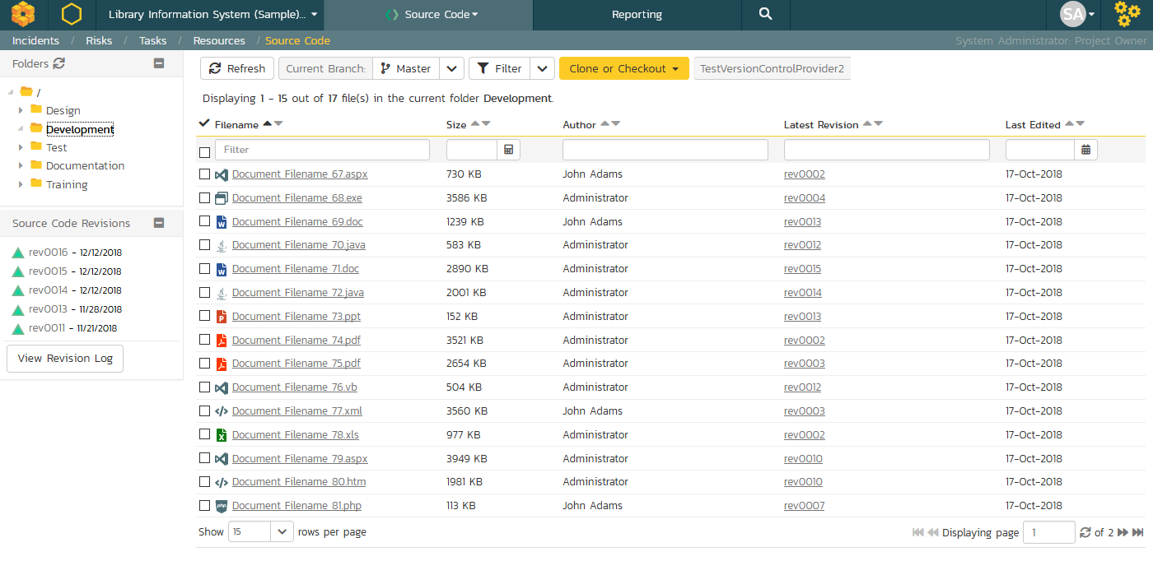

This screen consists of three main sections:

* The top left-hand pane displays a hierarchical list of the various folders that exist in the source code repository. Clicking on the expand icon will expand the child folders and clicking on the name of the folder will display the list of files in the folder in the main pane to the right.
* The main right-hand pane displays a list of all the files contained within the currently selected folder. This list can be filtered and sorted, and you can choose how many rows of documents to display on the page at one time.
* The bottom left-hand pane contains a list of the most recent revisions, together with the option to view the overall revision log for the product, clicking on that will display the revision log page (see section 12.3 for details).

Above the main right-hand pane, there is the **branch selector**. This lets you choose which branch in the source code repository is being viewed:

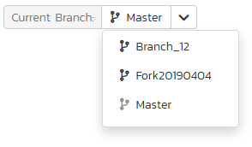

Some older source code management systems (e.g. CVS, Visual SourceSafe) do not have the formal concept of branches, so the dropdown list will simply list the one main branch (usually called “Trunk”).

## 12.2. Source Code File Details

When you click on a file in the source code file list described above, you are taken to the file details page illustrated below:

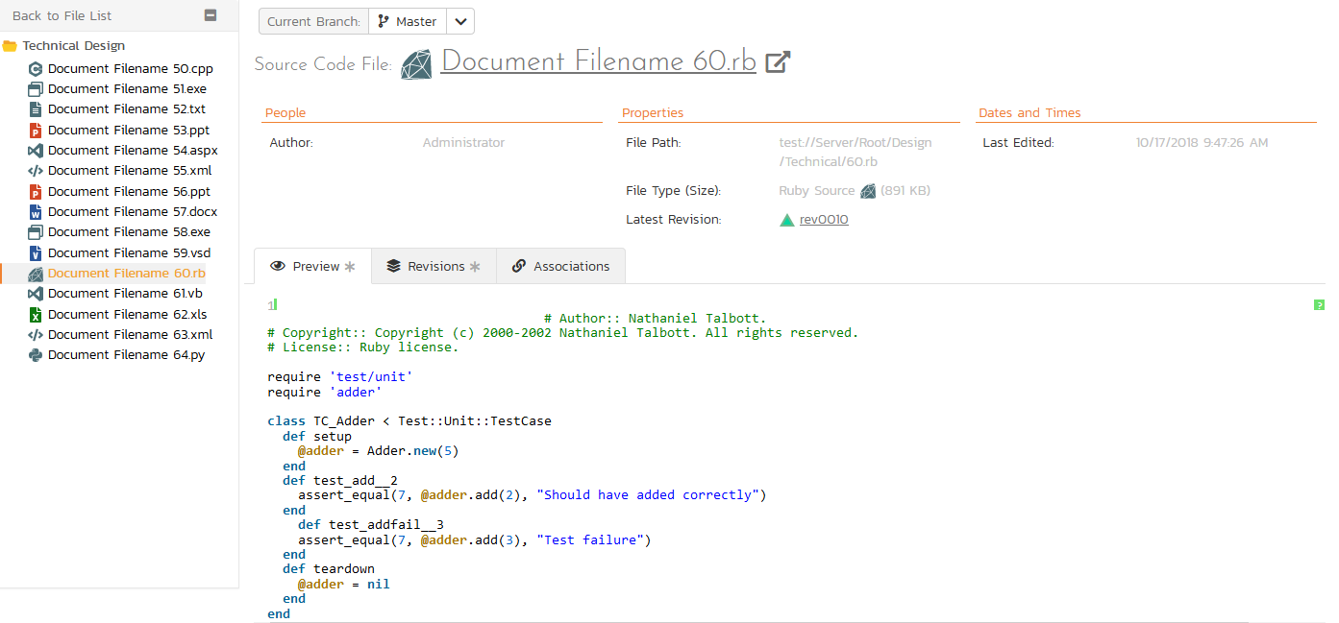

This page is made up of three areas; the left pane is for navigation, the upper part of the main pane contains information regarding the file, and the bottom part of the right pane contains **three tabs** that display a preview of the file (if textual), the list of file revisions stored in the version control system, and a list of associated artifacts.

The navigation pane consists of a link that will take you back to the source code file list, as well as a list of other files in the current folder. This latter list is useful as a navigation shortcut; you can quickly view the detailed information of all the peer files by clicking on the navigation links without having to first return to the main file list page.

The top part of the main pane allows you to view the details of the particular file in the version control system. Clicking on the “Source Code File” hyperlink will open the file in a separate window, and depending on the type of file, it may display in the page or prompt you to download it to your local computer. The “Latest Revision” hyperlink allows you to view details of the latest revision (see section 12.4 below).

The lower part of the main pane can be switched between the three different views by clicking the appropriate tab. Initially the pane will be in “Preview” mode, but it can be switched to “Revisions”, or “Associations” as well. The functionality in each of these views is described below:

### 12.2.1. Preview

This view is only available for files that are textual and it will display the contents of the file inside the tab, with the text color-coded to match the syntax of the programming language it is written in:

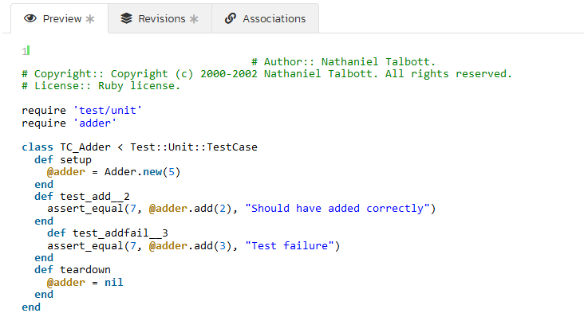

The syntax highlighting is based on the file type and file extension, so if you save a file with an incorrect extension (e.g. using .txt for a JavaScript file) it may not display the correct color-coding. For text files that are not for a specific programming language, it will simply display as plain text

### 12.2.2. Revisions

This view displays the list of revisions that have been committed for the current file:

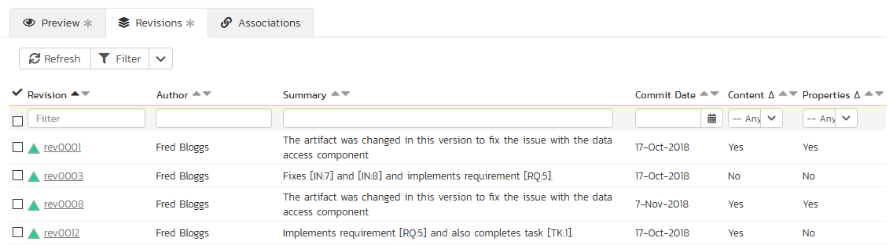

Each revision in the list is displayed with its name, the name of the person who made the revision, a description of what was changed, the date the change was made and two flags that denote whether the content was changed and/or if any of the properties of the file were changed. Clicking on the revision name will take you to the appropriate revision details page (see section 12.4).

### 12.2.3. Associations

This view displays a list of the SpiraPlan artifacts in the current product that are associated with the current file. This allows you to see which requirements, test cases, incidents, tasks, etc. are linked to the file. Clicking on the hyperlink for the artifact will take you to the appropriate artifact page inside the product (assuming your user has permissions to access that information).

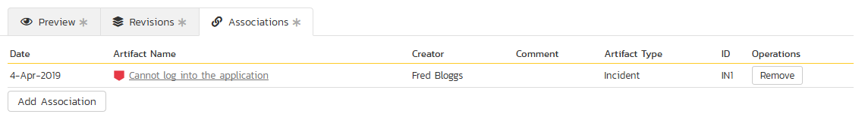

In addition, you can use the “Add New Association” button to add a new association from the current source code file to an existing artifact in SpiraTeam:

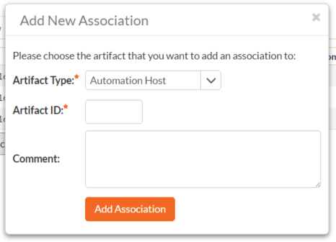

To add the association, you just need to select the type of artifact being associated (requirement, test case, incident, etc.) and the numeric ID of the artifact and then click the “Add Association” button.

For example, to add an association to Requirement RQ00005 you would choose Artifact Type = Requirement and Artifact ID = 5.

## 12.3. Source Code Revision List

If you click on the “View Revision Log” button on the main Source Code page, it will take you to the Revision List page that displays all the revisions made to the product in a sortable, filterable list:

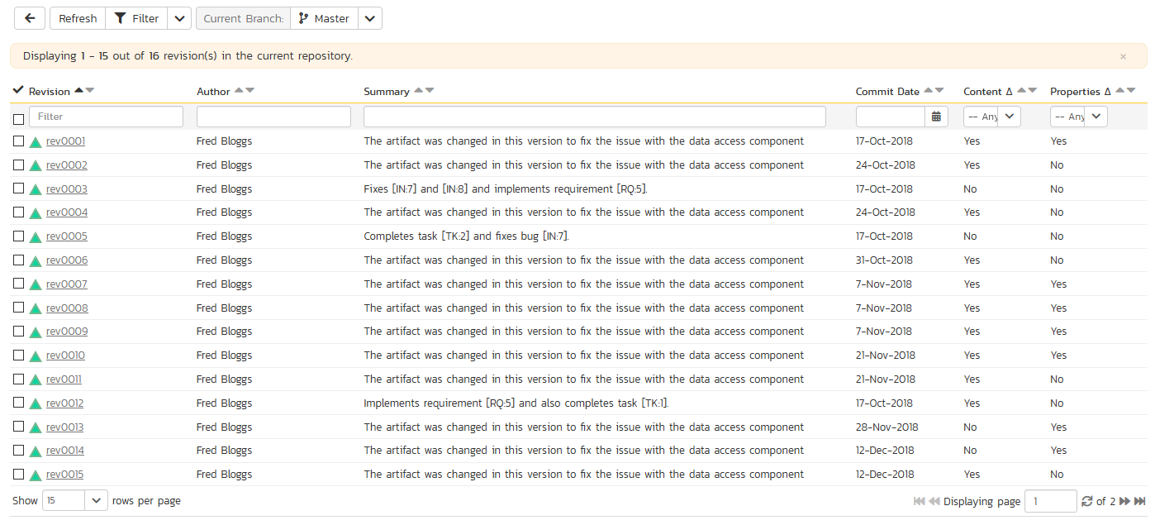

Each revision in the list is displayed with its name, a description of what changed in the revision, the name of the person who committed the revision, and whether the revision was a change of the actual content, or just a change of the properties of the content. Clicking on the hyperlink for the revision name will take you to the Revision Details page for that revision (see section 12.4 below).

Above the main right-hand pane, there is the **branch selector**. This lets you choose which branch in the source code repository is being viewed.

## 12.4. Source Code Revision Details

When you click on a revision hyperlink in either the product revision log or the file revisions tab described above, you are taken to the revision details page illustrated below:

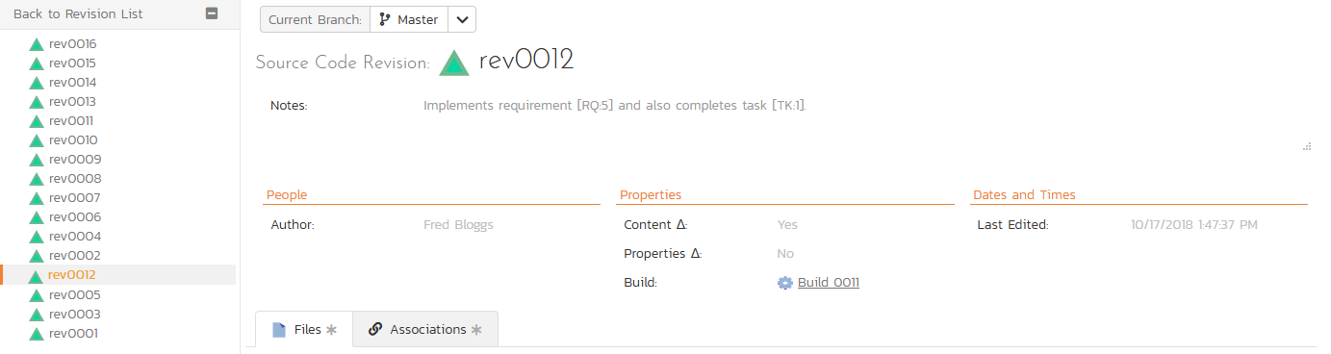

This page is made up of three areas; the left pane is for navigation, the upper part of the main pane contains the details of the revision, and the bottom part of the right pane contains the list of files that were changed in this revision and the list of artifacts that the revision is associated with.

The navigation pane consists of a link that will take you back to the source code revision list, as well as a list of other revisions associated with the current file. This latter list is useful as a navigation shortcut; you can quickly view the detailed information of all the peer revisions by clicking on the navigation links without having to first return to the main revision list page.

The top part of the main pane allows you to view the details of this revision in the version control system, including the description of what was changed, the date that the change was made, and the name of the person who made the change.

The lower part of the main pane can be switched between two different views by clicking the appropriate tab. Initially the pane will be in “Files” mode, but it can be switched to “Associations” as well. The functionality in each of these two views is described below:

### 12.4.1. Files

This view displays the list of files that were changed in the current revision:

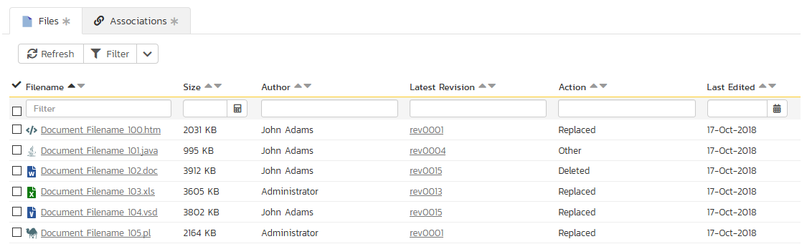

Each file in the list is displayed with its name, the file-size, who made changes to the file, what action was performed on the file (added, deleted, replaced, updated, etc.) and the most recent revision that exists for that file. Clicking on the filename will take you to the appropriate file details page (see section 12.2), and clicking on the revision hyperlink will take you the appropriate revision.

### 12.4.2. Associations

This view displays a list of the SpiraPlan artifacts in the current product that are associated with the current revision. This allows you to see which requirements, incidents or tasks were affected by this specific change to the source code:

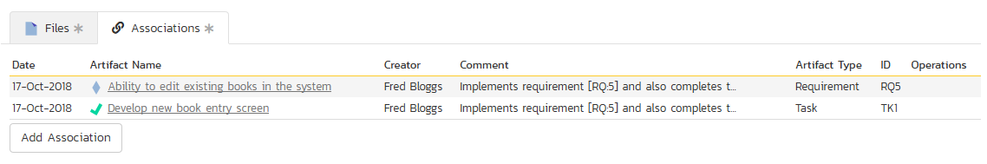

Clicking on the hyperlink for the artifact will take you to the appropriate artifact page inside the product (assuming your user has permissions to access that information).

In addition to the associations that are created from within the source code management system, you can add associations between source code revisions and SpiraPlan artifacts from within SpiraPlan interface itself. To do this, you simply need to click on the ‘Add Association’ button:

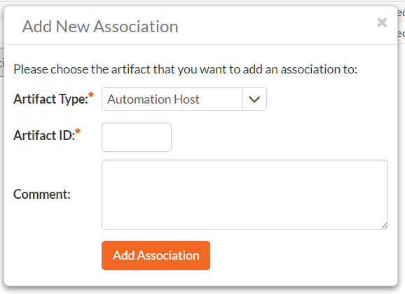

To add the association, you just need to select the type of artifact being associated (requirement, test case, incident, etc.) and the numeric ID of the artifact and then click the “Add Association” button.

For example to add an association to Requirement RQ00005 you would choose Artifact Type = Requirement and Artifact ID = 5.

# 13. Planning Board

The SpiraPlan planning board is a great way to visualize the backlog items (requirements, tasks, test cases and incidents) planned for your product. Based on the principles of **agile methodologies** such as Scrum and Kanban, the planning board is a great tool for planning agile products.

To access the SpiraPlan **product** planning board, select a product and go to Artifacts > Planning Board and the following screen will be displayed:

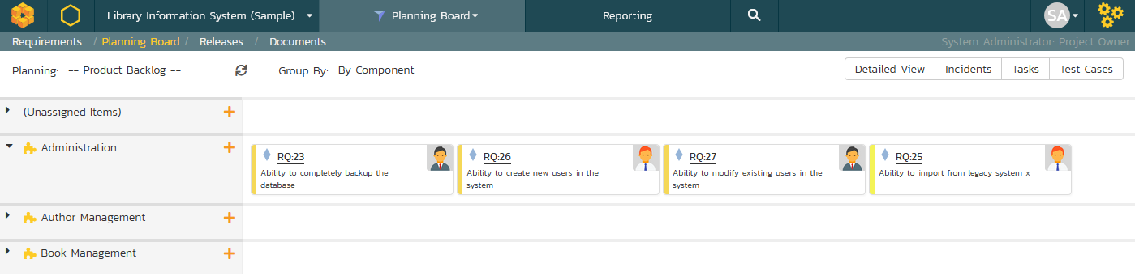

To access the SpiraTest **program** planning board, select a program and go to the Planning menu and the following screen will be displayed:

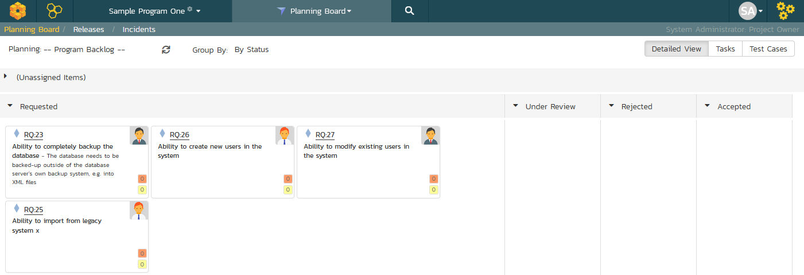

We shall first discuss the product planning board, and then in section 13.5 we will cover the program planning board.

By default, the system will display the product planning board in the product backlog view, with the backlog organized by component. You can change the view by click on the ‘**Planning’** drop down list:

* **Product Backlog** – This displays a list of all the backlog items that are not currently scheduled for a specific release or sprint. The items can be organized by component, package, priority or person.
* **All Releases** – This displays a list of all the releases as well as the product backlog and is designed to let you easily move items from the product backlog to a specific release.
* **Release View** – This displays a list of all the backlog items that are scheduled for the selected release and lets you organize them by sprint, status, or person.
* **Sprint View** - This displays a list of all the backlog items that are scheduled for the selected sprint (also known as a Sprint in some methodologies) and lets you organize them by status, or person.

The ‘**Group By’** dropdown list is used to change how the view is organized. This list of options available in the ‘Group By’ dropdown will depend on the view being displayed.

The planning board will include the following backlog items:

* **Requirements and Incidents** – these are displayed as ‘story cards’ and are the primary items that can be moved in the planning board.
* **Tasks and Test Cases** – these are secondary artifacts and are considered part of a requirement. So within the planning board they are displayed as being part of a specific requirement, and if you move a requirement, the associated tasks and test cases will move as well.

The backlog items themselves can be configured to display in different ways. The choice of display will depend on how many backlog items you have to display, how large your screen is and what information you need. The display is controlled by the four checkboxes at the top of the planning board:

* **Standard View** – This is the view that will be displayed when ‘detailed view’ is unchecked. It displays the minimum necessary information in each story card, but maximizes how many story cards can be displayed on the screen. Each story card will contain the icon, ID, name, user avatar, and estimate (in story points) of the requirement.  
    
  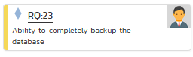
* **Detailed View** – This view includes additional information in each story card. It adds the long description, a progress bar indicator (that indicates what percentage of the item has been completed) and for requirement artifacts it includes the number of tasks (red background) and number of test cases (yellow background) in the two small boxes under the user:  
    
  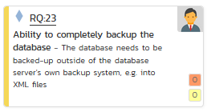
* **Incidents** – The planning board will always include requirement backlog items, but because the number of incidents can be very large, there is the option to include/exclude them from the planning board. When you have the “Incidents” checkbox selected, incidents will appear in the planning board with their own story card format. The main difference is that the effort is recorded in hours rather than story points:  
    
  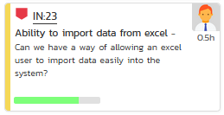
* **Tasks** – When the Tasks option is selected, the planning board will display the tasks associated with the requirements as part of each story card. Each task will be displayed with its ID and a miniature progress bar:  
    
  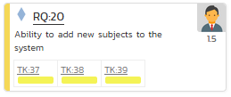
* **Test Cases** – When the Test Cases option is selected, the planning board will display the test cases associated with the requirements as part of each story card. Each test case will be displayed with its ID and a miniature test coverage bar-chart:  
    
  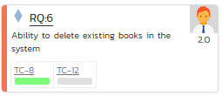

Regardless of the view, backlog items can be moved using “drag and drop” between the different parts of the planning board. To drag and drop multiple items, you should first select the items so that they are highlighted. Then you can drag and drop the entire selection:

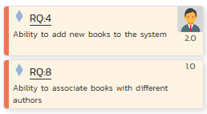

You can add new requirement backlog items by clicking the “+” button. This will display the following dialog box:

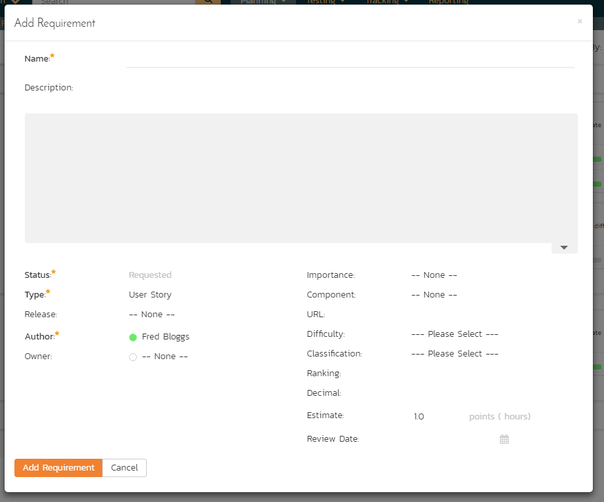

On this screen you can enter the fields for a new requirement, click “Add Requirement” and the requirement will be added to the appropriate section of the planning board.

In some of the views of the planning board there will be more data that can be displayed on one screen, in which case you will be able to scroll the planning board left and right using the specially provided arrow buttons.

Each of the views is now described in more detail in the sections below.

## 13.1. Product Backlog Planning

The product backlog view is designed to let you view the backlog items that have been created for the product and have not yet been assigned to a specific release or sprint. The backlog items can be requirements or incidents, and in the case of requirements, you can see the tasks and test cases associated with a specific requirement.

In this view you can drag and drop the backlog items from one section (e.g. component) to another and also rearrange the backlog items in their relative order. By default, the items are sorted according to their priority/importance value (the color of which is indicated in the left-hand side of the story card), but you can drag and drop them into a different order. This is particularly useful when you have several items of the same priority and you need to rank them. This process is typically called **backlog grooming**.

### 13.1.1. Product Backlog – By Component

This view is designed to let you see the product backlog organized by Component. Each of the components is displayed on the left-hand side and the backlog items displayed in the same row on the right. The backlog items can be requirements (with associated tasks and test cases) or incidents.

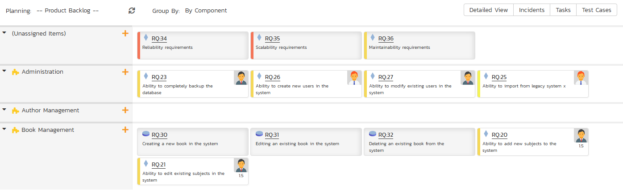

The top section will contain the list of items that are not assigned to a component, with the other sections containing the items that belong to the specific component.

### 13.1.2. Product Backlog – By Package

This view is designed to let you see the product backlog organized by requirement package (a summary requirement). Each of the packages is displayed on the left-hand side in a hierarchical structure, and the backlog items displayed in the same row on the right. The backlog items can be child requirements (with associated tasks and test cases) or incidents. In this view the incidents are the ones linked to the package through an association.

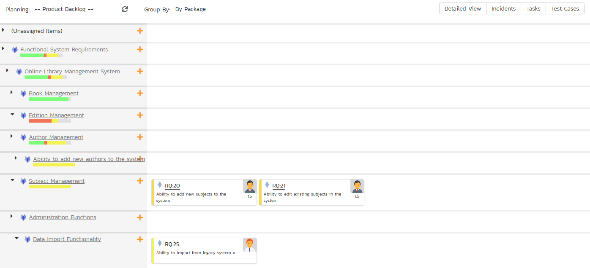

The top section will contain the list of items that are not assigned to a package, with the other sections containing the items that are children of the specific package.

### 13.1.3. Product Backlog – By Priority

This view is designed to let you see the product backlog organized by requirement importance. Each of the possible importance values is displayed on the left-hand side and the backlog items displayed in the same row on the right. The backlog items in this view will only be requirements (with associated tasks and test cases).

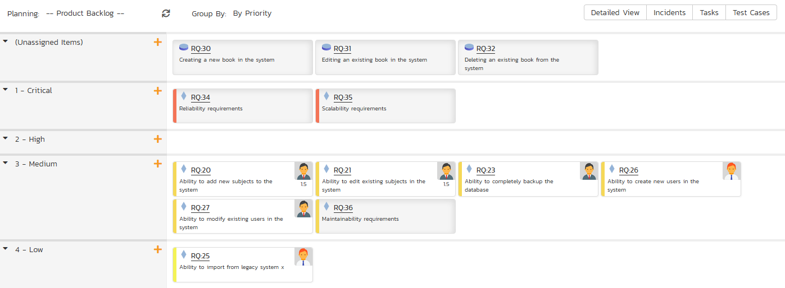

The top section will contain the list of items that are not assigned a priority, with the other sections containing the items that have been assigned to the specific priority.

### 13.1.4. Product Backlog – By Status

This view is designed to let you see the product backlog organized by requirement status. Each of the possible status values (for an unscheduled item) is displayed as a heading, with the backlog items displayed in the same column underneath. The backlog items in this view will only be requirements (with associated tasks and test cases). This view is commonly called a **Kanban** board:

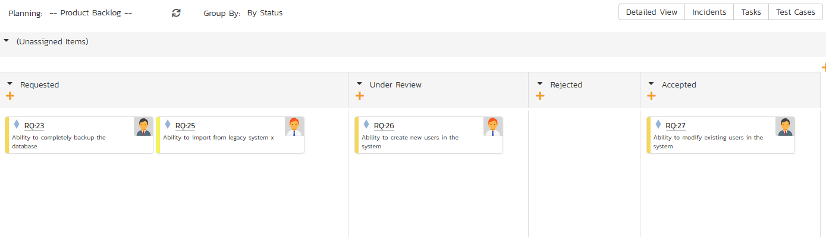

Each of the vertical sections is one of the requirements’ statuses, in order of the requirement lifecycle (Requested > Accepted). Once a requirement is assigned to a release or sprint it will come automatically ‘Planned’ and not appear in this view. You can drag and drop the requirements between the different statuses.

## 13.2. Release Planning

The ‘All Releases’ option lets you view all of the backlog items that have already been assigned to a release - and are therefore not in the product backlog. The backlog items can be requirements or incidents, and in the case of requirements, you can see the tasks and test cases associated with a specific requirement.

The lower section of the board allows you to view the items by either by release, priority, status, or person. Each section below will discuss each option in turn.

### 13.2.1. Release Planning – By Release

This release planning view is designed to let you view the backlog items that have been created for the product and associate them with different releases defined for the product

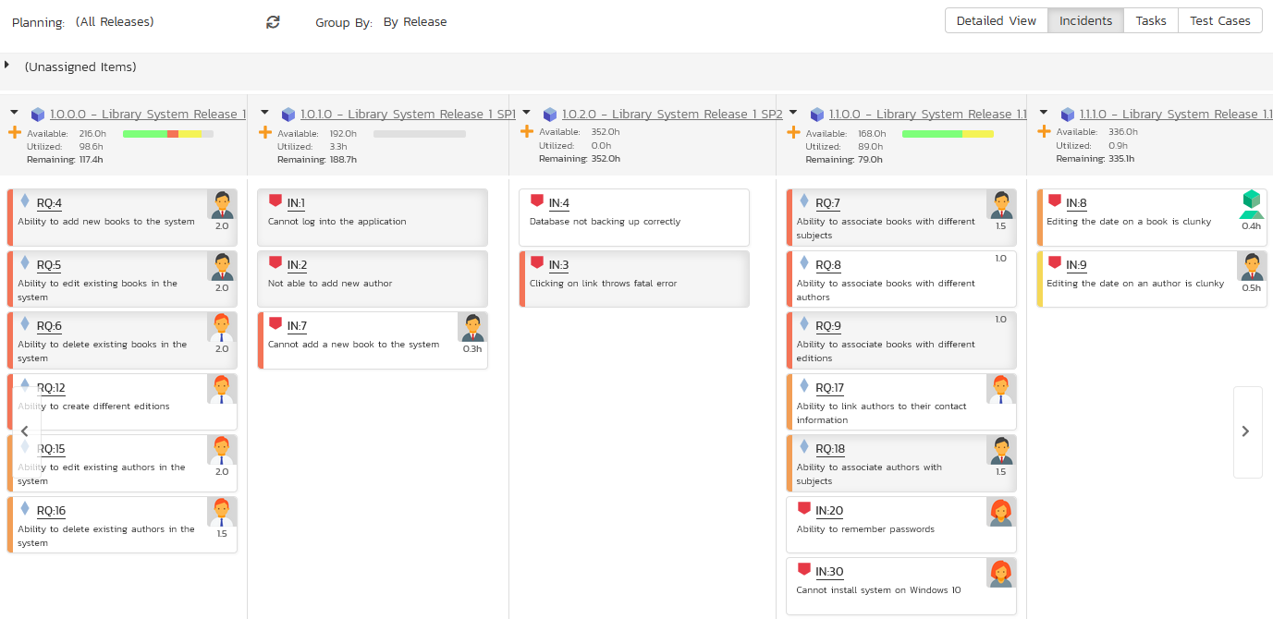

The ‘Unassigned Items’ section at the top allows you to see all the items not currently planned, and you can then drag and drop them into one of the lower sections that correspond to a specific release. Using the scroll arrows you can cycle through the releases and move any items from one release to another.

The header of each release section shows the overall progress and utilization of the release:

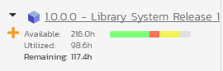

Clicking on the Release hyperlink will switch the planning board into the ‘Release Backlog’ view described in section 13.3 below.

### 13.2.2. Release Planning – By Priority

This view is designed to let you see the list of planned backlog items, organized by requirement importance. Each of the possible importance values is displayed on the left-hand side and the backlog items displayed in the same row on the right. The backlog items in this view will only be requirements (with associated tasks and test cases).

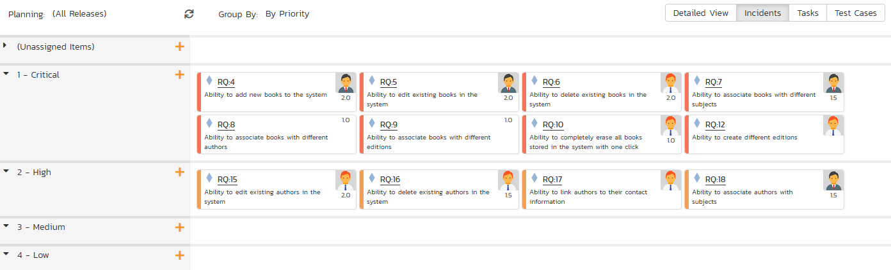

The top section will contain the list of items that are not assigned a priority, with the other sections containing the items that have been assigned to the specific priority.

### 13.2.3. Release Planning – By Status

This view is designed to let you see the product planned items organized by requirement status. Each of the possible status values (for a planned item) is displayed as a heading, with the backlog items displayed in the same column underneath. The backlog items in this view will only be requirements (with associated tasks and test cases). This view is commonly called a **Kanban** board:

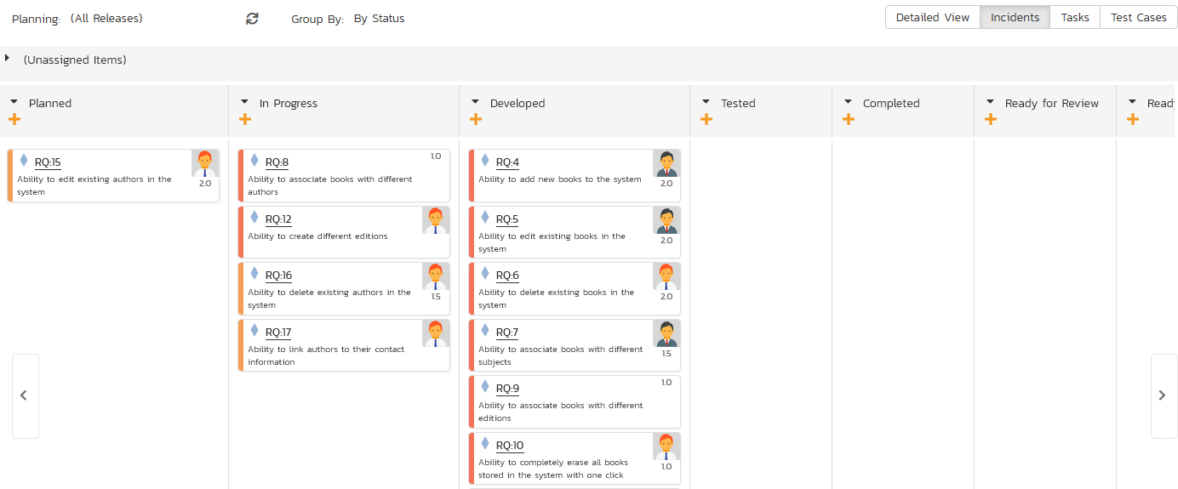

Each of the vertical sections is one of the requirements’ statuses, in order of the requirement lifecycle (Planned > Completed). You can click on the expand/collapse icons to hide any statuses that are not used. You can drag and drop the requirements between the different statuses. If you have the planning options enabled to have requirements status’ automatically update based on changes to the associated tasks and test cases, then items will automatically move between the statuses based on tasks being completed and test cases being executed.

### 13.2.4. Release Planning – By Person

This view is designed to let you see the product planned items organized by resource / person. Each of the users that is a member of the current release is displayed as a heading, with the backlog items displayed in the same column underneath. The backlog items in this view can be either requirements (with associated tasks and test cases) or incidents.

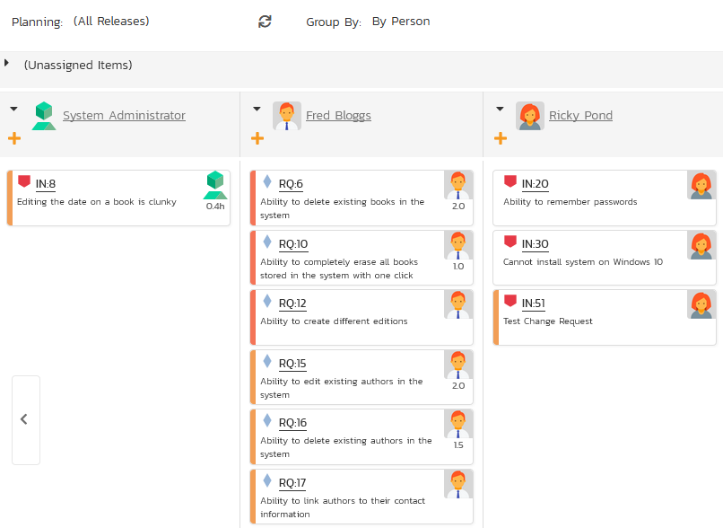

You can click on the expand/collapse icons to hide any resources that are not relevant. Above the resource headings there is a section with the release name; that contains backlog items that are scheduled for the current release but have not yet been assigned to a resource. You can drag and drop the backlog items between resources or to/from the release backlog. Any backlog items not assigned to a resource and release will be listed in the (Unassigned Items) section at the top.

## 13.3. Release Backlog Planning

The release backlog view is designed to let you view the backlog items that have been assigned to the selected release. You can always see the items not currently assigned to any release by expanding the ‘Unassigned Items’ section and then drag those items into the current release.

The lower section of the board allows you to segment the items by either iteration/sprint (typically used in **Scrum**), by status (typically used in **Kanban**), or by person.

### 13.3.1. Release Backlog – By Sprint

This view is designed to let you see the release backlog organized by iteration / sprint. Each of the sprints defined for the current release is displayed as a heading, with the backlog items displayed in the same column underneath. The backlog items in this view can be either requirements (with associated tasks and test cases) or incidents. This view is commonly called a **Scrum** board:

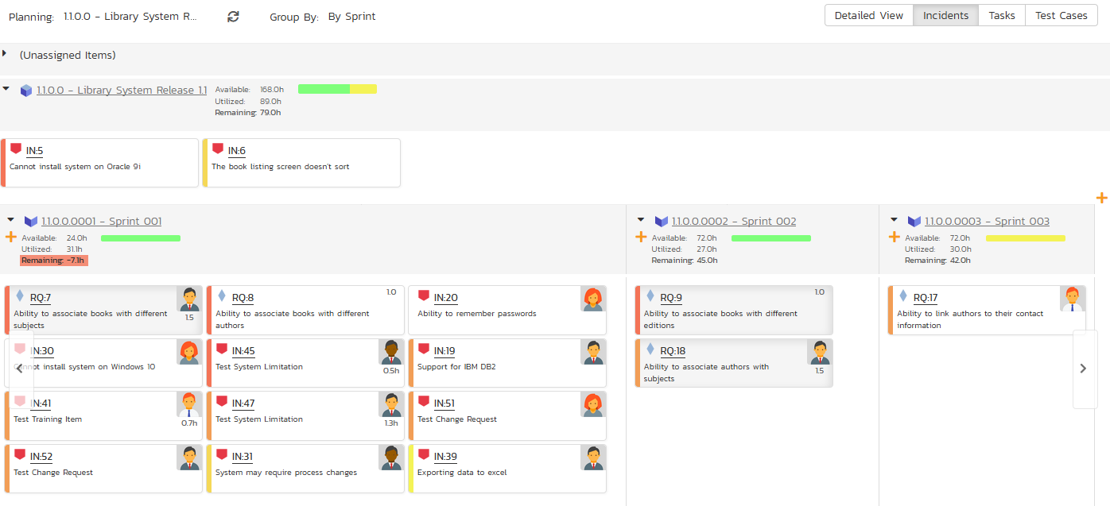

You can drag and drop the requirements between the different sprints. If you schedule a requirement for a specific sprint, all the child tasks that have not yet been started, will follow the parent requirement in being associated with the sprint. Once the backlog item has been added to the sprint, the utilized effort for the sprint will increase, and the available effort will decrease by the same amount.

Note: The system will allow you to assign more backlog items to an sprint than it is possible to complete, however this will result in a negative value for ‘available effort’. If this happens, the “Available Effort” value will be displayed in red, and you need to rebalance the items, extend the sprint length or add product personnel resources to the sprint.

Clicking on the Sprint hyperlinks in the headers will switch the planning board into the ‘Sprint Backlog’ view described in section 13.4 below.

### 13.3.2. Release Backlog – By Status

This view is designed to let you see the release backlog organized by requirement status. Each of the possible status values (for a planned item) is displayed as a heading, with the backlog items displayed in the same column underneath. The backlog items in this view will only be requirements (with associated tasks and test cases). This view is commonly called a **Kanban** board:

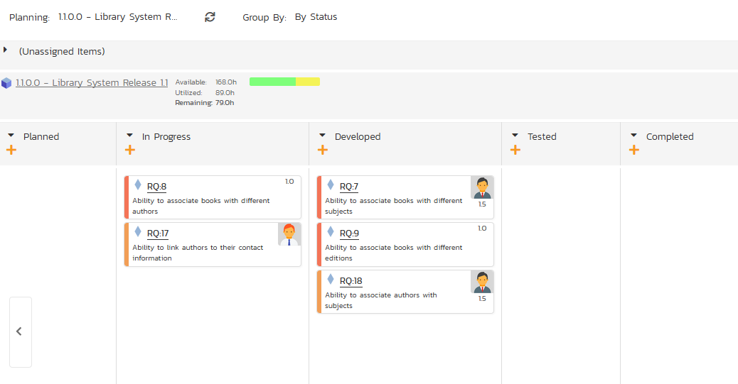

Each of the vertical sections is one of the requirements’ statuses, in order of the requirement lifecycle (Planned > Completed). You can click on the expand/collapse icons to hide any statuses that are not used. You can drag and drop the requirements between the different statuses. If you have the planning options enabled to have requirements status’ automatically update based on changes to the associated tasks and test cases, then items will automatically move between the statuses based on tasks being completed and test cases being executed.

### 13.3.3. Release Backlog – By Person

This view is designed to let you see the release backlog organized by resource / person. Each of the users that is a member of the current release is displayed as a heading, with the backlog items displayed in the same column underneath. The backlog items in this view can be either requirements (with associated tasks and test cases) or incidents.

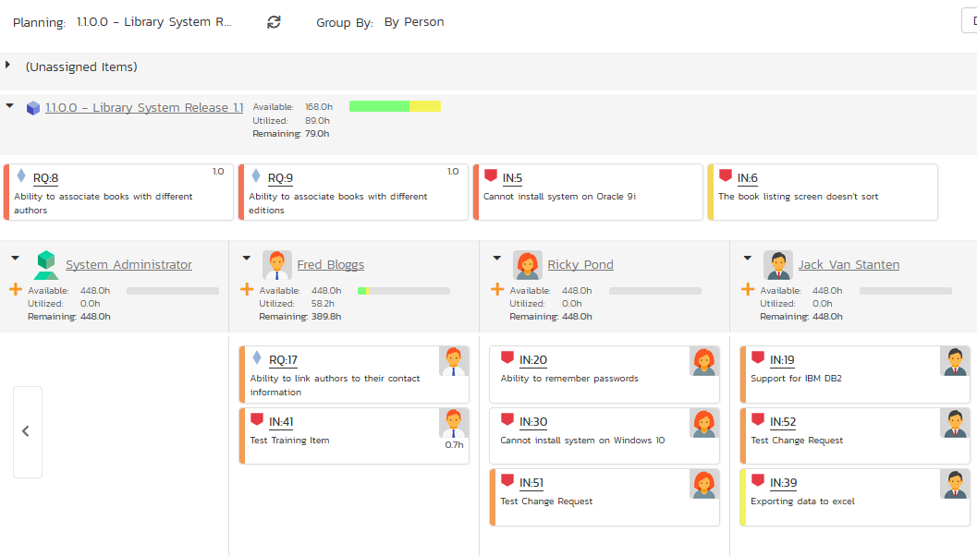

You can click on the expand/collapse icons to hide any resources that are not relevant. The system will display a progress bar for each resource to illustrate the allocation for that resource. Any resource that has a progress bar that is completely green has been fully scheduled and should not have any additional items assigned. If the progress bar for that resource turns red, it means that they have been over-scheduled and you need to reassign some of the items.

Above the resource headings there is a section with the release name; that contains backlog items that are scheduled for the current release but have not yet been assigned to a resource. You can drag and drop the backlog items between resources or to/from the release backlog. Any backlog items not assigned to a resource and release will be listed in the (Unassigned Items) section at the top.

### 13.3.4. Release Backlog – By Priority

This view is designed to let you see the list of planned backlog items in the current release, organized by requirement importance. Each of the possible importance values is displayed on the left-hand side and the backlog items displayed in the same row on the right. The backlog items in this view will only be requirements (with associated tasks and test cases).

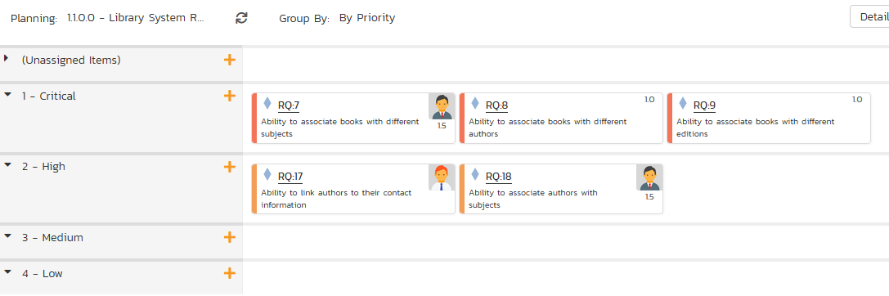

The top section will contain the list of items that are not assigned a priority, with the other sections containing the items that have been assigned to the specific priority.

## 13.4. Sprint Backlog Planning

The sprint backlog view is designed to let you view the backlog items that have been assigned to the selected iteration / sprint. You can always see the items not currently assigned to any release or sprint by expanding the ‘Unassigned Items’ section and then drag those items into the current release or sprint.

The lower section of the board allows you to segment the items by either status (typically used in **Kanban**), or by person. You can also view the Task artifacts by person or status for the current sprint.

### 13.4.1. Sprint Backlog – By Status

This view is designed to let you see the iteration / sprint plan organized by requirement status. Each of the possible status values (for a planned item) is displayed as a heading, with the backlog items displayed in the same column underneath. The backlog items in this view will only be requirements (with associated tasks and test cases).

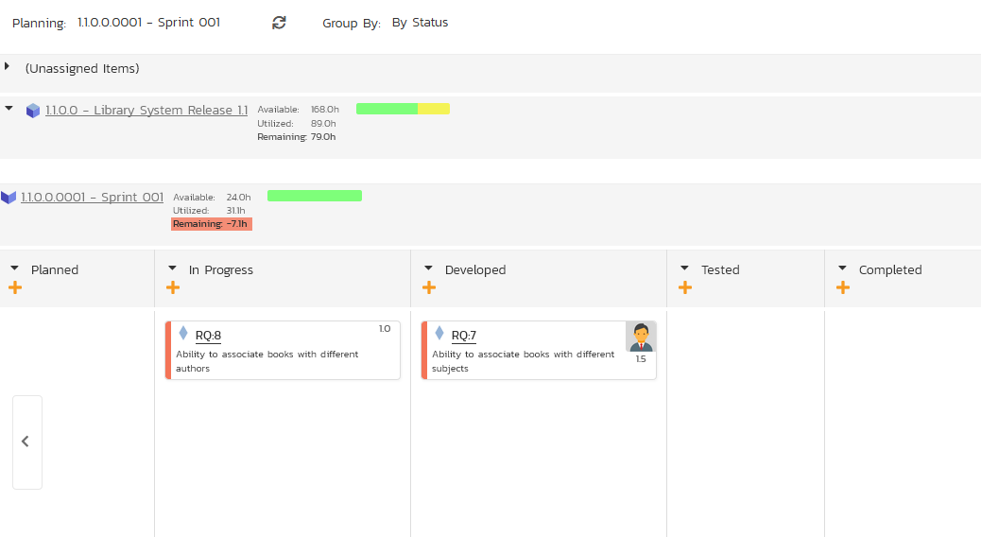

Each of the vertical sections is one of the requirements’ statuses, in order of the requirement lifecycle (Planned > Completed). You can drag and drop the requirements between the different statuses. If you have the planning options enabled to have requirements status’ automatically update based on changes to the associated tasks and test cases, then items will automatically move between the statuses based on tasks being completed and test cases being executed.

### 13.4.2. Sprint Backlog – By Person

This view is designed to let you see the iteration / sprint plan organized by resource / person. Each of the users that is a member of the current sprint is displayed as a heading, with the backlog items displayed in the same column underneath. The backlog items in this view can be either requirements (with associated tasks and test cases) or incidents.

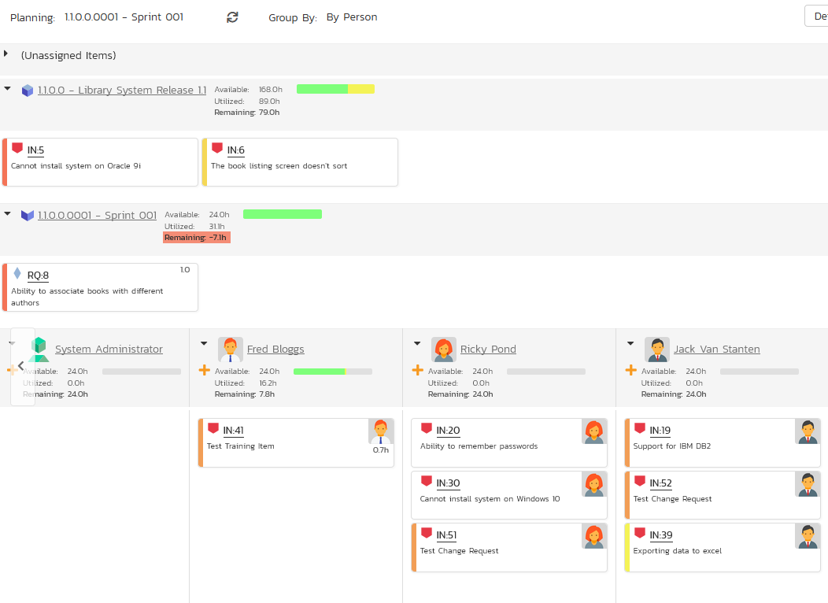

You can click on the expand/collapse icons to hide any resources that are not relevant. The system will display a progress bar for each resource to illustrate the allocation for that resource. Any resource that has a progress bar that is completely green has been fully scheduled and should not have any additional items assigned. If the progress bar for that resource turns red, it means that they have been over-scheduled and you need to reassign some of the items.

Above the resource headings there are sections with the release and sprint name; they contain backlog items that are scheduled for the current release or sprint but have not yet been assigned to a resource. You can drag and drop the backlog items between resources or to/from the release/sprint backlog. Any backlog items not assigned to a resource and release/sprint will be listed in the (Unassigned Items) section at the top.

### 13.4.3. Sprint Backlog – By Priority

This view is designed to let you see the list of planned backlog items in the current sprint, organized by requirement importance. Each of the possible importance values is displayed on the left-hand side and the backlog items displayed in the same row on the right. The backlog items in this view will only be requirements (with associated tasks and test cases).

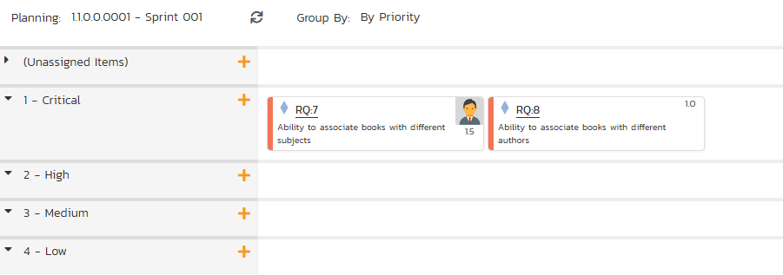

The top section will contain the list of items that are not assigned a priority, with the other sections containing the items that have been assigned to the specific priority.

# 14. Mobile Access

This section describes the functionality available in SpiraPlan® when accessing the system from a mobile device such as an iOS® smartphone / tablet (iPod Touch®, iPhone® and iPad®) or an Android® smartphone / tablet (Galaxy, Nexus, Droid, Kindle Fire®, etc.).

The application has been designed to be fully “responsive”, which means that it will dynamically rearrange the page based on the screen-sized used, to create an optimal experience on any device. As much as possible the application provides a consistent set of functions for any device. However, in order to make using the application on smaller devices as easy as possible, necessarily the experience on say, a smartphone, is less complete than on a desktop.

Whenever this user guide has referred to performing an action by ‘clicking’ if the same functionality is available, then ‘tapping’ on a mobile device will yield the same result. Due to the limitations of mobile devices, hovering over an element to display a “tooltip” is not possible.

Below, some illustrations of how the application looks at different screen sizes are provided.

## 14.1. My Page

Desktop (a tablet in landscape mode will appear largely identical)

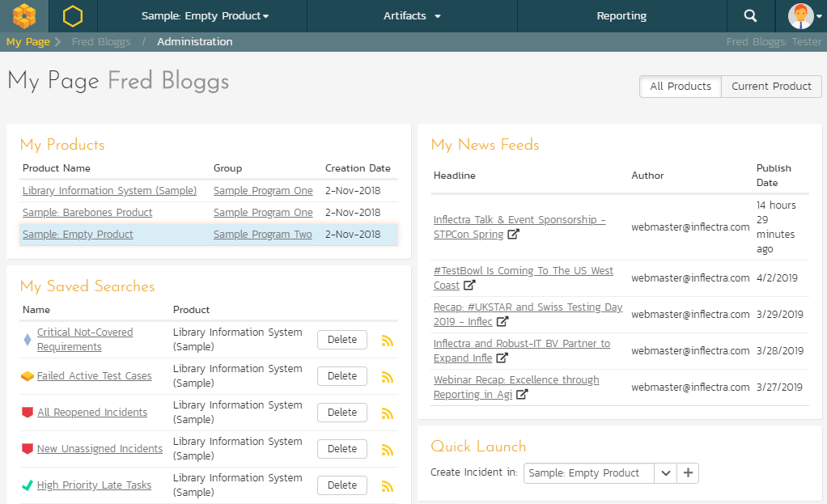

Table in portrait mode

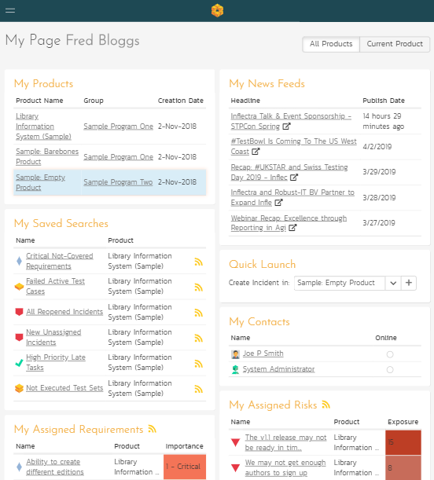

Smartphone in portrait mode

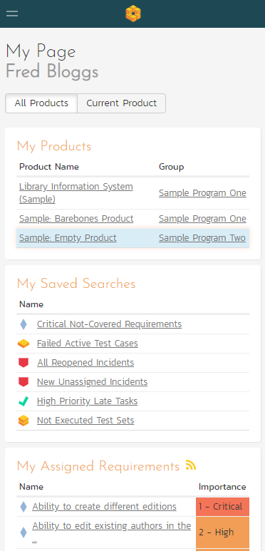

## 14.2. My Profile

Desktop (a tablet in landscape mode will appear largely identical)

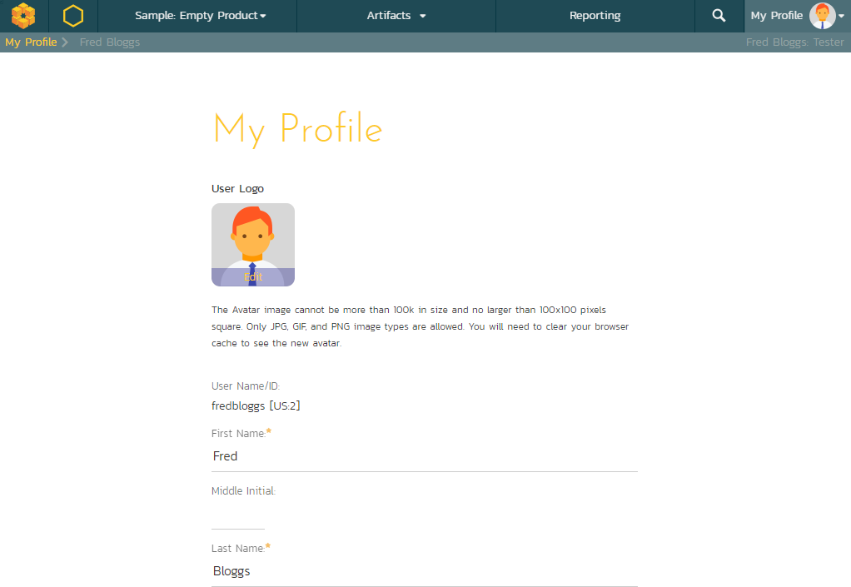

Tablet in portrait mode

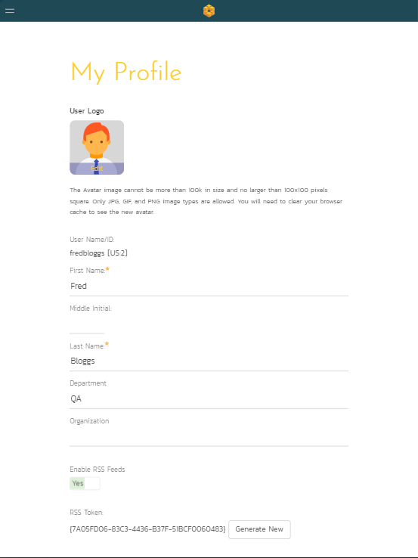

Smartphone in portrait mode

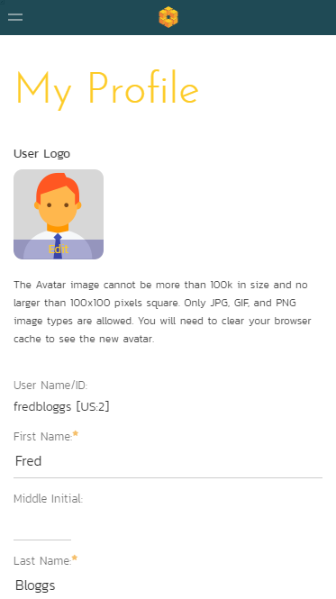

## 14.3. Example List Page

Desktop (a tablet in landscape mode will appear largely identical)

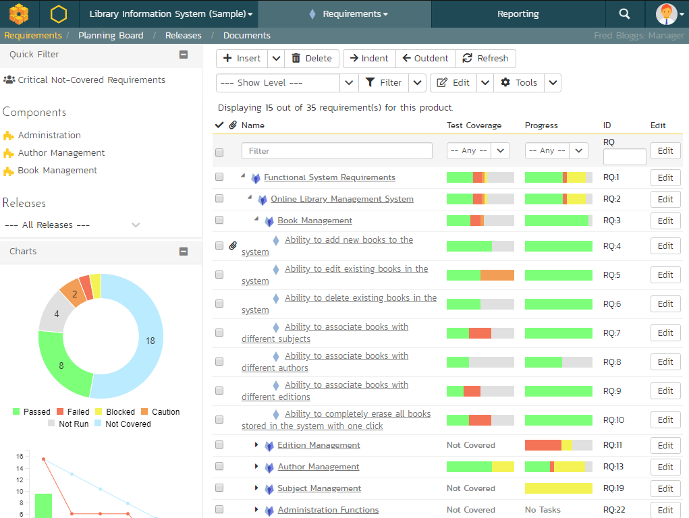

Tablet in portrait mode

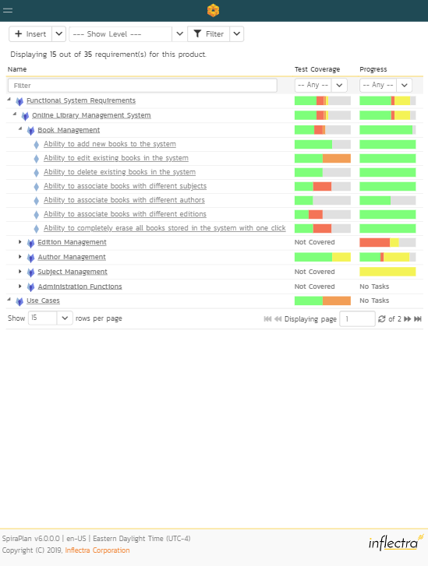

Smartphone in portrait mode

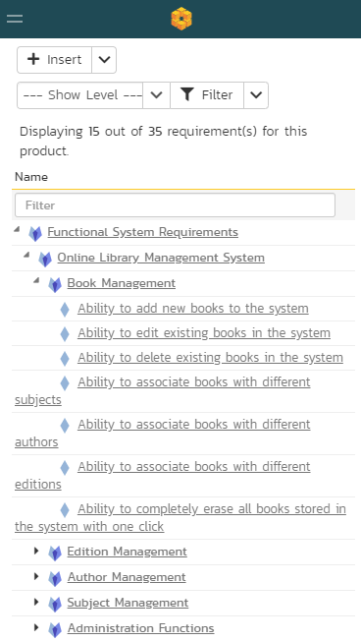

## 14.4. Example Details Page

Desktop (a tablet in landscape mode will appear largely identical)

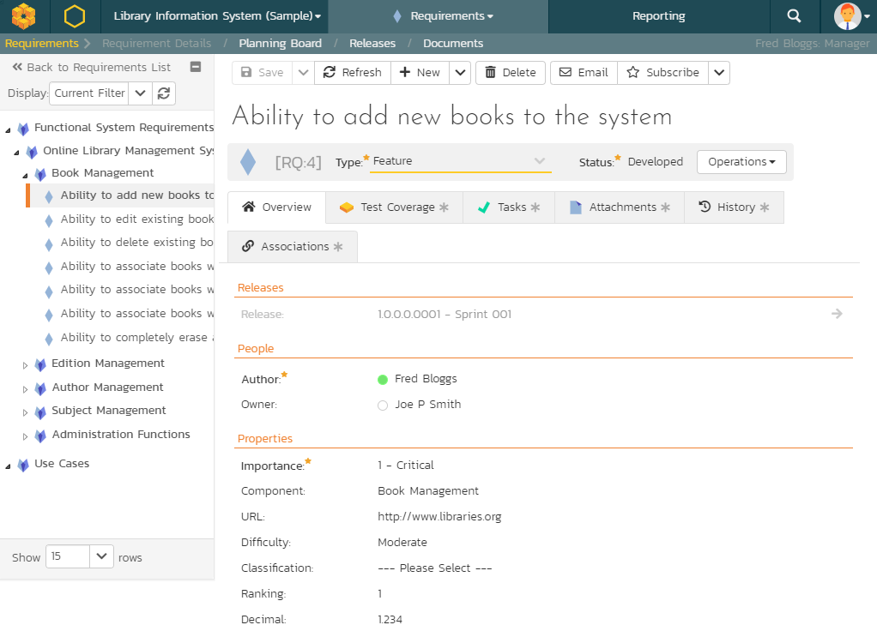

Tablet in portrait mode

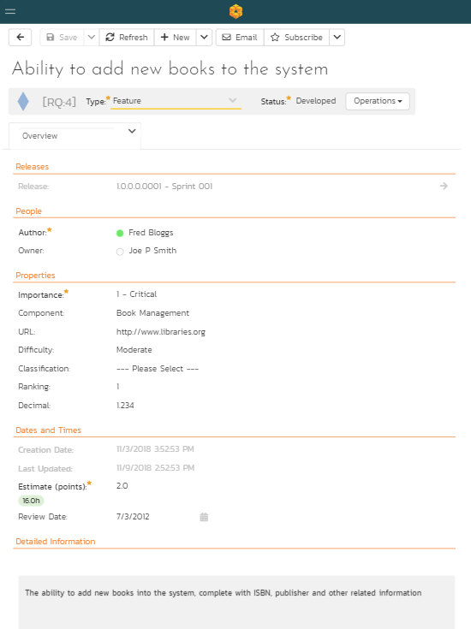

Smartphone in portrait mode

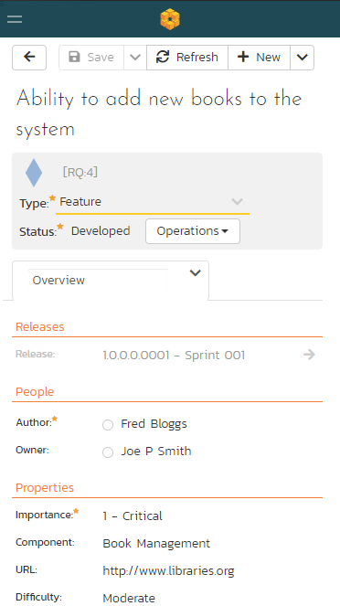

## 14.5. Test Execution

Desktop (a tablet in landscape mode will appear largely identical)

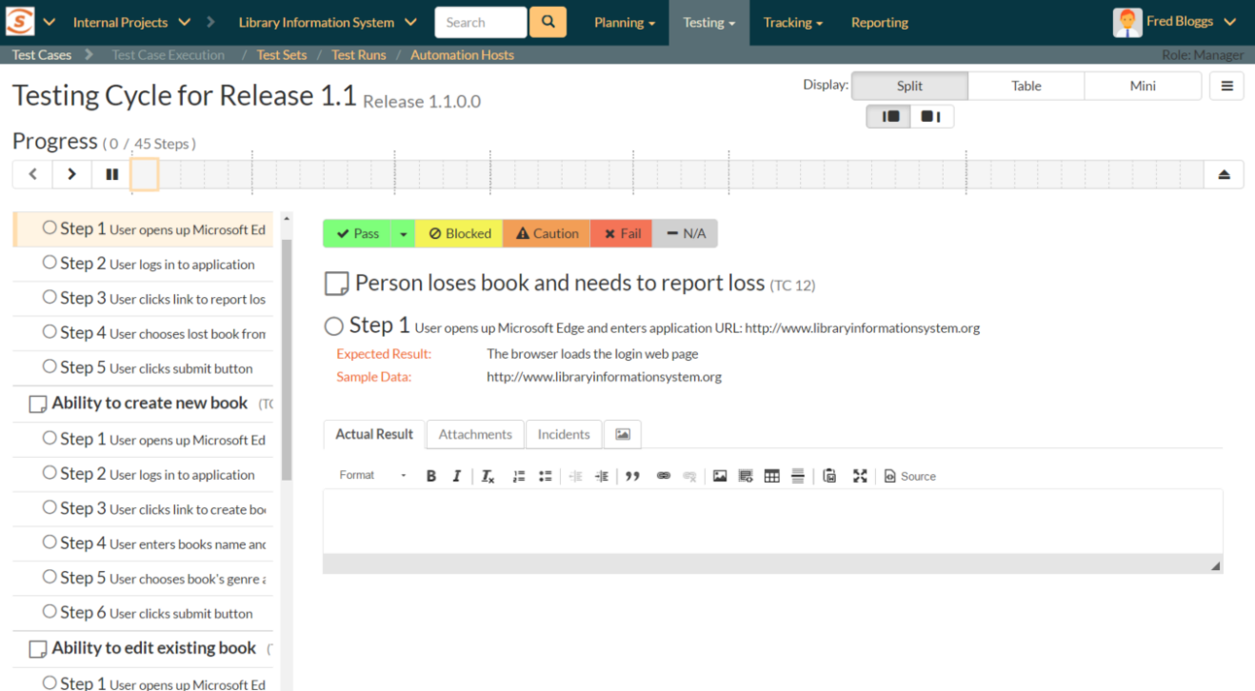

Tablet in portrait mode

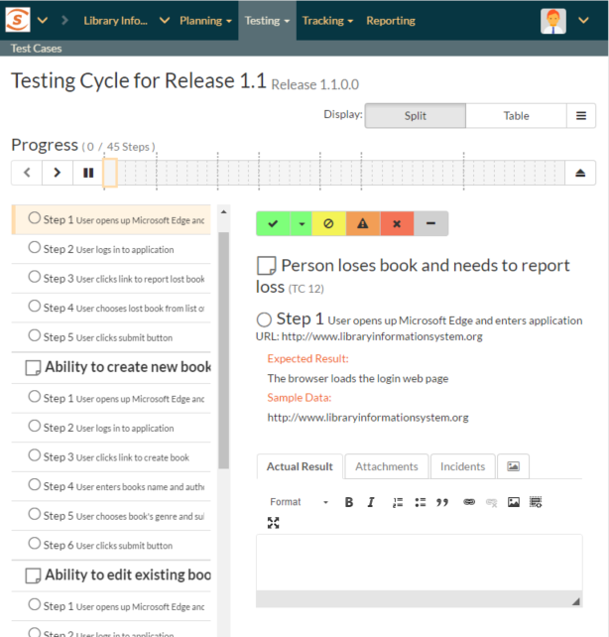

Smartphone in portrait mode

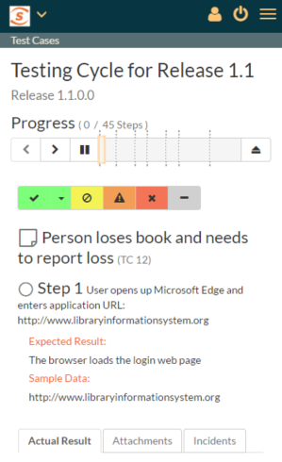

# 15. Program Management

The program management features of SpiraPlan let you manage multiple products as a single program. The features described in the section require that you are logged in as a user that has membership of the program (aka program) in question. You can be either of the two program roles (program owner or executive) to access these features. They can be accessed from the SpiraPlan workspace menu.

*Note: SpiraTest and SpiraTeam do not include these features.*

## 15.1. Program Planning Board

The program planning board is designed to let you view the backlog items that need to be planned for all of the products in a specific program (aka program) as well as view all of the planned items in each of the individual products. It is designed to let you see a product-group wide view of all requirements and associated test cases and tasks. You can access this feature by clicking on the **Planning** menu entry in the program navigation.

The program planning board has the following views:

* Program Backlog
  + By Priority
  + By Status
* All Products
  + By Product
  + By Priority
  + By Status
  + By Person
* Product
  + By Priority
  + By Status
  + By Person

Each of these views is described below:

### 15.1.1. Program Backlog – by Priority

This view is designed to let you see the program backlog organized by requirement importance. Each of the possible importance values is displayed on the left-hand side and the backlog items displayed in the same row on the right. The backlog items in this view will only be requirements (with associated tasks and test cases).

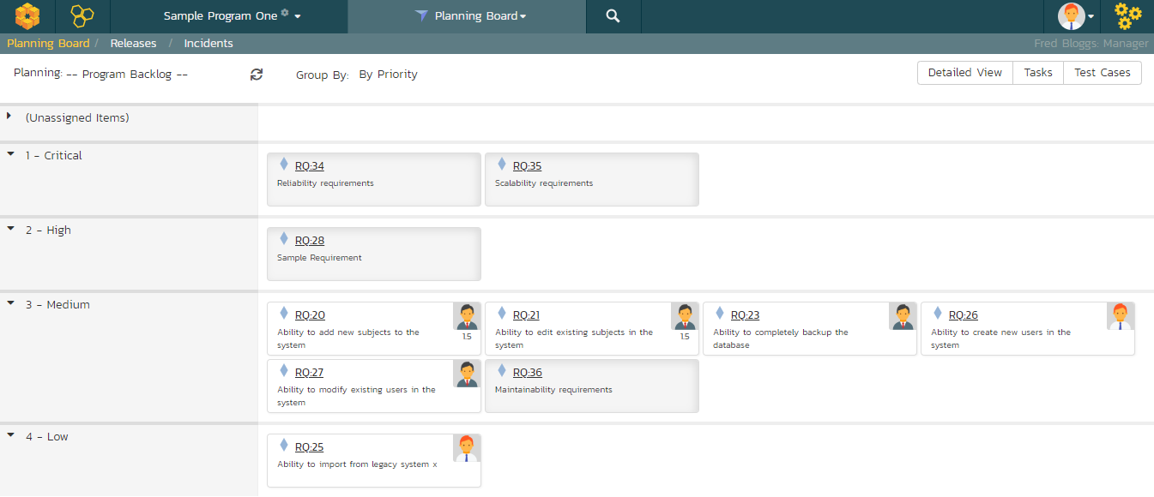

The top section will contain the list of items that are not assigned a priority, with the other sections containing the items that have been assigned to the specific priority.

### 15.1.2. Program Backlog – by Status

This view is designed to let you see the program backlog organized by requirement status. Each of the possible status values (for an unscheduled item) is displayed as a heading, with the backlog items displayed in the same column underneath. The backlog items in this view will only be requirements (with associated tasks and test cases). This view is commonly called a **Kanban** board:

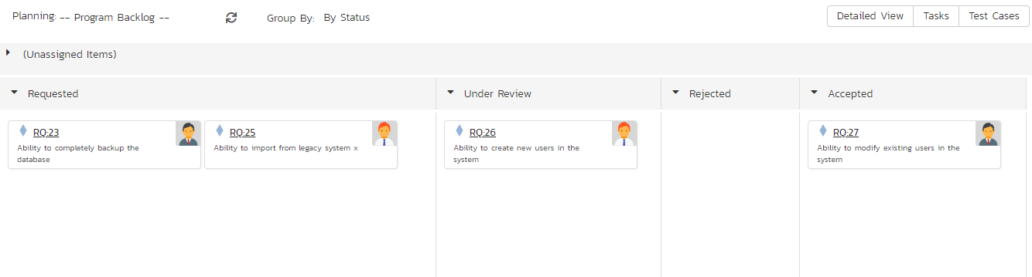

Each of the vertical sections is one of the requirements’ statuses, in order of the requirement lifecycle (Requested > Accepted). Once a requirement is assigned to a release or sprint it will come automatically ‘Planned’ and not appear in this view. You can drag and drop the requirements between the different statuses.

### 15.1.3. All Products – by Priority

This program planning view is designed to let you see all of the backlog items that have been scheduled for all of the products in the current program, organized by requirement importance/priority.

Each of the possible importance values is displayed on the left-hand side and the backlog items displayed in the same row on the right. The backlog items in this view will only be requirements (with associated tasks and test cases).



The top section will contain the list of items that are not assigned a priority, with the other sections containing the items that have been assigned to the specific priority.

### 15.1.4. All Products – by Product

The program planning view is designed to let you view the open (not-completed) backlog items currently planned per product. The backlog items are themselves only requirements, however you can see the tasks and test cases associated with a specific requirement.

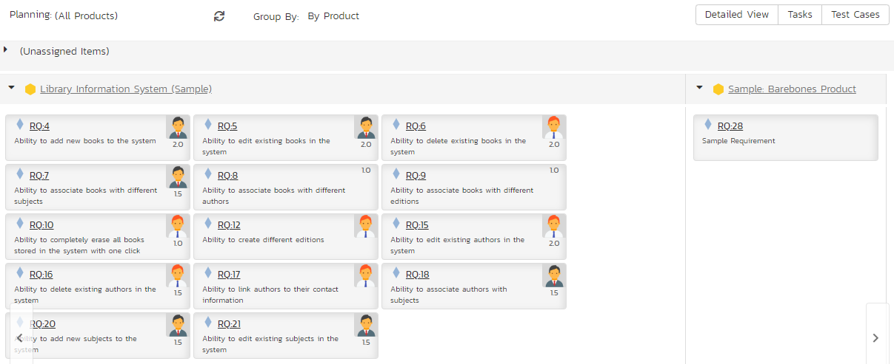

Clicking on the **product hyperlink** will switch the planning board into the ‘Product Backlog’ view described in section 13.5.4 below.

### 15.1.5. All Products – by Status

This view is designed to let you see the scheduled backlog items for the entire program organized by requirement status. Each of the possible status values (for a planned item) is displayed as a heading, with the backlog items displayed in the same column underneath. The backlog items in this view will only be requirements (with associated tasks and test cases). This view is commonly called a **Kanban** board:

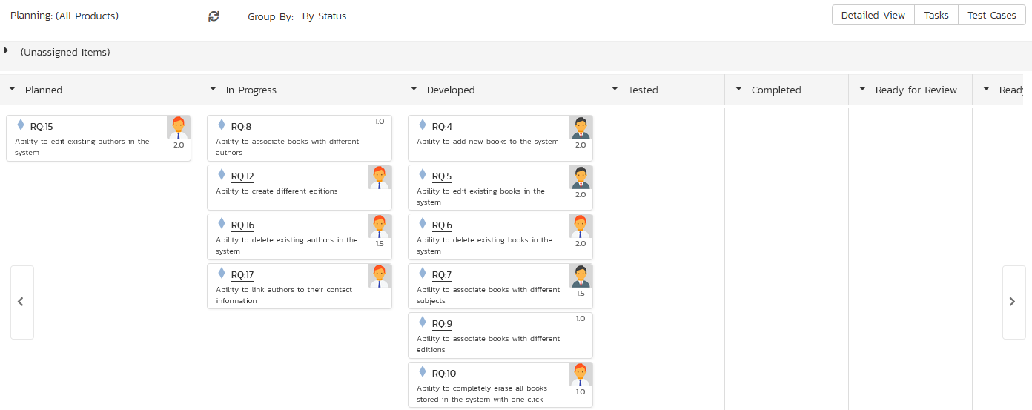

Each of the vertical sections is one of the requirements’ statuses, in order of the requirement lifecycle (Planned > Completed). You can click on the expand/collapse icons to hide any statuses that are not used. You can drag and drop the requirements between the different statuses. If you have the planning options enabled to have requirements status’ automatically update based on changes to the associated tasks and test cases, then items will automatically move between the statuses based on tasks being completed and test cases being executed.

### 15.1.6. All Products – by Person

This view is designed to let you see the program backlog organized by resource / person. Each of the users that is a member of any of the products in the current program is displayed as a heading, with the backlog items displayed in the same column underneath.

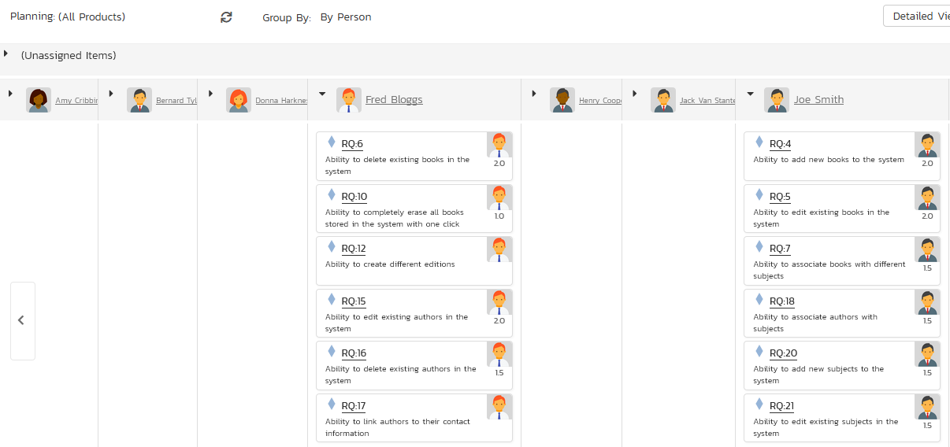

You can click on the expand/collapse icons to hide any resources that are not relevant. Above the resource headings there is a section called ‘Unassigned Items’; that contains backlog items that are scheduled but have not yet been assigned to a person.

### 15.1.7. Product – by Priority

This program planning view is designed to let you see all of the backlog items that have been scheduled for all of the products in the current program, organized by requirement importance/priority.

Each of the possible importance values is displayed on the left-hand side and the backlog items displayed in the same row on the right. The backlog items in this view will only be requirements (with associated tasks and test cases).

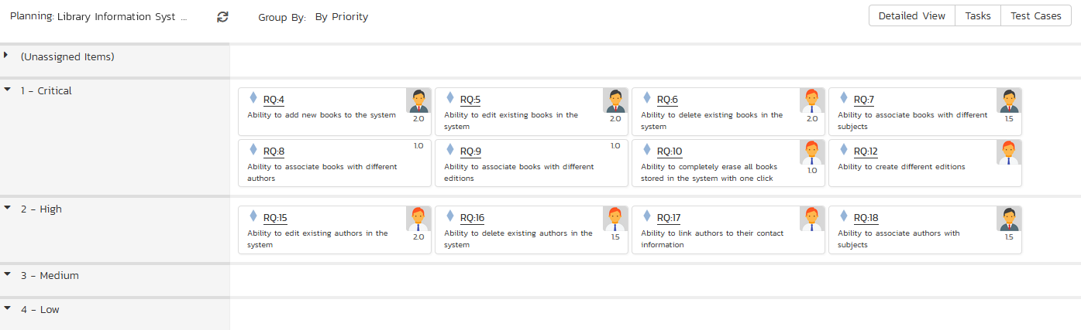

The top section will contain the list of items that are not assigned a priority, with the other sections containing the items that have been assigned to the specific priority.

### 15.1.8. Product – by Status

This view is designed to let you see the product backlog organized by requirement status. Each of the possible status values (for a planned item) is displayed as a heading, with the backlog items displayed in the same column underneath. The backlog items in this view will only be requirements (with associated tasks and test cases). This view is commonly called a **Kanban** board:

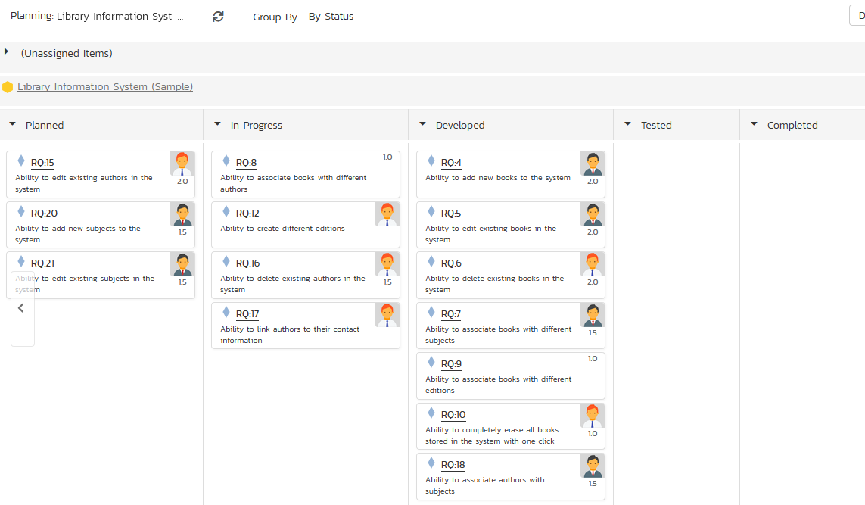

Each of the vertical sections is one of the requirements’ statuses, in order of the requirement lifecycle (Planned > Completed). You can click on the expand/collapse icons to hide any statuses that are not used. You can drag and drop the requirements between the different statuses. If you have the planning options enabled to have requirements status’ automatically update based on changes to the associated tasks and test cases, then items will automatically move between the statuses based on tasks being completed and test cases being executed.

### 15.1.9. Product – by Person

This view is designed to let you see the product backlog organized by resource / person. Each of the users that is a member of the current product is displayed as a heading, with the backlog items displayed in the same column underneath.

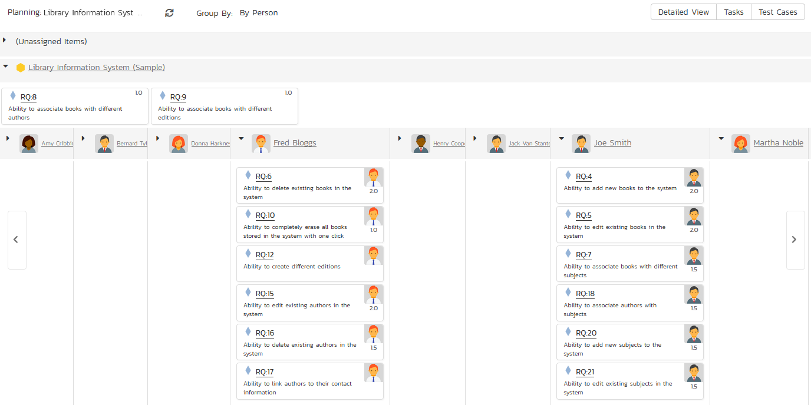

You can click on the expand/collapse icons to hide any resources that are not relevant. Above the resource headings there is a section with the product name; that contains backlog items that are scheduled for the current product but have not yet been assigned to a person.

## 15.2. Program Release Plan

The program release plan lets you see all of the products in the current program, together with their releases, sprints, and phases displayed in an integrated hierarchical view:

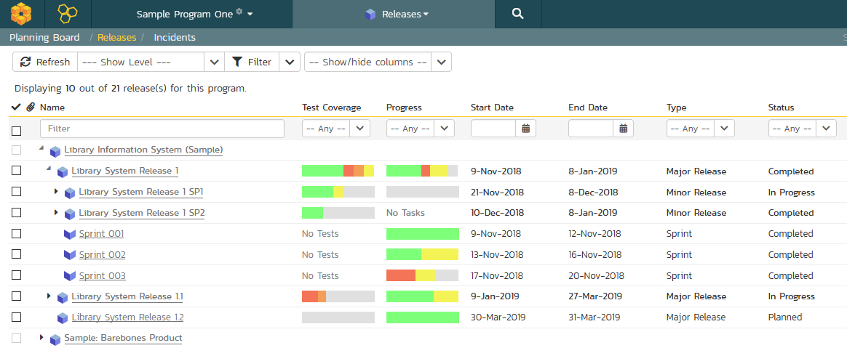

You can access this feature by clicking on the **Releases** menu entry in the program navigation.

This view lets you see all the releases, sprints, and phases with their dates, test coverage, progress and estimated/producted estimates. You can expand and collapse the products and releases to display the appropriate level of detail as well as filter by the various fields in the grid.

## 15.3. Program Incident List

The program incident list lets you see all of the incidents (bugs, enhancements, issues, risks, etc.) in the current program, displayed in an integrated table view. This view products program managers with the ability to see their incidents’ progress, dates, priorities, and other important fields:

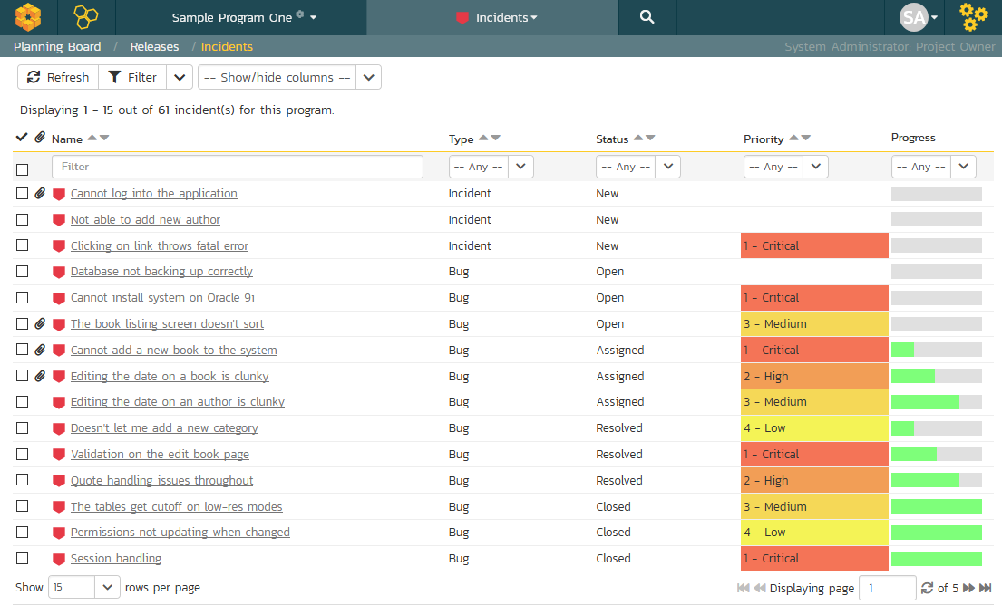

You can access this feature by clicking on the **Incidents** menu entry in the program navigation. You can filter and sort by specific product, or by the various fields displayed in the table.

# 16. Risks Management

This section outlines the risk management features of SpiraPlan® (not available in SpiraTest or SpiraTeam) and how they can be used to help understand, track, and mitigate risks across your products. The expected principle ways of managing risks is through assigning values to each risk’s probability and impact. These two fields, multiplied together, represent the potential (negative) exposure from the risk: a highly likely risk that would have a large impact has a higher exposure (and should be managed with a higher priority) than an unlikely risk which will not have much real world impact.

## 16.1. Risks List

When you click on the Tracking > Risks global navigation link, you will initially be taken to the risks list screen illustrated below:

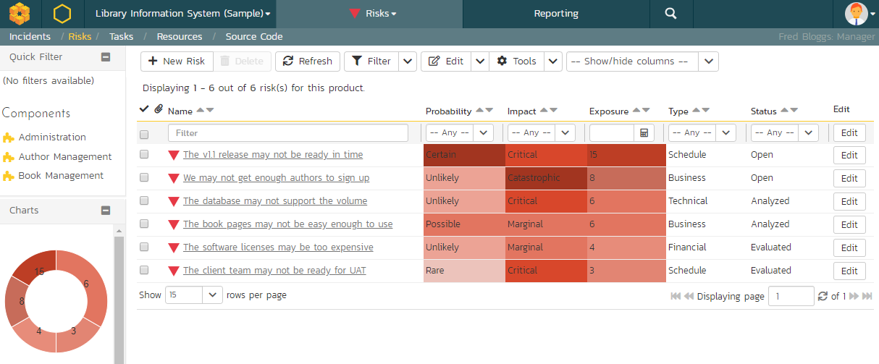

The risk list screen displays all the risks entered for the current product, in a filterable, sortable grid. The grid displays the risk number together with fields such as risk type (schedule, financial, etc.), status (open, evaluated, etc.), probability, impact, and exposure (calculated from the probability and impact). The choice of columns displayed is configurable per-user, per-product, giving extensive flexibility when it comes to viewing and searching risks.

The sidebar on the left gives you quick access to saved filters, along with useful charts to get an at-a-glance view of risks for this product.

In addition, you can view a more detailed description of the risk (along with any mitigations) by positioning the mouse pointer over the incident name hyperlink and waiting for the popup “tooltip” to appear. If you click on the risk name hyperlink, you will be taken to the risk details page described in section 16.2. Clicking on any of the pagination links at the bottom of the page will advance you to the next set of risks in the list according to the applied filter and sort-order. There is also a drop-down-list at the bottom of the page which allows you to specify how many rows should be displayed in each page, helping accommodate different user preferences.

### 16.1.1. Sorting and Filtering

You can easily filter and sort the list of risks as illustrated in the screen-shot below:

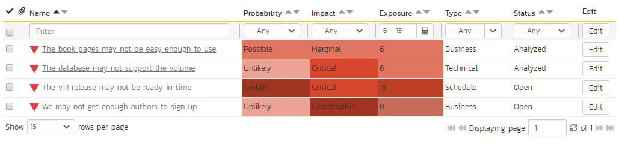

To filter the list by a field like type, probability, impact, or status choose an item from the appropriate drop-down list. For exposure you can search for a specific number range, and for the other fields, you enter a free-text phrase then click “Filter” or press the <ENTER> key to apply the different filters. Note that the name field is searched using a “LIKE” comparison, so that searching for “database” would include any item with the word database in the name. The other freetext fields need to be exact matches (e.g. dates, risk numbers).

To change the column that is sorted, or to change the direction of the current sort, click on the up/down arrow icon in the appropriate column. The currently sorted column is indicated by the darker arrow. In the screen-shot above, we are filtering on Exposures between 6 and 15 (inclusive), and sorting by ascending name.

Clicking on Filter > Clear Filter removes any set filters and expands the risk list to display all risks for the current product, and clicking on Filter > Save Filter allows you to save the filter to your ‘My Page’ for use in the future. The list of saved filters can also be retrieved by clicking Filter > Retrieve Filter.

As a shortcut, the left hand panel includes a set of **Quick Filters** that can be applied in a single-click:

* The topmost section displays any saved risk filters created by the current user or that are shared with the current user (the former are designated with an icon representing a single person, the latter a group of people)
* **Components** – This section lists the components defined for the current product. Clicking on any of the components in the list will filter the risks to only show those that are associated with the selected component.

### 16.1.2. New Risk

Clicking on the “New Risk” button takes you to the new risk screen. This is essentially the same screen as the risk details screen shown in section 16.2 except, depending on how the workflow has been configured for your product, certain fields may be disabled. For more details on setting and up configuring workflow for your product, please refer to the *SpiraTest Administration Guide*.

### 16.1.3. Delete

Clicking on the “Delete” button deletes the risk(s) whose check-boxes have been selected in the risk list.

### 16.1.4. Refresh

Clicking on the “Refresh” button simply reloads the list of risks; this is useful when new risks are being added by other users, and you want to make sure you have the most up-to-date list displayed.

### 16.1.5. Show / Hide Columns

This drop-down list allows you to change the fields that are displayed in the risk list as columns for the current product. To show a column that is not already displayed, select that column from the list of “Show…” column names and to hide an existing column, select that column from the list of “Hide…” column names. This is stored on a per-product basis, so you can have different display settings for each product you are a member of. The fields can be any of the built-in fields or any of the custom properties set up by the product owner.

### 16.1.6. Edit

Each risk in the list has an “Edit” button display in its right-most column. When you click this button or *double-click* on any of the cells in the row, you change the item from “View” mode to “Edit” mode. The various columns are made editable, and “Save” and “Cancel” buttons are displayed in the last column:

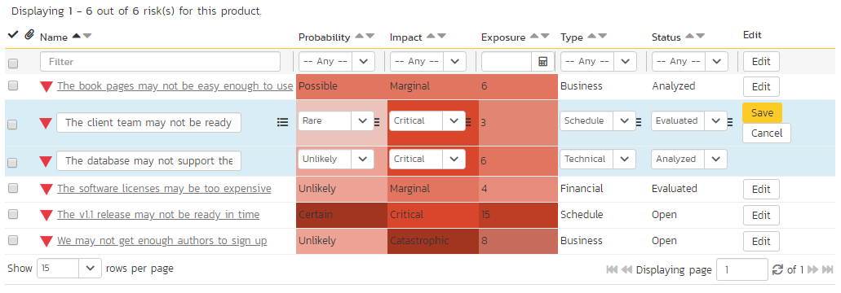

If you click “Edit” on more than one row, the “Save” and “Cancel” buttons are only displayed on the first row, and you can make changes to all the editable rows and then update the changes by clicking the one “Save” button. Also, if you want to make the same change to multiple rows (e.g. to change five risks from “Resolved” status to “Closed”), you can click on the “fill” icon to the right of the editable item, which will propagate the new value to all editable items in the same column.

If you want to edit lots of items, first select their checkboxes and then click the “Edit” button on the same row as the Filters and it will switch all the selected items into edit mode.

When you have made your updates, you can either click “Save” to commit the changes, or “Cancel” to revert back to the original information. Alternatively, pressing the <ENTER> key will commit the changes and pressing the <ESCAPE> key will cancel the changes.

### 16.1.7. Cloning Risks

To create a clone of an existing risk or set of risks, select the check-boxes of the risks you want to copy and then click Edit > “Clone”. This will make a copy of the current risk with its name suffixed with ‘… - Copy’ to distinguish itself from the original. Any file attachments and mitigations will also be copied along with the risk itself.

### 16.1.8. Exporting Risks

To export a risk or set of risks from the current product to another product in the system, select the check-boxes of the risk(s) you want to export and then click the Tools > “Export to Product”. This will then bring up a list of possible destination products:

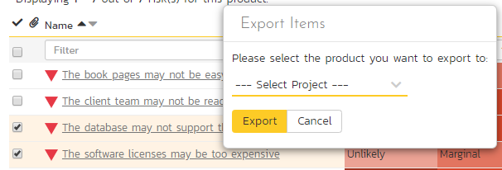

Once you have chosen the destination product and clicked the “Export” button, the risks will be exported from the current product to the destination product. Any file attachments will also be copied to the destination product along with the risks.

### 16.1.9. Printing Items

To quickly print a single risk or list of risks you can select the items’ checkboxes and then click Tools > Print Items. This will display a popup window containing a printable version of the selected items. You can also save the report in a variety of common formats from the same Tools menu.

## 16.2. Risk Details

When you click on a risk item in the risks list described in section 16.1, you are taken to the risk details page illustrated below:

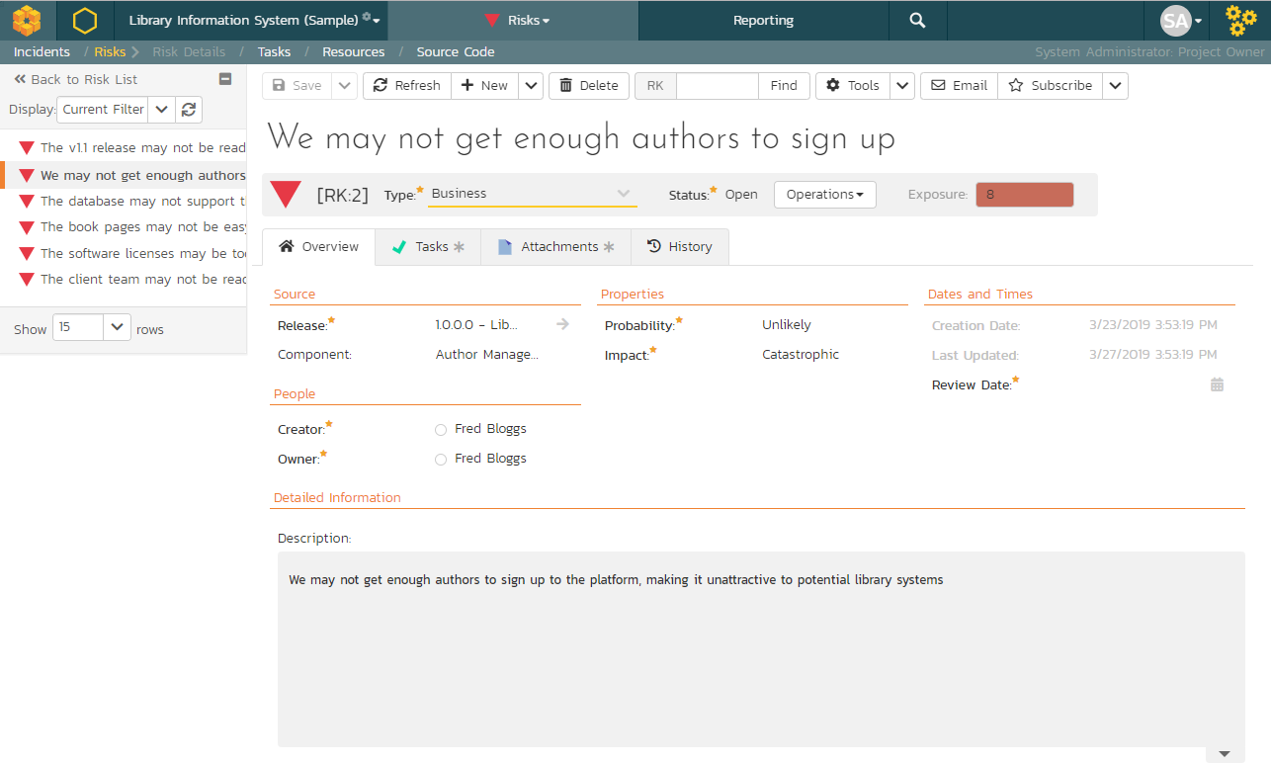

This page is made up of *three* areas;

1. the left pane displays the risks list navigation;
2. the right pane’s header, which displays: the operations toolbar; the editable name of the selected risk; and the info bar (with a shaded background), which also contains the workflow status transitions (see below); and
3. the right pane’s tabbed interface with rich information related to the risk.

Please note that on smaller screen sizes the navigation pane is not displayed. While the navigation pane has a link to take you back to the risks list, on mobile devices a ‘back’ button is shown on the left of the operations toolbar.

The navigation pane can be collapsed by clicking on the “-“ button, or expanded by clicking anywhere on the gray title area. On desktops the user can also control the exact width of the navigation pane by dragging and dropping a red handle that appears on hovering at the rightmost edge of the navigation pane.

The navigation pane shows a list of the peer risks to the one selected. This list is useful as a navigation shortcut; you can quickly view the coverage information of all the peer risks by clicking on the navigation links without having to first return to the risks list page. The navigation list can be switched between three different modes:

* The list of risks matching the current filter
* The list of all risks, irrespective of the current filter
* The list of risks assigned to the current user

On the main right-hand side of the page, which of the fields for the currently selected risk are available and which are required will depend on your stage in the risk workflow. For example, an identified risk might not require a “Release” whereas an evaluated risk could well do. The types of change allowed and the fields that are enabled/visible/required will depend on how your product administrator has set up the system for you. Administrators should refer to the *SpiraPlan Administration Guide* for details on configuring the risk workflows to better meet their needs.

Depending on the user’s role and whether they are listed as the owner or author of the risk, displayed in the info bar beneath the risk name is the current workflow status and an “operations” button which, when clicked, will show a set of allowed workflow operations:

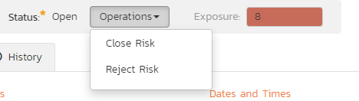

These workflow transitions allow the user to move the risk from one status to another. For example, when the risk is in the Open status, you may be given options to:

* **Close Risk** – changes status to “Closed”
* **Reject Risk** – changes the status to “Rejected”

After changing the status of the risk by clicking on the workflow link, you can then fill in any additional fields that are now enabled and/or required. Once you’ve made the changes to the appropriate fields, you can either click “Save”, “Save and Close”, or “Save and New” to commit the changes or “Refresh” to discard the changes and reload the risk from the database. In addition, you can print the current risk by clicking “Print”, which will display a printable version of the page in a separate window.

Please note that if digital signatures have been enabled for a particular workflow operation (and therefore a digital signature is required to confirm the status change. Workflow operations requiring a digital signature are marked with a padlock icon:

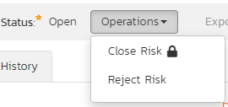

On attempting to save changes made after clicking a workflow operation that requires a digital signature you will be presented with the following popup:

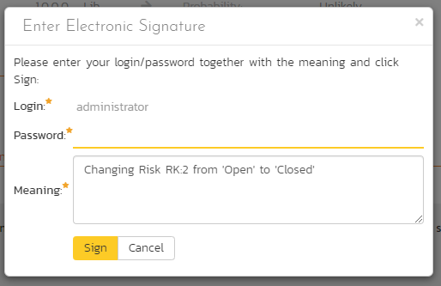

Using the “Email” button on the toolbar, you can send an email containing details of the risk to an email address or another user on the system:



You can specify the subject line for the email, and either a list of email addresses, separated by semicolons, or an existing product user .The content of the email is specified in the System Administration – Notification Templates.

To be notified of any changes made to the current artifact via email, click the “Subscribe” button. If you already subscribed, the button will instead let you “Unsubscribe” to stop receiving emails about that particular artifact. Depending on your role, you may also see a dropdown arrow to the right of this button. This will let you subscribe others in the product to this artifact.

The bottom part of the right pane can be switched between four views: “Overview”, “Tasks”, “Attachments”, “History”, each of which will be described in more detail below.

### 16.2.1. Overview - Details

The Overview tab is divided into a number of different sections. Each of these can be collapsed or expanded by clicking on the title of that section. It displays the description, fields and comments associated with the risk.

The top part of this tab displays the various standard fields and custom properties associated with the risk. Fields (both standard and custom) are grouped under the collapsible headings (marked by orange text and underline) in the screenshot below. For instance, all fields regarding dates are grouped together in the “Dates and Times” area.

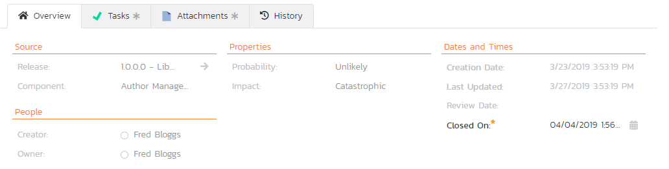

### 16.2.1.1. Followers

Using the “Subscribe” button on the toolbar, you can quickly follow the item, and receive updates on certain changes to it. Depending on your role, you may also see a dropdown to this button, which let’s you add another product member as a follower to this item.





You can also quickly see who is following an incident under the “People” section in the Overview tab.



To view information about the follower, or to unfollow them from the item, hover over their avatar to display a user profile card.



### 16.2.2. Overview – Detailed Information

The Detailed Information section contains the long, formatted description of the risk, as well as any rich text custom fields. You can enter rich text or paste in from a word processing program or web page into these fields. Clicking on the shaded areas of one of these detailed fields will display the rich text toolbar.

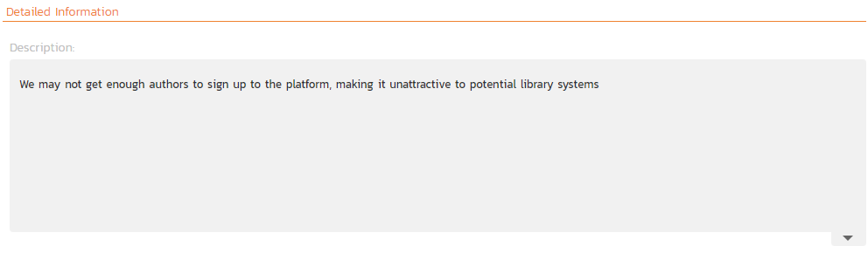

### 16.2.3. Overview – Mitigations

The mitigations section is where you can enter information about any plans or ideas about how the risk in question can be mitigated, in other words how its impact or probability can and/or will be lowered. The list of mitigations displays the position number, and the description, and date fields.

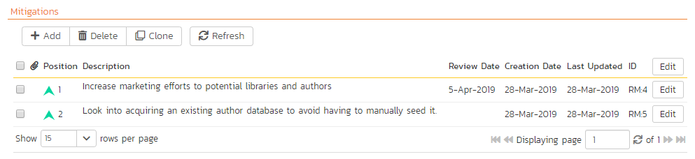

Clicking on the “Add” button inserts a new mitigation *before* the currently selected (by means of the check-box) step. Clicking the “Add” button without selecting an existing step will insert a new mitigation at the end of the list. When a new mitigation is inserted, its fields are displayed in “Edit” mode, so the description and review date fields are editable, allowing you to enter the data:

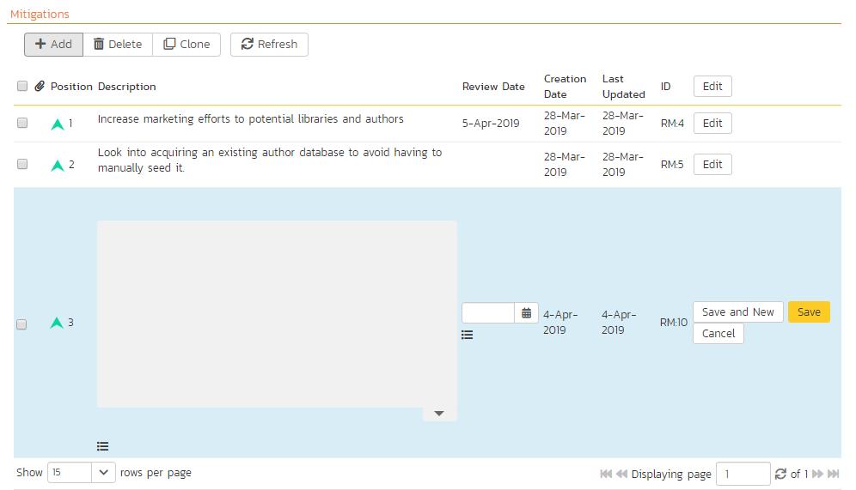

To move the mitigations around in the list, click and hold on the mitigation you want to move and drag it to the location desired.

If at least one mitigation is selected (using the checkboxes on the left-hand side), then clicking “Clone” will clone those mitigations and add them to the bottom of the list.

### 16.2.4. Overview - Comments

The Comments section allows you to add and view discussions relating to the risk:

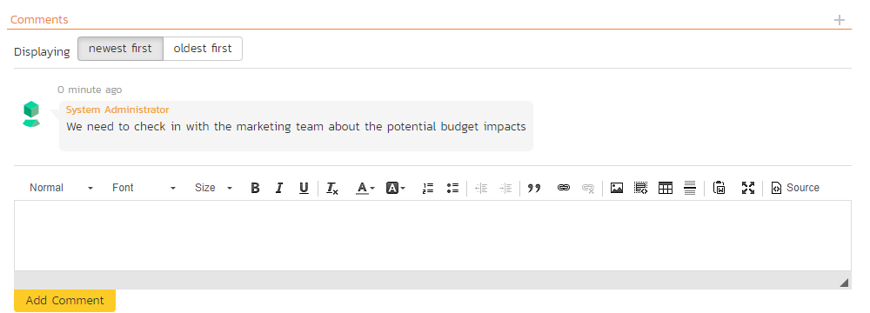

Existing comments are displayed in order underneath the textbox in date order (either newest first or oldest first). To add a new comment, enter it into the textbox, and click the “Add Comment” button.

### 16.2.5. Tasks

This tab shows the list of product tasks that need to be completed for the risk to be properly managed/mitigated:

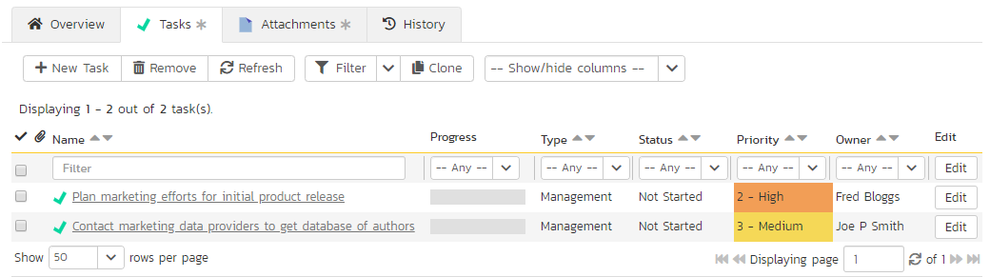

Each of the tasks is displayed together with, by default, its name, description (by hovering the mouse over the name), progress, priority, start-date, current owner, estimated effort, producted effort and numeric task identifier. Clicking on the task name will bring up the Task Details page which is described in more detail in section 8.2. This allows you to edit the details of an existing task.

You can perform the following actions on a task from this screen:

* **New Task** – inserts a new task in the task list with a default set of values. The task will be associated with the current risk.
* **Remove** – removes the task from this risk without actually deleting the task
* **Refresh** – updates the list of tasks from the server, useful if other people are adding tasks to this risk at the same time.
* **Filter / Apply Filter** – Applies the entries in the filter boxes to the list of tasks
* **Clear Filters** – Clears the current filter, so that all tasks associated with the current risk are shown.
* **Edit** – Clicking the “Edit” button to the right of the task allows you to edit the task inline directly on this screen. Only columns visible will be editable.
* **Show/Hide Columns** – Allows you to choose which Task columns are visible

Note that if you create a new task on the risks page, the component, release/sprint, and owner are automatically copied from the parent risk. You can change these suggested values before clicking “Save”

### 16.2.6. Attachments

The attachment tab displays the list of documents, screenshots or web-links (URLs) that have been “attached” to the risk. The documents can be in any format, though SpiraPlan® will only display icons for certain known types.

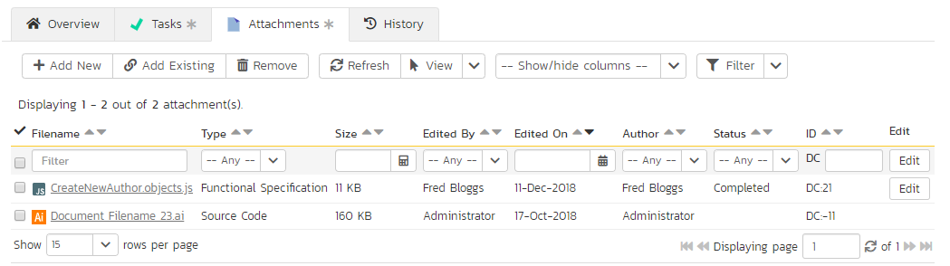

The attachment list includes the filename/URL that was originally uploaded together with the file-size (in KB), name of the person who attached it and the date uploaded. In addition, if you position the pointer over the filename and hold it there for a few seconds, a detailed description is displayed as a tooltip.

To actually view the document, click on the filename hyperlink and a new web browser window will open. Depending on the type of file, this window will either display the document / web-page or prompt you for a place to save it on your local computer. To remove an existing attachment from a risk, simply click the “Remove” button and the attachment will be removed from the list. Using the standard filter/sort options you can also sort and filter the list of attachments to make it more manageable.

If you are using SpiraPlan or SpiraTeam (but not SpiraTest) you can also choose to include file attachments stored in a linked version control system (e.g. Subversion, CVS, Perforce, etc.) by selecting the “Include Source Code Documents” option.

To attach a new document to the risk, you need to first click the “Add New” button to display the new attachment dialog box:



There are three different types of item that can be attached to a risk:

* To upload a file, choose “File” as the type and then click the Browse button and select the file from your local computer, optionally enter a detailed description then click the “Upload” button. The document will be copied from your computer and attached to the artifact.
* To attach a web-link (URL) to the artifact, you need to choose “URL” as the type and then enter the fully qualified URL (e.g. [http://mywebsite.com?Document=1](http://mywebsite.com/?Document=1)), an optional description and then click the “Upload” button to attach the web-link.
* To attach a screenshot to the artifact, you need to choose “Screenshot” as the type and then copy the image to your computer’s clipboard (e.g. on Windows computers, the PRINT SCREEN button captures the current page and adds to the clipboard). Once the image is in the clipboard, paste it into the editor using CTRL+V (or the equivalent keystroke for your operating system) and the item will appear in the preview window. You can then fill in the other fields and click “Upload” to attach the image.

Note: If you are using a non-Windows® computer (e.g. Macintosh®) that doesn’t put file extensions on filenames (e.g. .xls for an Excel sheet) automatically, then you will need to manually add the file extension to the filename before uploading if you want it to be displayed with the correct icon in the attachment list.

You can also associate an existing document (that’s already stored in SpiraTeam) with the risk. To do that, click on the “Add Existing” button to bring up the add file association dialog box:



You can then choose to either associate a document stored in the SpiraPlan Documents repository or (in the case of SpiraPlan/SpiraTeam but not SpiraTest) from the linked source code repository. In either case you first select the appropriate folder, and then pick the document(s) from the file list on the right. In the case of a source code file association you can also add a comment.

### 16.2.7. History

This tab displays the list of changes that have been performed on the risk artifact since its creation. An example risk change history is depicted below:

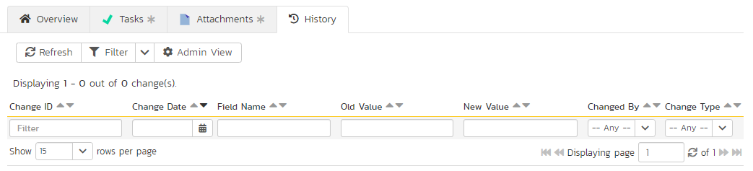

The change history displays the date that each change was made, together with the fields that were changed, the old and new values and the person who made the change. This allows a complete audit trail to be maintained of all changes in the system. In addition, if you are logged in as a product administrator you can also click on the “Admin View” hyperlink to revert any unwanted changes.

# Appendix 1: Keyboard Shortcuts

SpiraPlan® includes an array of keyboard shortcuts to speed up navigation and use of the application. All functionality can be performed using a mouse and clicking and therefore using a keyboard shortcut is never required. However, keyboard shortcuts can be an efficient way of performing common tasks. A list of the keyboard shortcuts and what they do is available throughout the application in two ways:

* Via the user profile action menu

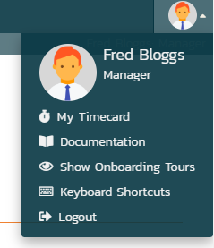

* By typing “?” anywhere in the application (not when the cursor is in a text field). For example, on Windows machines typing shift and the ? key together.

There are two main ways of using the shortcuts: either pressing a key or key(s) at the same time (indicated by a single key or “a + b”); or pressing a number of keys in succession as with normal typing (indicated by “a … b”). The popup menu explaining the shortcuts is illustrated below (please note that the keyboard shortcuts displayed will vary depending on the current page:

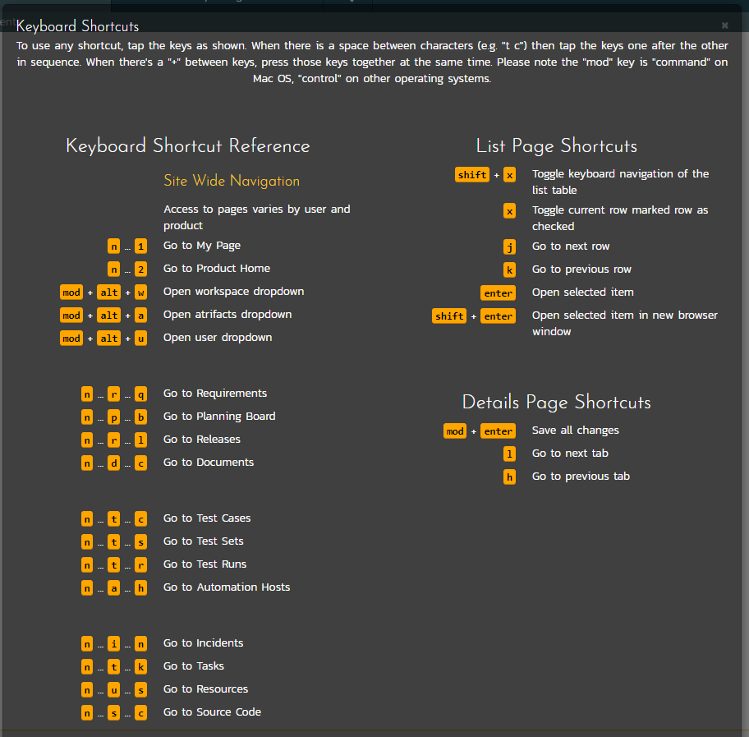

# Legal Notices

This publication is provided as is without warranty of any kind, either express or implied, including, but not limited to, the implied warranties of merchantability, fitness for a particular purpose, or non-infringement.

This publication could include technical inaccuracies or typographical errors. Changes are periodically added to the information contained herein; these changes will be incorporated in new editions of the publication. Inflectra® Corporation may make improvements and/or changes in the product(s) and/or program(s) and/or service(s) described in this publication at any time.

SpiraTest®, SpiraPlan®, SpiraTeam® and Inflectra® are registered trademarks of Inflectra Corporation in the United States of America and other countries. Microsoft®, Windows®, Explorer® and Microsoft Product® are registered trademarks of Microsoft Corporation. iOS, iPod, iPad and iPhone are registered trademarks of Apple Corporation, Android® is a registered trademark of Google Corporation, and Kindle Fire® is a registered trademark of Amazon LLC. All other trademarks and product names are property of their respective holders.

Please send comments and questions to:

Technical Publications

Inflectra Corporation

8121 Georgia Ave

Suite 504

Silver Spring, MD 20910

U.S.A.

[*support@inflectra.com*](mailto:support@inflectra.com)